T12 Meeting Minutes 02-02-2022

Reminder: Mute your audio and disable the video feature after starting this Webex meeting. Too many attendee’s with active video can interfere with everyone’s audio quality. Hover over the lower edge of your monitor screen to find the icon and disable your video.

These meetings will be recorded and posted on the WPC site.
Please be advised your image will be captured and recorded during the video conference.
Your participation in this videoconference equals consent to be recorded as required by law.

New Business
- ETO maintenance – release on 2/3/2022
- WSWA maintenance – nothing this week
- Velaro maintenance – nothing this week
- Tickets into production –
  - WA-4381 New PE called ‘PacMtn Opioid NDWG PY21-23’. Contact Erica Maki in Grants Management with questions.
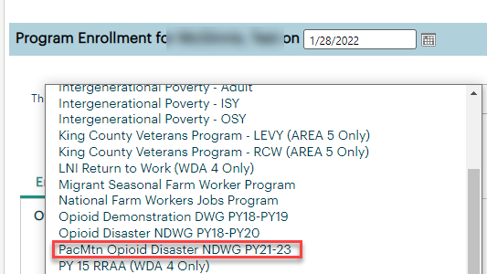

- Project updates – nothing this week
- What’s new on WPC –
  - Archived WorkSource Information Notices (WIN). In order to maintain the Workforce Professional Center site with up-to-date and relevant state guidance, we archived the following WINs for the reasons indicated:
    - Year Closed Out/Funds Expired:
    - 0069 - Revised PY15/FY16 WIOA Title I Allotments by WDA
    - 0076 - PY16/FY17 WIOA Title I Allotments by WDA
    - 0087 - PY17/FY18 WIOA Title I Allotments by WDA
    - 0091 - PY18/FY19 WIOA Title I Allotments by WDA
- Folded into WorkSource System Policy 1020 (Data Integrity and Performance Handbook):
    - 0084 - Supplemental State Guidance for the WIOA Title-I Youth Program
    - 0088 - Case Note Guidance
    - 0089 - Recording Youth Program Elements Provided to WIOA Title-I Youth Participants by Non-WIOA Providers for WIOA Title-I Federal Reporting
    - 0092 - Requirement to Record a WIOA Title-I Youth Program Element to Trigger Participation
    - 0098 - Measurable Skill Gains (MSG) Guidance for ETO
    - 0100 - School Status at Exit for WIOA Title-I Youth Participants

  - Other: WIN - Title - Archive Reason
    - 0016 - Combined Use of OJT and WOTC for Veterans - Governor’s release of additional WIA discretionary funds for PY2012 Veteran OJTs-obsolete guidance
    - 0038 - Mortgage Relief for UI Claimants and Unemployed Workers - Sunset in 2016
    - 0045 - Educational Functioning Levels - WIA-era numeracy/literacy info.
    - 0052 - WorkSource Policy Definitions - WIA-era references
    - 0067 - Veterans Point of Entry - Now WorkSource System Policy 1009, Rev. 3
    - 0072 - Creating new WIOA Services in SKIES prior to WIT Go-Live - SKIES no longer exists
    - 0075 - Enrollment of Incumbent Workers into WIOA DW-funded programs in SKIES prior to WIT Go-Live - Now part of WIOA Title I Policy 5607, Rev. 5 (Incumbent Workers)
    - 0093 - Dislocated Workers and Training Benefits (re: non-native finfish industry) - No non-renewals of leases by the Department of Natural Resources (DNR) due to release of non-native finfish
    - 0097 - Public Charge Rule - Public charge rule cancelled by the current federal administration on March 9, 2021
- Report enhancements – nothing this week
- Training issues/open discussion
  - Reminder: Link to claimants 1099’s available in eServices

  - Many reported issues with ETO can be resolved by clearing your cache, adding blocked sites to your ‘OL list and restarting your computer. Check out this document ‘Checklist of things to do before submitting a service request’ desk aid
  - We receive many tickets where staff can’t edit participant TP’s. The most common issue preventing you from editing another’s TP is because the participant hasn’t been added to your office.
    - Guidance in ‘Finding a participant in ETO’ desk aid
  - Discussion: There are 5 spaces available on the General Information dashboard for these 6 TPs to land. Demographic, disability, MSFW, Veteran details, Guide interface and Target Occupation.
    - Question: Do you find value in the Guide Interface and Target Occupation TPS and want them on the GI dashboard?
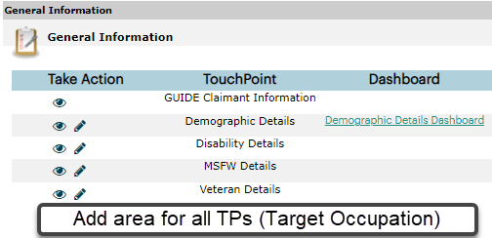
    - Consensus was to add another place holder so 6 TPs can land here
  - Discussion: Create a Record (CAR)
    - Updating detail TPs (Demographics, Disability, MSFW, Veteran)
      - If participant has WSWA account, update details there
      - If Participant doesn’t have WSWA account
      - Training material including ESD Policy guidance is on the WPC site
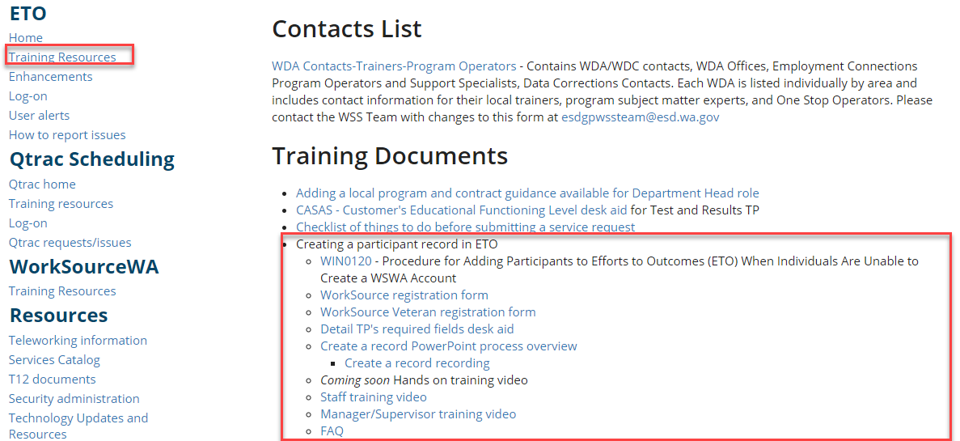

      - Report for monitoring staff created participants
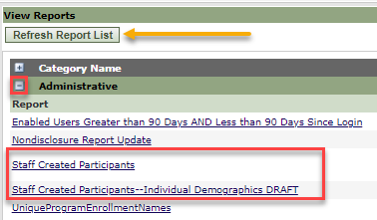

  - Employer fraud
    - Working on new process and changes to WSWA to warn job seekers
    - Direct job seekers to Washington State Office of the Attorney General for information on employment scams
    - Job seekers can contact the Attorney General’s office and file a complaint ‘Contact Us’
  - Correction from last week. What does it mean when you see WorkSource Youth Center on the General Information dashboard?
    - It refers to the office assignment not to a Program Enrollment. When a job seeker creates a WSWA account they are automatically assigned all offices in the WDA. The office assignment is done in reverse alpha order. So for Snohomish County, WS Youth Center is the last office alphabetically in that area.
  - Office closures
    - Submit remedy ticket to update the WS locator
  - Submit remedy tickets vs sending email to team
    - Remember if you suggest an enhancement at T12, submit a remedy ticket.
- Remedy tickets – Recently the service desk has been back logged with tickets which delays ETO/WSWA ticket assignment to our team. SSN correction tickets are a high priority, needing an immediate fix so staff can record services provided to customers timely. Email us at esdgpwssteam@esd.wa.gov if you receive a response within 24 hours. We can locate the ticket and start working on it.
- ETO Basic and Refresher Training - Next training is on 2/7/22 9-12
  - ETO Basic training is the 1st Monday 9:00-12 and 3rd Tuesday 1:30-4:30 of every month (except holidays). Send email to Lynn Aue to receive more information, training account if needed and be added to the training Webex call. All ETO/WSWA system users are welcome to attend the training but please do not forward invites as I need to review all attendees and assign training accounts if needed.
  - Refresher training recordings and user guides are posted on the WPC website here https://wpc.wa.gov/tech/ETO-refresher-training
  - Submit a remedy ticket to request additional training opportunities and resources
Old Business
- Reminder: Submit remedy tickets for all work requests here. The WSS team cannot begin work without a service request. Reaching out to us directly can affect the time it takes to resolve your issue. Thanks!
  - Submitting remedy tickets – help us by providing enough details to work your issue. Suggestions to speed up discovering and resolving issue without lots of back-and-forth emails.
    - Screen shots include the entire screen, browser bar, not just a pinpoint of the TP that isn’t correct.
    - Report tickets need the WDA, office and start and end dates parameters you used to run the problematic report
    - We will send you 2 emails asking for additional information. Second request for response will advise you the ticket will close in 24 hours.
- Desk aid on things to try before submitting a remedy ticket; includes instructions for clearing your cache
- WA-4414 fix coming soon Some employers are reporting landing on the Monster pay page. Direct them to click on ‘Home’ or ‘Sign in’ Clicking on ‘Post a Job’ here takes them to a page asking for money. We are working on cleaning this up.
  - Advise your employers to clear their cache so they get out of the loop of landing on this page when log into their account!
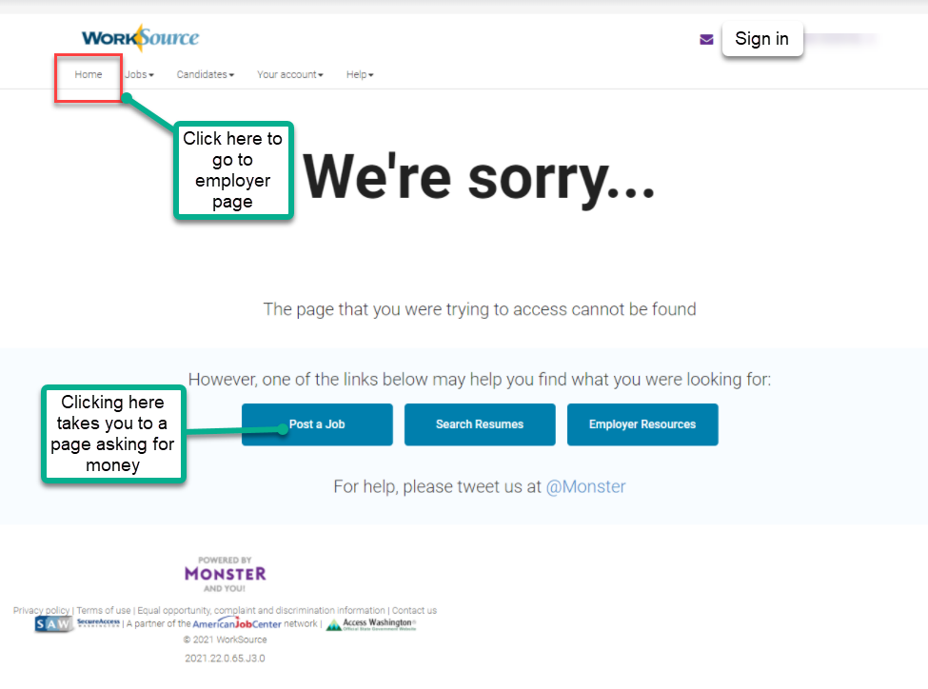

- Internet Explorer (IE) will be deprecated after the SharePoint migration project completes but before Windows 11 is deployed (Summer 2022). It will occur sometime between those two projects, approximately 3-6 months.
  - Prepare now by transitioning to Edge or Chrome.
  - Don’t forget to transfer your favorites to Edge or Chrome and also add a copy to your document folder for recovery purposes!
    - How to import Favorites from IE to Chrome video
    - How to import Favorites from IE to Edge
        - Click on Favorites ‘star’
        - Click on ellipses (3 dots)
        - Select either Import (from Chrome or IE) or Export a copy to a local folder

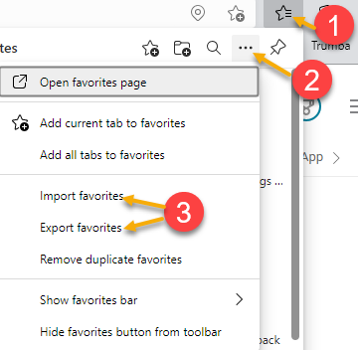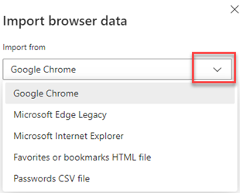

Unemployment Insurance (UI) claim and data information can be found on the UI page here https://esd.wa.gov/

CHAT
General Information section discussion:
Question: Would it be helpful if we added more lines to display 6 lines instead of just 5?
from Kerns, Adeline (ESD) to everyone: 10:14 AM
I do not use this section and am not familiar with what it is used for but adding information that we need in this handy location would be helpful.
from Kerns, Adeline (ESD) to everyone: 10:15 AM
I like as much as information as possible on the dashboard.
from MacLennan, Mary (ESD) to everyone: 10:16 AM
@Mariya - even if the target occupation doesn't display in that general information area, doesn't mean it doesn't exist. So we recommend you check the Review Seeker/Participants Touchpoints like Lynn just showcased to see if it exists. Then you don't have to go to UTAB.

Program/Office discussion:
from Kerns, Adeline (ESD) to everyone: 10:17 AM
Can you change the header in that column from Program to Office?
from MacLennan, Mary (ESD) to everyone: 10:18 AM
@Adeline - no, we can't change that as it's Monster's core product

Create a Record discussion:
from Natalya Verley - Workforce Snohomish to everyone: 10:22 AM
Is that when it shows "DRAFT" in red and in parentheses?—No, this doesn’t have anything to do with the create a record process Update demographics discussion:
from Cisneros, Miriam (ESD) to everyone: 10:29 AM
Can you touch on updating info on details, such as demographics?
from Susan Gustafson to everyone: 10:33 AM
With their permission, you can update their demographics by impersonation their WorkSource WA account. I think

ATTENDEES
Abigail Taft
Abplanalp, Christopher
Anderson, Laura
Aparicio, Rudy
Arbes, Brent
Ariana Cordova
Baker, Marayia
B Oliveri
Cascio, Jaclyn
Chase, Kim
Christina Shaffer
Cisneros, Miriam
Cori-Ann Ching
Davis, Anita
Dawn Oakes
Dunning, Shellie
Elias Zafar
Emily Anderson
Enwall, Jo Ann
Frost, Jennifer
Granillo, Tiffany
Griffith, Michelle
Heidi Lamers
Holmes, Carolyn
Ish
Jackie Wetchler
Jessie Cardwell
Jim
Johnson, Angela
Jordan, Irene
Josie Capetillo
Kerns, Adeline
Kylie Bartlett
Lilia
Linda Rowling
Luci Bench
Lux Dmitri
Mariya Kazantseva
Maya Anderson
Mimi Reeves
Natalya Verley
Peiris, Malmi
Pochi
Selam
Smick, Rikki
Soto, Raul
Standley, Amanda
Susan Gustafson
Sutton, Terry
Tamara Toles
Taylor, Mei-Ling
Teresa Anda
Tina Newcomer
Tristan Erickson
Verduzco, Albert
Vey Damneun
Abigail Taft
Abplanalp, Christopher
Anderson, Laura

