T12 Meeting Minutes 12-8-2021

Reminder: Mute your audio and disable the video feature after starting this Webex meeting. Too many attendee’s with active video can interfere with everyone’s audio quality. To do this, hover over the lower edge of your monitor screen to find the icons.

These meetings will be recorded and posted on the WPC site.
Please be advised your image will be captured and recorded during the video conference.
Your participation in this videoconference equals consent to be recorded as required by law.

New Business
- ETO maintenance – nothing this week
- WSWA maintenance – nothing this week
- Velaro maintenance – nothing this week
- Tickets into production –
  - WA-4331 Employer event TP is not editable
  - WA-4334 Mentoring (Youth) ITSS service. Change from transactional to durational service
    - After the change you need to delete the service with the end date and create a new service that will not autofill an end date
- Project updates –
  - LinkedIn Learning (LnL) demo during the December 15th T12 call. Grants Management has obtained 11,000 licenses WS staff can provide to participants. These licenses allow WS staff to monitor participants activity on LnL.
- What’s new on WPC – nothing this week
- Report enhancements – nothing this week
- Training issues/open discussion –
  - To-Do question from 12/1/21 Mary
    - Find guidance on the WPC in the Customer management ETO guide – Staff version 3 on pages 19 and 49
  - Change offices/case manager in ETO. Process for those with the Department Head role only
    - Desk aid
  - Remedy tickets – Recently the service desk has been back logged with tickets which delays ETO/WSWA ticket being assigned to our team. If you don’t hear from us within 24 hours email us at esdgpwssteam@esd.wa.gov and we will search for the ticket and start working on it.
SSN correction tickets are a high priority, needing an immediate fix so staff can record the services timely they provide to customers. If you don’t hear from us the day you submit the ticket, email the WSS team esdgpwssteam@esd.wa.gov about it and we will search for it to begin working it.
  - Job seekers are not able to change their WSWA email address. This is a known issue and not a WSWA issue but a WaTech issue. We are working on a resolution but cannot provide a timeline for fix
    - Click on change email, receive message they are experiencing technical difficulties and instructed to call the WSWA Washington service desk @ 888-316-5627. This is the Monster WSWA help desk
    - It would be helpful if staff could change emails for participants via ETO/impersonation
  - Chrome issues – Instructions on how to clear your cache are included in the ‘Checklist of things to do before submitting a service request’ desk aid found on the WPC site.
    - Clearing Chrome cache starts from the top right side of the browser bar
- Click the triple dots to open the Chrome tools menu
- Hover over “More tools”
- Click “Clear browsing data” which opens a new screen
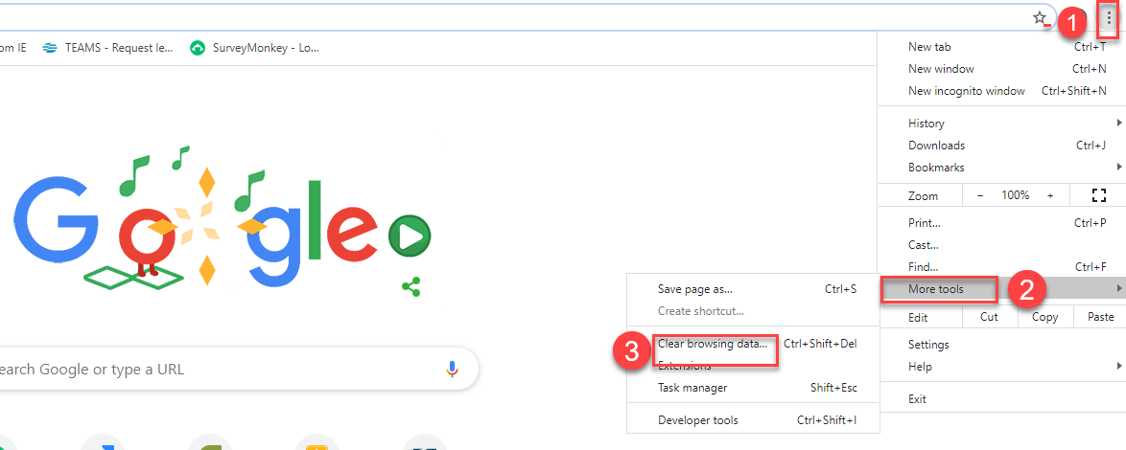

- Click “Clear data”
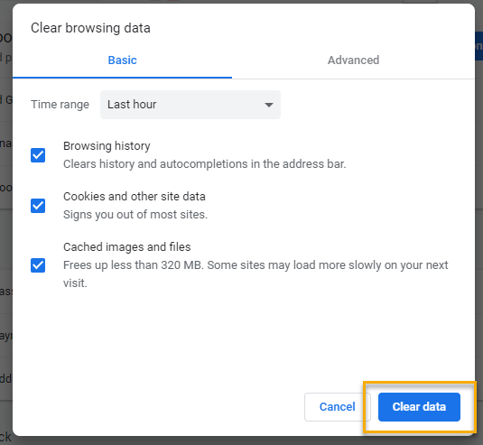

  - Submitting remedy tickets – help us by providing enough details to work your issue. Suggestions to speed up discovering and resolving issue without lots of back-and-forth emails.
    - Screen shots include the entire screen, browser bar, not just a pinpoint of the TP that isn’t correct.
    - Report tickets need the WDA, office and start and end dates parameters you used to run the problematic report
    - We will send you 2 emails asking for additional information. Second request for response will advise you the ticket will close in 24 hours.
  - Some employers are reporting landing on the Monster pay page. Direct them to click on ‘Home’ or ‘Sign in’ Clicking on ‘Post a Job’ here takes them to a page asking for money. We are working on cleaning this up.
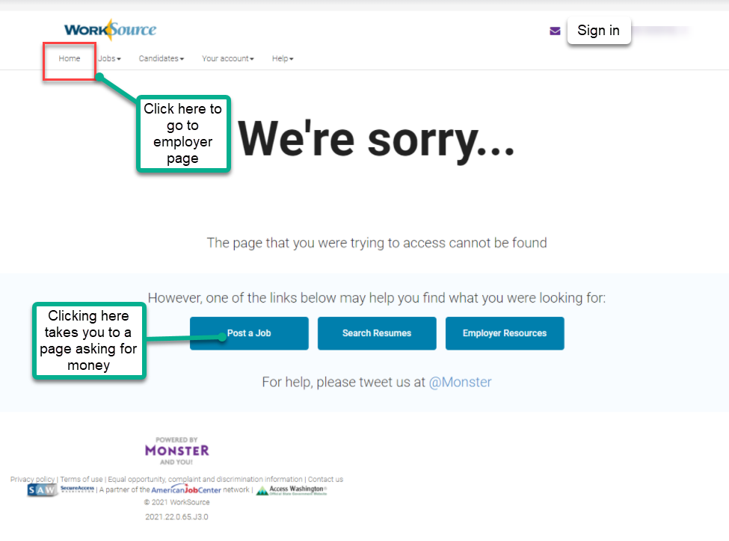
  - Internet Explorer (IE) will be deprecated after the SharePoint migration project completes but before Windows 11 is deployed (Summer 2022). It will occur sometime between those two projects, approximately 3-6 months.
    - Prepare now by transitioning to Edge or Chrome.
    - Don’t forget to transfer your favorites to Edge or Chrome and also add a copy to your document folder for recovery purposes!
      - How to import Favorites from IE to Chrome video
      - How to import Favorites from IE to Edge
        - Click on Favorites ‘star’
        - Click on ellipses (3 dots)
        - Select either Import (from Chrome or IE) or Export a copy to a local folder

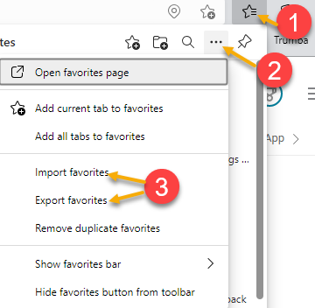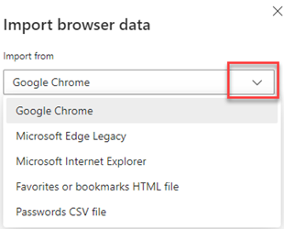

- ETO Basic and Refresher Training - Next training is on 12/21/21 1:30-4
  - ETO Basic training is the 1st Monday 9:30-12 and 3rd Tuesday 1:30-4 of every month (except holidays). Send email to Lynn Aue to receive more information, training account if needed and be added to the training Webex call. All ETO/WSWA system users are welcome to attend the training but please do not forward invites as I need to review all attendees and assign training accounts if needed.
  - Refresher training recordings and user guides are posted on the WPC website here https://wpc.wa.gov/tech/ETO-refresher-training
  - Submit a remedy ticket to request additional training opportunities and resources
- Reminder: Submit remedy tickets for all work requests here. The WSS team cannot begin work without a service request. Reaching out to us directly can affect the time it takes to resolve your issue. Thanks!
Unemployment Insurance (UI) claim and data information can be found on the UI page here https://esd.wa.gov/

CHAT
Conversation about changing offices/case managers from the PE. Who uses the process found in the desk aid?
from Emily Anderson to everyone: no for case managers, yes offices
from Griffith, Michelle (ESD) to everyone: I have a case management report pulled up if you want me to share (so we can view the ‘taken by’ field)
from Luci Bench to everyone: not for case managers, but yes offices
from Maya Anderson to everyone: That would be a great change (adding a case manager TP)
from Kerns, Adeline (ESD) to everyone: TAA CM's cannot edit the TAA Program Enrollment and change offices (those with staff roles in ETO, this process is only available for those with department head role)
from Griffith, Michelle (ESD) to everyone: Great example, Colleen!
from Maya Anderson to everyone: Yes, I have to manually update the report when we send it to our team.
from Kerns, Adeline (ESD) to everyone: Cannot change the TAA CM, it defaults to DH name
from Cook, Colleen (ESD) to everyone: Thanks Lynn!
from Chloe to everyone: does this apply to the training account or production only? Production
from Chloe to everyone: okay, thank you
from Griffith, Michelle (ESD) to everyone: Thank you Lynn! Stepping away for another meeting. Appreciate the work you're doing.
from Anderson, Laura J (ESD) to everyone: Thank you - I have another meeting as well!
from Teresa Anda to everyone: Can we revisit the change offices/case manager in ETO topic? Discussion on allowing all staff to have the ability to edit the PE TP so the office/case manager changes
from Mary to everyone: Also, FYI, we have been in touch with WaTech to ask if a participant has multiple emails if there is a way to combine them all.
from Luci Bench to everyone: Our staff can't edit another staff
from Emily Anderson to everyone: Yes Teresa! That was the problem as I recall.
from Kylie Bartlett to everyone: So the desk aid says the demographics page needs to be screenshots saved. Where do those screenshots need to be uploaded? Upload the screen shot in a case note that describes the action (s) you took and why
from Kylie Bartlett to everyone: Perfect! Thank you for explaining!
from susan Gustafson to everyone: 10:48 AM
Thanks
from McKnight, Diana (ESD) to everyone: 10:48 AM
Very informative and thank you again
from Cancel, Regina B (ESD) to everyone: 10:48 AM
Thanks Lynn!
from Luci Bench to everyone: 10:48 AM
thanks lynn!
from Tamara Toles WSW to everyone: 10:48 AM
Thank you
from Teresa Anda to everyone: 10:49 AM
Thank you all!
from Mariya Kazantseva to everyone: 10:49 AM
Thank you!

ATTENDEES
Aaron Pentland
Abigail Taft
Anderson, Laura
Aparicio, Rudy
Ariana Cordova
Autumn Hughes
B Oliveri
Booth, Shannon
Cancel, Regina
Chloe
Cook, Colleen
Cori-Ann Ching
Dawn Oakes
Douglas Evans
Emily Anderson
Granillo, Tiffany
Griffith, Michelle
Heidi Schauble
Holmes, Carolyn
Hudgens, Sheila
Isiaih Nelson
Jackie Wetchler
Jessie Cardwell
Jim
Jordan, Irene
Kerns, Adeline
Kylie Bartlett
Lilia
Lisa Pietkauskis
Luci Bench
Lux Dmitri
Mack, Donna
Mariya Kazantseva
Martin, Monique
Mattoo, Aninda
Maya Anderson
McCormack, Donetta
McKnight, Diana
Peiris, Malmi
Pochi
Reasoner, Suzette
Selam
Sue Keltner
Susan Gustafson
Tamara Toles
Teresa Anda
Tina Newcomer
Vey Damneun
Zander

