T12 Meeting Minutes 12-22-2021

Reminder: Mute your audio and disable the video feature after starting this Webex meeting. Too many attendee’s with active video can interfere with everyone’s audio quality. To do this, hover over the lower edge of your monitor screen to find the icons.

These meetings will be recorded and posted on the WPC site.
Please be advised your image will be captured and recorded during the video conference.
Your participation in this videoconference equals consent to be recorded as required by law.

New Business
- No meeting 12/29/21
- Meeting invites for 2022 quarter 1 will be sent out 12/23/21
- ETO maintenance – nothing this week
- WSWA maintenance – nothing this week
- Velaro maintenance – nothing this week
- Tickets into production –
  - WA-4338 Uploading emails or .msg files to the RESEA Required Elements Initial form causes an error.
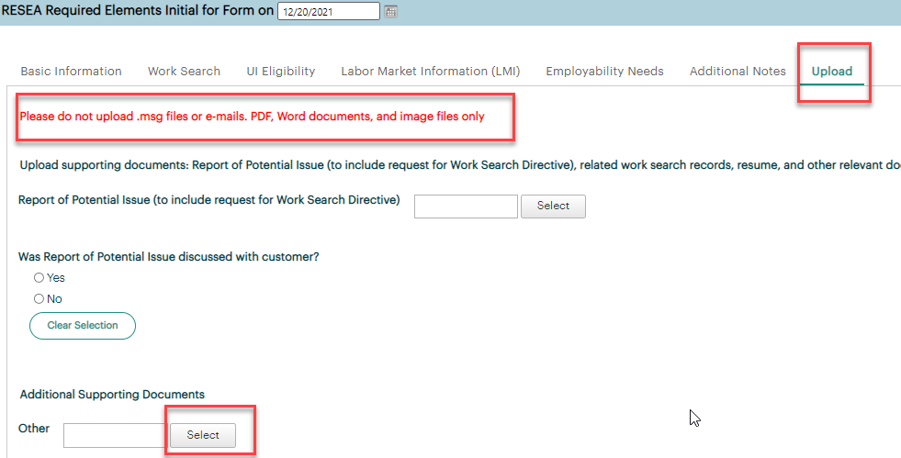

  - WA-4336 Add an indicator calling out virtual services as a method of contact to Basic Service and ITSS TPs. This week we added WSWA live chat. This method of contact does not display for RESEA services. Note: We are asking to add contact method to the Individualized Training and Support Services TP report
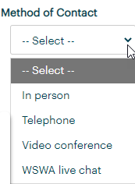
    - Basic Service TP:
      - The element is only required for the RESEA services
      - The element is optional for all other services
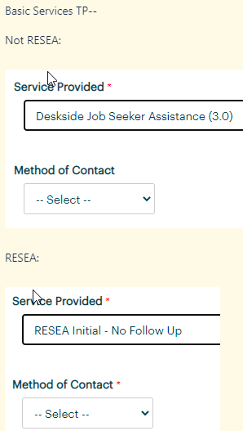
    - ITSS Service TP:
      - The element is optional for all services
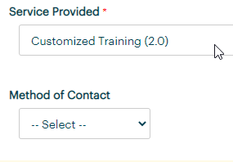

- Project updates – nothing this week
- What’s new on WPC – nothing this week
- Report enhancements – nothing this week
- Training issues/open discussion
  - RESEA update – Teresa Sparks, moved January 5th meeting
  - Searching for participants in ETO
    - Changing the ‘in’ field to ‘WorkSource’
    - Using the Opt-out widget for non-ESD partners
    - Example of what can happen when you don’t do a complete search of all ETO participant records and a new participant record is added. How I conduct research on tickets requests to merge duplicates
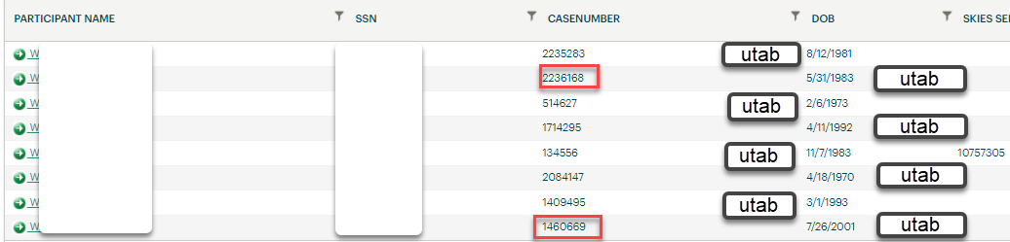

- Remedy tickets – Recently the service desk has been back logged with tickets which delays ETO/WSWA ticket assignment to our team. SSN correction tickets are a high priority, needing an immediate fix so staff can record services provided to customers timely. Email us at esdgpwssteam@esd.wa.gov if you receive a response within 24 hours. We can locate the ticket and start working on it.
- ETO Basic and Refresher Training - Next training is on 1/03/22 9:30-12
  - ETO Basic training is the 1st Monday 9:30-12 and 3rd Tuesday 1:30-4 of every month (except holidays). Send email to Lynn Aue to receive more information, training account if needed and be added to the training Webex call. All ETO/WSWA system users are welcome to attend the training but please do not forward invites as I need to review all attendees and assign training accounts if needed.
  - Refresher training recordings and user guides are posted on the WPC website here https://wpc.wa.gov/tech/ETO-refresher-training
  - Submit a remedy ticket to request additional training opportunities and resources
Old Business
- Reminder: Submit remedy tickets for all work requests here. The WSS team cannot begin work without a service request. Reaching out to us directly can affect the time it takes to resolve your issue. Thanks!
  - Submitting remedy tickets – help us by providing enough details to work your issue. Suggestions to speed up discovering and resolving issue without lots of back-and-forth emails.
    - Screen shots include the entire screen, browser bar, not just a pinpoint of the TP that isn’t correct.
    - Report tickets need the WDA, office and start and end dates parameters you used to run the problematic report
    - We will send you 2 emails asking for additional information. Second request for response will advise you the ticket will close in 24 hours.
- Some employers are reporting landing on the Monster pay page. Direct them to click on ‘Home’ or ‘Sign in’ Clicking on ‘Post a Job’ here takes them to a page asking for money. We are working on cleaning this up.
  - Advise your employers to clear their cache so they get out of the loop of landing on this page when log into their account!
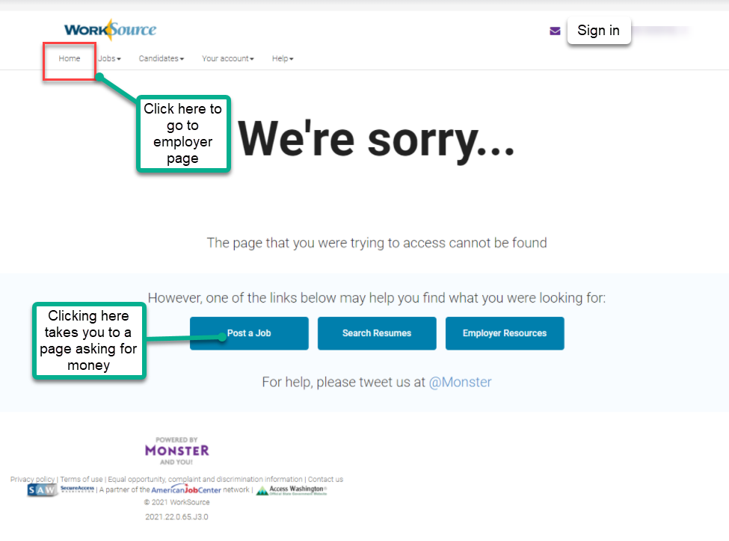

- Internet Explorer (IE) will be deprecated after the SharePoint migration project completes but before Windows 11 is deployed (Summer 2022). It will occur sometime between those two projects, approximately 3-6 months.
  - Prepare now by transitioning to Edge or Chrome.
  - Don’t forget to transfer your favorites to Edge or Chrome and also add a copy to your document folder for recovery purposes!
    - How to import Favorites from IE to Chrome video
    - How to import Favorites from IE to Edge
        - Click on Favorites ‘star’
        - Click on ellipses (3 dots)
        - Select either Import (from Chrome or IE) or Export a copy to a local folder

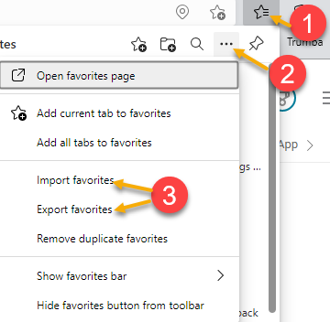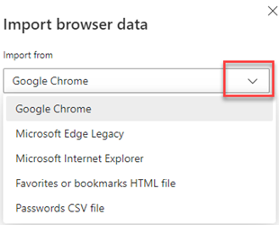

- Chrome issues – Instructions on how to clear your cache are included in the ‘Checklist of things to do before submitting a service request’ desk aid found on the WPC site.
    - Clearing Chrome cache starts from the top right side of the browser bar
- Click the triple dots to open the Chrome tools menu
- Hover over “More tools”
- Click “Clear browsing data” which opens a new screen
- Click “Clear data”

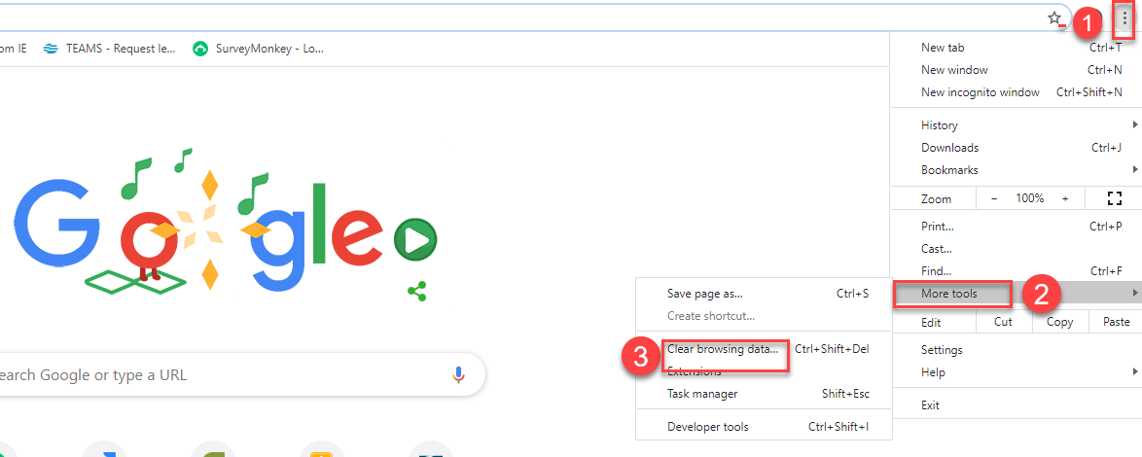

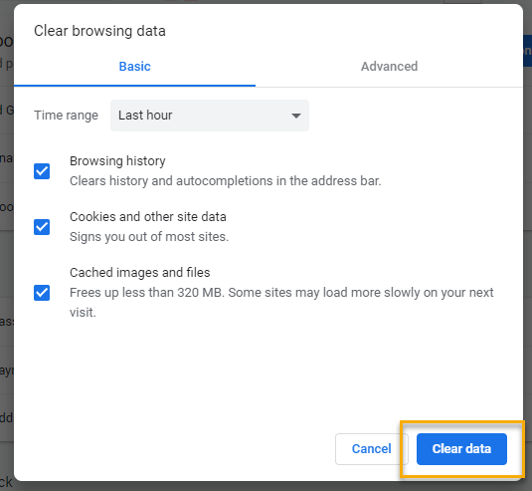
Unemployment Insurance (UI) claim and data information can be found on the UI page here https://esd.wa.gov/

CHAT
Discussion about the Individualized Training and Support Services TP report that went live during the meeting
from Teresa Anda to everyone: 10:09 AM Oh, maybe that's why the report is timing out. :(
from Mary to everyone: 10:10 AM @Teresa - if you tried running it at the exact time they were adding the column, it could have been why. If you hit the refresh report list button, it should work now. :)
from Teresa Anda to everyone: 10:11 AM @ Mary- I will try it again today and will keep my fingers crossed :)
from Teresa Anda to everyone: 10:20 AM @Mary - Yay, back to under 5 minutes! I did get the following information message "No data to retrieve in DNH"
from Teresa Anda to everyone: 10:23 AM What is the Daily new hire info show?
from Mary to everyone: 10:24 All It displays if a Daily New Hire TouchPoint was created within the date range you ran the report for.
from Mary to everyone: 10:25 AM @Teresa - I thought we mentioned that a few weeks ago, maybe it got missed. I'll ask Lynn to include it in the minutes and we'll update it on the WPC site for the report enhancements.
from Mary to everyone: 10:22 AM @Teresa - that means there shouldn't be any 'Yes' data in the Daily New Hire column. There were 2 new columns added. One for Daily New Hire and the other Method of Contact.

Discussion about using the Opt-Out Lookup for non-ESD staff to locate participants in ETO
from Carol Cauthron to everyone: 10:21 AM Is it possible, if the customer is enrolled in several offices, for one to show as opted out?
from Carol Cauthron to everyone: 10:21 AM Perfect! Thank you!
from Carol Cauthron to everyone: 10:22 AM Cool. Thank you.

Discussion about employers who land on WSWA paid page and how to clear issue so they land on their account and can post jobs
from Carol Cauthron to everyone: 10:27 AM
We've also found that asking the employer to clear their browser history then try to log in again, works the majority of the time, just fyi.

ATTENDEES

Abplanalp, Christopher
Arbes, Brent
Ariana Cordova
B Oliveri
Cancel, Regina
Carol Cauthron
Dawn Oakes
Dean Coxford
Dorothy Rocha
Douglas Evans
File, Christopher
Gard, Robbin
Granillo, Tiffany
Holmes, Carolyn
Isiaih Nelson
Jordan, Irene
Lilia
Lisa Pietkauskis
Luci Bench
Lux Dmitri
Mack, Donna
Maya Anderson
McKnight, Diana
Metcalf, Kimberly
Peiris, Malmi
Pochi
Tamara Toles
Teresa Anda
Tina Newcomer
Tracy Ferrell
Vey Damneun

