T12 Meeting Minutes 12-15-2021

Reminder: Mute your audio and disable the video feature after starting this Webex meeting. Too many attendee’s with active video can interfere with everyone’s audio quality. To do this, hover over the lower edge of your monitor screen to find the icons.

These meetings will be recorded and posted on the WPC site.
Please be advised your image will be captured and recorded during the video conference.
Your participation in this videoconference equals consent to be recorded as required by law.

New Business
- ETO maintenance – nothing this week
- WSWA maintenance – nothing this week
- Velaro maintenance – nothing this week
- Tickets into production –
  - WA-4336 Add an indicator calling out virtual services as a method of contact to Basic Service and ITSS TPs. Note: we are asking to add contact method to the report
    - Basic Service TP:
      - The element is only required for the RESEA services
      - The element is optional for all other services
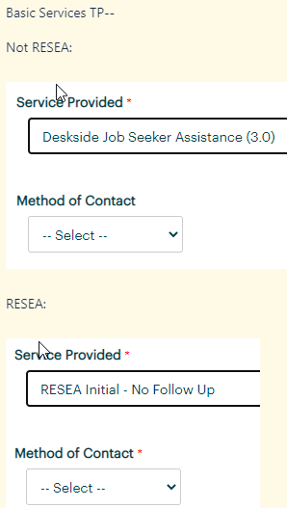
    - ITSS Service TP:
      - The element is optional for all services
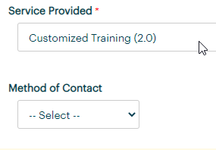

  - WA-4334 Mentoring (Youth) ITSS service. Change from transactional to durational service
    - Correction from last week’s discussion: Last week I stated the process to remove the end date from the TP was to edit and re-save to it. This is not true, a service taken before the change will always remain a point in time service, meaning the end date is defaulted to the start date by the system. To make this service durational you must delete the original service and re-enter it.
- Project updates – nothing this week
- What’s new on WPC –
  - LinkedIn Learning PowerPoint and Q & A for today’s presentation
- Report enhancements – nothing this week
- Training issues/open discussion
  - LinkedIn Learning presentation – Donna Mack and Ariana Cordova
  - RESEA update – Teresa Sparks, moved to next week
  - Follow-up
    - Changing offices and case manager in ETO. Currently the process is done by those with the Department Head role only. We discussed making this process available for all staff to move offices and caseloads. Further discussion on this change brought awareness that the risk to this widespread practice is too great to data integrity. We are moving forward with the new case manager TP to track who and what office is providing services to participants
- Remedy tickets – Recently the service desk has been back logged with tickets which delays ETO/WSWA ticket assignment to our team. SSN correction tickets are a high priority, needing an immediate fix so staff can record services provided to customers timely. Email us at esdgpwssteam@esd.wa.gov if you receive a response within 24 hours. We can locate the ticket and start working on it.
- ETO Basic and Refresher Training - Next training is on 12/21/21 1:30-4
  - ETO Basic training is the 1st Monday 9:30-12 and 3rd Tuesday 1:30-4 of every month (except holidays). Send email to Lynn Aue to receive more information, training account if needed and be added to the training Webex call. All ETO/WSWA system users are welcome to attend the training but please do not forward invites as I need to review all attendees and assign training accounts if needed.
  - Refresher training recordings and user guides are posted on the WPC website here https://wpc.wa.gov/tech/ETO-refresher-training
  - Submit a remedy ticket to request additional training opportunities and resources
Old Business
- Reminder: Submit remedy tickets for all work requests here. The WSS team cannot begin work without a service request. Reaching out to us directly can affect the time it takes to resolve your issue. Thanks!
  - Submitting remedy tickets – help us by providing enough details to work your issue. Suggestions to speed up discovering and resolving issue without lots of back-and-forth emails.
    - Screen shots include the entire screen, browser bar, not just a pinpoint of the TP that isn’t correct.
    - Report tickets need the WDA, office and start and end dates parameters you used to run the problematic report
    - We will send you 2 emails asking for additional information. Second request for response will advise you the ticket will close in 24 hours.
- Some employers are reporting landing on the Monster pay page. Direct them to click on ‘Home’ or ‘Sign in’ Clicking on ‘Post a Job’ here takes them to a page asking for money. We are working on cleaning this up.
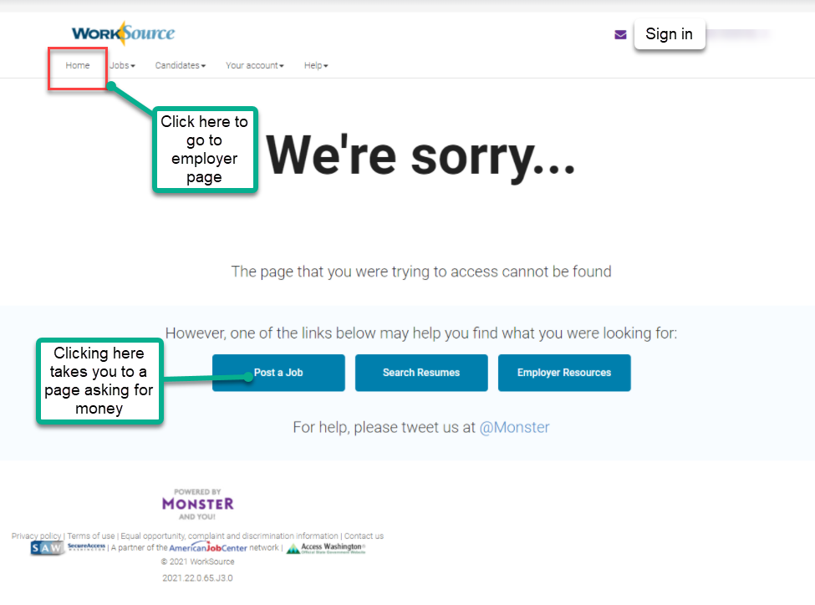

- Internet Explorer (IE) will be deprecated after the SharePoint migration project completes but before Windows 11 is deployed (Summer 2022). It will occur sometime between those two projects, approximately 3-6 months.
  - Prepare now by transitioning to Edge or Chrome.
  - Don’t forget to transfer your favorites to Edge or Chrome and also add a copy to your document folder for recovery purposes!
    - How to import Favorites from IE to Chrome video
    - How to import Favorites from IE to Edge
        - Click on Favorites ‘star’
        - Click on ellipses (3 dots)
        - Select either Import (from Chrome or IE) or Export a copy to a local folder

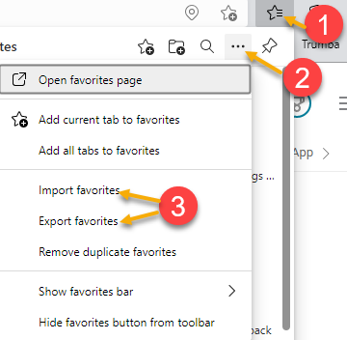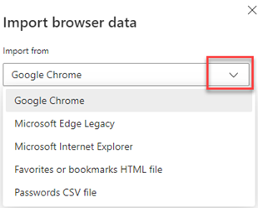

- Chrome issues – Instructions on how to clear your cache are included in the ‘Checklist of things to do before submitting a service request’ desk aid found on the WPC site.
    - Clearing Chrome cache starts from the top right side of the browser bar
- Click the triple dots to open the Chrome tools menu
- Hover over “More tools”
- Click “Clear browsing data” which opens a new screen
- Click “Clear data”

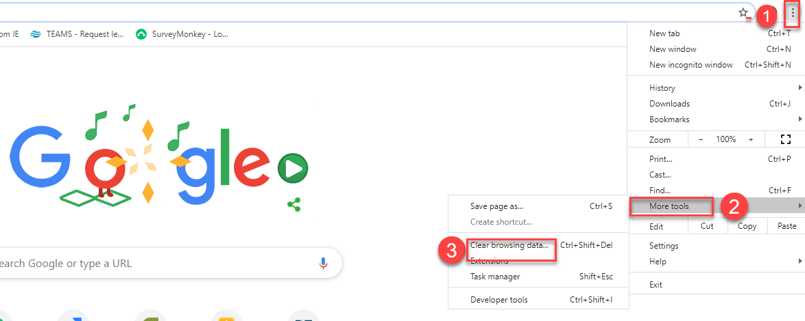

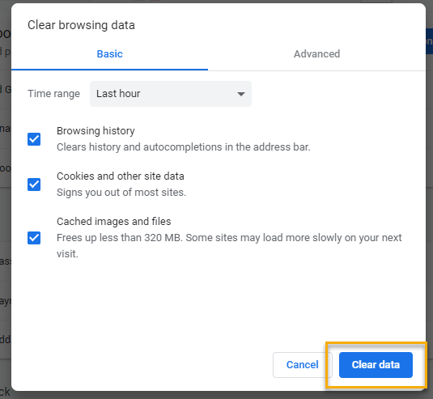
Unemployment Insurance (UI) claim and data information can be found on the UI page here https://esd.wa.gov/

CHAT
from Heidi Schauble to everyone: 10:07 AM Can or will email be added as a method of contact? Emails can count as services as long as there is two-way contact and a service described in the service catalogue is provided.
from Kerns, Adeline (ESD) to everyone: 10:10 AM Email would require a case note descripting the 2-way engagement
from Emily Anderson to everyone: 10:10 AM Depending on the service and what is provided, email does not always count as a service. Yes, what Adeline said!
from Heidi Schauble to everyone: 10:10 AM That is correct, email does not always count but it can and does in multiple situations.
from Heidi Schauble to everyone: 10:12 AM Got it, thank you. If you find out how to make that request let us know, it would be helpful to track as case managers are not going to know which one to select for emails as they are not in person or video calls.

Conversation about the LinkedIn Learning licenses
from Tracy Ferrell to everyone: 10:15 AM Eastern IS participating!!
from Abplanalp, Christopher T (ESD) to everyone: 10:19 AM Additionally, these licenses connect to the customer's LinkedIn profile.
from Aue, Lynn (ESD) to everyone: 10:21 AM Thanks Donna!
from Chase, Kim (ESD) to everyone: 10:21 AM
Is there any training available for LinkedIn?
from Mack, Donna R (ESD) to everyone: 10:21 AM sorry Tracey!
from Tracy Ferrell to everyone: 10:21 AM No problem, Donna.
from Mack, Donna R (ESD) to everyone: 10:22 AM Ariana also created a manual that is helpful for staff
from Mary to everyone: 10:24 AM @Lynn - are you going to upload this to the ETO training resources on the WPC site? The PowerPoint and Q & A are already on the WPC https://wpc.wa.gov/tech/ETO-refresher-training
from Aue, Lynn (ESD) to everyone: 10:24 AM is this the only LiL TP that should be entered for tracking? Or if your participant takes a class on their own should staff record a service for that training? – Donna will ask this question and get back to Lynn
from Aue, Lynn (ESD) to everyone: 10:28 AM Staff can access LiL free through their local library
from Aue, Lynn (ESD) to everyone: 10:29 AM
from Heidi Schauble to everyone: 10:31 AM Donna, are you able to clarify whether the licenses that have already been distributed prior to the July 1st cutoff will continue to have access to LinkedIn Learning or whether those licenses will expire July 2022? Donna added that the licenses can now be tracked from the initial onset but when they expire in July 2022 staff will not be able to view participants account records
from Vey Damneun to everyone: 10:32 AM Is that same for Coursera? Not training program and not measurable not
from Aue, Lynn (ESD) to everyone: 10:32 AM @Vey that is a question to ask ESD Policy email at SystemPolicy@ESD.WA.GOV
from Vey Damneun to everyone: 10:33 AM Thanks
from Heidi Schauble to everyone: 10:34 A Got it, thank you!

Discussion on not changing permissions for all staff having the ability to change offices and case managers vis the Program Enrollment TP, moving forward with the new case manager TP and new report to support it
from Kerns, Adeline (ESD) to everyone: 10:43 AM What if we need to change the office ? At this time follow your current process
from Maya Anderson to everyone: 10:45 AM How will this new TP affect the case management report. The new TP will not affect the case management report. There will be a new report to track case managers and offices. Adding this new TP to existing reports will add too much data to consume and could cause reports to break.
from Autumn Hughes to everyone: 10:46 AM If someone’s ETO account has been disabled for 90+ days of inactivity, how do we reinstate their access: Does the Access Approver need to send a new Access request form to have their account reactivated or is an email sufficient? ESD policy 2010 requires all system access will be denied or disabled after 90 days of inactivity. The first of every month we run a report to determine which accounts have not been access for 90 days. We send an email to those affected staff advising them if they do not sign into ETO their account will be disabled in 7 days. On the 7th day we run the report again and send those staff who did not log into ETO another email advising them their account has been disable and provide instructions on how to re-enable their accounts by contacting their local Access Requester and submitting a request on their behalf. The signing a Non-disclosure agreement (NDA) process is exactly the same. Which email address for ESD do we use? The email address is on the request form. All information on Access Requests can be found on the WPC site here https://wpc.wa.gov/tech/security
from Mack, Donna R (ESD) to everyone: 10:47 AM I need to drop now. Thank you all for inviting us to talk about LiL. Have a wonderful day and holiday season! Thanks Donna and Ariana for your presentation. Much appreciated!

ATTENDEES
Abigail Taft
Abplanalp, Christopher
Ariana Cordova
Autumn Hughes
Baker, Mirayia
Barke, Tami
B Oliveri
Cascio, Jaclyn
Chase, Kim
Chloe
Cook, Colleen
Cori-Ann Ching
Dawn Oakes
Dean Coxford
Dee
Diana
Douglas Evans
Emily Anderson
Enwall, Jo Ann
Erickson, Tristan
Farmer, Carly
Granillo, Tiffany
Hall, Shane
Heidi Schauble
Holmes, Carolyn
Jackie Wetchler
Jordan, Irene
Kerns, Adeline
Kylie Bartlett
Lilia
Lisa Pietkauskis
Luci Bench
Lux Dmitri
Mack, Donna
Malmi Peiris
Mariya Kazantseva
Maya Anderson
McNamee, Tamela
PoChi
Sparks, Teresa
susan Gustafson
Tamara Toles
Taylor Inman-Scott
Teresa Anda
Tina Newcomer
Tracy Ferrell
Vey Damneun
Wood, Lora

