T12 Meeting Minutes 12-1-2021

Reminder: After starting a Webex meeting mute your audio and disable the video feature. Too many attendee’s with active video can interfere with everyone’s audio quality. Hover over the lower edge of your monitor screen to find the icons.

These meetings will be recorded and posted on the WPC site.
Please be advised your image will be captured and recorded during the video conference.
Your participation in this videoconference equals consent to be recorded as required by law.

New Business
- ETO maintenance – nothing this week
- WSWA maintenance – nothing this week
- Velaro maintenance – maintenance on Friday, December 3, at 3:30:00 AM PT, the estimated duration is 1 hour. We do not expect any impact to your service, yet in some cases, there may be a brief interruption. As always if you discover an issue with Velaro submit a remedy ticket.
- Tickets into production – nothing this week
- Project updates – nothing this week
- What’s new on WPC – nothing this week
- Report enhancements –
  - Job Seekers
    - Seekers Served--Basic Services; Added 3 new columns - Method of Contact, Other Program and Daily New Hire
- Training issues/open discussion –
  - Entering a group service with notes
    - Notes added to a group service do not create a case note TP but are documented within the Basic Service TP. To see the note, run the Case Note History report from the participants dashboard widget.
  - Reopening a closed program enrollment desk aid
    - You need to create a durational service and requires program attachment. Usually there isn’t a PE to select so you need to select any program from the ‘Other Program’ category.
    - Next day the desired PE will be opened and then delete the ‘faked’ service
  - Chrome issues – Instructions on how to clear your cache are included in the ‘Checklist of things to do before submitting a service request’ desk aid found on the WPC site.
    - Clearing Chrome cache starts from the top right side of the browser bar
- Click the triple dots to open the Chrome tools menu
- Hover over “More tools”
- Click “Clear browsing data” which opens a new screen
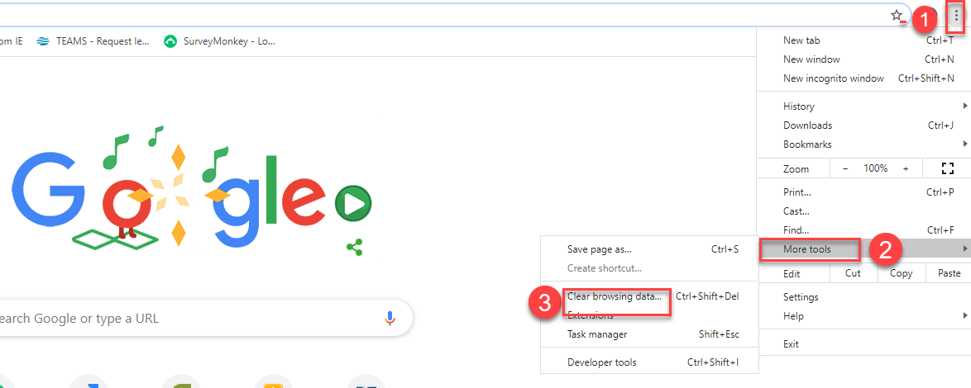

- Click “Clear data”
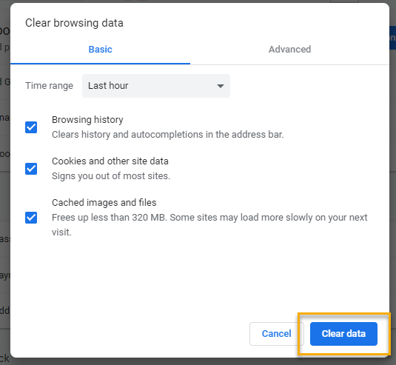

  - Submitting remedy tickets – help us by providing enough details to work your issue. Suggestions to speed up discovering and resolving issue without lots of back-and-forth emails.
    - Screen shots include the entire screen, browser bar, not just a pinpoint of the TP that isn’t correct.
    - Report tickets need the WDA, office and start and end dates parameters you used to run the problematic report
    - We will send you 2 emails asking for additional information. Second request for response will advise you the ticket will close in 24 hours.
  - Some employers are reporting landing on the Monster pay page. Direct them to click on ‘Home’ or ‘Sign in’ Clicking on ‘Post a Job’ here takes them to a page asking for money. We are working on cleaning this up.
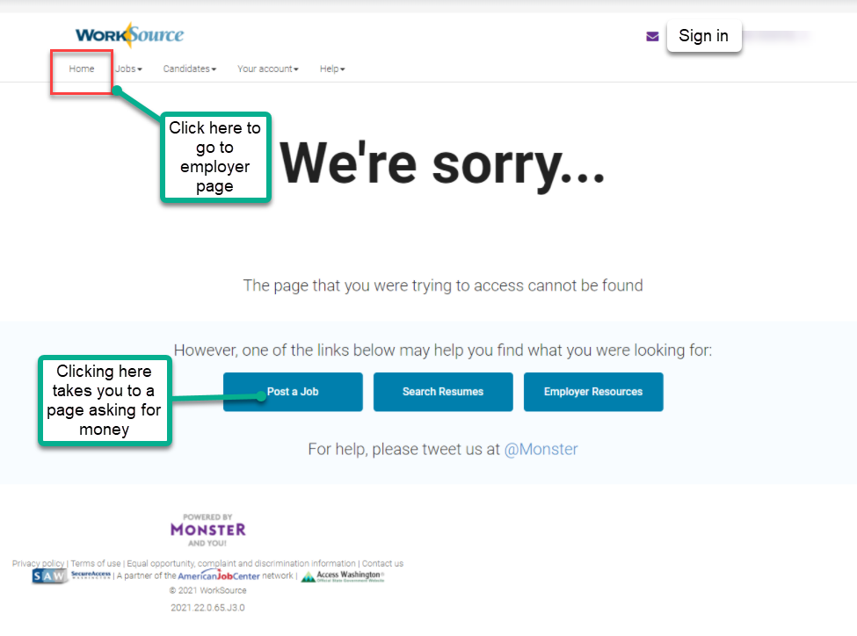
  - Internet Explorer (IE) will be deprecated after the SharePoint migration project completes but before Windows 11 is deployed (Summer 2022). It will occur sometime between those two projects, approximately 3-6 months.
    - Prepare now by transitioning to Edge or Chrome.
    - Don’t forget to transfer your favorites to Edge or Chrome and also add a copy to your document folder for recovery purposes!
      - How to import Favorites from IE to Chrome video
      - How to import Favorites from IE to Edge
        - Click on Favorites ‘star’
        - Click on ellipses (3 dots)
        - Select either Import (from Chrome or IE) or Export a copy to a local folder

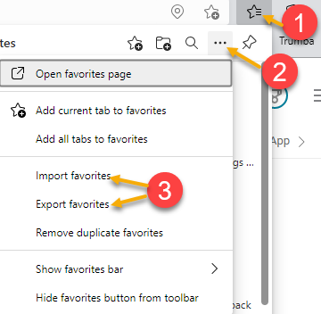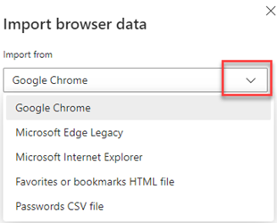

- ETO Basic and Refresher Training - Next training is on 12/6/21 9:30-12
  - ETO Basic training is the 1st Monday 9:30-12 and 3rd Tuesday 1:30-4 of every month (except holidays). Send email to Lynn Aue to receive more information, training account if needed and be added to the training Webex call. All ETO/WSWA system users are welcome to attend the training but please do not forward invites as I need to review all attendees and assign training accounts if needed.
  - Refresher training recordings and user guides are posted on the WPC website here https://wpc.wa.gov/tech/ETO-refresher-training
  - Submit a remedy ticket to request additional training opportunities and resources
- Reminder: Submit remedy tickets for all work requests here. The WSS team cannot begin work without a service request. Reaching out to us directly can affect the time it takes to resolve your issue. Thanks!
Unemployment Insurance (UI) claim and data information can be found on the UI page here https://esd.wa.gov/

CHAT
from Kerns, Adeline (ESD) to everyone: 10:07 AM If you intentionally want all of your customers enrolled in the same program like TAA, could you attach the active program enrollment or must you do the other program workaround? Yes, if you are enrolling all customers in the same program, you can select it at the time you complete the group service.

ATTENDEES
Abigail Taft
Anderson, Laura J (ESD)
Aphkas, Tarseny ESD Partner
Ariana Cordova
Aue, Lynn (ESD)
Baker, Mirayia (ESD)
Boliveri
Booth, Shannon (ESD)
Booth, Shannon (ESD)
Cancel, Regina B (ESD)
Cascio, Jaclyn (ESD)
Cook, Colleen (ESD)
Dawn Oakes
DEAN COXFORD
Dorothy Rocha
Douglas Evans
Dryden, Jack (ESD)
Emily Anderson
Emily Anderson
Enwall, Jo Ann (ESD)
Gard, Robbin (ESD)
Gillis, Deanna F. (ESD)
Griffith, Michelle (ESD)
Heidi Lamers
Heidi Schauble
Holmes, Carolyn (ESD)
Isiaih Nelson
Jackie Wetchler she/hers
Jessie Cardwell-BFWDC
Jordan, Irene (ESD)
Kerns, Adeline (ESD)
Kylie Bartlett
Lilia
Maier, Seth (ESD)
Malmi Peiris
Maribel Dominguez
Mary MacLennan
Maya Anderson
Name
Newkirk, Kim (ESD)
PoChi
Reasoner, Suzette (ESD)
Selam
Standley, Amanda (ESD)
susan Gustafson
Tamara Toles WSW
Tina Newcomer
TSutton
Vey Damneun
Wood, Lora A ESD
Zander

