**T12 Meeting Minutes 11-3-2021**

**Reminder:** After starting a Webex meeting to mute your audio and disable the video feature. Too many attendee’s with active video can interfere with everyone’s audio quality. Hover over the lower edge of your monitor screen to find the icons.



**These meetings will be recorded and posted on the WPC site.**

Please be advised your image will be captured and recorded during the video conference.

Your participation in this videoconference equals consent to be recorded as required by law.

**New Business**

* MFA/SSLVPN issue for those on the ESD network only
  + Some users were experiencing issues with the ESD MFA SSLVPN connection earlier today. The service desk was aware of it and worked with WaTech. Just a reminder, please do not submit multiple tickets or calls as this overloads their team and hinders resolution. For those who used the work around and connected using the old version of VPN, please disconnect and connect to the MFA/VPN
* ETO maintenance – nothing this week
* WSWA maintenance – The Monster site (WSWA) will experience scheduled annual maintenance window beginning approximately **Friday,** **November 12th, 7 PM PST** to **10 PM PST** for a total of 3 (three) hours.

During this time, the employer site and job seeker site will be down to accommodate this scheduled yearly initiative. Site availability will be limited during this time. ESD will add a banner to WSWA for customers awareness.

* Velaro maintenance – nothing this week
* Tickets into production – nothing this week
  + WA-4308 change to the non-disclosure (NDA) language in ETO
    1. Answer to question from last meeting; you do not need to sign the new NDA until your yearly anniversary date.
* Project updates – nothing this week
* What’s new on WPC – nothing this week
* Report enhancements -
  + Operational Reports – nothing this week
* Training issues/open discussion –
  + Issues with NDA report – slow run time. Making a change to the date range which will shorten the time it takes to complete.
  + Job seekers unable to create WSWA accounts because their SSN is already in use
    - This issue is frequently caused by UI identity theft. Submit a remedy ticket and we will review the case, disassociate the SSN with the ‘fraudster’ and follow up with the job seeker so they will be able to create the WSWA account.
  + ETO Training accounts – *New process*
    - All ETO training account passwords were reset. If you need training accounts submit a remedy ticket. Within 24 hours you will receive a ‘Training account user log’ form to complete and return. After the form is returned we will send you passwords. The passwords will be changed the day after your training is completed.
  + *Reminder:* please respond to remedy tickets. We will send you 2 emails asking for additional information and also advise you in the final email that the ticket will close in 24 hours.
  + WSWA search for job postings not pulling expected results. Example: Burien
    - Best practice to produce the most complete return is so add the city to the first search area
    - Many towns & cities in Washington *share* ZIP codes.  Seekers might try searching with the city’s name along with the job title as some recruiters are posting positions with the city’s name *in* the job title field.
    - Add city into job posting title, add town to first search area

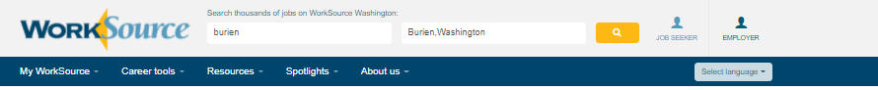

* + - In this particular case, the job posting’s ZIP code maps to Tukwila, but the job is in Burien.  Adjusting the radius will bring other job postings within that designated radius area. Job postings are then listed in order of newest to oldest by posting date

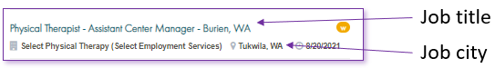

* + - When recruiters create a job posting they use the ‘Find ZIP code’ tool. The tool is connected to the USPS and will autofill the zip code into the job order and has an assigned default city for the cities sharing that code. In the case of White Center, the coder fills in the code and defaults to Seattle. In the case of Burien, the coder fills in the code and defaults to Tukwila. Recruiters have the ability to change the city name, but many don’t make this change or realize they have the ability to do so. This is what causes the appearance of a discrepancy or ‘dead zones’ in job posting searches.
    - This ZIP code search using White Center’s code 98146, auto filled the city to Seattle

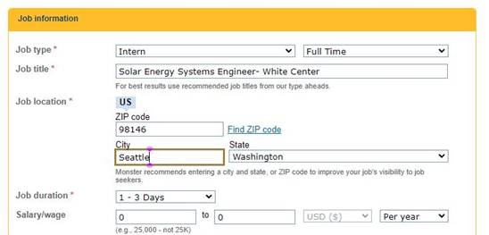

* We changed the default city Seattle to White Center and saved the changes. Now a White Center, WA search will produce this job in WSWA

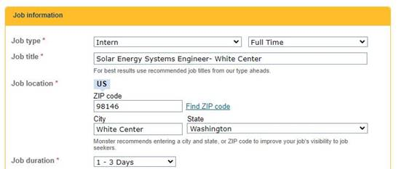

* + ETO issue. Logging in and not being able to find participants
    - Follow the ‘Finding a participant desk aid’ before submitting ticket
    - More issues with staff using Chrome
      * Clear your cache (clearing cache can remove the allowed sites for pop-ups)
      * Check for pop-up blockers
      * Add allowed sites
  + Internet Explorer (IE) will be deprecated after the SharePoint migration project completes but before Windows 11 is deployed (Summer 2022). It will occur sometime between those two projects, approximately 3-6 months.
    - Prepare now by transitioning to Edge or Chrome.
    - Don’t forget to transfer your favorites to Edge or Chrome and also add a copy to your document folder for recovery purposes!
      * How to import Favorites from IE to Chrome [video](https://www.youtube.com/watch?v=Mk0VMAmPclg)
      * How to import Favorites from IE to Edge
        1. Click on Favorites ‘*star’*
        2. Click on ellipses (3 dots)
        3. Select either Import (from Chrome or IE) or Export a copy to a local folder

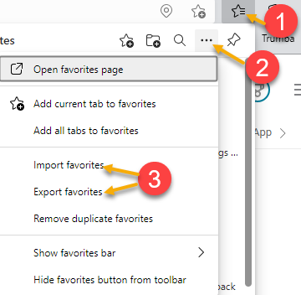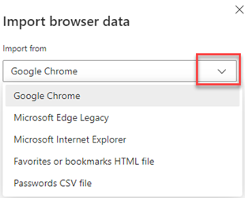

* ETO Basic and Refresher Training - Next training is on 11/16/21 1:30-4
  + ETO Basic training is the 1st Monday 9:30-12 and 3rd Tuesday 1:30-4 of every month (except holidays). Send email to Lynn Aue to receive more information, training account if needed and be added to the training Webex call. *All ETO/WSWA system users are welcome to attend the training but please do not forward invites as I need to review all attendees and assign training accounts if needed.*
  + Training recordings and user guides are posted on the WPC website here <https://wpc.wa.gov/tech/ETO-refresher-training>
  + Submit a remedy ticket to request additional training opportunities and resources
* ***Reminder:*** Submit remedy tickets for all work requests [here](https://wpc.wa.gov/tech/issues). The WSS team cannot begin work without a service request. Reaching out to us directly can affect the time it takes to resolve your issue. Thanks!

**Unemployment Insurance** (UI) claim and data information can be found on the UI page here <https://esd.wa.gov/>

**CHAT**

*from Aue, Lynn (ESD) to everyone: 10:00 AM*

Good morning, we will start in a minute

*from Nelva March to everyone: 10:04 AM*

Can we sign it ahead of time? *You can sign an NDA whenever you like, but you will get a reminder the week before your 1-year anniversary date saying it’s time to sign now.*

*from Baker, Hope (ESD) to everyone: 10:14 AM*

How many days before should we submit the remedy ticket for training accounts? *You should submit the remedy ticket 2 days before you need the accounts. If you don’t receive the training account user log within 24 hours send an email to our team email box as tickets sometimes get lost by misassignment.*

*from Baker, Hope (ESD) to everyone: 10:17 AM*

Thanks Lynn!

**ATTENDEES**

Aaron Pentland

Abigail Taft

Abplanalp, Christopher

Adriana Lopez

Ariana Cordova

B Oliveri

Baker, Hope

Brian Doyle

Cascio Jaclyn

Chase, Kim

Dawn Oakes

Dean Coxford

Donna Hendrickson

Dorothy Rocha

Emitt Thrower

Granillo, Tiffany

Heidi Lamers

Heidi Schauble

Holmes, Carolyn

Jackie Wetchler

Jessie Cardwell

Jim

Jordan Irene

King, Kendall

Lilia

Malmi Peiris

Mariya Kazantseva

McNamee, Tamela

Nelva March

Selam

Susan Gustafson

Tamara Toles

T Aphkas

Taylor Inman-Scott

Teresa Anda

Tina Newcomer

Tracy Ferrell

Tristan Erickson

Vey Damneun

Zander