T12 Meeting Agenda 11-24-2021

Reminder: After starting a Webex meeting to mute your audio and disable the video feature. Too many attendee’s with active video can interfere with everyone’s audio quality. Hover over the lower edge of your monitor screen to find the icons.

These meetings will be recorded and posted on the WPC site.
Please be advised your image will be captured and recorded during the video conference.
Your participation in this videoconference equals consent to be recorded as required by law.

New Business
- ETO maintenance – nothing this week
- WSWA maintenance – nothing this week
- Velaro maintenance – nothing this week
- Tickets into production – nothing this week
- Project updates –
  - LinkedIn Learning demo during the December 8th T12 call. Grants Management has obtained 11,000 licenses WS staff can provide to participants. These licenses allow WS staff to monitor participants activity on LnL.
- What’s new on WPC –
  - ETO training resources. New ETO basic training agenda includes links to resources.
    - Reminder: Refresher trainings covering many topics for case management, ETO functionality and Business services are on the WPC site under the Technology tab>ETO>Training Resources>Refresher Training
- Report enhancements – nothing this week
- Training issues/open discussion –
  - Remedy tickets – Recently the service desk has been back logged with tickets which delays ETO/WSWA ticket being assigned to our team. If you don’t hear from us within 24 hours email us at esdgpwssteam@esd.wa.gov and we will search for the ticket and start working on it.
These SSN correction tickets are a high priority, needing an immediate fix so staff can record the services provided to customers timely. If you don’t hear from us the day you submit the ticket, email the WSS team esdgpwssteam@esd.wa.gov and we will search for it to begin working it.
  - Reports of job seekers being ask for ID verification when logging into their WSWA account. They also get the message it is due to this being their first time accessing the account, even though they have logged into WSWA previously the same day.
    - Cause: this occurs because user can have multiple SAW accounts with different usernames and email addresses.
      - Users think they need a different SAW account for eService’s, WSWA and other state agencies.
      - The same SAW account can be used to access all of the above
      - Participant don’t have access to the SAW email address anymore.
        - Ex. Forgot PW or the PW was on their old phone, use family or friends’ email, or they use a throw away-email used only to access the activation email.
      - When they call the help desk they are told to create a new SAW account
    - Ask participant to log into secureaccess.wa.gov (not WSWA or any other site) using each of their usernames to see which username is attached to their WSWA account.
    - Our team is reaching out to WaTech to check if there was a way to combine usernames all into one. We’ll update you once we hear back.
    - Not a WSWA issue but a WaTech issue
  - Job seekers are reporting to WorkSource staff they are unable to create WSWA account because their SSN is already in use. This issue is frequently caused by UI identity theft.
    - Submit a remedy ticket and we will review the case, disassociate the SSN with the fraudster.
    - Staff can then follow up with the job seeker and notify them so they can create a WSWA account.
    - The SSN associated with someone else interferes with RESEA work. Submit a remedy ticket and we will review the case, disassociate the SSN with the fraudster.
  - Job seekers are not able to change their WSWA email address. This is a known issue and not a WSWA issue but a WaTech issue. We are working on a resolution but cannot provide a timeline for fix
    - Click on change email, receive message they are experiencing technical difficulties and instructed to call the WSWA Washington service desk @ 888-316-5627. This is the Monster WSWA help desk
      - It would be helpful if staff could change emails for participants via ETO/impersonation
  - Chrome issues – Instructions on how to clear your cache are included in the ‘Checklist of things to do before submitting a service request’ desk aid found on the WPC site.
    - Clearing Chrome cache starts from the top right side of the browser bar
- Click the triple dots to open the Chrome tools menu
- Hover over “More tools”
- Click “Clear browsing data” which opens a new screen
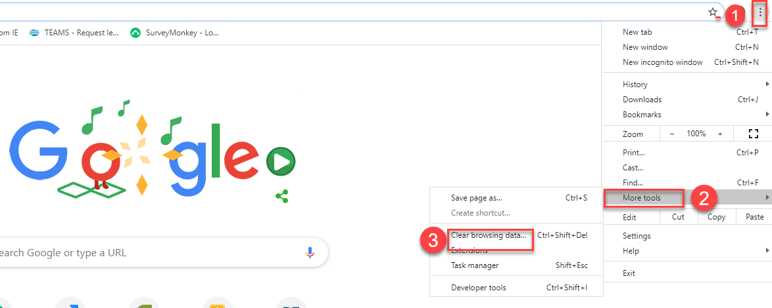

- Click “Clear data”
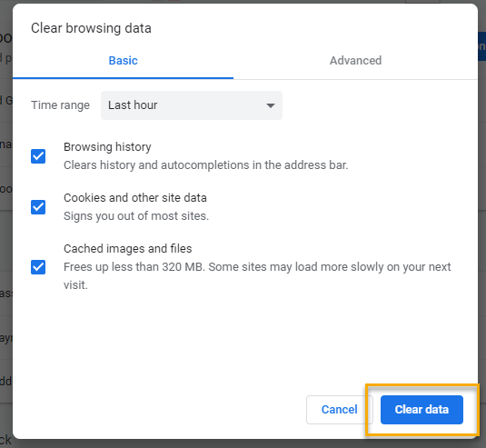

  - Submitting remedy tickets – help us by providing enough details to work your issue. Suggestions to speed up discovering and resolving issue without lots of back-and-forth emails.
    - Screen shots include the entire screen, browser bar, not just a pinpoint of the TP that isn’t correct.
    - Report tickets need the WDA, office and start and end dates parameters you used to run the problematic report
    - We will send you 2 emails asking for additional information. Second request for response will advise you the ticket will close in 24 hours.
  - Some employers are reporting landing on the Monster pay page. Direct them to click on ‘Home’ or ‘Sign in’ Clicking on ‘Post a Job’ here takes them to a page asking for money. We are working on cleaning this up.
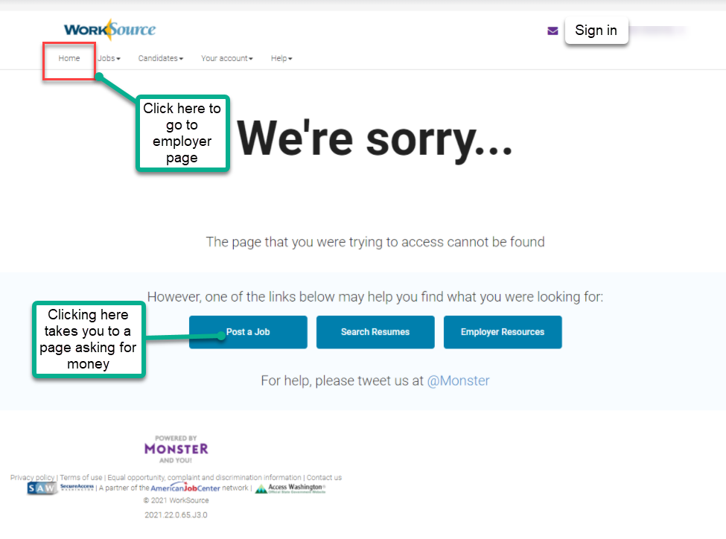

  - Internet Explorer (IE) will be deprecated after the SharePoint migration project completes but before Windows 11 is deployed (Summer 2022). It will occur sometime between those two projects, approximately 3-6 months.
    - Prepare now by transitioning to Edge or Chrome.
    - Don’t forget to transfer your favorites to Edge or Chrome and also add a copy to your document folder for recovery purposes!
      - How to import Favorites from IE to Chrome video
      - How to import Favorites from IE to Edge
        - Click on Favorites ‘star’
        - Click on ellipses (3 dots)
        - Select either Import (from Chrome or IE) or Export a copy to a local folder

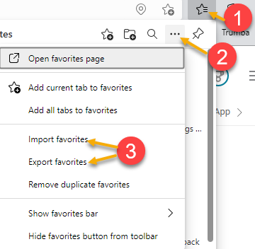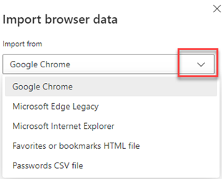

- ETO Basic and Refresher Training - Next training is on 12/6/21 9:30-12
  - ETO Basic training is the 1st Monday 9:30-12 and 3rd Tuesday 1:30-4 of every month (except holidays). Send email to Lynn Aue to receive more information, training account if needed and be added to the training Webex call. All ETO/WSWA system users are welcome to attend the training but please do not forward invites as I need to review all attendees and assign training accounts if needed.
  - Refresher training recordings and user guides are posted on the WPC website here https://wpc.wa.gov/tech/ETO-refresher-training
  - Submit a remedy ticket to request additional training opportunities and resources
- Reminder: Submit remedy tickets for all work requests here. The WSS team cannot begin work without a service request. Reaching out to us directly can affect the time it takes to resolve your issue. Thanks!
Unemployment Insurance (UI) claim and data information can be found on the UI page here https://esd.wa.gov/

CHAT
from Aue, Lynn (ESD) to everyone: 10:01 AM Good morning, we will start in a minute, giving folks time to log in
from Mack, Donna R (ESD) to everyone: 10:02 AM Happy Thanksgiving Eve!
from Mack, Donna R (ESD) to everyone: 10:11 AM very frustrating from a customer perspective! Concerns the WSWA changing PWs and email addresses
from Maldonado, Rene A (ESD) to everyone: 10:17 AM most of these folks don't use email. we help them create one to meet our system needs.
from Granillo, Tiffany (ESD) to everyone: 10:17 AM We have folks who use the "throw" away emails because they don't have emails
from Po Chi to everyone: 10:22 AM We used to be able to change the birthday in ETO. Now we can't The settings are locked down on the View/Edit page because staff were making incorrect changes to participants information that later needed correction. Submit a remedy ticket and we will make the change for you
from Granillo, Tiffany (ESD) to everyone: 10:26 AM do we need to add participants to our office Administration as well? Would we have to add it to an office to edit? Yes, you need to add participant to the office you are logged into to open the ‘save’ button

ATTENDEES
Aparicio, Rudy (ESD)
Tina Newcomer
Aue, Lynn (ESD)
Isiaih Nelson
Peiris, Malmi ESD
Mariya Kazantseva
Tracy Ferrell
Boylston, Eileen ESD
Jessie Cardwell-BFWDC
McNamee, Tamela (ESD)
TAphkas
Vey Damneun
Zander
Ariana Cordova
Douglas Evans
Frank, Angela (ESD)
Mack, Donna R (ESD)
Maya Anderson
Abigail Taft
Dorothy Rocha
Jordan, Irene (ESD)
Lilia
Dawn Oakes
Enwall, Jo Ann (ESD)
Cascio, Jaclyn (ESD)
Po Chi
Cancel, Regina B (ESD)
Selam
Maldonado, Rene A (ESD)
Amy
Dryden, Jack (ESD)
Granillo, Tiffany (ESD)
Maier, Seth (ESD)
Farmer, Carly (ESD)
Granillo, Tiffany (ESD)
Jim - Business Solutions
Peiris, Malmi ESD

