T12 Meeting Minutes 11-17-2021

Reminder: After starting a Webex meeting to mute your audio and disable the video feature. Too many attendee’s with active video can interfere with everyone’s audio quality. Hover over the lower edge of your monitor screen to find the icons.

These meetings will be recorded and posted on the WPC site.
Please be advised your image will be captured and recorded during the video conference.
Your participation in this videoconference equals consent to be recorded as required by law.

New Business
- ETO maintenance – nothing this week
- WSWA maintenance – nothing this week
- Velaro maintenance – nothing this week
- Tickets into production – nothing this week
- Project updates –
  - ESD Number Replacement Project. New employers are assigned an ESD number when they register as an employer. The ESD number is used for quarterly wage reporting and any other NGTS or UTAB communications with ESD. The NGTS system has a pool of ESD numbers available for assignment. The current configuration is a 9-digit number. The pool of available numbers will be depleted by the end of 2022, so NGTS will move to a 12-digit numbering system
- What’s new on WPC –
  - ETO training resources. New ETO basic training agenda includes links to resources.
    - Reminder: Refresher trainings covering many topics for case management, ETO functionality and Business services are on the WPC site under the Technology tab>ETO>Training Resources>Refresher Training
- Report enhancements -
  - Local Reporter Data
    - Common Measures Exits; NEW--created new report for program enrollments with system exit date on or after specified date
- Training issues/open discussion –
  - Remedy tickets – Recently the service desk has been back logged with tickets which delays ETO/WSWA ticket being assigned to our team. If you don’t hear from us within 24 hours email us at esdgpwssteam@esd.wa.gov and we will search for the ticket and start working on it.
  - Reports of job seekers asking for ID verification when logging into their existing WSWA account
    - Reports of job seekers being asked for this information when logging in multiple times a day
    - After answering ID verifying questions, First/last name, mailing address, DOB and ‘not a robot’ they are directed to call the SAW helpdesk (SAW helpdesk often is not helpful in resolving these issues)
    - Gather as much detail from the seeker (name, email address used to log in, date, time, etc)and submit the information in a remedy ticket so we can investigate further
    - Technical support for SAW issues https://esd.wa.gov/unemployment/technical-support
  - Job seekers are reporting to WorkSource staff they are unable to create WSWA account because their SSN is already in use. This issue is frequently caused by UI identity theft.
    - Submit a remedy ticket and we will review the case, disassociate the SSN with the fraudster.
    - Staff can then follow up with the job seeker and notify them so they can create a WSWA account.
    - The SSN associated with someone else interferes with RESEA work. Submit a remedy ticket and we will review the case, disassociate the SSN with the fraudster.
These SSN correction tickets are a high priority, needing an immediate fix so staff can record the services provided to customers timely. If you don’t hear from us the day you submit the ticket, email the WSS team esdgpwssteam@esd.wa.gov and we will search for it to begin working it.
  - Chrome issues – Instructions on how to clear your cache are included in the ‘Checklist of things to do before submitting a service request’ desk aid found on the WPC site.
    - Clearing Chrome cache starts from the top right side of the browser bar
- Click the triple dots to open the Chrome tools menu
- Hover over “More tools”
- Click “Clear browsing data” which opens a new screen
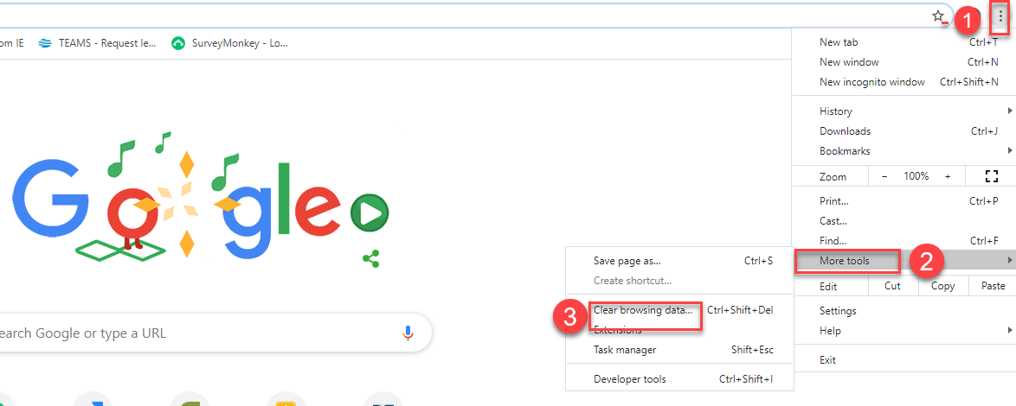

- Click “Clear data”
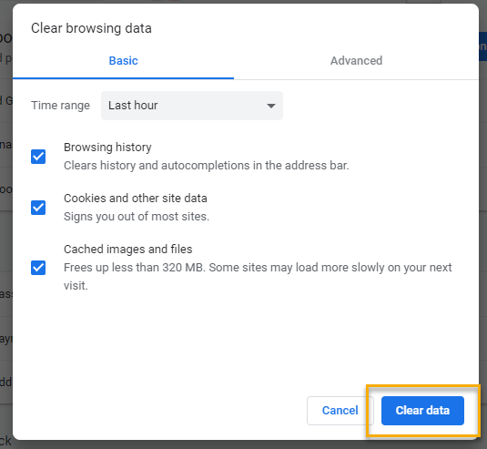

  - Submitting remedy tickets – help us by providing enough details to work your issue. Suggestions to speed up discovering and resolving issue without lots of back-and-forth emails.
    - Screen shots include the entire screen, browser bar, not just a pinpoint of the TP that isn’t correct.
    - Report tickets need the WDA, office and start and end dates parameters you used to run the problematic report
    - We will send you 2 emails asking for additional information. Second request for response will advise you the ticket will close in 24 hours.
  - Some employers are reporting landing on the Monster pay page. Direct them to click on ‘Home’ or ‘Sign in’ Clicking on ‘Post a Job’ here takes them to a page asking for money. We are working on cleaning this up.
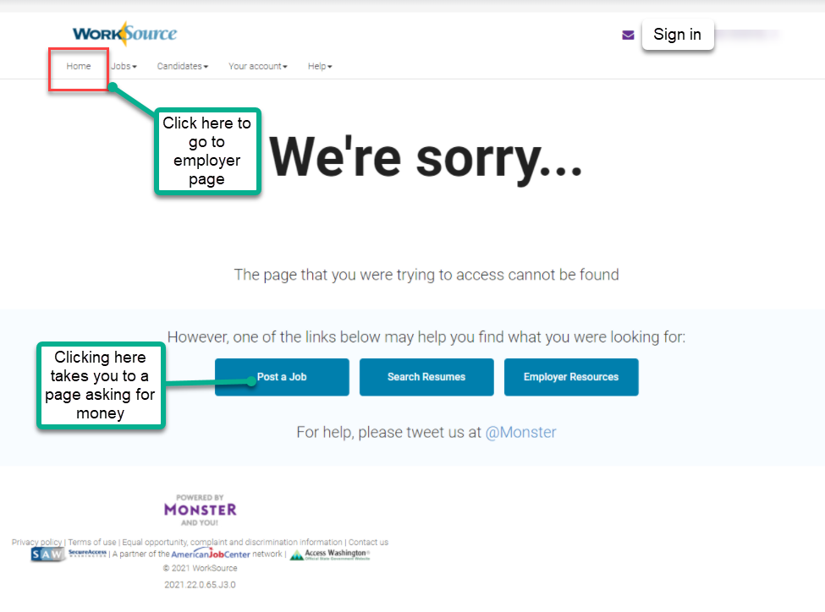

  - Internet Explorer (IE) will be deprecated after the SharePoint migration project completes but before Windows 11 is deployed (Summer 2022). It will occur sometime between those two projects, approximately 3-6 months.
    - Prepare now by transitioning to Edge or Chrome.
    - Don’t forget to transfer your favorites to Edge or Chrome and also add a copy to your document folder for recovery purposes!
      - How to import Favorites from IE to Chrome video
      - How to import Favorites from IE to Edge
        - Click on Favorites ‘star’
        - Click on ellipses (3 dots)
        - Select either Import (from Chrome or IE) or Export a copy to a local folder

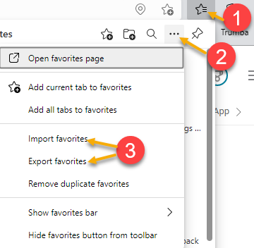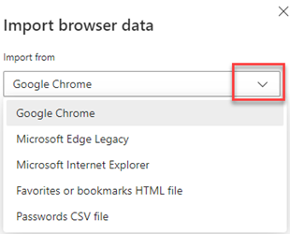

- ETO Basic and Refresher Training - Next training is on 12/6/21 9:30-12
  - ETO Basic training is the 1st Monday 9:30-12 and 3rd Tuesday 1:30-4 of every month (except holidays). Send email to Lynn Aue to receive more information, training account if needed and be added to the training Webex call. All ETO/WSWA system users are welcome to attend the training but please do not forward invites as I need to review all attendees and assign training accounts if needed.
  - Refresher training recordings and user guides are posted on the WPC website here https://wpc.wa.gov/tech/ETO-refresher-training
  - Submit a remedy ticket to request additional training opportunities and resources
- Reminder: Submit remedy tickets for all work requests here. The WSS team cannot begin work without a service request. Reaching out to us directly can affect the time it takes to resolve your issue. Thanks!
Unemployment Insurance (UI) claim and data information can be found on the UI page here https://esd.wa.gov/

CHAT
from Mary MacLennan to everyone: 10:13 AM
Also, to tag onto what Lynn is speaking about, please do not include SSNs in Remedy! Please just provide their ETO or UTAB case IDs.
from Jackson, Lelanie (ESD) to everyone: 10:15 AM
I've ran into this issue as well.
from Mary MacLennan to everyone: 10:21 AM
For technical support on SAW issues, you can refer claimants to this page for helpful information: https://esd.wa.gov/unemployment/technical-support

ATTENDEES

Abigail Taft
Anderson, Laura
Aparicio, Rudy
Ariana Cordova
Cascio, Jaclyn
Chase, Kim
Christopher File
Cori-Ann Ching
Dawn Oaks
Dean Coxford
Dorothy Rocha
Douglas Evans
Emily Anderson
Emitt Thrower
Enwall, Jo Ann
Gard, Robbin
Gillis, Deanna
Hall, Shane
Heidi Lamers
Holmes, Carolyn
Jackie Wetchler
Jackson, Lelanie
Jessie Cardwell
Jordan, Irene
Kerns, Adeline
King, Kendall
Lisa Pietkauskis
Luci Bench
Mack, Donna
Malmi Peiris
Maya Anderson
McNamee, Tamela
Noll, Pamela
Po Chi
Selam
Standley, Amanda
T Aphkas
Teresa Anda
Ton Nguyen
Tracy Ferrell
Tristan Erickson
Vey Damneun
Zander

