T12 Meeting Minutes 11-10-2021

Reminder: After starting a Webex meeting to mute your audio and disable the video feature. Too many attendee’s with active video can interfere with everyone’s audio quality. Hover over the lower edge of your monitor screen to find the icons.

These meetings will be recorded and posted on the WPC site.
Please be advised your image will be captured and recorded during the video conference.
Your participation in this videoconference equals consent to be recorded as required by law.

New Business
- ETO maintenance – nothing this week
- WSWA maintenance – The Monster site (WSWA) will experience scheduled annual maintenance window beginning approximately Friday, November 12th, 7 PM PST to 10 PM PST for a total of 3 (three) hours.
During this time, the employer site and job seeker site will be down to accommodate this scheduled yearly initiative. Site availability will be limited during this time. ESD added a banner to WSWA in English and Spanish for customers awareness.
- Velaro maintenance – nothing this week
- Tickets into production – nothing this week
- Project updates – nothing this week
- What’s new on WPC – nothing this week
- Report enhancements -
  - Administrative
    - Non-Disclosure Update; Report started to timeout; modified lookback date to 1/1/2020 instead of 7/2016
  - Employer & Job Posting Reports
    - Job Postings Report; Modified so all roles can see report
- Training issues/open discussion –
    - Submitting remedy tickets – help us by providing enough details to work your issue. Suggestions to speed up discovering and resolving issue without lots of back-and-forth emails.
    - Screen shots include the entire screen, browser bar, not just a pinpoint of the TP that isn’t correct.
    - Report tickets need the WDA, office and start and end dates parameters you used to run the problematic report
  - Job seekers unable to create WSWA accounts because their SSN is already in use
    - This issue is frequently caused by UI identity theft. Submit a remedy ticket and we will review the case, disassociate the SSN with the ‘fraudster’ and follow up with the job seeker so they will be able to create the WSWA account.

  - Some employers are reporting landing on the Monster pay page. Direct them to click on ‘Home’ or ‘Sign in’ Clicking on ‘Post a Job’ here takes them to a page asking for money. We are working on cleaning this up.
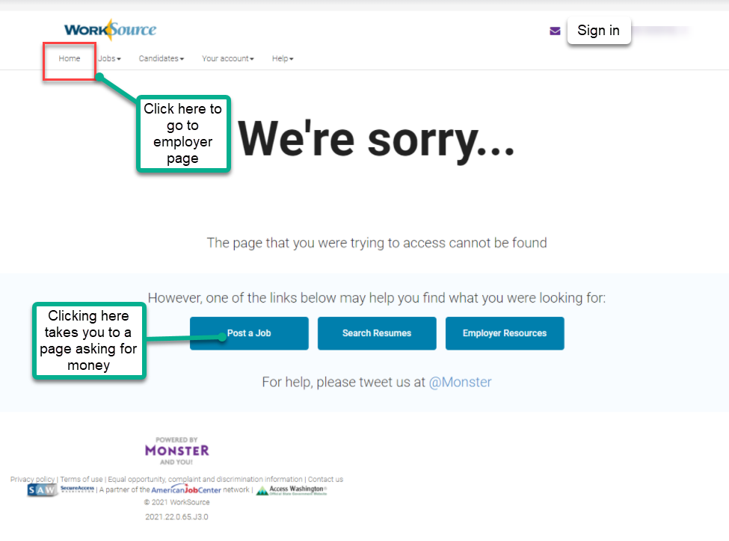
  - Reminder: please respond to remedy tickets. We will send you 2 emails asking for additional information and also advise you in the final email that the ticket will close in 24 hours.
  - Internet Explorer (IE) will be deprecated after the SharePoint migration project completes but before Windows 11 is deployed (Summer 2022). It will occur sometime between those two projects, approximately 3-6 months.
    - Prepare now by transitioning to Edge or Chrome.
    - Don’t forget to transfer your favorites to Edge or Chrome and also add a copy to your document folder for recovery purposes!
      - How to import Favorites from IE to Chrome video
      - How to import Favorites from IE to Edge
        - Click on Favorites ‘star’
        - Click on ellipses (3 dots)
        - Select either Import (from Chrome or IE) or Export a copy to a local folder

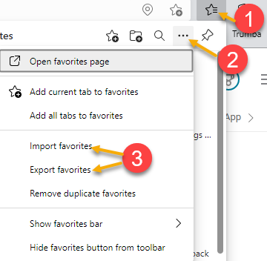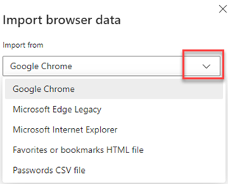

- ETO Basic and Refresher Training - Next training is on 11/16/21 1:30-4
  - ETO Basic training is the 1st Monday 9:30-12 and 3rd Tuesday 1:30-4 of every month (except holidays). Send email to Lynn Aue to receive more information, training account if needed and be added to the training Webex call. All ETO/WSWA system users are welcome to attend the training but please do not forward invites as I need to review all attendees and assign training accounts if needed.
  - Training recordings and user guides are posted on the WPC website here https://wpc.wa.gov/tech/ETO-refresher-training
  - Submit a remedy ticket to request additional training opportunities and resources
- Reminder: Submit remedy tickets for all work requests here. The WSS team cannot begin work without a service request. Reaching out to us directly can affect the time it takes to resolve your issue. Thanks!
Unemployment Insurance (UI) claim and data information can be found on the UI page here https://esd.wa.gov/

CHAT
from Teresa Anda to everyone: 10:12 AM
Sometimes the screenshot is too big to be legible.
from Mary MacLennan to everyone: 10:13 AM
Yes, some screenshots are rather large, but they are still helpful when provided in tickets.
from Cancel, Regina B (ESD) to everyone: 10:17 AM
Thanks Lynn!
from Tamara Toles WSW to everyone: 10:17 AM
Thank you
from Teresa Anda to everyone: 10:17 AM
Mary, thank you for the Common Measures Exits report. It's looking good!
from Po Chi to everyone: 10:18 AM
thanks
from McKnight, Diana (ESD) to everyone: 10:18 AM
Thanks for this great info
from Mariya Kazantseva to everyone: 10:18 AM
Thank you!
from Mary MacLennan to everyone: 10:18 AM
@Teresa - that's awesome. I'll close the ticket and we'll add it to the agenda for next week.

ATTENDEES

Aaron Pentland
Abigail Taft
Abplanalp, Christopher
Aparicio, Rudy
Ariana Cordova
B Oliveri
Cancel, Regina
Cascio, Jaclyn
Chase, Kim
Cori-Ann Ching
Dawn Oakes
Dean Coxford
Donna Hendrickson
Dorothy Rocha
Douglas Evans
Dryden, Jack
Emily Anderson
Enwall, Jo Ann
Farmer, Carly
Gard, Robbin
Shane Hall
Heidi Lamers
Heidi Schauble
Holmes, Carolyn
Jessie Cardwell
Jim
Johnson, Melinda
Jordan, Irene
Kerns, Adeline
King, Kendall
Kylie Bartlett
Lilia
Luci Bench
Mack, Donna
Malmi Peiris
Maricha Friedman
Mariya Kazantseva
McKnight, Diana
Natalya Verley
Nelva March
Po Chi
Selam
Sparks, Teresa
Tamara Toles
Teresa Anda
Tina Newcomer
Vey Damneun
Zander

