**T12 Meeting Minutes 10-6-2021**

**Reminder:** After starting a Webex meeting to mute your audio and disable the video feature. Too many attendee’s with active video can interfere with everyone’s audio quality. Hover over the lower edge of your monitor screen to find the icons.



**These meetings will be recorded and posted on the WPC site.**

Please be advised your image will be captured and recorded during the video conference.

Your participation in this videoconference equals consent to be recorded as required by law.

**New Business**

* ETO maintenance – nothing this week
* WSWA maintenance – release to include tickets into production for the new hiring statuses for business services
* Velaro maintenance – nothing this week
* Tickets into production –
  + WA-4120 2 new hiring statuses for business services Job Posting TP to manage candidates goes into production 10/7/21. There is also a Spanish version.

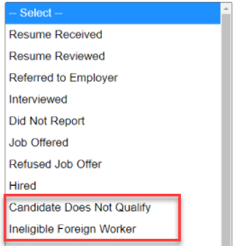

* Project updates – nothing this week
* What’s new on WPC –
  + Trumba desk aid for [online event calendar editor training](https://storemultisites.blob.core.windows.net/media/WPC/wswa/training/Online-event-calendar-training-rev-04.28.14.pdf)
  + EcSA change to program name and new [desk aid](https://storemultisites.blob.core.windows.net/media/WPC/tech/staff-resources/ETO-ecsa-guidance-updated-final.pdf)
  + Report enhancements –
    - Employer & Job Posting Reports
      * Job Postings Report; NEW report to combine 3 separate job postings reports
    - Local Reporter Data
      * Individualized Training and Support Services TPs; Added 'Date Last Updated' column
    - Veteran
      * Outreach through UI; Modified report logic to only pull those with UI claim
* Training issues/open discussion –
  + IE will NOT be deprecated this month! The timeline for deprecation is AFTER the SharePoint migration project completes but BEFORE Windows 11 is deployed (Summer 2022). It will occur sometime between those two projects: best guess, 3-6 months.
    - Prepare by transitioning to Edge or Chrome. Note: We (ESD staff) notice issues using Chrome and our new SharePoint sites
      * Add sites to prevent pop up blockers
      * Remember; clearing cache can remove the allowed site(s) for pop-up blocking
      * Transfer your favorites to Edge browser
        1. Click on Favorites ‘*star’*
        2. Click on ellipses

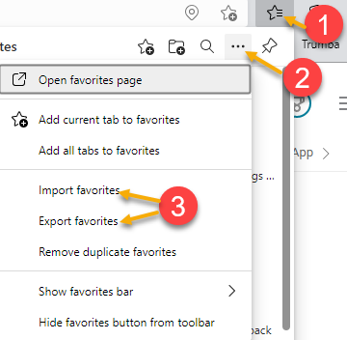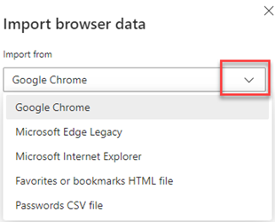

* + Future ETO report enhancements – Mary
    - Program Enrollment Report With Demographic and Veteran Details

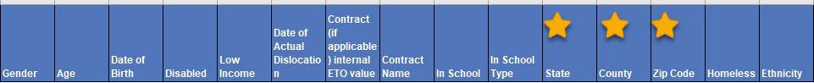









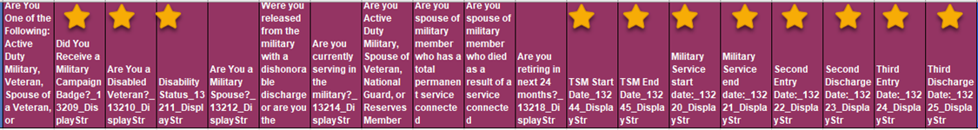



* ETO Basic and Refresher Training - Next training is on 10/19/21 1:30-3:50
  + ETO Basic training is the 1st Monday 9:30-11:50 and 3rd Tuesday 1:30-3:50 of every month (except holidays). Send email to Lynn Aue to receive more information, training account if needed and be added to the training Webex call. *All ETO/WSWA system users are welcome to attend the training but please do not forward invites as I need to review all attendees and assign training accounts if needed.*
  + Training recordings and user guides are posted on the WPC website here <https://wpc.wa.gov/tech/ETO-refresher-training>
  + Submit a remedy ticket to request additional training opportunities and resources
* ***Reminder:*** Submit remedy tickets for all work requests [here](https://wpc.wa.gov/tech/issues). The WSS team cannot begin work without a service request. Reaching out to us directly can affect the time it takes to resolve your issue. Thanks!

**UI announcements –**

**Initial regular claims and total claims for all benefits decreased during the week of September 26**

**OLYMPIA –** During the week of September 26 to October 2, there were 4,814 initial regular unemployment claims, down 2.0 percent from the prior week. Total claims filed by Washingtonians for all unemployment benefit categories numbered 86,615 down 10.8 percent from the prior week.

* Initial regular claims applications are 69 percent below weekly new claims applications for the same period last year during the pandemic.
* The 4-week moving average for regular initial claims was 4,860, a decrease of 98 from the previous week’s 4-week moving average. During the same time in 2019, it was 5,488.
* Decreases in layoffs in accommodation and food services and retail trade contributed to a decrease of 100 regular initial claims over the previous week.
* Although federal benefit programs, including Pandemic Unemployment Assistance (PUA) and Pandemic Emergency Unemployment Compensation (PEUC) as well as the additional $300 per week for most claimants, expired the week ending Sept. 4, 2021, benefits will continue to be paid after Sept. 4, 2021 for individuals whose claims are pending in adjudication or on appeal if they are determined to be eligible for payment. Learn more at [esd.wa.gov/covid-19](https://lnks.gd/l/eyJhbGciOiJIUzI1NiJ9.eyJidWxsZXRpbl9saW5rX2lkIjoxMDAsInVyaSI6ImJwMjpjbGljayIsImJ1bGxldGluX2lkIjoiMjAyMTEwMDcuNDcwMzI3MDEiLCJ1cmwiOiJodHRwOi8vd3d3LmVzZC53YS5nb3YvY292aWQtMTk_dXRtX21lZGl1bT1lbWFpbCZ1dG1fc291cmNlPWdvdmRlbGl2ZXJ5In0.wNFTjEkWeKbM15t6ffcdqAMMM4RU0h7F4U8WRMBPqbw/s/1795819766/br/113549715736-l).

In the week ending October 2, the Employment Security Department (ESD) paid out over $35 million for 35,580 individual claims. Since the crisis began in March 2020, ESD has paid more than $21.4 billion in benefits to over 1.2 million Washingtonians.

**CHAT**

*from Susan Gustafson to everyone: 10:09 AM*

Thanks. I needed info. on Trumba.

*from Mary MacLennan to everyone: 10:11 AM*

@Monique - I wonder if your Veteran SP site hasn't been migrated yet?

*from Martin, Monique (ESD) to everyone: 10:12 AM*

@Mary - Not yet...https://shared.sp.wa.gov/sites/ESD/ECProgramsOneStop/SitePages/Home.aspx

*from Mary MacLennan to everyone: 10:12 AM*

So once it does get migrated, you should be able to move files like I shared earlier.

*from Martin, Monique (ESD) to everyone: 10:13 AM*

That will be good :) Thank you!

*from Abplanalp, Christopher T (ESD) to everyone: 10:16 AM*

Thanks for working on this. What is the actual name for the new report?

*from Abplanalp, Christopher T (ESD) to everyone: 10:17 AM*

Operational Reports

*from Abplanalp, Christopher T (ESD) to everyone: 10:17 AM*

Thanks!

*from Dorothy Rocha to everyone: 10:17 AM*

These reports work for WDA9. They haven’t timed out in a long time.

*from heidi.schauble to everyone: 10:18 AM*

What is the time range where it will typically time out again?

*from heidi.schauble to everyone: 10:19 AM*

Thanks for clarifying, we often use it for an entire program year.

*from Emily Anderson to everyone: 10:20 AM*

I'd say a week is too short to be helpful at all. We pull a quarter at a time at a minimum, preferably by program year.

*from Dorothy Rocha to everyone: 10:20 AM*

We pull by program year

*from heidi.schauble to everyone: 10:20 AM*

We have definitely questioned the accuracy so knowing it will run but not pull everything is good to know.

*from Dorothy Rocha to everyone: 10:23 AM*

The denied are reported as well

*from Mary MacLennan to everyone: 10:24 AM*

That's great information Teresa...I've not tried that!

*from Emily Anderson to everyone: 10:26 AM*

I'd rather have an error and no data than only partial data that we are assuming is correct.

*from heidi.schauble to everyone: 10:27 AM*

I would also prefer an error rather than getting reports and assuming they are accurate.

*from Nelva March to everyone: 10:27 AM*

Can we get error messages on all the reports then? We are working on this!

**ATTENDEES**

Abigail Taft

Abplanalp, Christopher

Adriana Lopez

Anderson, Laura

Aparicio, Rudy

Arturo Espinoza

B Oliveri

Baker, Mirayia

Brian Doyle

Chandler Manson

Christina Shaffer

Cook, Colleen

Dean

Donna Hendrickson

Dorothy Rocha

Douglas Evans

Dryden, Jack

Emily Anderson

Emitt Thrower

Enwall, Jo Ann

Farmer, Carly

File, Christopher

Flores, Melisa

Gillis, Deanna

Heidi Schauble

Holmes, Carolyn

Jackie Wetchler

Jessie Cardwell

Jim Brunkhorst

Jordan, Irene

Josefina Capetillo

Kerns, Adeline

Kylie Bartlett

Lilia

Luci Bench

Mack, Donna

Malmi Peiris

Mariya Kazantseva

Martin, Monique

McNamee, Tamela

Movsesyan, Elina

Nelva March

Po Chi

Selam

Susan, Gustafson

Tamara

T Aphkas

Teresa Anda

Tina Newcomer

Ton

Tracy Ferrell

Tristan Erickson

Vey Damneun

Zielinski, Brooke