**T12 Meeting Minutes 10-27-2021**

**Reminder:** After starting a Webex meeting to mute your audio and disable the video feature. Too many attendee’s with active video can interfere with everyone’s audio quality. Hover over the lower edge of your monitor screen to find the icons.



**These meetings will be recorded and posted on the WPC site.**

Please be advised your image will be captured and recorded during the video conference.

Your participation in this videoconference equals consent to be recorded as required by law.

**New Business**

* ETO maintenance – nothing this week
* WSWA maintenance – nothing this week
* Velaro maintenance – nothing this week
* Tickets into production –
  + WA-4316 ITSS TP missing in the training environment fixed
  + WA-4308 change to the non-disclosure (NDA) language in ETO
    1. Answer to question from last meeting; you do not need to sign the new NDA until your yearly anniversary date.
* Project updates – nothing this week
* What’s new on WPC – nothing this week
* Report enhancements -
  + Operational Reports
    - Program Enrollment Report with Demographic and Veteran Details-Limited; Updated report logic so report won't timeout
    - Program Enrollment Report - Demographic and Veteran Details-ORIGINAL; Updated report logic so report won't timeout
* Training issues/open discussion –
  + WSWA search for job postings not pulling expected results. Example: Burien
    - Many towns & cities in Washington *share* ZIP codes.  Seekers might try searching with the city’s name along with the job title as some recruiters are posting positions with the city’s name *in* the job title field.
    - Add city into job posting title, add town to first search area

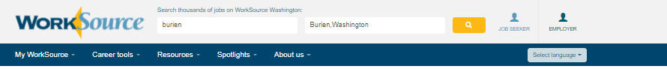

* + - In this particular case, the job posting’s ZIP code maps to Tukwila, but the job is in Burien.  Adjusting the radius will bring other job postings within that designated radius area. Job postings are then listed in order of newest to oldest by posting date

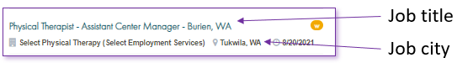

* + - When recruiters create a job posting they use the ‘Find ZIP code’ tool. The tool is connected to the USPS and will autofill the zip code into the job order and has an assigned default city for the cities sharing that code. In the case of White Center, the coder fills in the code and defaults to Seattle. In the case of Burien, the coder fills in the code and defaults to Tukwila. Recruiters have the ability to change the city name, but many don’t make this change or realize they have the ability to do so. This is what causes the appearance of a discrepancy or ‘dead zones’ in job posting searches.
    - This ZIP code search using White Center’s code 98146, auto filled the city to Seattle

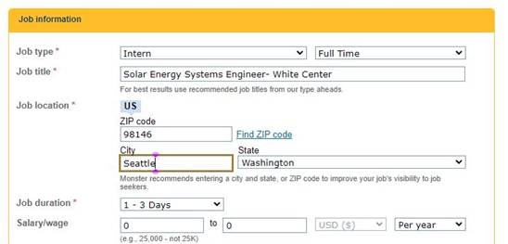

* We changed the default city Seattle to White Center and saved the changes. Now a White Center, WA search will produce this job in WSWA

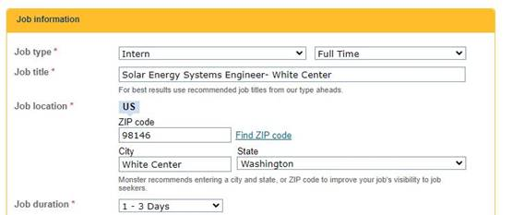

* + WPC – [Reporting page](https://wpc.wa.gov/reports/wswa-reporting) resources
    - Supply/demand [report](https://esd.wa.gov/labormarketinfo/supply-demand-report)
    - [Questions](https://esd.wa.gov/labormarketinfo/learn-about-an-occupation#/search) about the OID in demand jobs by county
  + ETO issue. Logging in and finding participants using Chrome
    - Clear your cache
    - Check for pop-up blockers
  + IE will not be deprecated in October! The timeline for deprecation is after the SharePoint migration project completes but before Windows 11 is deployed (Summer 2022). It will occur sometime between those two projects: Best guess, 3-6 months.
    - Prepare by transitioning to Edge or Chrome. Note: We (ESD staff) notice issues using Chrome and our new SharePoint sites
      * Add sites to prevent pop up blockers
      * Remember; clearing cache can remove the allowed site(s) for pop-up blocking
      * Transfer your favorites to Edge browser
        1. Click on Favorites ‘*star’*
        2. Click on ellipses

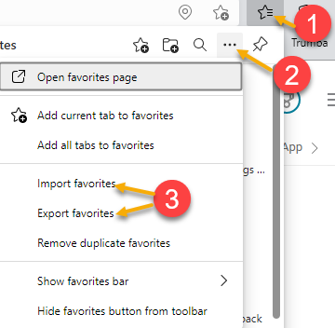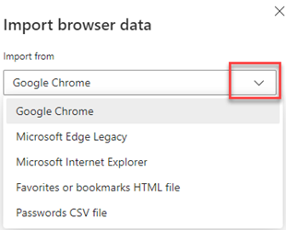

* ETO Basic and Refresher Training - Next training is on 11/1/21 9:30-12
  + ETO Basic training is the 1st Monday 9:30-12 and 3rd Tuesday 1:30-4 of every month (except holidays). Send email to Lynn Aue to receive more information, training account if needed and be added to the training Webex call. *All ETO/WSWA system users are welcome to attend the training but please do not forward invites as I need to review all attendees and assign training accounts if needed.*
  + Training recordings and user guides are posted on the WPC website here <https://wpc.wa.gov/tech/ETO-refresher-training>
  + Submit a remedy ticket to request additional training opportunities and resources
* ***Reminder:*** Submit remedy tickets for all work requests [here](https://wpc.wa.gov/tech/issues). The WSS team cannot begin work without a service request. Reaching out to us directly can affect the time it takes to resolve your issue. Thanks!

**Unemployment Insurance** (UI) claim and data information can be found on the UI page here <https://esd.wa.gov/>

**CHAT**

**ATTENDEES**

No chat or attendance taken this week