T12 Meeting Minutes 10-13-2021
Reminder: After starting a Webex meeting to mute your audio and disable the video feature. Too many attendee’s with active video can interfere with everyone’s audio quality. Hover over the lower edge of your monitor screen to find the icons.

These meetings will be recorded and posted on the WPC site.
Please be advised your image will be captured and recorded during the video conference.
Your participation in this videoconference equals consent to be recorded as required by law.
New Business
- ETO maintenance – nothing this week
- WSWA maintenance – nothing this week
- Velaro maintenance – nothing this week
- Tickets into production –
  - WA-4293 Changes to the participant view/edit page
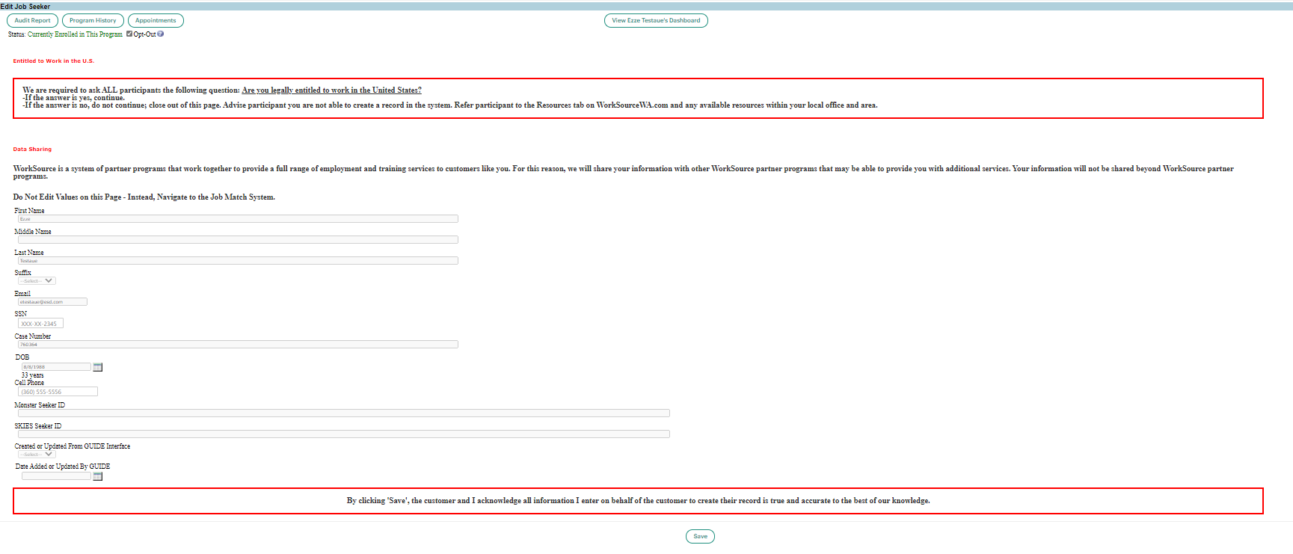
- Project updates – nothing this week
- What’s new on WPC –
  - CASAS desk aid
- Training issues/open discussion –
  - Customer’s Educational Functioning Level link on Test and Results TP broken, desk aid is on WPC site
  - IE will not be deprecated this month! The timeline for deprecation is after the SharePoint migration project completes but before Windows 11 is deployed (Summer 2022). It will occur sometime between those two projects: best guess, 3-6 months.
    - Prepare by transitioning to Edge or Chrome. Note: We (ESD staff) notice issues using Chrome and our new SharePoint sites
      - Add sites to prevent pop up blockers
      - Remember; clearing cache can remove the allowed site(s) for pop-up blocking
      - Transfer your favorites to Edge browser
        - Click on Favorites ‘star’
        - Click on ellipses
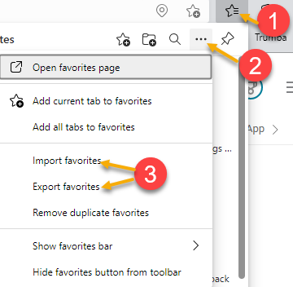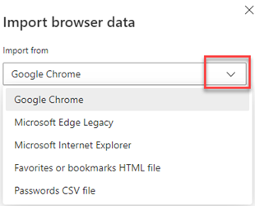

  - Future ETO report enhancements –
    - Mary – Program Enrollment with Demographic and Veteran Details original and limited reports. We received comments that the report doesn’t run for some WDA’s. We discovered a work around to use while we figure out why this is happening. Try running the report for 2 WDA’s to produce the report and then filter out the area you don’t want.
- ETO Basic and Refresher Training - Next training is on 10/19/21 1:30-3:50
  - ETO Basic training is the 1st Monday 9:30-11:50 and 3rd Tuesday 1:30-3:50 of every month (except holidays). Send email to Lynn Aue to receive more information, training account if needed and be added to the training Webex call. All ETO/WSWA system users are welcome to attend the training but please do not forward invites as I need to review all attendees and assign training accounts if needed.
  - Training recordings and user guides are posted on the WPC website here https://wpc.wa.gov/tech/ETO-refresher-training
  - Submit a remedy ticket to request additional training opportunities and resources
- Reminder: Submit remedy tickets for all work requests here. The WSS team cannot begin work without a service request. Reaching out to us directly can affect the time it takes to resolve your issue. Thanks!

Unemployment Insurance (UI) claim and data information can be found on the UI page here https://esd.wa.gov/

CHAT
from Adriana Lopez to everyone: 10:01 AM
I don't think she's talking yet. Unless I dont have sound
from Kylie Bartlett to everyone: 10:01 AM
I can hear you , yes!
from Emily Anderson to everyone: 10:12 AM
Since it's a bigger report, we do have time out issues at times. It is a heavily used report for us.
from File, Christopher (ESD) to everyone: 10:15 AM
Thanks!
from Boylston, Eileen ESD to everyone: 10:15 AM
Thanks
from susan Gustafson to everyone: 10:16 AM
Thanks
from Adriana Lopez to everyone: 10:16 AM
Thank you
from Garcia, Gena (ESD) to everyone: 10:16 AM
Thank you !!!
from Mariya Kazantseva to everyone: 10:16 AM
Thank you!
from Flores, Melisa (ESD) to everyone: 10:16 AM
Thanks

ATTENDEES

Aaron Pentland
Abigail Taft
Adriana Lopez
Aparicio, Rudy
Arbes, Brend
Arturo Espinoza
Baker, Mirayia
Boylston, Eileen
Christina Shaffer
Cook, Diana
Crews, Sandy
Dean Coxford
Dorothy Rocha
Dryden, Jack
E Movsesyan
Emily Anderson
File, Christopher
Flood, Jeffery
Flores, Melisa
Garcia, Gena
Gillis, Deanna
Griffith, Michelle
Holmes, Carolyn
Jackie Wetchler
Jessie Cardwell
Jordan, Irene
Kerns, Adeline
King, Kendall
Kylie Bartlett
Luci Bench
Maier, Seth
Manson, Emily
Mariya Kazantseva
McNamee, Tamela
Nelva March
Ni Dufaigh, T. Jaide
Selam
Sparks, Teresa
Standley, Amanda
Sue Keltner
Susan Gustafson
Tamara
Tina Newcomer
Vey Damneun

