T12 Meeting Minutes 01-05-2022

Reminder: Mute your audio and disable the video feature after starting this Webex meeting. Too many attendee’s with active video can interfere with everyone’s audio quality. To do this, hover over the lower edge of your monitor screen to find the icons.

These meetings will be recorded and posted on the WPC site.
Please be advised your image will be captured and recorded during the video conference.
Your participation in this videoconference equals consent to be recorded as required by law.

New Business
- ETO maintenance – nothing this week
- WSWA maintenance – nothing this week
- Velaro maintenance – The Velaro Product Team will be performing maintenance activity on Friday, January 7, at 3:30:00 AM PT, the estimated duration is 1 hour. We do not expect any impact to your service, yet in some cases, there may be a brief interruption. Please submit a remedy ticket if you experience issues after maintenance.
- Tickets into production – nothing this week
- Project updates – nothing this week
- What’s new on WPC –
  - Updated ‘Create a Record’ PowerPoint and video
    - Short demo on the process
    - WIN0120
    - WS registration forms
  - Coming soon; hands on video of the process
- Report enhancements – nothing this week
- Training issues/open discussion
  - Adding/deleting the T12 distribution list
  - Added more time to ETO basic training and updated the staff development calendar
  - Remedy tickets asking for participant data corrections
    - My team cannot make data corrections for staff. It is prohibited by policy. If you cannot make your own data corrections ask your supervisor, lead or program operator/specialist who can make the correction for you. The WPC site has this desk aid to help you locate your WDA data correction specialist.
      - Policy guidance on real time data entry/corrections and case notes are on the WPC site
  - Can you make another ETO Basic Training recording? Yes I will!
- Remedy tickets – Recently the service desk has been back logged with tickets which delays ETO/WSWA ticket assignment to our team. SSN correction tickets are a high priority, needing an immediate fix so staff can record services provided to customers timely. Email us at esdgpwssteam@esd.wa.gov if you receive a response within 24 hours. We can locate the ticket and start working on it.
- ETO Basic and Refresher Training - Next training is on 1/18/22 1:30-4:30
  - ETO Basic training is the 1st Monday 9:00-12 and 3rd Tuesday 1:30-4:30 of every month (except holidays). Send email to Lynn Aue to receive more information, training account if needed and be added to the training Webex call. All ETO/WSWA system users are welcome to attend the training but please do not forward invites as I need to review all attendees and assign training accounts if needed.
  - Refresher training recordings and user guides are posted on the WPC website here https://wpc.wa.gov/tech/ETO-refresher-training
  - Submit a remedy ticket to request additional training opportunities and resources
Old Business
- Reminder: Submit remedy tickets for all work requests here. The WSS team cannot begin work without a service request. Reaching out to us directly can affect the time it takes to resolve your issue. Thanks!
  - Submitting remedy tickets – help us by providing enough details to work your issue. Suggestions to speed up discovering and resolving issue without lots of back-and-forth emails.
    - Screen shots include the entire screen, browser bar, not just a pinpoint of the TP that isn’t correct.
    - Report tickets need the WDA, office and start and end dates parameters you used to run the problematic report
    - We will send you 2 emails asking for additional information. Second request for response will advise you the ticket will close in 24 hours.
- Some employers are reporting landing on the Monster pay page. Direct them to click on ‘Home’ or ‘Sign in’ Clicking on ‘Post a Job’ here takes them to a page asking for money. We are working on cleaning this up.
  - Advise your employers to clear their cache so they get out of the loop of landing on this page when log into their account!
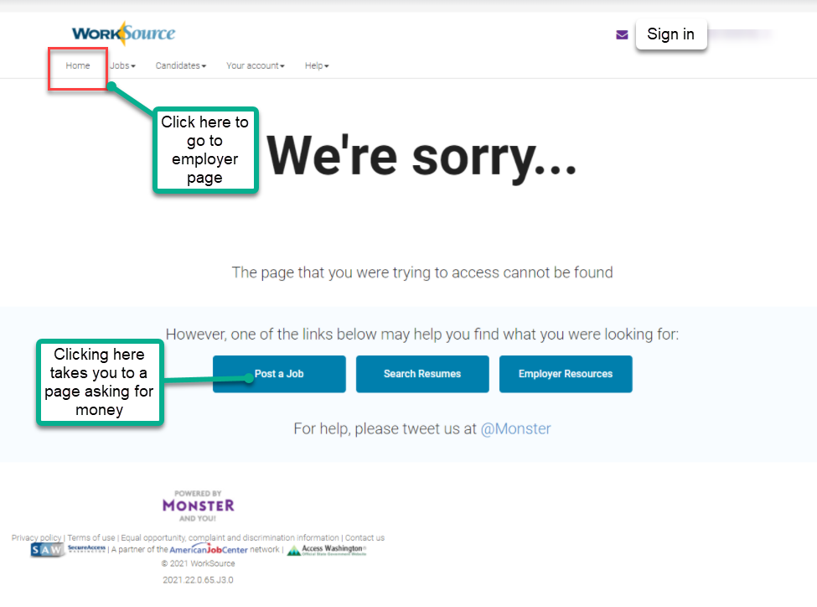

- Internet Explorer (IE) will be deprecated after the SharePoint migration project completes but before Windows 11 is deployed (Summer 2022). It will occur sometime between those two projects, approximately 3-6 months.
  - Prepare now by transitioning to Edge or Chrome.
  - Don’t forget to transfer your favorites to Edge or Chrome and also add a copy to your document folder for recovery purposes!
    - How to import Favorites from IE to Chrome video
    - How to import Favorites from IE to Edge
        - Click on Favorites ‘star’
        - Click on ellipses (3 dots)
        - Select either Import (from Chrome or IE) or Export a copy to a local folder

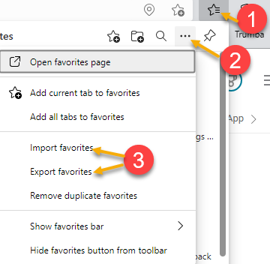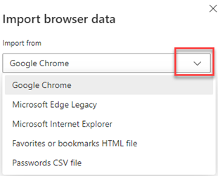

- Chrome issues – Instructions on how to clear your cache are included in the ‘Checklist of things to do before submitting a service request’ desk aid found on the WPC site.
    - Clearing Chrome cache starts from the top right side of the browser bar
- Click the triple dots to open the Chrome tools menu
- Hover over “More tools”
- Click “Clear browsing data” which opens a new screen
- Click “Clear data”

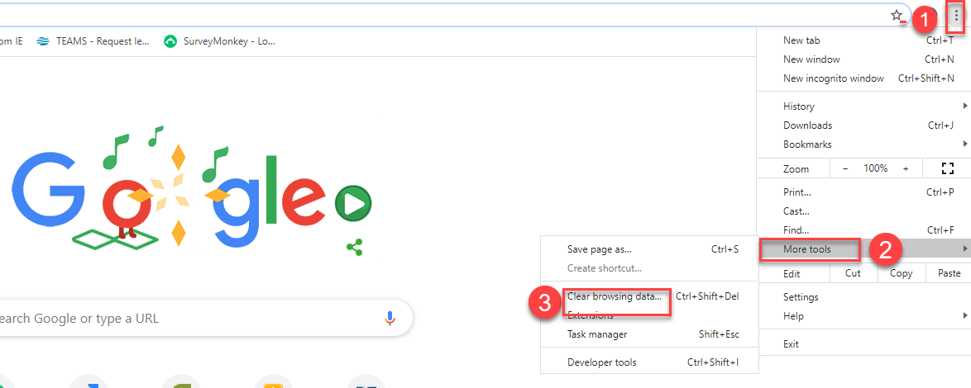

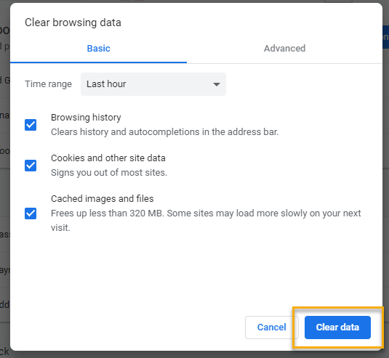
Unemployment Insurance (UI) claim and data information can be found on the UI page here https://esd.wa.gov/

CHAT
from Robbin Gard: Can you put the ESD DL ITSD Training Team email address in the Bcc field instead of the To field so responses don’t go to everyone on the DL?
from Aue, Lynn (ESD) to everyone: 9:59 AM I could do that. Brilliant idea!
Question from Teresa
They’ve noticed issues with Basic Services not aligning in RAS, so they are getting ready to send out data corrections. Is there a group that complete these?
from Gard, Robbin (ESD) to everyone: 10:14 AM
Teresa are you talking about disparity with RESEA touchpoints and the # of completed appointments?
from Sparks, Teresa A (ESD) to everyone: 10:20 AM
@ Robbin, TP's in general for some offices. For some reason these are being missed.

from Aue, Lynn (ESD) to everyone: 10:14 AM
https://storemultisites.blob.core.windows.net/media/WPC/adm/policy/0082-1.pdf
from Aue, Lynn (ESD) to everyone: 10:16 AM
https://storemultisites.blob.core.windows.net/media/WPC/adm/policy/0088.pdf
from Kerns, Adeline (ESD) to everyone: 10:19 AM Adeline Kerns and Michelle Griffith Program Operator and Specialist for TAA Program

ATTENDEES

Aaron Pentland
Anderson, Laura
Aparicio, Rudy
Arbes, Brent
Balbon, Jean
Cancel, Regina
Cascio, Jaclyn
Chase, Kim
Cori-Ann Ching
Dawn Oakes
Dean Coxford
Dorothy Rocha
Elias Zafar
Emily Anderson
Ensor, Michael
File, Christopher
Gard, Robbin
Hall, Shane
Holmes, Carolyn
Jessie Cardwell
Jordan, Irene
Kerns, Adeline
King, Kendall
Kylie Bartlett
Lisa Pietkauskis
Malmi Peiris
Maricha Friedman
Mariya Kazantseva
Maya Anderson
Natalya Verley
PoChi
Reasoner, Suzette
Selam
Smick, Rikki
Sparks, Teresa
Tamara Toles
Taylor
Teresa Anda
Tracy Ferrell
Vey Damneun
Wood, Laura

