T12 Meeting Minutes 01-26-2022

Reminder: Mute your audio and disable the video feature after starting this Webex meeting. Too many attendee’s with active video can interfere with everyone’s audio quality. Hover over the lower edge of your monitor screen to find the icon and disable your video.

These meetings will be recorded and posted on the WPC site.
Please be advised your image will be captured and recorded during the video conference.
Your participation in this videoconference equals consent to be recorded as required by law.

New Business
- ETO maintenance – nothing this week
- WSWA maintenance – nothing this week
- Velaro maintenance – nothing this week
- Tickets into production –
  - WA-4393; updating the TAA payment details TP. Applies only to TAA
  - WA-4403; adding ‘Job ID’ column to job postings
- Project updates – nothing this week
- What’s new on WPC –
  - Updated desk aid for removing duplicate TP from the general information dashboard
- Report enhancements –
  - UI Claimant/RESEA category
    - RESEA Draft TouchPoints> NEW; report to display when either the RESEA Required Elements Initial or RESEA Action Plan Initial TouchPoints are in still in 'Draft' status
- Training issues/open discussion
  - Reminder: Link to claimants 1099’s available in eServices
  - Issues reported when printing case notes from the Case Note History widget. Work around is to print one to the 4 reports included on the side navigation report menu
    - Start from the navigation menu, select ‘Reports’, and then open the ‘Operational category’. Select one of the case note reports and enter the participant case ID# and run the report.
    - Print by clicking the printer icon to download the document to your machine and print all pages or
    - Export the report to have the ability to select the pages and the format (Excel or PDF) you want to print
    - We have identified a bug with the ‘Case Notes 4.0 -No Basic Services Included report doesn’t have enough characters to display participant’s full name
  - Job ID column added to job postings
  - ‘Method of contact’ drop down field available on Basic Services and ITS Services
    - This function was requested by leadership to capture the data on how the customers are contacted.
      - Basic Services is required for RESEA only.
      - Optional for all other’s. ITSS is optional for all
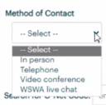
  - My Caseload feature – who uses this for case management tracking? Or would a Case Manager TP be more useful to track case managers and co-enrollment?
    - A tool for supervisors, Program Operators/Specialist to manage staff caseloads so participants don’t fall through the cracks and have a disruption of service
    - Demo on adding/removing participants
    - Currently ‘Transfer’ on the My Caseload feature doesn’t function as expected

  - Employer fraud
    - Direct job seekers to Washington State Office of the Attorney General for information on employment scams
    - Job seekers can contact the Attorney General’s office and file a complaint ‘Contact Us’
  - Updated the participant General Information dashboard clean-up desk aid
  - Is there a texting solution for ETO?
    - ETO Engage is a one-way texting solution. Feedback from staff is Engage is cumbersome to use. Some staff use it to remind participants about upcoming appointments. There is a threshold on the number of contacts you can text at one time. Sometimes it stalls out if a bad phone number was entered.
    - There is a texting solution project in the works.
  - Office closures
    - Submit remedy ticket to update the WS locator
  - Submit remedy tickets vs sending email to team
    - Remember if you suggest an enhancement at T12 to submit a remedy ticket.
- Remedy tickets – Recently the service desk has been back logged with tickets which delays ETO/WSWA ticket assignment to our team. SSN correction tickets are a high priority, needing an immediate fix so staff can record services provided to customers timely. Email us at esdgpwssteam@esd.wa.gov if you receive a response within 24 hours. We can locate the ticket and start working on it.
- ETO Basic and Refresher Training - Next training is on 2/7/22 9-12
  - ETO Basic training is the 1st Monday 9:00-12 and 3rd Tuesday 1:30-4:30 of every month (except holidays). Send email to Lynn Aue to receive more information, training account if needed and be added to the training Webex call. All ETO/WSWA system users are welcome to attend the training but please do not forward invites as I need to review all attendees and assign training accounts if needed.
  - Refresher training recordings and user guides are posted on the WPC website here https://wpc.wa.gov/tech/ETO-refresher-training
  - Submit a remedy ticket to request additional training opportunities and resources
Old Business
- Reminder: Submit remedy tickets for all work requests here. The WSS team cannot begin work without a service request. Reaching out to us directly can affect the time it takes to resolve your issue. Thanks!
  - Submitting remedy tickets – help us by providing enough details to work your issue. Suggestions to speed up discovering and resolving issue without lots of back-and-forth emails.
    - Screen shots include the entire screen, browser bar, not just a pinpoint of the TP that isn’t correct.
    - Report tickets need the WDA, office and start and end dates parameters you used to run the problematic report
    - We will send you 2 emails asking for additional information. Second request for response will advise you the ticket will close in 24 hours.
- Desk aid on things to try before submitting a remedy ticket; includes instructions for clearing your cache
- Some employers are reporting landing on the Monster pay page. Direct them to click on ‘Home’ or ‘Sign in’ Clicking on ‘Post a Job’ here takes them to a page asking for money. We are working on cleaning this up.
  - Advise your employers to clear their cache so they get out of the loop of landing on this page when log into their account!
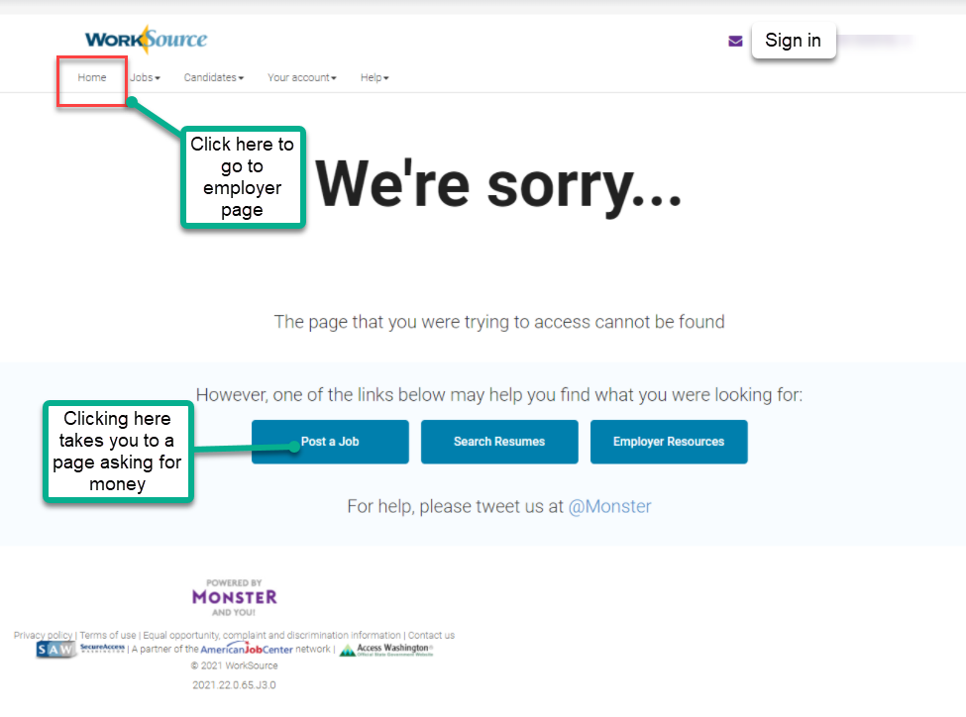

- Internet Explorer (IE) will be deprecated after the SharePoint migration project completes but before Windows 11 is deployed (Summer 2022). It will occur sometime between those two projects, approximately 3-6 months.
  - Prepare now by transitioning to Edge or Chrome.
  - Don’t forget to transfer your favorites to Edge or Chrome and also add a copy to your document folder for recovery purposes!
    - How to import Favorites from IE to Chrome video
    - How to import Favorites from IE to Edge
        - Click on Favorites ‘star’
        - Click on ellipses (3 dots)
        - Select either Import (from Chrome or IE) or Export a copy to a local folder

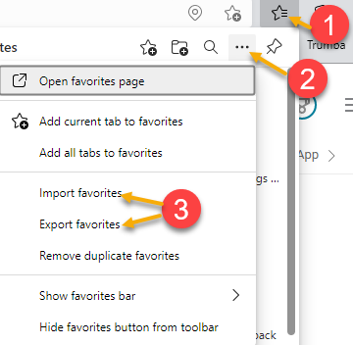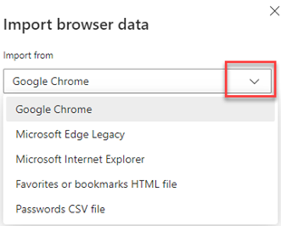

Unemployment Insurance (UI) claim and data information can be found on the UI page here https://esd.wa.gov/

CHAT
What is the age range for WIOA Youth?
from Smith, Jasmine (ESD) to everyone: 10:08 AM 16-24 at time of enrollment
Adding job ID# to job postings
from Pelot, Paul (ESD) to everyone: 10:24 AM Handy for Business Services, awesome!
from Tracy Ferrell to everyone: 10:28 AM

Method of Contact
What about adding Email as a form of contact? Please submit your suggestion in a remedy ticket
from MacLennan, Mary (ESD) to everyone: 10:34 AM @Tracy - we had discussions about adding 'Email' when we discussed this a month or so ago and the consensus was it's not always an approved method of contact for providing either a basic or ITS service.

My Caseload
from Malmi Peiris to everyone: 10:35 AM once a customer is exited are we to remove them from our case load? You should remove participants from your case load when you finish managing the case. Remember, My Caseload is a feature like a favorites list. It doesn’t keep a participation episode or Program Enrollment active
from Eileen Boylston to everyone: 10:35 AM It does make it easier to track I've always used it
from Tracy Ferrell to everyone: 10:36 AM I don't have cases. But I used it recently to track a correction that I was working on. It was handy!!
from Dorothy Rocha to everyone: 10:38 AM Some of our case managers use it. It would be nice to have a report that could be run based on case manager caseload info
from Heidi Lamers to everyone: 10:38 AM I really like the My Caseload feature.
from Emily Anderson to everyone: 10:39 AM We have some staff who use it and love it, others don't like it at all. It is clunky and can take too long to add/remove from MacLennan, Mary (ESD) to everyone: 10:41 AM We are researching whether reporting can be done from the My Caseload functionality
from Martin, Monique (ESD) to everyone: 10:42 AM I wonder if the "transfer" button on "My Caseload" makes staff think they can transfer their caseload by using that button...if that could be removed, that would be great.
from Pelot, Paul (ESD) to everyone: 10:43 AM I concur with Monique.
from Pelot, Paul (ESD) to everyone: 10:45 AM Oh, I understand now how to use transfer. Thank you!
from Kerns, Adeline (ESD) to everyone: 10:46 AM Before we take out functions of the My Caseload tp can we check with all programs as there may be a need in another program.
from Emily Anderson to everyone: 10:48 AM Yes, Adeline! This is my concern as well. I don' think this meeting covers a broad enough audience to make significant additions or changes without feedback from outside.
from Kerns, Adeline (ESD) to everyone: 10:52 AM
customers which makes it more of a chore than a useful tool at times.

ETO Engage
from MacLennan, Mary (ESD) to everyone: 10:54 AM I know there can be issues if you send group messages and include too many participants. So it works better if you limit the number you include.

Can’t find employer
from Pelot, Paul (ESD) to everyone: 10:39 AM Will do for sure. I e-mailed Lynn about it, and it was fixed the next morning. But will submit a ticket next time. :-)

System outage
from Kerns, Adeline (ESD) to everyone: Can you say anything about the program enrollments and TPs dropping last week? Did people report that services or PE taken during the down time were missing? 1/21/22 there was a high impact bug in ETO causing program enrollment and some service information to not display. We were assured no data was lost. The feedback we received was no data was lost.
from Pelot, Paul (ESD) to everyone: 10:57 AM My Touchpoints were fully restored! Yay!

ATTENDEES

Abigail Taft
Aparicio, Rudy
Ariana Cordova
B Oliveri
Cancel, Regina
Cori-Ann Ching
Corpuel, Jessica
Dawn Oakes
Dean Coxford
Dorothy Rocha
Eileen Boyston
Emily Anderson
Emitt Thrower
Enwall, Jo Ann
Erickson, Tristan
Gillis, Deanna
Hall, Shane
Heidi Lamers
Holmes, Carolyn
Ihrig, Louis
Ish
Jackie Wetchler
Jessie Cardwell
Jordan, Irene
Kerns, Adeline
Kylie Bartlett
Linda Rowling
Lisa Pietkauskis
Lux Dmitri
Mack, Donna
Malmi Peiris
Manson, Emily
Maribel Dominguez
Mariya Kazantseva
Martin, Monique
Natalya Verley
Pelot, Paul
PoChi
Rhonda
Smith, Jasmine
Sutton, Terry
Tamara Toles
Teresa Anda
Tina Newcomer
Tracy Ferrell
Zafar, Elias
Zander

