T12 Meeting Minutes 01-19-2022

Reminder: Mute your audio and disable the video feature after starting this Webex meeting. Too many attendee’s with active video can interfere with everyone’s audio quality. To do this, hover over the lower edge of your monitor screen to find the icons.

These meetings will be recorded and posted on the WPC site.
Please be advised your image will be captured and recorded during the video conference.
Your participation in this videoconference equals consent to be recorded as required by law.

New Business
- ETO maintenance – nothing this week
- WSWA maintenance – nothing this week
- Velaro maintenance – The Velaro Product Team will be performing maintenance activity on Friday, January 21, at 3:30:00 AM PT, the estimated duration is 1 hour. We do not expect any impact to your service, yet in some cases, there may be a brief interruption.
- Tickets into production – nothing this week
- Project updates – nothing this week
- What’s new on WPC –
  - T12 2022 minutes page completed, minutes and recordings for this month will be posted by COB 1/20/22 Trying when time allows
  - Removing duplicate TPs from the general information dashboard desk aid
- Report enhancements – nothing this week
- Training issues/open discussion
  - 1099’s available in eServices
  - Delayed job postings
    - Most job postings go live within an hour after posting
    - 24-hour delay if they contain potential ‘fraud’ words. The team is working on reducing this list
      - This is a sample list of the terms but not all of them that can throw a fraud warning, sending an email to our team and putting the job in pending status for 24 hours.

travel coordinator
helion energy
incyte
employment solution
shipping and receiving clerk
virtual assistant
stay at home
cash checks
depositing checks
receiving packages
@juno.com
156.146.59.16
back page
air products and chemicals
personal errands
package shipping
mystery shopping
zollars
@usa.com

    - Find pending jobs from the companies sub-entity account. Submit a remedy ticket to have the job released sooner than 24 hours.
      - Note: The job will remain on the list even after they are released. It should not need to be removed.
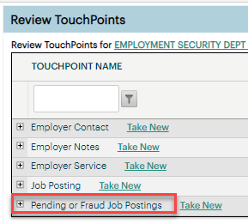
  - Removing duplicate TPs from the general information dashboard – demo and discussion on the process and desk aid
    - Note: the desk aid shown in the live demo video has been updated. Refer to the new desk aid on the WPC
  - Issues finding recruiter/employers –
    - Need to enter the exact spelling in the ETO quick search
    - Consider using the company ‘X’ code
    - Cannot search by UBI, FEIN or ESR number
    - Employer accounts expire after 3 years if they are accessed only via impersonation. Solution, once every 3 years the employer needs to log in using their SAW account from WSWA.
    - Submit a remedy ticket if you need more help locating an employer/recruiter account. Include the company name, recruiter name and email used to create the account in the ticket.
    - More details on this topic in chat
  - Office closures
    - Let us know by submitting a remedy ticket if your office is closing and you need to update the WS locator
  - Late data entry
    - Per Policy, Basic and ITS Services must be recorded within 14 days of providing the service as called out in WIN0082 ‘Real Time Data Entry in ETO’
    - Case note guidance now in WorkSource Data Integrity and Performance Policy and Handbook
  - Issues printing case notes – discussion will happen next week
- Remedy tickets – Recently the service desk has been back logged with tickets which delays ETO/WSWA ticket assignment to our team. SSN correction tickets are a high priority, needing an immediate fix so staff can record services provided to customers timely. Email us at esdgpwssteam@esd.wa.gov if you receive a response within 24 hours. We can locate the ticket and start working on it.
- ETO Basic and Refresher Training - Next training is on 2/7/22 9-12
  - ETO Basic training is the 1st Monday 9:00-12 and 3rd Tuesday 1:30-4:30 of every month (except holidays). Send email to Lynn Aue to receive more information, training account if needed and be added to the training Webex call. All ETO/WSWA system users are welcome to attend the training but please do not forward invites as I need to review all attendees and assign training accounts if needed.
  - Refresher training recordings and user guides are posted on the WPC website here https://wpc.wa.gov/tech/ETO-refresher-training
  - Submit a remedy ticket to request additional training opportunities and resources
Old Business
- Reminder: Submit remedy tickets for all work requests here. The WSS team cannot begin work without a service request. Reaching out to us directly can affect the time it takes to resolve your issue. Thanks!
  - Submitting remedy tickets – help us by providing enough details to work your issue. Suggestions to speed up discovering and resolving issue without lots of back-and-forth emails.
    - Screen shots include the entire screen, browser bar, not just a pinpoint of the TP that isn’t correct.
    - Report tickets need the WDA, office and start and end dates parameters you used to run the problematic report
    - We will send you 2 emails asking for additional information. Second request for response will advise you the ticket will close in 24 hours.
- Desk aid on things to try before submitting a remedy ticket; includes instructions for clearing your cache
- Some employers are reporting landing on the Monster pay page. Direct them to click on ‘Home’ or ‘Sign in’ Clicking on ‘Post a Job’ here takes them to a page asking for money. We are working on cleaning this up.
  - Advise your employers to clear their cache so they get out of the loop of landing on this page when log into their account!
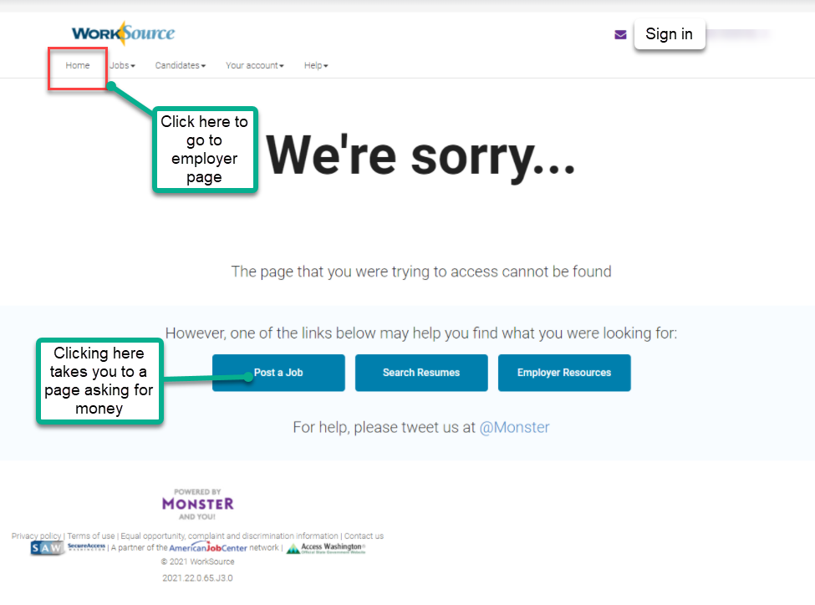

- Internet Explorer (IE) will be deprecated after the SharePoint migration project completes but before Windows 11 is deployed (Summer 2022). It will occur sometime between those two projects, approximately 3-6 months.
  - Prepare now by transitioning to Edge or Chrome.
  - Don’t forget to transfer your favorites to Edge or Chrome and also add a copy to your document folder for recovery purposes!
    - How to import Favorites from IE to Chrome video
    - How to import Favorites from IE to Edge
        - Click on Favorites ‘star’
        - Click on ellipses (3 dots)
        - Select either Import (from Chrome or IE) or Export a copy to a local folder

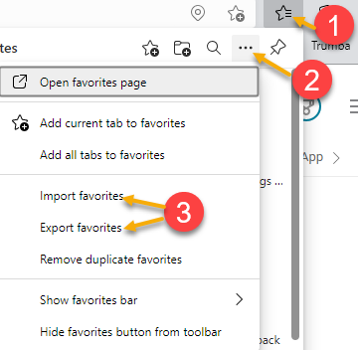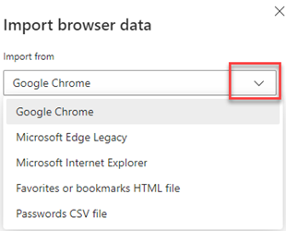

Unemployment Insurance (UI) claim and data information can be found on the UI page here https://esd.wa.gov/

CHAT
Job posting language that triggers potential fraud and delays postings 24 hours
Fraud from Martin, Monique (ESD) to everyone: are these all of the prohibited words, or the ones that are being reduced? These are some of the words. We are in the process of eliminating many of them. We will discuss the remaining words after clean-up
from Martin, Monique (ESD) to everyone: is there a list of words to watch for so I can let our team know? Just the ones listed above
from Martin, Monique (ESD) to everyone: Thank you :)

Finding recruiters/employers
from McNamee, Tamela (ESD) to everyone: 10:16 AM Any tricks or tips to find the recruiter for the business accounts? They call because they no longer have access and ask for me to post the job for them. I'm having a hard time posting jobs for businesses because I can't find the recruiter account. WSWA accounts need to be logged into from the internet at least once every 3 years. If you (staff) log into employer accounts via impersonation, the account will expire in 3 years. If this happens, submit a remedy ticket and we will work with you to help the employer log into their accounts and re-enabled it.
from Boylston, Eileen ESD to everyone: 10:19 AM If they have a recruiter assigned to their account, you can find the recruiter by finding the ETO account for that employer and then select Find recruiter match, then you can select the recruiter, once in you can impersonate them and post the job. If they don't have a recruiter assigned, you can't post jobs for them. That is correct
from McNamee, Tamela (ESD) to everyone: 10:22 AM Sometimes, there are 80 business accounts with the same name.
from Pahulu, Emeline (ESD) to everyone: 10:24 AM If there are 80 employers find the employer with Sub Entity
from Martin, Monique (ESD) to everyone: 10:26 AM Do we have BSU Employer Services Training established already? I am working on some for LVERs, but if we already have ETO training for it, I would love to access it. There is training material on the WPC site. ETO training resources> Refresher Training and WorkSourceWA> Training resources

WIOA Eligibility Application – UI status -WA-4411
from Natalya Verley to everyone: 10:32 AM Under the UI Claimant Status dropdown of the WIOA Eligibility Application there are a couple of acronyms - can we go over what those stand for?
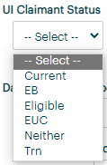
Current = currently claiming
EB = Extended Benefits
Eligible = eligible claim
EUC = emergency unemployment claim
Neither = not eligible
Trn = Training Benefits
from Dorothy Rocha to everyone: 10:43 AM What would you use for someone who exhausted UI?? Neither
from Natalya Verley to everyone: 10:44 AM EB looked like exhausted benefits It does, but actually stands for Extended Benefits
from Martin, Monique (ESD) to everyone: 10:45 AM EB= Extended Benefits
from Ariana Cordova to everyone: 10:45 AM Could "Exhausted" be added to the drop-down for UI Claimant? These are mapped to the PIRL (federal reporting tool). They cannot be changed without approval by System Performance and Policy
from Natalya Verley to everyone: 10:46 AM I second Ariana's suggestion
from Natalya Verley to everyone: 10:50 AM Lynn - could help text be added to that section- UI Claimant status

Method of Contact
from McNamee, Tamela (ESD) to everyone: 10:35 AM Some of the touchpoints have a "Method of Contact" dropdown. Can "Email" be added as an option? Submit a remedy ticket and we can ask for a change

ATTENDEES

Aaron Pentland
Abigail Taft
Abplanalp, Christopher T (ESD)
Anderson, Laura J (ESD)
Aparicio, Rudy (ESD)
Arbes, Brent W ESD
Ariana Cordova
Booth, Shannon (ESD)
Boylston, Eileen ESD
Cancel, Regina B (ESD)
Cascio, Jaclyn (ESD)
Chase, Kim (ESD)
Cori-Ann Ching
Dawn Oakes
DEAN COXFORD
Donna Hendrickson
Dorothy Rocha
Dunning, Shellie (ESD)
Emily Anderson
Emitt Thrower
Enwall, Jo Ann (ESD)
Erickson, Tristan ESD Partner
Gillis, Deanna F. (ESD)
Heidi Lamers
Holmes, Carolyn (ESD)
Jessie Cardwell-BFWDC
Johnson, Melinda Y (ESD)
Jordan, Irene (ESD)
Kerns, Adeline (ESD)
King, Kendall (ESD)
Lilia
Linda Rowling
Lisa Pietkauskis
Luci Bench
Lux Dmitri
Mariya Kazantseva
Martin, Monique (ESD)
Mattoo, Aninda (ESD)
Maya Anderson
McNamee, Tamela (ESD)
Metcalf, Kimberly K (ESD)
Natalya Verley
Pahulu, Emeline (ESD)
Peiris, Malmi ESD
Pochi
Reasoner, Suzette (ESD)
Robinson, Melissa J (ESD)
Samba, Ngenarr 'Samba' (ESD)
Selam
Soto, Raul (ESD)
Sparks, Teresa A (ESD)
susan Gustafson
Sutton, Terry ESD Partner
Tamara Toles WSW
Teresa Anda
Tina Newcomer
Tracy Ferrell
Wood, Lora A ESD
Zafar, Elias ESD Partner
Zander

