T12 Meeting Agenda 01-12-2022

Reminder: Mute your audio and disable the video feature after starting this Webex meeting. Too many attendee’s with active video can interfere with everyone’s audio quality. To do this, hover over the lower edge of your monitor screen to find the icons.

These meetings will be recorded and posted on the WPC site.
Please be advised your image will be captured and recorded during the video conference.
Your participation in this videoconference equals consent to be recorded as required by law.

New Business
- ETO maintenance – nothing this week
- WSWA maintenance – nothing this week
- Velaro maintenance – nothing this week
- Tickets into production – nothing this week
- Project updates – nothing this week
- What’s new on WPC –
  - Updated Checklist of things to do before submitting a service request desk aid
  - New! ETO report pop-up blockers desk aid
- Report enhancements –
  - Trade Assistance Act
    - TAA Determination Letter; Deleted; duplicate of dashboard version
    - TAA Entitlement Letter; Deleted; duplicate of dashboard version
  - Operational Reports
    - Case Management 'Staff Work' Report; NEW--created new report for services linked to Program Enrollment, including a column of the most recent durational service Last Updated Date.
- Training issues/open discussion
  - What service do you take in ETO for: Intake/orientation/outreach services?
    - Team feels the current services are good as is.
  - Reminder: my team cannot correct ETO participant data. If you are unable to correct a TP, ask your supervisor or lead for help. If they don’t have the permissions to make the correction there is a desk aid with WDA data correction staff on the WPC
  - Pop-up blocker interfering when running ETO reports (see new desk aid on WPC)
  - Delay in adding 2022 T12 minutes to WPC
  - Delay in employer account approvals
  - Add an identifier in Basic Service to add more details at a glance about the TP
    - Consensus from the team is it would be a time safer and is needed
    - Team needs to submit a remedy ticket asking for this change
  - Next week – issues printing case notes
- Remedy tickets – Recently the service desk has been back logged with tickets which delays ETO/WSWA ticket assignment to our team. SSN correction tickets are a high priority, needing an immediate fix so staff can record services provided to customers timely. Email us at esdgpwssteam@esd.wa.gov if you receive a response within 24 hours. We can locate the ticket and start working on it.
- ETO Basic and Refresher Training - Next training is on 1/18/22 1:30-4:30
  - ETO Basic training is the 1st Monday 9:00-12 and 3rd Tuesday 1:30-4:30 of every month (except holidays). Send email to Lynn Aue to receive more information, training account if needed and be added to the training Webex call. All ETO/WSWA system users are welcome to attend the training but please do not forward invites as I need to review all attendees and assign training accounts if needed.
  - Refresher training recordings and user guides are posted on the WPC website here https://wpc.wa.gov/tech/ETO-refresher-training
  - Submit a remedy ticket to request additional training opportunities and resources
Old Business
- Reminder: Submit remedy tickets for all work requests here. The WSS team cannot begin work without a service request. Reaching out to us directly can affect the time it takes to resolve your issue. Thanks!
  - Submitting remedy tickets – help us by providing enough details to work your issue. Suggestions to speed up discovering and resolving issue without lots of back-and-forth emails.
    - Screen shots include the entire screen, browser bar, not just a pinpoint of the TP that isn’t correct.
    - Report tickets need the WDA, office and start and end dates parameters you used to run the problematic report
    - We will send you 2 emails asking for additional information. Second request for response will advise you the ticket will close in 24 hours.
- Some employers are reporting landing on the Monster pay page. Direct them to click on ‘Home’ or ‘Sign in’ Clicking on ‘Post a Job’ here takes them to a page asking for money. We are working on cleaning this up.
  - Advise your employers to clear their cache so they get out of the loop of landing on this page when log into their account!
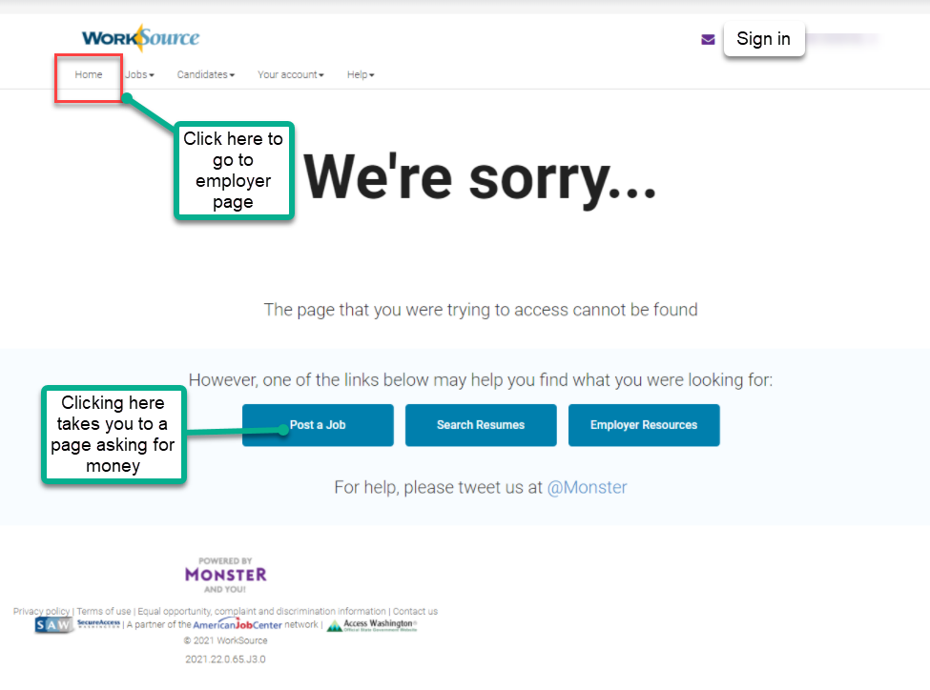

- Internet Explorer (IE) will be deprecated after the SharePoint migration project completes but before Windows 11 is deployed (Summer 2022). It will occur sometime between those two projects, approximately 3-6 months.
  - Prepare now by transitioning to Edge or Chrome.
  - Don’t forget to transfer your favorites to Edge or Chrome and also add a copy to your document folder for recovery purposes!
    - How to import Favorites from IE to Chrome video
    - How to import Favorites from IE to Edge
        - Click on Favorites ‘star’
        - Click on ellipses (3 dots)
        - Select either Import (from Chrome or IE) or Export a copy to a local folder

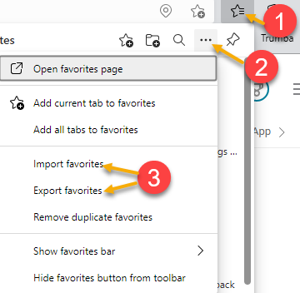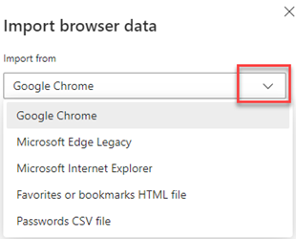

- Chrome issues – Instructions on how to clear your cache are included in the ‘Checklist of things to do before submitting a service request’ desk aid found on the WPC site.
    - Clearing Chrome cache starts from the top right side of the browser bar
- Click the triple dots to open the Chrome tools menu
- Hover over “More tools”
- Click “Clear browsing data” which opens a new screen
- Click “Clear data”

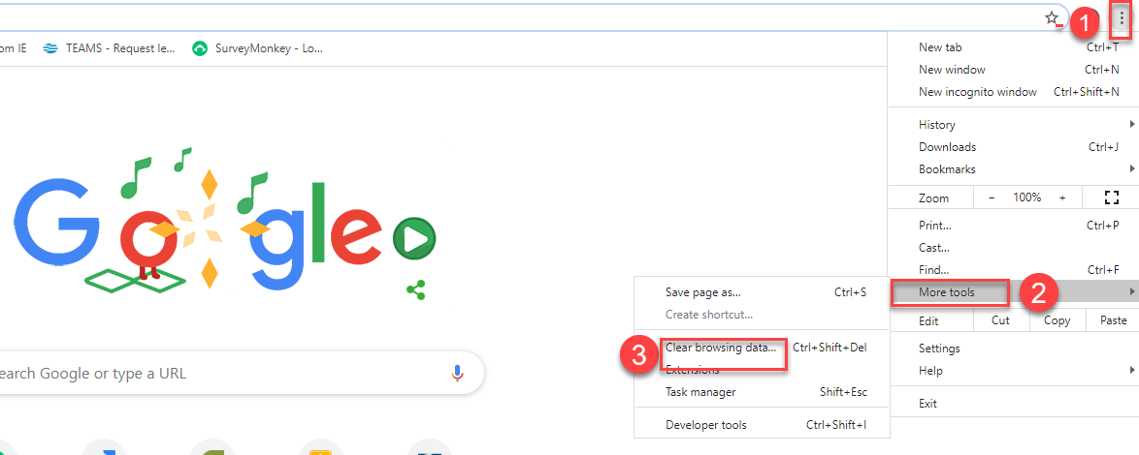

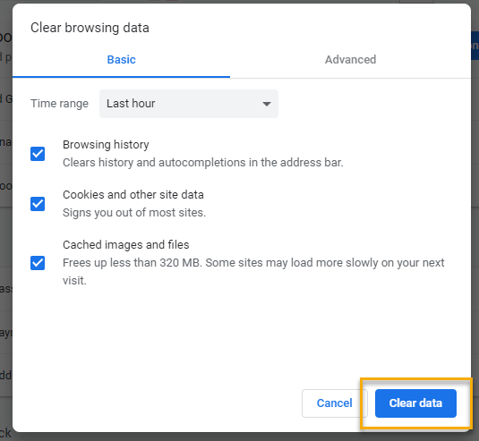
Unemployment Insurance (UI) claim and data information can be found on the UI page here https://esd.wa.gov/

CHAT
New Services
from Emily Anderson to everyone: 10:08 AM Think services are covered pretty well.

Basic Services Identifier
from McNamee, Tamela (ESD) to everyone: 10:08 AM Adding an "Identifier" to the Basic Services would be helpful.
from Emily Anderson to everyone: 10:12 AM yes
from Jessie Cardwell-BFWDC to everyone: 10:12 AM yes
from Johnson, Angela (ESD) to everyone: 10:12 AM Huge- save time and extra documentation

TAA Determination Letters Report
from Kerns, Adeline (ESD) to everyone: 10:10 AM For the TAA Entitlement Report that is now dashboard only. Is there still a way to run report for all current TAA Determination Letters?
Adeline - did there used to be a way to print ALL determination letters? Was that a report? Just trying to get this info so I can research as I'm not familiar with this.
from Kerns, Adeline (ESD) (privately): 10:22 AM I do not recall but when I saw that this report was deleted I wondered if there was a way to run a report of the TAA Determinations. I am specifically trying to run a report that shows me all the Interstate cases that have a determination from another state. There is a box in the entitlement letter field that shows if an entitlement is from out of state.

from Peiris, Malmi ESD to everyone: 10:14 AM I have a customer who doesn't appear on ETO when searched by name. But when I search by SS number another name comes up. I was wondering if submitting a ticket would be the correct way to go about reporting this issue? thank you !
from MacLennan, Mary (ESD) to everyone: 10:16 AM @Malmi - Yes, please submit a remedy ticket. Thanks!
from Peiris, Malmi ESD to everyone: 10:17 AM
Thank you Mary

Case Management Reports
from McNamee, Tamela (ESD) to everyone: 10:29 AM Where do we find directions on how to create our own case management reports? We need a report to show our exits, so we can do follow-ups. You don’t have the ability to write your own reports. Check out the Program Enrollment Outcomes report
from Maya Anderson to everyone: 10:31 AM We use the Program Enrollment Outcomes report
from Linda Rowling to everyone: 10:32 AM Under Local Reporter Data
from Kerns, Adeline (ESD) to everyone: 10:32 AM TAA runs a Case Management report from the Operational Reports. We have to sort and filter it to what we need.
from McNamee, Tamela (ESD) to everyone: 10:32 AM
Thank you!

ATTENDEES

Aaron Pentland
Abigail Taft
Abplanalp, Christopher
Aparicio, Rudy
Arbes, Brent
B Oliveri
Cancel, Regina
Carol Cauthron
Cori-Ann Ching
Dawn Oakes
Dean Coxford
Dorothy Rocha
Douglas Evans
Elias Zafar
Emily Anderson
Enwall, Jo Ann
Erickson, Tristan
File, Christopher
Gillis, Deanna
Heidi Lamers
Holmes, Carolyn
Hudgens, Sheila
Jackie Wetchler
Jessie Cardwell
Johnson, Angela
Jordan, Irene
Kerns, Adeline
Linda Rowling
Lisa Pietkauskis
Luci Bench
Mack, Donna
Manson, Emily
Mariya Kazantseva
Maya Anderson
McNamee, Tamela
Natalya Verley
Peiris, Malmi
Pochi
Reasoner, Suzette
Robinson, Melissa
Samba, Ngenarr
Selam
Smith, Jasmine
Sparks, Teresa
Standley, Amanda
Sue Keltner
Tamara Toles
Tim Robison
Tina Newcomer
Tracy Ferrell
T Sutton
Vey Damneun

