T12 Meeting Minutes 7-20-2022

Reminder: Mute your audio and disable the video feature after starting this Webex meeting. Too many attendee’s with active video can interfere with everyone’s audio quality. Hover over the lower edge of your monitor screen to find the icon and disable your video.

These meetings will be recorded and posted on the WPC site.
Please be advised your image will be captured and recorded during the video conference.
Your participation in this videoconference equals consent to be recorded as required by law.
New Business
- ETO maintenance – nothing this week
- WSWA maintenance – nothing this week
- Velaro maintenance – nothing this week
- Qtrac – nothing this week
- Tickets into production –
  - WA-4531 Update the "Homeless Veteran Reintegration Program" touch point to reflect PY2022 grant numbers.
  - WA-4530 Requesting deactivation of CCWA services and removal of "Career Connect WA" from Program of Enrollment dropdown in ETO.
    - Deactivation is coordinated with issuance of WIN 0077 Change 13, WorkSource Services Catalog and posting of revised catalog.
    - Changes will happen tonight, and WIN will be updated on WPC tomorrow
- ETO report enhancement updates –
  - Local Reporter Data
    - Individualized Training and Support Services TPs> Deleted 'Daily New Hire' column
- What’s new on WPC – ETO basic training videos
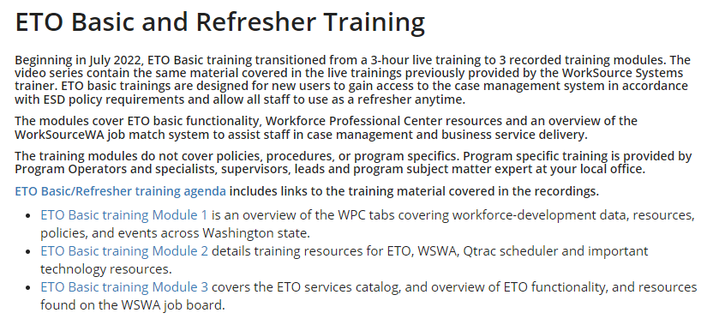
- Training issues/open discussion/ticket updates
  - WaTech is planning to update their SAW cert in production on July 27th @ 7:30 AM. This requires updating RAS at the same time so that when WaTech completes their cert update, claimants will still be able to login to the scheduler. It will take roughly 5 mins for the RAS deployment to complete. We will need to have staff out of the system by 7:30 as the system will not be accessible during the update.
    - Contact Shellie Dunning , RESEA Program Operator, at shellie.dunning@esd.wa.gov with additional questions
  - Current TAA program expired 6/30/22, but while we wait for congress to reauthorize the program, we can continue providing TAA services to eligible trade affected workers.
    - Customers already enrolled can continue to receive TAA program services
    - New customers? Check out the 30-minutes TAA Program Overview through the ESD Learning Center (not available for non-ESD staff).
    - To find out what services can be provided for a customer while they are waiting for TAA enrollment email the TAA team at esdgpwataa@esd.wa.gov
  - On July 16, 2022, Washington will join the rest of the United States in using the 988-dialing code — the new three-digit number for call, text, or chat that connects people to the existing National Suicide Prevention Lifeline (NSPL). People can dial 988 if they are having thoughts of suicide, mental health or substance use crises, or any other kind of emotional distress.
    - People can also dial 988 if they are worried about a loved one who may need crisis support. Prior to July 2022, NSPL crisis centers were accessed by calling 1-800-273-TALK (8255). This number will remain active during the transition to 988.
    - For more information about the 988 Suicide and Crisis Lifeline check out this website.
  - Employer login error message. Clearing cache usually resolves this issue. Incognito
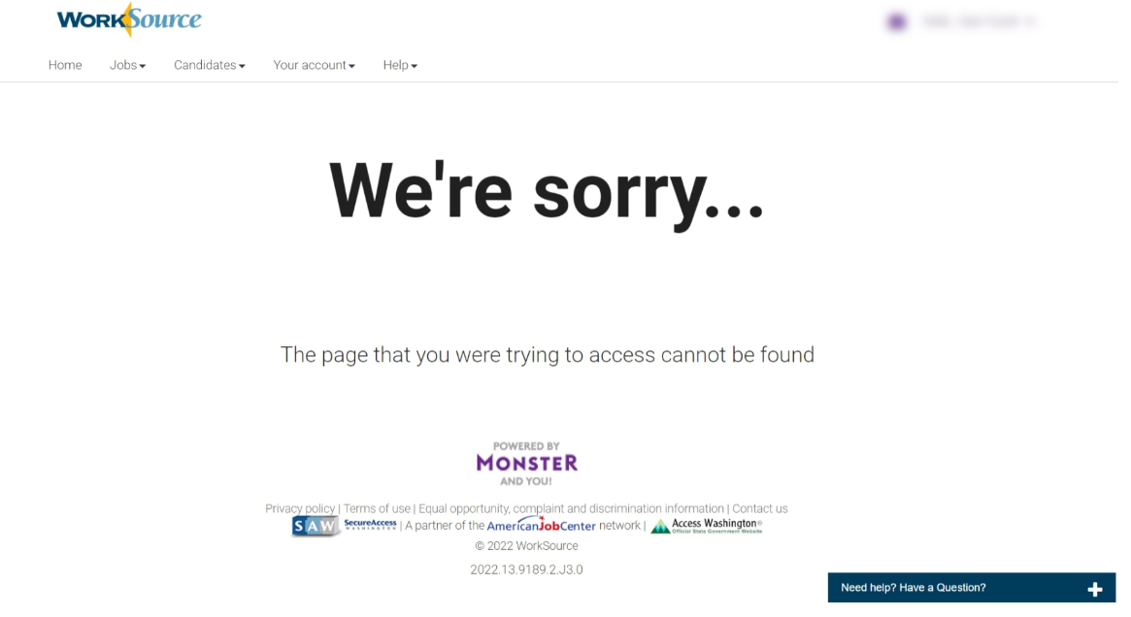
  - Correction from agenda WSWA job seekers, not employer, account issue when using mobile devices.
    - Live Chat agents work with job seekers who report issues when viewing accounts in portrait mode, so it is recommended switching to landscape view for the best experience.
    - Other issues are keyboard isn’t fully visible and can’t find the magnifying glass or triple line dropdown.
    - Reported issue on the user set up page is the ‘Live Chat’ box covers the ‘next’ button and the minimize button is difficult to find. We are reaching out to the vendor to see if we can resolve this.
  - WA-4426 Case Note report changed from portrait view to landscape view. However, this change removed the quick view (WA-4434) so staff must use the paging ability found in the bottom right-hand corner of the report. We are working with the vendor to have the quick view restored.
  - WA-4437 Missing elements when printing ‘Outcomes, Program Completion’ TP is a known bug. SSG has a fix and will notify us when they plan to push it out in a future release. Still waiting for the change date.
  - WA-4512 WorkSourceWA - 'Advanced Search' for job postings causes error. Waiting on Vendor for update
  - WIT replacement suggestions can be sent to the link at the bottom of this page on the WPC site: https://wpc.wa.gov/wswa/wit-replacement-project
- ETO Basic and Refresher Training - Moved from live training delivery to recorded videos
  - ETO basic /refresher training videos posted to WPC https://wpc.wa.gov/tech/ETO-refresher-training
  - Submit a remedy ticket to request additional training opportunities and resources
Old Business
- Employer fraud and impact to job seekers, leaving this here for awareness
  - Talk to your employers about including their ESR numbers (UI tax ID number) in the account creation. We cannot approve accounts with verifying this information or speaking with the employer.
  - Submit remedy ticket if job seekers report they have been contacted by fraudster. Gather and include as much information from the job seeker, text messages, screen shots from online interviews, ‘employer’ emails and phone numbers, etc.
  - Working on new process and changes to WSWA to warn job seekers about employer scams.
  - Direct job seekers to Washington State Office of the Attorney General for information on employment scams
  - Job seekers can contact the Attorney General’s office and file a complaint ‘Contact Us’
    - The AG’s office is now recommending job seekers and employers contact the FBI
    - Question raised during a previous call; Is this fraud to the point where we should be encouraging customers to keep their resumes and contact info private on WorkSourceWa.com?
      - That is a decision the job seeker needs to make for themselves. The WSWA website provides information about resumes, avoiding scams, terms of use and risks. Protect job seekers by advising them to not include DOB, SSN, street address and references in resumes. Some still do that! Ask them to review the employment scam information on the Attorney General’s web site.
    - Remember, job seekers can upload resumes on WSWA and can keep them private. The disadvantage to this is employers cannot do a resume match using key words.
    - Tip from the USAJOBS website
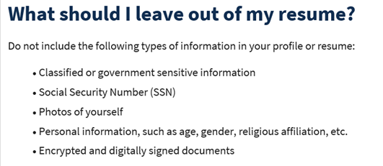
- Reminder: Submit remedy tickets for all work requests here. The WSS team cannot begin work without a service request. Reaching out to us directly can affect the time it takes to resolve your issue. Thanks!
  - Submitting remedy tickets – help us by providing enough details to work your issue. Suggestions help to speed up discovering and resolving the issue without lots of back-and-forth emails.
    - Include participant or employer name and case ID number
    - Screen shots include the entire screen, browser bar, not just a pinpoint of the TP that isn’t correct.
    - Screen shots of error messages
    - What you were doing when you got the ‘Robot’ or error message
    - Report tickets need the WDA, office and start and end dates parameters you used to run the problematic report ETO report issue can be caused by pop-up blocker.
      - Watch this quick video to help with the pop-up blocker issue
    - We will send you 2 emails asking for additional information. Second request for response will advise you the ticket will close in 24 hours.
  - Duplicate accounts and SSN correction tickets are a high priority, needing an immediate fix so staff can record services provided to customers timely. You can reach out to the service desk asking for a ticket status update here ESDDLITBITechnicalSolutions@ESD.WA.GOV or if you don’t receive a response within 24 hours from the WSS team about your ticket, email us at esdgpwssteam@esd.wa.gov so we can locate the ticket and start working on it.
  - Submit remedy ticket to update the WS locator with office closures, changes to office hours, contact information or location.
  - Remember if you suggest an enhancement at T12, submit a remedy ticket.
- Desk aid on things to try before submitting a remedy ticket; includes instructions for clearing your cache

Unemployment Insurance (UI) claim and data information can be found on the UI page here https://esd.wa.gov/

Chat
Employer login error message:
from Peabody, Deborah ESD to everyone: 10:09 AM
They can also sign-in with the Chrome Incognito Window
Discussion: If clear cache while on with Live Chat, lose them. Using Chrome Incognito doesn’t lose browser history; so they can clear their cache and not drop from the Live Chat.
from Ni Dufaigh, T. Jaide (ESD) to everyone: 10:15 AM
Could you please list those steps in the Chat?
from Peabody, Deborah ESD to everyone: 10:22 AM
#Error-Employer login unsuccessful: Staff: verify in ETO the recruiter account is active and you can impersonate the account.
If active, ask the employer to sign-in in through the Chrome Incognito Window (it doesn't use browser history).
If that works, and the employer would like to continue using their regular Chrome window, they'll need to clear their browser history before signing in because this website cannot load the employer dashboard from a cached page (former sign-in).

WSWA employer account issue when using mobile devices:
from Peabody, Deborah ESD to everyone: 10:10 AM
Employers don't usually connect via mobile phone or tablet, it's only Job Seekers
from Peabody, Deborah ESD to everyone: 10:11 AM
All three of those issues are Job Seeker related also.
from Peabody, Deborah ESD to everyone: 10:11 AM
That too, is a setup for a Job Seeker account, not an employer account.

EcSA program discussion:
from Luci Bench to everyone: 10:24 AM
State Funded
from Maidadi, Ismaila (ESD) to everyone: 10:25 AM
https://storemultisites.blob.core.windows.net/media/WPC/adm/policy/0129.pdf
from Maidadi, Ismaila (ESD) to everyone: 10:26 AM
I will bring it up to policy
from Luci Bench to everyone: 10:27 AM
Thank you Ish!
from Natalya - Workforce Snohomish to everyone: 10:27 AM
Thanks Ish!
from Luci Bench to everyone: 10:27 AM
i don't have access to that link, Ish
from Maidadi, Ismaila (ESD) to everyone: 10:27 AM
That was just the WIN link
from Luci Bench to everyone: 10:28 AM
Thank you
Response: If you can’t get the link Ish provided above to work, go to WPC.wa.gov and click on Policy, State Guidance and scroll down to WIN 0129.

Other:
from Natalya - Workforce Snohomish to everyone: 10:29 AM
For the WIOA Eligibility Application in ETO - could there be a clearer identifier for Basic vs WIOA.
Lynn: Please submit a remedy ticket for this ask

from Selam to everyone: 10:31 AM
Good idea Deborah. For the WIOA Eligibility Application in ETO - can we have something for WIOA Youth only.
Mary: Please submit a remedy ticket for this ask

Attendees

Aaron Pentland
Bair, Carya
Cascio, Jaclyn
Cauthron, Carol
Chase, Kim
Donna Hendrickson
Dorothy Rocha
Enwall, Jo Ann
Gillis, Deanna
Heidi Lamers
Holmes, Carolyn
Jessie Cardwell
Jordan, Irene
Kaiser, Deb
Kerns, Adeline
Lilia
Lolade Fapohunda
Luci Bench
Mack, Donna
Maidadi, Ismaila
Mark Chase
Maya Anderson
Natalya
Ni Dufaigh, T. Jaide
Ostergren, Pochi
Peabody, Deborah
Sally
Selam
Tamara Toles
Tracy Ferrell
Vey Damneun
Zander

