T12 Meeting Minutes 8-17-2022

Reminder: Mute your audio and disable the video feature after starting this Webex meeting. Too many attendee’s with active video can interfere with everyone’s audio quality. Hover over the lower edge of your monitor screen to find the icon and disable your video.

These meetings will be recorded and posted on the WPC site.
Please be advised your image will be captured and recorded during the video conference.
Your participation in this videoconference equals consent to be recorded as required by law.
New Business
- ETO maintenance – nothing this week
- WSWA maintenance – nothing this week
- Velaro maintenance – nothing this week
- Qtrac – nothing this week
- Tickets into production – nothing this week
- ETO report enhancement updates – nothing this week
- What’s new on WPC –
  - New ETO basic training agenda
  - Moving ETO training documents to the appropriate folders on this page
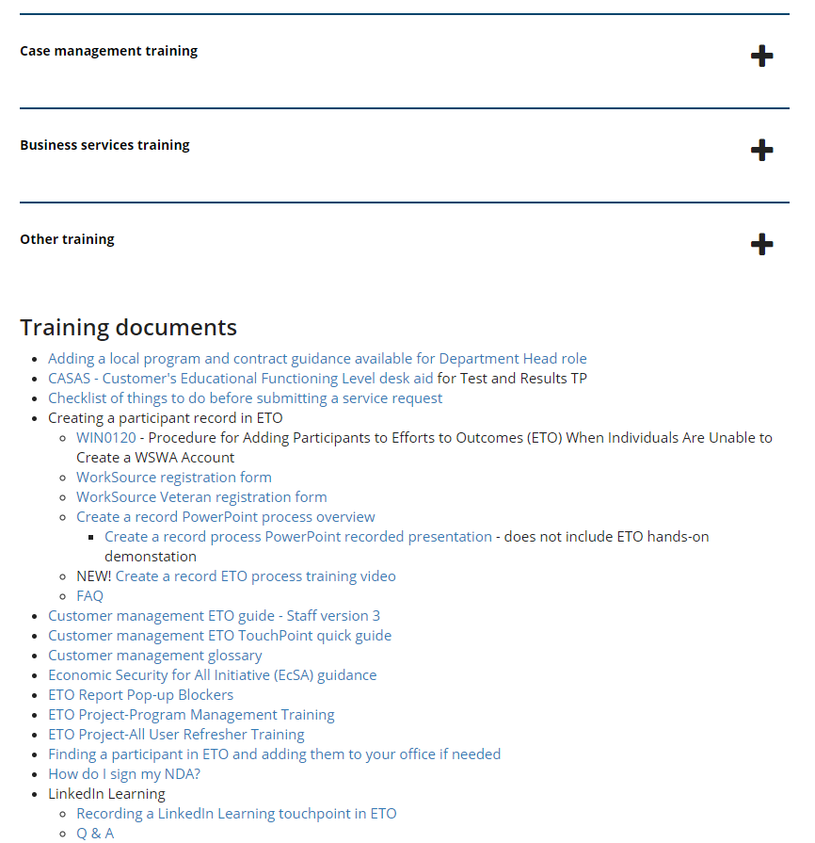
- Training issues /ticket updates
  - Training issue –
    - ETO reports; Always refresh ETO report menu before running reports. Failure to do so will produce and old version of the report and not provide the expected result.
    - ETO reports; pop-up blocker video
  - WA-4561 Resume search function for employers on WSWA has a 5-year expiration date and are instructed to call the Monster help desk @ 1-800-MONSTER to extend use.
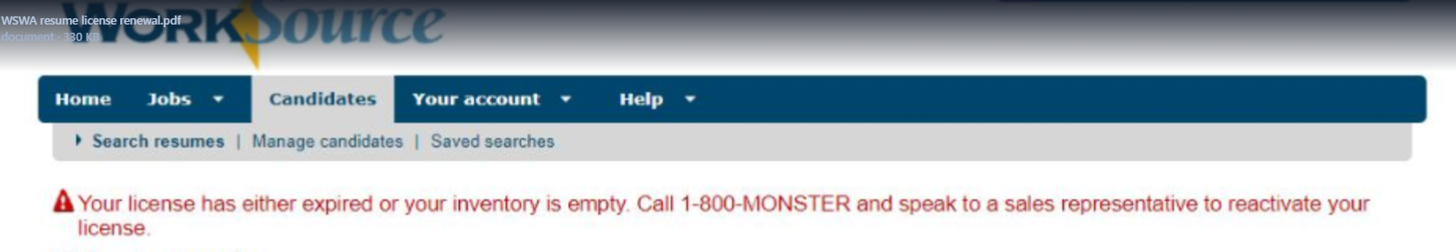
  - WA-4437 Missing elements when printing ‘Outcomes, Program Completion’ TP is a known bug. SSG has a fix and will notify us when they plan to push it out in a future release. Still in backlog, waiting on vendor for date
  - WA-4512 WorkSourceWA - 'Advanced Search' for job postings causes error. Work began 7/26/22. Projected go live pending.
- Announcements – nothing this week
- RESEA/RAS security update release improvements last night, Tuesday August 16^{th,} addressed security concerns from an audit.
  - If you notice changes with the system email RESEA Program Operator Shellie Dunning with concerns.
- Zoom is coming!
  - What is Zoom? Zoom is a cloud-based video conferencing service you can use to virtually meet with others by video, audio, or both while conducting live chats and it lets you record those sessions to view later.
  - Implementation is waiting on ensuring Zoom meets all ESD’s security requirements.
  - Prepare for Zoom by checking out their growing list of on-demand courses, live training and short videos found on the Zoom Learning Center
  - New Teams chat feature you can use this chat for drafts, to upload files and get comfortable with the features of Teams chat. Just remember there is a 7-day retention policy on content in chat
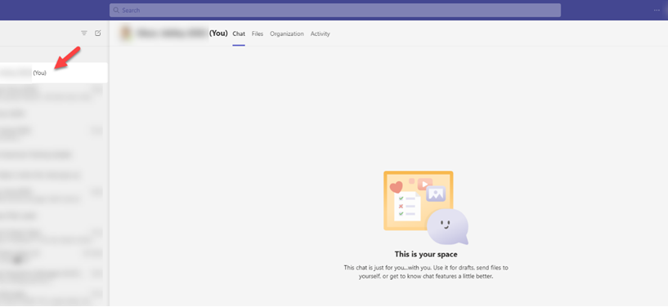
- Open discussion:
  - Ways to share T12 meeting information more broadly
    - Post minutes at office with co-workers who don’t attend weekly meetings
    - Discuss meeting content and extend invitation to co-workers at all staff meetings
- WIT replacement suggestions can be sent to the link at the bottom of this page on the WPC site: https://wpc.wa.gov/wswa/wit-replacement-project
Old Business
- ETO Basic and Refresher Training - Live training moved to recorded videos
  - ETO basic /refresher training videos posted to WPC https://wpc.wa.gov/tech/ETO-refresher-training
  - Submit a remedy ticket to request additional training opportunities and resources
- 988 is a new, easy-to-remember way to reach the National Suicide Prevention Lifeline (NSPL). It's confidential, free, and available 24/7/365. People calling or texting 988 will be connected to a trained crisis counselor.
- Employer fraud and impact to job seekers:
  - Talk to your employers about including their ESR numbers (UI tax ID number) in the account creation. We cannot approve accounts with verifying this information or speaking with the employer.
  - Submit remedy ticket if job seekers report they have been contacted by fraudster. Gather and include as much information from the job seeker, text messages, screen shots from online interviews, ‘employer’ emails and phone numbers, etc.
  - Working on new process and changes to WSWA to warn job seekers about employer scams.
  - Direct job seekers to Washington State Office of the Attorney General for information on employment scams
  - Job seekers can contact the Attorney General’s office and file a complaint ‘Contact Us’
    - The AG’s office is now recommending job seekers and employers contact the FBI
    - Question raised during a previous call; Is this fraud to the point where we should be encouraging customers to keep their resumes and contact info private on WorkSourceWa.com?
      - That is a decision the job seeker needs to make for themselves. The WSWA website provides information about resumes, avoiding scams, terms of use and risks. Protect job seekers by advising them to not include DOB, SSN, street address and references in resumes. Some still do that! Ask them to review the employment scam information on the Attorney General’s web site.
    - Remember, job seekers can upload resumes on WSWA and can keep them private. The disadvantage to this is employers cannot do a resume match using key words.
    - Tip from the USAJOBS website
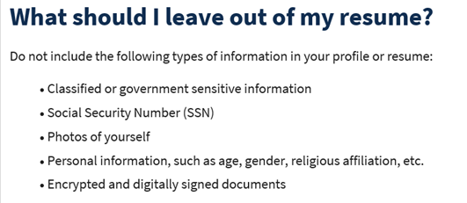
- Reminder: The WSS team cannot begin work without a service request. Reaching out to us directly can affect the time it takes to resolve your issue. Submit remedy tickets for all work requests here. Thanks!
  - Desk aid on things to try before submitting a remedy ticket; includes instructions for clearing your cache
  - Submitting remedy tickets – help us by providing enough details to work your issue. Suggestions help to speed up discovering and resolving the issue without lots of back-and-forth emails.
    - Include participant or employer name and case ID number
    - Screen shots include the entire screen, browser bar, not just a pinpoint of the TP that isn’t correct.
    - Screen shots of error messages
    - What you were doing when you got the ‘Robot’ or error message
    - Report tickets need the WDA, office and start and end dates parameters you used to run the problematic report ETO report issue can be caused by pop-up blocker.
      - Watch this quick pop-up blocker issue video
    - We will send you 2 emails asking for additional information. Second request for response will advise you the ticket will close in 24 hours.
  - Duplicate accounts and SSN correction tickets are a high priority, needing an immediate fix so staff can record services provided to customers timely. You can reach out to the service desk asking for a ticket status update here ESDDLITBITechnicalSolutions@ESD.WA.GOV or if you don’t receive a response within 24 hours from the WSS team about your ticket, email us at esdgpwssteam@esd.wa.gov so we can locate the ticket and start working on it.
  - Submit remedy ticket to update the WS locator with office closures, changes to office hours, contact information or location.
  - Remember if you suggest an enhancement at T12, submit a remedy ticket.

Unemployment Insurance (UI) claim and data information can be found on the UI page here https://esd.wa.gov/

Chat

Resume Search Function-
from CChesnut to everyone: 10:07 AM
Why does the employer need to call? The resume search license is a security and fraud prevention feature of WSWA and expires at the 5-year benchmark. Submit a remedy ticket if you are interested in changing the functionality of the resume search feature and we will forward it to our Intake and Analysis team for further review.

Zoom-
from Robbin to everyone: 10:10 AM
Lynn can you speak to why we are moving to Zoom and how will this impact the use of the WebEx boards that were installed during the pandemic? We reached out to the source ashley Olson, who said that Zoom was 100% customer driven, and partners had been asking as well throughout the pandemic. It’s just taken time to get the ball rolling on it.
from Cascio, Jaclyn (ESD) to everyone: 10:11 AM
I think they're looking at some ways those boards can be used to join meetings hosted in other platforms.
from Cascio, Jaclyn (ESD) to everyone: 10:14 AM
Here's a link from WebEx about using the boards with other applications: Thanks Jaclyn! https://hardware.webex.com/deployment/enable-other-meeting-platforms/#1939137436980697
from Cascio, Jaclyn (ESD) to everyone: 10:14 AM
(I'm sure IT Will figure out exactly how that will work for us... but it implies it's possible?)
from Abplanalp, Christopher T (ESD) to everyone: 10:15 AM
We are making the shift to Zoom because customers have asked for it. The ultimate goal would be to make Zoom the primary platform for customer interactions. How the rollout and transition will go is still a work in progress.

Process for moving staff from one office to another- Staff worked for a non-ESD partner and was hired by ESD. How do we transition their ETO account? When staff leave one agency to another their previous ETO account needs to be disabled and need a new ETO account associated with the new agency. Follow the process found on the WPC site and submit an ETO Add/Change form for the change. Staff do not need to retake ETO training again.

Attendees

Abplanalp, Christopher
Amanda Standley
Amesha Jewell
Aparicio, Rudy
Ariana Cordova
Ballinger, Charles
Cascio, Jaclyn
C Chesnut
Cerridwen Rodriguez
Cori-Ann Ching
Donna Hendrickson
Enwall, Jo Ann
Heidi Lamers
Holmes, Carolyn
Jessie Cardwell
Jordan, Irene
Kimberly Chase
Laura Anderson
Lilia
Linda Rowling
Luci Bench
Mack, Donna
Mark Chase
Maya Anderson
Natalya
Robbin
Sally
Selam
Sparks, Teresa
Susan Gustafson
Teresa Anda
Vey Damneun
Zander

