T12 Meeting Minutes 7-27-2022

Reminder: Mute your audio and disable the video feature after starting this Webex meeting. Too many attendee’s with active video can interfere with everyone’s audio quality. Hover over the lower edge of your monitor screen to find the icon and disable your video.

These meetings will be recorded and posted on the WPC site.
Please be advised your image will be captured and recorded during the video conference.
Your participation in this videoconference equals consent to be recorded as required by law.
New Business
- ETO maintenance – nothing this week
- WSWA maintenance – nothing this week
- Velaro maintenance – nothing this week
- Qtrac – nothing this week
- Tickets into production –
  - WA-4549 Correction to the message delivered at meeting. There was not a new service created but we added a service name column to the Review Seeker/Participant TouchPoints page for State Funded Services TP to easily see which TP was taken.
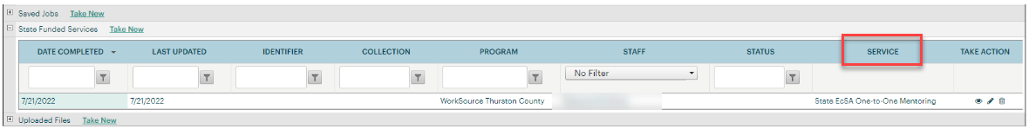
- ETO report enhancement updates – nothing this week
- RESEA/RAS texting solution
  - August 1, 2022, Employment Security Department’s RESEA program will be able to send claimants automated text message notifications through its appointment scheduler, RAS. The new feature will allow RAS to send templated notices and reminders to claimants who’ve been selected to participate in the program. More information was sent out to T12 on 7/25/22 including the attachments sent with today’s agenda.
  - For more information, email RESEA Program Operator Shellie Dunning.
- What’s new on WPC –
  - ETO training resources
  - RESEA
- Training issues /ticket updates
  - Training issue- Always refresh ETO report menu before running reports. Failure to do so will produce and old version of the report and not provide the expected result.
  - WA-4426 Case Note report changed from portrait view to landscape view. However, this change removed the quick view (WA-4434) so staff must use the paging ability found in the bottom right-hand corner of the report. Quick view has been restored. Still may have multiple pages but you can still scroll through with quick view. This happens when there are many case notes.
  - WA-4437 Missing elements when printing ‘Outcomes, Program Completion’ TP is a known bug. SSG has a fix and will notify us when they plan to push it out in a future release. Still in backlog, waiting on vendor for date
  - WA-4512 WorkSourceWA - 'Advanced Search' for job postings causes error. Work is in progress
- Announcements
  - WaTech updated their SAW certification in production July 27th @ 7:30 AM. This required updating RAS at the same time so that when the update is complete, claimants will still be able to login to the scheduler. The update took about 5 minutes and staff were instructed to not be in RAS at this time. No issues were reported.
    - Contact Shellie Dunning, RESEA Program Operator, to report issues or additional questions
  - EcSA State Funded Services – Policy’s answer to why the new EcSA services are not in the ‘Services Catalog’ and are currently found in WIN0129
    - There are unresolved questions from some local areas that need to be addressed before a decision can be made on the addition of the state EcSA services on the service catalog in a separate tab. The initial agreement was to have those services only in the WIN so not to confuse service delivery providers between the state EcSA (not reportable in the PIRL), and the federal EsCA (reportable in the PIR).
  - Zoom is coming!
    - What is Zoom? Zoom is a cloud-based video conferencing service you can use to virtually meet with others by video, audio, or both while conducting live chats and it lets you record those sessions to view later.
    - Implementation is waiting on ensuring Zoom meets all ESD’s security requirements.
    - Prepare for Zoom by checking out their growing list of on-demand courses, live training and short videos found on the Zoom Learning Center
  - New Teams chat feature you can use this chat for drafts, to upload files and get comfortable with the features of Teams chat. Just remember there is a 7-day retention policy on content in chat
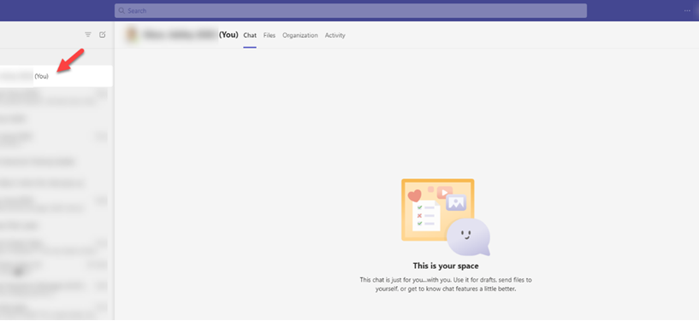
- Open discussion
- WIT replacement suggestions can be sent to the link at the bottom of this page on the WPC site: https://wpc.wa.gov/wswa/wit-replacement-project
- ETO Basic and Refresher Training - In July live training moved to recorded videos
  - ETO basic /refresher training videos posted to WPC https://wpc.wa.gov/tech/ETO-refresher-training
  - Submit a remedy ticket to request additional training opportunities and resources
- 988 is a new, easy-to-remember way to reach the National Suicide Prevention Lifeline (NSPL). It's confidential, free, and available 24/7/365. People calling or texting 988 will be connected to a trained crisis counselor.
Old Business
- Employer fraud and impact to job seekers, leaving this here for awareness
  - Talk to your employers about including their ESR numbers (UI tax ID number) in the account creation. We cannot approve accounts with verifying this information or speaking with the employer.
  - Submit remedy ticket if job seekers report they have been contacted by fraudster. Gather and include as much information from the job seeker, text messages, screen shots from online interviews, ‘employer’ emails and phone numbers, etc.
  - Working on new process and changes to WSWA to warn job seekers about employer scams.
  - Direct job seekers to Washington State Office of the Attorney General for information on employment scams
  - Job seekers can contact the Attorney General’s office and file a complaint ‘Contact Us’
    - The AG’s office is now recommending job seekers and employers contact the FBI
    - Question raised during a previous call; Is this fraud to the point where we should be encouraging customers to keep their resumes and contact info private on WorkSourceWa.com?
      - That is a decision the job seeker needs to make for themselves. The WSWA website provides information about resumes, avoiding scams, terms of use and risks. Protect job seekers by advising them to not include DOB, SSN, street address and references in resumes. Some still do that! Ask them to review the employment scam information on the Attorney General’s web site.
    - Remember, job seekers can upload resumes on WSWA and can keep them private. The disadvantage to this is employers cannot do a resume match using key words.
    - Tip from the USAJOBS website
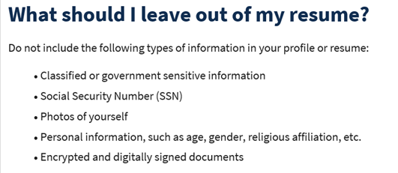
- Reminder: Submit remedy tickets for all work requests here. The WSS team cannot begin work without a service request. Reaching out to us directly can affect the time it takes to resolve your issue. Thanks!
  - Submitting remedy tickets – help us by providing enough details to work your issue. Suggestions help to speed up discovering and resolving the issue without lots of back-and-forth emails.
    - Include participant or employer name and case ID number
    - Screen shots include the entire screen, browser bar, not just a pinpoint of the TP that isn’t correct.
    - Screen shots of error messages
    - What you were doing when you got the ‘Robot’ or error message
    - Report tickets need the WDA, office and start and end dates parameters you used to run the problematic report ETO report issue can be caused by pop-up blocker.
      - Watch this quick video to help with the pop-up blocker issue
    - We will send you 2 emails asking for additional information. Second request for response will advise you the ticket will close in 24 hours.
  - Duplicate accounts and SSN correction tickets are a high priority, needing an immediate fix so staff can record services provided to customers timely. You can reach out to the service desk asking for a ticket status update here ESDDLITBITechnicalSolutions@ESD.WA.GOV or if you don’t receive a response within 24 hours from the WSS team about your ticket, email us at esdgpwssteam@esd.wa.gov so we can locate the ticket and start working on it.
  - Submit remedy ticket to update the WS locator with office closures, changes to office hours, contact information or location.
  - Remember if you suggest an enhancement at T12, submit a remedy ticket.
- Desk aid on things to try before submitting a remedy ticket; includes instructions for clearing your cache

Unemployment Insurance (UI) claim and data information can be found on the UI page here https://esd.wa.gov/

Chat
Services Provided discussion:
from private member to Lynn Aue: 10:21 AM
What service provided should we use for our client attending Post-Secondary Education in ETO for WIOA Youth out of School?
Mary: I’m working with Data Integrity and Policy on adding 2 new Postsecondary Education services. This is still in requirements gathering stages, and most likely won’t be implemented in ETO until mid- to end of August.
from Emily Anderson to everyone: 10:22 AM
I'd refer to the Service Catalog. There should be an option listed that fits there.
from Dorothy Rocha to everyone: 10:23 AM
We use the Occupational Skills Training (Youth Only) touchpoint.

From private member to Lynn Aue: Do you know why - Post Secondary Preparation and transition activities is not duration service in ETO? For questions about services it is always best to go to the Services Catalog and read the description. All services also include the WIOA Citation. Copy this section and add it to a browser search of the CFR for more information. Section 129 (c)(2)(K); 20 CFR 681.460 (a)(14); TEGL 21-16, Section 7, page 22

Note: Remember, there are 2 types of services, durational and transactional or point in time. Durational services have a start date and could have an end date the same as the start date or a date in the future. A transactional service has the same start and end date. Both types can trigger or extend Wagner Peyser or WIOA participation.

Attendees

Aparicio, Rudy
Ariana Cordova
Boylston, Eileen
Cauthron, Carol
Christopher File
Crews, Sandy
Dawn Oakes
Donna Hendrickson
Dorothy Rocha
Emily Anderson
Galvan, Ardriel
Heidi Lamers
Jessie Cardwell
Johnson, Kristi
Luci Bench
Mack, Donna
Martin, Monique
Metcalf, Kimberly
Natalya
Noll, Pamela
Ostergren, Pochi
Peabody, Deborah
Selam
Teresa Anda
Vey Damneun

