T12 Agenda – 1/10/2024
Reminder: Please mute your audio and disable the video feature after joining this Teams meeting. Too many attendees with active audio and video can interfere with everyone’s audio quality.
These meetings will be recorded and posted on the WPC site.
Please be advised your image will be captured and recorded during the video conference.
Your participation in this videoconference equals consent to be recorded as required by law.

New Business
Maintenance
- ETO maintenance - takes place on the 3rd weekend of every month; Saturday 6pm PT to Sunday at 3am PT
- Velaro maintenance - nothing this week
- WSWA maintenance - nothing this week

Enhancements & Training
- ETO/WSWA enhancement work - nothing this week
- Report enhancements
    - Individualized Training and Support Services TPs report - Add fields:
      - Date Created
      - Created by
      - Date entered
    - Veterans: Outreach Through UI
      - Was not pulling the correct data when entering search parameters; this has been fixed.
- What’s new on WPC – nothing this week
- Training issues
    - Printing RESEA Action Plans
      - When printing, use Microsoft Print to PDF 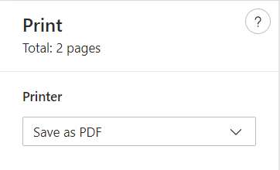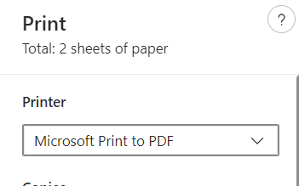

Service Requests
Ticket updates
- WA-4657: State Ecsa Participation script Bug
- Fix failed. Working with MGS on a path forward.
- WA-4865: Program enrollment Bug
- Program Enrollment touchpoint is not displaying the correct program of enrollment or a blank program of enrollment when viewing the touchpoint
- Still working with vendor to determine a fix, this is a high priority item.

New Grants awarded:
- NDWG: Opioid Crisis Grants (SW Washington and Spokane)
- New Programs of Enrollment tied to existing NDWG services
- Completed end of October and ready to use in ETO to honor the grant.
- Washington Commerce Interagency Agreement (ESSB5187) - Implementation planning is underway
- EcSa Community reinvestment implementation
- Part 2 – Creating and implementing a new Program of Enrollment strictly for Community reinvestment Fund (CRF) and adding five services to that will be tracked under the grant.
- PROWD – In discovery phase
October 4th - A new federal grant aims to help connect people exiting King County federal corrections custody with re-entry and employment services.
The Washington State Employment Security Department and the Workforce Development Council of Seattle-King County will receive more than $6.2 million from a four-year federal grant called Partners for Reentry Opportunities in Workforce Development (PROWD). The grant stems from a first-of-its-kind partnership between the U.S. Department of Labor, the U.S. Department of Justice, and the Federal Bureau of Prisons.

Open Discussion
- ETO Engage: has anyone experienced any issues?

Resources & Reminders
- ETO Basic and Refresher Training
  - ETO basic /refresher training videos posted to WPC https://wpc.wa.gov/tech/ETO-refresher-training
  - ETO basic training knowledge review test
  - Submit a remedy ticket by following the guidance in this desk aid if you would like training accounts for staff to use while taking the basic training course
  - Supervisors and trainers can request the ETO basic training knowledge review answer key by sending an email to esdgpwssteam@esd.wa.gov
  - Submit a remedy ticket to request additional training opportunities and resources

- Requesting ETO Training Accounts
  - A desk aid outlining how to request ETO training accounts has been posted to the WPC here: Workforce Professionals Center - ETO Training resources (wa.gov)
  - Here, also, is a direct link to the document:
    - https://storemultisites.blob.core.windows.net/media/WPC/tech/staff-resources/ETO-Requesting%20Training%20Accounts.pdf

- Submitting Remedy Service Requests
  - The WorkSource Systems Support (WSS) team cannot begin work without a service request ticket. Reaching out to individual staff directly, can affect the time it takes to resolve your issue. Please submit Remedy tickets for all work requests here. Thank you!
  - Review this Desk aid on things to try before submitting a Remedy ticket; includes instructions for clearing your cache.

