**T12 Meeting Minutes 9-14-2022**

**Reminder:** Mute your audio and disable the video feature after starting this Webex meeting. Too many attendee’s with active video can interfere with everyone’s audio quality. Hover over the lower edge of your monitor screen to find the icon and disable your video.



**These meetings will be recorded and posted on the WPC site.**

Please be advised your image will be captured and recorded during the video conference.

Your participation in this videoconference equals consent to be recorded as required by law.

**New Business**

* ETO maintenance – nothing this week
* WSWA maintenance – nothing this week
* Velaro maintenance – nothing this week
* Qtrac – nothing this week
* Tickets into production –
  + WA-4574 Deactivation of 2 services. This work will include updates to the Services Catalog and WIN0077. Changes will be in Training 9/7/22 and in production 9/14/22.

Change to basic service

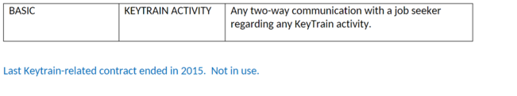

Change to follow-up service

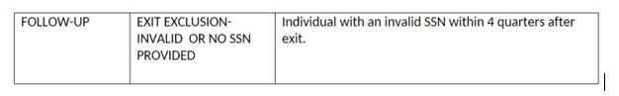

* ETO report enhancement updates – nothing this week
* What’s new on WPC – nothing this week
* Training issues /ticket updates
  + Training issue –
    - ETO reports; Always refresh ETO report menu before running reports. Failure to do so will produce and old version of the report and not provide the expected result.
    - ETO reports; [pop-up blocker video](https://storemultisites.blob.core.windows.net/media/WPC/tech/staff-resources/ETO-report-pop-up-blocker.docx)
  + WA-4437 Missing elements when printing ‘Outcomes, Program Completion’ TP is a known bug. SSG has a fix and will notify us when they plan to push it out in a future release. Still in backlog, waiting on vendor for date
  + WA-4554 Updates to ITSS and Follow-up TPs. The work going to production is yet to be determined, pending WS Advisory review and discussion on who will provide field training.

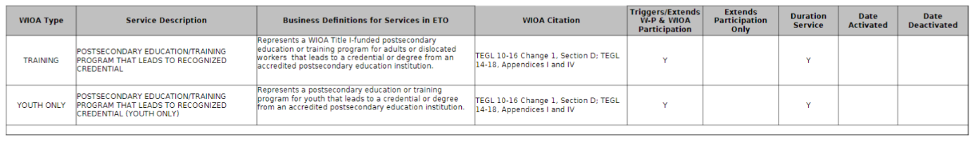

* Announcements –
  + [WIN0077(rev14)](https://storemultisites.blob.core.windows.net/media/WPC/adm/policy/0077-14.pdf) will include a new tab for the EcSA State Funded Services. The new Services Catalog will be published the morning of 9/15/22
* Coming soon! Zoom is a cloud-based video conferencing service you can use to virtually meet with others by video, audio, or both while conducting live chats and it lets you record those sessions to view later.
  + Implementation is waiting to ensure Zoom meets all ESD’s security requirements. Employment Connections is currently doing user testing.
  + ESD is in discussions with security and data privacy for access control.
  + We have started discussions with the vendor about training opportunities for staff.
  + Prepare for Zoom by checking out their growing list of on-demand courses, live training and short videos found on the [Zoom Learning Center](mailto:https://learning.zoom.us/learn)
* Open discussion:
  + 9/21/22 meeting is cancelled, we will resume meeting on 9/28/22
  + Submitting WS office changes
    - To request changes to the WorkSourceWA.com office locator, reach out to your local Brand and Media designee to begin that process. Not sure who your WDA Brand and Media designee is? Check out the [Brand Base Camp website.](https://worksourcebrandbasecamp.wa.gov/about/brandandmediagroup/contacts) (This information is also found under ‘Old business.’)
* Follow the WIT replacement project on the [WPC](https://wpc.wa.gov/wswa/wit-replacement-project). There is a [form](https://forms.office.com/g/i0Svkcfphx) at the bottom of the page where you can submit your suggestions.

**Old Business**

* ETO Basic and Refresher Training - Live training moved to recorded videos
  + ETO basic /refresher training videos posted to WPC <https://wpc.wa.gov/tech/ETO-refresher-training>
  + ETO basic training knowledge review [test](https://storemultisites.blob.core.windows.net/media/WPC/tech/staff-resources/ETO%20basic%20training%20knowledge%20review.docx)
  + Submit a remedy ticket to request additional training opportunities and resources
* 988 is a new, easy-to-remember way to reach the National Suicide Prevention Lifeline (NSPL). It's confidential, free, and available 24/7/365. People calling or texting 988 will be connected to a trained crisis counselor.
* Employer fraud and impact to job seekers:
  + Talk to your employers about including their ESR numbers (UI tax ID number) in the account creation. We cannot approve accounts with verifying this information or speaking with the employer.
  + Submit remedy ticket if job seekers report they have been contacted by fraudster. Gather and include as much information from the job seeker, text messages, screen shots from online interviews, ‘employer’ emails and phone numbers, etc.
  + Working on new process and changes to WSWA to warn job seekers about employer scams.
  + Direct job seekers to Washington State Office of the Attorney General for information on [employment scams](https://www.atg.wa.gov/search/node/employment%20scams)
  + Job seekers can contact the Attorney General’s office and file a complaint [‘Contact Us’](https://www.atg.wa.gov/)
    - The AG’s office is now recommending job seekers and employers contact the FBI
    - **Question raised during a previous call;** Is this fraud to the point where we should be encouraging customers to keep their resumes and contact info private on WorkSourceWa.com?
      * That is a decision the job seeker needs to make for themselves. The WSWA website provides information about resumes, avoiding scams, terms of use and risks. Protect job seekers by advising them to not include DOB, SSN, street address and references in resumes. Some still do that! Ask them to review the employment scam information on the Attorney General’s web site.
    - Remember, job seekers can upload resumes on WSWA and can keep them private. The disadvantage to this is employers cannot do a resume match using key words.
    - Tip from the USAJOBS website

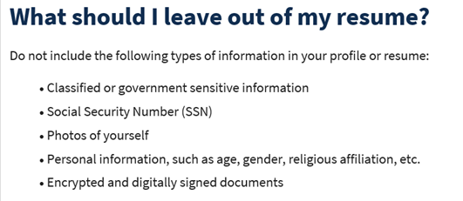

* ***Reminder:*** The WSS team cannot begin work without a service request. Reaching out to us directly can affect the time it takes to resolve your issue. Submit remedy tickets for all work requests [here](https://wpc.wa.gov/tech/issues). Thanks!
  + [Desk aid](https://storemultisites.blob.core.windows.net/media/WPC/tech/staff-resources/Checklist_of_things_to_try_before_submitting_a_service_ticket_or_call_the_help_desk_1-11-22.docx) on things to try before submitting a remedy ticket; includes instructions for clearing your cache
  + Submitting remedy tickets – help us by providing enough details to work your issue. Suggestions help to speed up discovering and resolving the issue without lots of back-and-forth emails.
    - Include participant or employer name and case ID number
    - Screen shots include the entire screen, browser bar, not just a pinpoint of the TP that isn’t correct.
    - Screen shots of error messages
    - What you were doing when you got the ‘Robot’ or error message
    - Report tickets need the WDA, office and start and end dates parameters you used to run the problematic reportETO report issue can be caused by pop-up blocker.
      * Watch this quick pop-up blocker issue [video](https://storemultisites.blob.core.windows.net/media/WPC/tech/staff-resources/ETO-report-pop-up-blocker.docx)
    - We will send you 2 emails asking for additional information. Second request for response will advise you the ticket will close in 24 hours.
  + Duplicate accounts and SSN correction tickets are a high priority, needing an immediate fix so staff can record services provided to customers timely. You can reach out to the service desk asking for a ticket status update here [ESDDLITBITechnicalSolutions@ESD.WA.GOV](mailto:ESDDLITBITechnicalSolutions@ESD.WA.GOV) or if you don’t receive a response within 24 hours from the WSS team about your ticket, email us at [esdgpwssteam@esd.wa.gov](mailto:esdgpwssteam@esd.wa.gov) so we can locate the ticket and start working on it.
  + To request changes to the WorkSourceWA.com office locator, reach out to your local Brand and Media designee to begin that process. Not sure who your WDA Brand and Media designee is? Check out the [Brand Base Camp website.](https://worksourcebrandbasecamp.wa.gov/about/brandandmediagroup/contacts)
  + Remember if you suggest an enhancement at T12, submit a remedy ticket.

**Unemployment Insurance** (UI) claim and data information can be found on the UI page here <https://esd.wa.gov/>

**EcSA**

*from Linda Rowling to everyone: 10:08 AM*

State EcSA services will be added to the catalogue - will they also now be able to be pulled to a report?

*from MacLennan, Mary (ESD) to everyone: 10:08 AM*

@Linda - I've had a request to add that report. Once we get the remedy ticket submitted, to include all the data elements, we will start working to get that report built out.

*from Linda Rowling to everyone: 10:10 AM*

great - thanks Mary. Really looking forward to that report :)

*from MacLennan, Mary (ESD) to everyone: 10:11 AM*

It wasn't a part of the initial roll-out of EcSA; however I think so many people asked for a report, so hopefully it will be available soon.

**Question:** Teresa Anda – don’t State EcSA services already pull into the reports?

No, these services are recorded on a new TouchPoint, so they do not display on any existing reports.

*from Linda Rowling to everyone: 10:19 AM*

EcSA 2 services pull to the services report but not the State EcSA services

**WSWA Locator**

*from Mack, Donna R ESD to everyone: 10:12 AM*

Constant concern for WSWA. It is difficult to keep contacts updated in the website timely.

*from MacLennan, Mary (ESD) to everyone: 10:13 AM*

@Donna - I agree...I noticed some areas are starting to use generic emails instead of individual staff emails. I thought that was a great idea!

**Attendees**

Amanda Standley

Amesha Jewell

Ariana Cordova

Cascio, Jaclyn

Cerridwen Rodriguez

Christopher Abplanalp

Clark, Andrea

Cori-Ann Ching

Donna Hendrickson

Dorothy Rocha

Emily Anderson

Enwall, Jo Ann

File, Christopher

Heather Brink

Heidi Lamers

Holmes, Carolyn

Jack Dryden

Jessie Cardwell

Kelly Dawson

Kerns, Adeline

Lilia

Linda Rowling

Mack, Donna

Maya Anderson

Ni Dufaigh, T. Jaide

Ostergren, Pochi

Selam

Shawna

Sue Keltner

Tamara Toles

Teresa Anda

Tim Robison

Tina Newcomer

Vey Damneun

Young, Carol

Zander