T12 Meeting Minutes 7-13-2022

Reminder: Mute your audio and disable the video feature after starting this Webex meeting. Too many attendee’s with active video can interfere with everyone’s audio quality. Hover over the lower edge of your monitor screen to find the icon and disable your video.

These meetings will be recorded and posted on the WPC site.
Please be advised your image will be captured and recorded during the video conference.
Your participation in this videoconference equals consent to be recorded as required by law.
New Business
- ETO maintenance – nothing this week
- WSWA maintenance – nothing this week
- Velaro maintenance – nothing this week
- Qtrac – nothing this week
- Tickets into production – nothing this week
- ETO report enhancement updates – nothing this week
- What’s new on WPC – ETO basic training videos
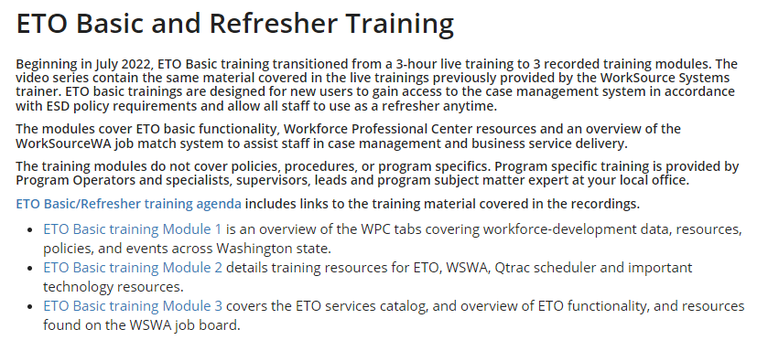
- Training issues/open discussion/ticket updates
  - Changes to training environment and training accounts – email sent via ETO messaging today:
    - July 6, 2022, The ETO Training environment was unavailable while the configuration is restored from Production and various test accounts are brought over. The Training environment no longer has real job seeker data in it for security purposes. Over the years, as we’ve implemented various changes in ETO, the changes were first built in the Training environment. However, not all of these changes were implemented in Production or backed out of the Training environment. For that reason, our Training and Production environments have become out of sync. The configuration effort to realign our training and Production environments will provide a better, more accurate training experience for staff, while increasing security of job seeker data by keeping it out of the Training environment.
    - The WorkSource System Support team recently worked with our vendor, Social Solutions Global, to realign the configuration between our Training and Production environments. If you currently have staff who are using Training accounts via an open Remedy ticket, we reached out to you with updated information upon successful completion of the alignment. If you need a Training account issued for staff who are scheduled to onboard, this will not interrupt our current process. Submit a service request ticket through the ESD Technical Support Service Desk Request Online or email this Service Request Form indicating how many accounts you need, and the dates you need them to be available.
  - WIN0129 Implemented on June 29, 2022, communicates guidance and instructions for the State Economic Security for All (EcSA) program that is supported by State General Funds (as distinct from federal EcSA funded by WIOA Title I Governor’s statewide activities funds).
    - Please email questions to Employment System Administration and Policy.
    - If you know of someone who would appreciate receiving future policies like this, please forward so they can subscribe to our bulletins.
    - Note: State Funded Services TP is now fully functional in the training environment
  - WA4-4531 Update the "Homeless Veteran Reintegration Program" touch point to reflect PY2022 grant numbers.
  - WA-4461 WorkSourceWA career profile tool error. Issue resolved
  - WA-4426 Case Note report changed from portrait view to landscape view. However, this change removed the quick view (WA-4434) so staff must use the paging ability found in the bottom right-hand corner of the report. We are working with the vendor to have the quick view restored.
  - WA-4437 Missing elements when printing ‘Outcomes, Program Completion’ TP is a known bug. SSG has a fix and will notify us when they plan to push it out in a future release. Still waiting for the change date.
  - WA-4512 WorkSourceWA - 'Advanced Search' for job postings causes error. Waiting on Vendor for update
  - WIT replacement suggestions can be sent to the link at the bottom of this page on the WPC site: https://wpc.wa.gov/wswa/wit-replacement-project
- ETO Basic and Refresher Training - Moved from live trainings to recorded videos
  - ETO basic /refresher training videos posted to WPC https://wpc.wa.gov/tech/ETO-refresher-training
  - Submit a remedy ticket to request additional training opportunities and resources
Old Business
- Employer fraud and impact to job seekers, leaving this here for awareness
  - Talk to your employers about including their ESR numbers (UI tax ID number) in the account creation. We cannot approve accounts with verifying this information or speaking with the employer.
  - Submit remedy ticket if job seekers report they have been contacted by fraudster. Gather and include as much information from the job seeker, text messages, screen shots from online interviews, ‘employer’ emails and phone numbers, etc.
  - Working on new process and changes to WSWA to warn job seekers about employer scams.
  - Direct job seekers to Washington State Office of the Attorney General for information on employment scams
  - Job seekers can contact the Attorney General’s office and file a complaint ‘Contact Us’
    - The AG’s office is now recommending job seekers and employers contact the FBI
    - Question raised during a previous call; Is this fraud to the point where we should be encouraging customers to keep their resumes and contact info private on WorkSourceWa.com?
      - That is a decision the job seeker needs to make for themselves. The WSWA website provides information about resumes, avoiding scams, terms of use and risks. Protect job seekers by advising them to not include DOB, SSN, street address and references in resumes. Some still do that! Ask them to review the employment scam information on the Attorney General’s web site.
    - Remember, job seekers can upload resumes on WSWA and can keep them private. The disadvantage to this is employers cannot do a resume match using key words.
    - Tip from the USAJOBS website
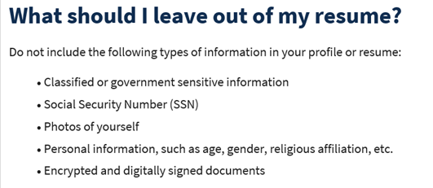
- Reminder: Submit remedy tickets for all work requests here. The WSS team cannot begin work without a service request. Reaching out to us directly can affect the time it takes to resolve your issue. Thanks!
  - Submitting remedy tickets – help us by providing enough details to work your issue. Suggestions help to speed up discovering and resolving the issue without lots of back-and-forth emails.
    - Include participant or employer name and case ID number
    - Screen shots include the entire screen, browser bar, not just a pinpoint of the TP that isn’t correct.
    - Screen shots of error messages
    - What you were doing when you got the ‘Robot’ or error message
    - Report tickets need the WDA, office and start and end dates parameters you used to run the problematic report ETO report issue can be caused by pop-up blocker.
      - Watch this quick video to help with the pop-up blocker issue
    - We will send you 2 emails asking for additional information. Second request for response will advise you the ticket will close in 24 hours.
  - Duplicate accounts and SSN correction tickets are a high priority, needing an immediate fix so staff can record services provided to customers timely. You can reach out to the service desk asking for a ticket status update here ESDDLITBITechnicalSolutions@ESD.WA.GOV or if you don’t receive a response within 24 hours from the WSS team about your ticket, email us at esdgpwssteam@esd.wa.gov so we can locate the ticket and start working on it.
  - Submit remedy ticket to update the WS locator with office closures, changes to office hours, contact information or location.
  - Remember if you suggest an enhancement at T12, submit a remedy ticket.
- Desk aid on things to try before submitting a remedy ticket; includes instructions for clearing your cache

Unemployment Insurance (UI) claim and data information can be found on the UI page here https://esd.wa.gov/

Chat
from Olson, Ashley (ESD) to everyone: 10:24 AM For ESD staff with access to InsideESD you can see this page for more info on the transition from IE to Edge/Chrome: http://insideesd/divisions/ie-sunset After June 8, 2022 it is suggested you contact the Technical Solutions service desk for help with locating your favorites that weren’t imported into Edge before IE sunset.
from Movsesyan, Elina (ESD) to everyone: 10:24 AM I really appreciate these ongoing training calls. If I am not able to attend the particular training meeting, I always can join you at a later date. I hope you will continue these excellent training sessions. I appreciate the compliment and the calls are going to continue until there is no value in them. I appreciate all of you for your willingness to contribute and support each other during these calls! You can find the minutes and the meeting recording on the WPC site under T12 documents
from Ni Dufaigh, T. Jaide (ESD) to everyone: 10:24 AM Just to clarify - earlier today, you asked for an email regarding Business Services. Would you like that redirected to the group link? I am going to start creating new business services training videos. I am looking for suggestions on what the field would like to see in the videos. Please send suggestions either to the team email box or directly to me @ lynn.aue@esd.wa.gov Thanks!
from Movsesyan, Elina (ESD) to everyone: 10:25 AM Thank you so much, Ashley, for your quick response!
from Maya Anderson to everyone: 10:27 AM Has the issue with saving certain touchpoints been resolved? In June there was an issue saving TPs because the system wanted you to change the service date to the date you were making the save. That issue was resolved on June 23, 2022. If there are other TPs you are not able to save, submit a remedy ticket and we will review it.
Deb from Live Chat: When will the Advanced Search problem in WSWA be resolved? from MacLennan, Mary (ESD) to everyone: 10:30 AM We do have an open ticket for the Advanced Search problem, but still no date on resolution.
I have asked for an update from the vendor.

Attendees

Abplanalp, Christopher
B Oliveri
Cancel, Regina
Chase, Kim
Dawn Oakes
Donna Hendrickson
Gillis, Deanna
Heather Brink
Heidi Lamers
Holmes, Carolyn
Hudgens, Sheila
Jordan, Irene
Kerns, Adeline
Laura Anderson
Lilia
Luci Bench
Maya Anderson
Movsesyan, Elina
Ni Dufaigh, T. Jaide
Olson, Ashley
Peabody, Deborah
Sally
Susan Gustafson
Tamara Toles
Tracy Ferrell
Vey Damneun
Zander

