T12 Meeting Minutes 6/22/2022

Reminder: Mute your audio and disable the video feature after starting this Webex meeting. Too many attendee’s with active video can interfere with everyone’s audio quality. Hover over the lower edge of your monitor screen to find the icon and disable your video.

These meetings will be recorded and posted on the WPC site.
Please be advised your image will be captured and recorded during the video conference.
Your participation in this videoconference equals consent to be recorded as required by law.
New Business
- ETO maintenance – nothing this week
- WSWA maintenance – nothing this week
- Velaro maintenance – nothing this week
- Qtrac – nothing this week
- Tickets into production –
  - WA-4514 Taking touchpoints in ETO (whether new or previously saved) that are dated as before or after the current calendar date are not able to be saved. This is affecting several touchpoints in ETO, including the WIOA Eligibility Application, TAA Training Forms, and more. This is a widespread issue caused by recent ETO maintenance. We are actively working with the vendor in correcting this issue and will let you all know when this is corrected via an ETO message.

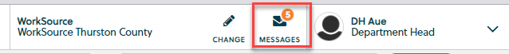

- ETO report enhancement updates – nothing this week.
- What’s new on WPC – video update coming this week
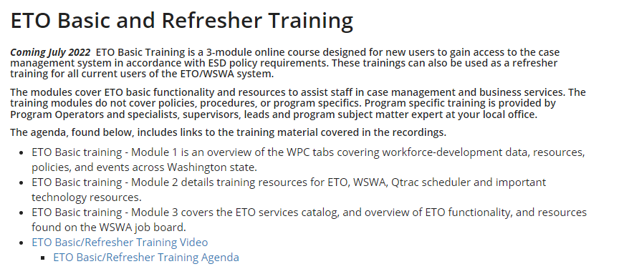
- Training issues/open discussion/ticket updates
  - T12 cancelled next week 6/29/22, no meeting 7/6/22 but will resume meetings 7/13/22. Next quarter meeting invite will be sent out this week.
  - WIT replacement suggestions can be sent to the link at the bottom of this page on the WPC site: https://wpc.wa.gov/wswa/wit-replacement-project
  - WA-4465 We received a ticket concerning the WSWA Qtrac scheduler isn’t working as expected and WorkSource Office Locator drop-down menus are sometimes missing when using Chrome. The issue is resolved by clearing the cache. I submitted a ticket asking the vendor why the issue is resolved by clearing cache and could be caused by a system update. Issue under review.
  - WA-4426 Recently we made enhancements to the Case Note reports by adding the ‘Identifier’ column. This change made columns so narrow it caused the PDF to be more pages. We are asking if the report can be changed from portrait view to landscape view to resolve this issue but now there is an issue with ‘white space’ or all the note areas are the same size to the note with the largest amount of text. Nothing to report this week but continue to use these workarounds:
    - Tip: If you export to report to Excel, you can change the row height to remove the white space.
    - When printing to PDF, ‘uncheck’ Report 2 (the query logic), so you won’t get the query logic pages within their PDF and this shortens the length of the report
    - There is an issue with the left-side navigation window causing the report not to run, time out. To resolve this issue, close the left-side navigation window.
      - During this testing we discovered this is an issue with the Case Note History widget and at time causing this report to time out. The widget does not allow you to close out the left-side navigation window so you will need to run the Case not history report starting form the report menu.
  - WA-4437 Missing elements when printing ‘Outcomes, Program Completion’ TP is a known bug. SSG has a fix and will notify us when they plan to push it out in a future release. Still waiting for the change date

- ETO Basic and Refresher Training - Is moving to recorded videos
  - Updated video training will be posted to WPC soon
  - Refresher training recordings and user guides are posted on the WPC website here https://wpc.wa.gov/tech/ETO-refresher-training
  - Submit a remedy ticket to request additional training opportunities and resources
Old Business
- Employer fraud and impact to job seekers, leaving this here for awareness
  - Talk to your employers about including their ESR numbers (UI tax ID number) in the account creation. We cannot approve accounts with verifying this information or speaking with the employer.
  - Submit remedy ticket if job seekers report they have been contacted by fraudster. Gather and include as much information from the job seeker, text messages, screen shots from online interviews, ‘employer’ emails and phone numbers, etc.
  - Working on new process and changes to WSWA to warn job seekers about employer scams.
  - Direct job seekers to Washington State Office of the Attorney General for information on employment scams
  - Job seekers can contact the Attorney General’s office and file a complaint ‘Contact Us’
    - The AG’s office is now recommending job seekers and employers contact the FBI
    - Question raised during a previous call; Is this fraud to the point where we should be encouraging customers to keep their resumes and contact info private on WorkSourceWa.com?
      - That is a decision the job seeker needs to make for themselves. The WSWA website provides information about resumes, avoiding scams, terms of use and risks. Protect job seekers by advising them to not include DOB, SSN, street address and references in resumes. Some still do that! Ask them to review the employment scam information on the Attorney General’s web site.
    - Remember, job seekers can upload resumes on WSWA and can keep them private. The disadvantage to this is employers cannot do a resume match using key words.
    - Tip from the USAJOBS website
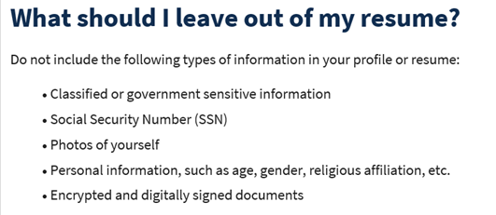
- Reminder: Submit remedy tickets for all work requests here. The WSS team cannot begin work without a service request. Reaching out to us directly can affect the time it takes to resolve your issue. Thanks!
  - Submitting remedy tickets – help us by providing enough details to work your issue. Suggestions help to speed up discovering and resolving the issue without lots of back-and-forth emails.
    - Include participant or employer name and case ID number
    - Screen shots include the entire screen, browser bar, not just a pinpoint of the TP that isn’t correct.
    - Screen shots of error messages
    - What you were doing when you got the ‘Robot’ or error message
    - Report tickets need the WDA, office and start and end dates parameters you used to run the problematic report ETO report issue can be caused by pop-up blocker.
      - Watch this quick video to help with the pop-up blocker issue
    - We will send you 2 emails asking for additional information. Second request for response will advise you the ticket will close in 24 hours.
  - Duplicate accounts and SSN correction tickets are a high priority, needing an immediate fix so staff can record services provided to customers timely. You can reach out to the service desk asking for a ticket status update here ESDDLITBITechnicalSolutions@ESD.WA.GOV or if you don’t receive a response within 24 hours from the WSS team about your ticket, email us at esdgpwssteam@esd.wa.gov so we can locate the ticket and start working on it.
  - Submit remedy ticket to update the WS locator with office closures, changes to office hours, contact information or location.
  - Remember if you suggest an enhancement at T12, submit a remedy ticket.
- Desk aid on things to try before submitting a remedy ticket; includes instructions for clearing your cache

Unemployment Insurance (UI) claim and data information can be found on the UI page here https://esd.wa.gov/

Chat
from Maricha Friedman to everyone: 10:09 AM
Question, and please point me to the appropriate training resource that shows this if it's in there, but how do I add a new business entity to record a service (not job match)? The business is not in ETO.
from Lynn: Unable to manually add employers in ETO, direct them to create WSWA account. Maricha will reach out to Business Solutions member to ask direction how they accomplish this.
from Dorothy Rocha to everyone: 10:15 AM
Maybe a certificate of completion at the end? They need to go through entire series to get to the certificate that maybe they can email to themselves…???
from MacLennan, Mary (ESD) to everyone: 10:17 AM
@Dorothy - I think the complication is that there is no way of knowing they watched all 3 videos.

Attendees

Aaron Pentland
Abplanalp, Christopher
Aparicio, Rudy
Dawn Oakes
Dawn Plante
Donna Hendrickson
Dorothy Rocha
Frost, Jennifer
Gillis, Deanna
Heidi Lamers
Holme, Teri
Holmes, Carolyn
Ismaila Maidadi
Jordan, Irene
Kendall King
Linda Rowling
Lolade Fapohunda
Lux Dmitri
Maricha Friedman
Mariya Kazantseva
Maya Anderson
Oliveri, Brett
Ostergren, Pochi
Raeleene Rodriguez
Selam
Soto, Raul
Teresa Anda
Tracy Ferrell
Vey Damneun
Zander

