T12 Meeting Minutes 6/1/2022

Reminder: Mute your audio and disable the video feature after starting this Webex meeting. Too many attendee’s with active video can interfere with everyone’s audio quality. Hover over the lower edge of your monitor screen to find the icon and disable your video.

These meetings will be recorded and posted on the WPC site.
Please be advised your image will be captured and recorded during the video conference.
Your participation in this videoconference equals consent to be recorded as required by law.
New Business
- ETO maintenance – nothing this week
- WSWA maintenance – nothing this week
- Velaro maintenance – nothing this week
- Qtrac – nothing this week
- Tickets into production – nothing this week
- ETO report enhancement updates – nothing this week.
- What’s new on WPC – nothing this week
- Training issues/open discussion/ticket updates
  - On June 8 at 5 p.m., the Internet Explorer web browser is going away. Microsoft will no longer support Internet Explorer anywhere. (For those of you who are history buffs, Internet Explorer made its debut in 1995 as Microsoft’s first web browser.)
    - If you are not using Internet Explorer as your default browser, you don’t need to do anything.
    - Internet Explorer is being replaced by Edge. However, both Chrome and Firefox web browsers will also still be available to use.
    - Most ESD systems, sites and applications do not rely on Internet Explorer. If there are any, we have Information Technology Services Division staff working to make sure there are no disruptions.
The icon for the Edge web browser is
    - Desk aids for IE change
      - How to reset your default browser
      - Move your favorites
  - ETO Basic Training will continue June 6th and 21st
  - WIT replacement suggestions—use the link at the bottom of this page on the WPC site: https://wpc.wa.gov/wswa/wit-replacement-project
  - Chrome users experience more issues running ETO reports because clearing your cache removes your favorites. Check out this short video on how to resolve this before submitting a remedy ticket.
  - WA-4488 Interface 19 was not updating TAA obligations. The files are updated, and we are looking at the root cause and updating the PIRL. Issue has been resolved; ticket closed
  - WA-4338 RESEA Required Elements TP – There is a reported dashboard issue caused by the type of file uploaded to the parent TP. The .msg file type caused the issue. Issue has been resolved; ticket closed
  - WA-4438 Known issue with some participants RESEA dashboard not accessible to some users. Trying to determine if this is a dashboard bug. The TP is functioning as designed. In order to record the child response the users will need access to the program where the parent response was recorded, and it will need to be recorded in that same office. We will need to work out a solution with the RESEA team.
    - Ex: You were logged into WS Yakima when you created the TPs. You also work in WS Sunnyside and have access to that office. When you are logged into WS Sunnyside you will not have the ability to edit the TP because it was created in WS Yakima.
  - WA-4454 RESEA Required Elements Initial Response form not printing correctly. Issue has been resolved; ticket closed
  - WA-4465 We received a ticket concerning that the WSWA Qtrac scheduler and WorkSource Office Locator don’t work correctly using IE browser. On the locater the drop-down menus are missing. Talking with live chat agents it was discovered this also is occurring when using Chrome. The issue is resolved by clearing the cache. I will be submitting a ticket asking why the sudden issue is resolved by clearing cache. Issue under review.
  - WA-4426 Recently we made enhancements to the Case Note reports by adding the ‘Identifier’ column. This change made columns so narrow it caused the PDF to be more pages. We are asking if the report can be changed from portrait view to landscape view to resolve this issue but now there is an issue with ‘white space’ or all the note areas are the same size to the note with the largest amount of text. Nothing to report this week but continue to use these workarounds:
    - Tip: If you export to report to Excel, you can change the row height to remove the white space.
    - When printing to PDF, ‘uncheck’ Report 2 (the query logic), so you won’t get the query logic pages within their PDF and this shortens the length of the report
    - There is an issue with the left-side navigation window causing the report not to run, time out. To resolve this issue, close the left-side navigation window.
      - During this testing we discovered this is an issue with the Case Note History widget and at time causing this report to time out. The widget does not allow you to close out the left-side navigation window so you will need to run the Case not history report starting form the report menu.
  - WA-4437 Missing elements when printing ‘Outcomes, Program Completion’ TP is a known bug. SSG has a fix and will notify us when they plan to push it out in a future release. Still waiting for the change date

- ETO Basic and Refresher Training - Next training is 6/6/22 9-12
  - ETO Basic training is the 1st Monday 9:00-12 and 3rd Tuesday 1:30-4:30 of every month (except holidays). Send email to Lynn Aue to receive more information, get a training account if needed and be added to the training Webex call. All ETO/WSWA system users are welcome to attend the training but please do not forward invites as I need to review all attendees and assign training accounts if needed.
  - Refresher training recordings and user guides are posted on the WPC website here https://wpc.wa.gov/tech/ETO-refresher-training
  - Submit a remedy ticket to request additional training opportunities and resources
Old Business
- Employer fraud and impact to job seekers, leaving this here for awareness
  - Talk to your employers about including their ESR numbers (UI tax ID number) in the account creation. We cannot approve accounts with verifying this information or speaking with the employer.
  - Submit remedy ticket if job seekers report they have been contacted by fraudster. Gather and include as much information from the job seeker, text messages, screen shots from online interviews, ‘employer’ emails and phone numbers, etc.
  - Working on new process and changes to WSWA to warn job seekers about employer scams.
  - Direct job seekers to Washington State Office of the Attorney General for information on employment scams
  - Job seekers can contact the Attorney General’s office and file a complaint ‘Contact Us’
    - The AG’s office is now recommending job seekers and employers contact the FBI
    - Question raised during a previous call; Is this fraud to the point where we should be encouraging customers to keep their resumes and contact info private on WorkSourceWa.com?
      - That is a decision the job seeker needs to make for themselves. The WSWA website provides information about resumes, avoiding scams, terms of use and risks. Protect job seekers by advising them to not include DOB, SSN, street address and references in resumes. Some still do that! Ask them to review the employment scam information on the Attorney General’s web site.
    - Remember, job seekers can upload resumes on WSWA and can keep them private. The disadvantage to this is employers cannot do a resume match using key words.
    - Tip from the USAJOBS website
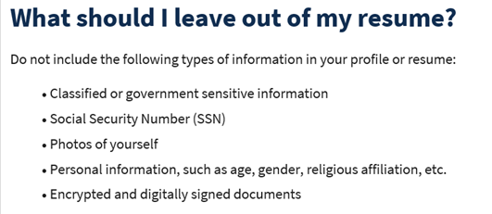
- Reminder: Submit remedy tickets for all work requests here. The WSS team cannot begin work without a service request. Reaching out to us directly can affect the time it takes to resolve your issue. Thanks!
  - Submitting remedy tickets – help us by providing enough details to work your issue. Suggestions help to speed up discovering and resolving the issue without lots of back-and-forth emails.
    - Screen shots include the entire screen, browser bar, not just a pinpoint of the TP that isn’t correct.
    - Screen shots of error messages
    - What you were doing when you got the ‘Robot’ or error message
    - Report tickets need the WDA, office and start and end dates parameters you used to run the problematic report
    - We will send you 2 emails asking for additional information. Second request for response will advise you the ticket will close in 24 hours.
  - Duplicate accounts and SSN correction tickets are a high priority, needing an immediate fix so staff can record services provided to customers timely. You can reach out to the service desk asking for a ticket status update here ESDDLITBITechnicalSolutions@ESD.WA.GOV or if you don’t receive a response within 24 hours from the WSS team about your ticket, email us at esdgpwssteam@esd.wa.gov so we can locate the ticket and start working on it.
  - Submit remedy ticket to update the WS locator with office closures, changes to office hours, contact information or location.
  - Remember if you suggest an enhancement at T12, submit a remedy ticket.
- Desk aid on things to try before submitting a remedy ticket; includes instructions for clearing your cache
- Internet Explorer (IE) will sunset June 8, 2022
  - The default browser will be Edge
  - Prepare now by transitioning to Edge or Chrome.
  - Don’t forget to transfer your favorites to Edge or Chrome and also add a copy to your document folder for recovery purposes!
    - How to import Favorites from IE to Chrome video
    - How to import Favorites from IE to Edge
        - Click on Favorites ‘star’
        - Click on ellipses (3 dots)
        - Select either Import (from Chrome or IE) or Export a copy to a local folder

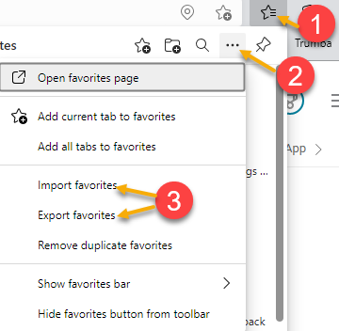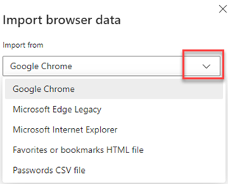

Unemployment Insurance (UI) claim and data information can be found on the UI page here https://esd.wa.gov/

Case Note History report—
from Tina Newcomer to everyone: 10:05 AM
Did I miss an update about ETO and the "Case Notes History" not showing all the case notes any longer? When I try to see the case note history only the last 5 shows
from MacLennan, Mary (ESD) to everyone: 10:06 AM
@Tina - you have to page through them by using the paging arrows at the bottom right corner.
from Tina Newcomer to everyone: 10:07 AM
Thank You Mary
from MacLennan, Mary (ESD) to everyone: 10:07 AM
And I'm still working with the vendor on fixing the widget report.
from Vey Damneun to everyone: 10:08 AM
Tks Mary!
from Tina Newcomer to everyone: 10:09 AM
Ok Thank You

ETO Training discussion—
from Jessie Cardwell-BFWDC to everyone: 10:05 AM
When ETO Training goes to online, how will local areas receive confirmation that people have completed the training?
Response—Problem is we can’t put on ESD’s learning center because not all staff have access. That’s why we have to put it on the WPC site. Working with EC and ROMs trying to figure this out.
from Jessie Cardwell-BFWDC to everyone: 10:13 AM
Thank you, Lynn. :)

ATTENDEES

Aparicio, Rudy
Baker, Mirayia
Cascio, Jaclyn
Cori-Ann Ching
Dawn Oakes
Donna Hendrickson
Dunning, Shellie
Dzenita Musabegovic
Hardy, Jessica
Heather Bring
Heidi Lamers
Holmes, Carolyn
Isiaih Nelson
Jessie Cardwell
Johnson, Angela
Jordan, Irene
Kerns, Adeline
King, Kendall
Kluth, Crystina
Lilia
Linda Rowling
Lolade Fapohunda
Luci Bench
Lux Dmitri
Mack, Donna
Maricha Friedman
Mariya Kazantseva
Monique Martin
Natalya
Oliveri, Brett
Selam
Smick, Rikki
Sparks, Teresa
Tamara Toles
Tina Newcomer
Vey Damneun

