The Demo for “Create an ETO Participant” is cancelled for today. The demo is postponed until the process is ready to present. Demos are planned for 9/16/20 and 9/23/20
T12 Meeting Minutes 9-9-2020
New Business
- ETO Enhancements –
  - Multi-Factor Authentication (MFA) deployment will not occur 9/14/20 and is still to be determined. Demo. MFA Presentation PowerPoint, demo video and FAQ’s are found here https://wpc.wa.gov/tech/ETO-refresher-training
    - Preparation for MFA in ETO production requires you enter your work phone number in ETO (says Cell Phone but does support a land line) by opening your profile and clicking the “Manage My Account” menu and entering your work number.

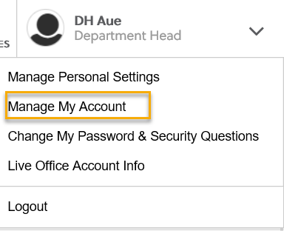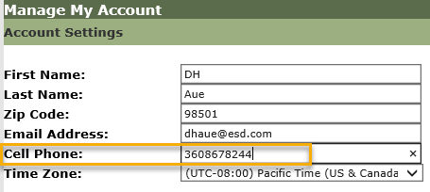
    - What if I don’t have a work number? We are aware some staff don’t have work phones at this time. Contact your supervisor so they can can submit a service request to get you set up with a phone or the Softphone computer application on your desktop.
      - What about personal phones?
    - A survey was sent out 8/20/20 to determine which office’s phone service supports MFA and to determine those who don’t have access to a direct phone line. Let us know in the chat if you didn’t receive the survey so we can connect with you. You will receive a response to the survey today.
    - Staff with phone extensions or those who don’t have direct phone lines will be temporarily exempted from MFA until a solution is found.
    - Demo 9/9/20 and 9/16/20 during the T12 meeting. More training is TBD if needed. All ETO users are invited to attend via ETO internal email sent out the Monday prior to Webex meeting.
- Create an ETO Participant record by staff to record services
  - Demo planned for 9/23/20 during the T12 call. All ETO users will be invited to attend via ETO internal email the Monday prior to call.
- Tickets into production –
  - WA-3861 change to language on Veterans homeless question in WSWA and ETO (implemented 9/2/20)
  - During last week’s call, the question was raised if this change was a federal requirement. The question was asked to Seth Maier, Veteran Program Operator, his response was:
The edit to the ETO homeless question, which now includes actively or planning to escape domestic violence is supported by VPL 03-14 section IV: Guidance. This guidance was to align the Veterans program with the homeless definition within the McKinney-Vento Homeless Assistance Act and it makes those Veterans and other persons eligible for individualized career services – which would include assistance in the barrier of escaping or planning to escape domestic violence, which our field staff are available to assist in navigating. The DV topic is certainly a barrier in employment.
https://www.dol.gov/sites/dolgov/files/VETS/legacy/files/VPL-03-14-Change-2.pdf
- ETO Maintenance – Nothing this week
- Training issue(s) of the week –
  - Please: Submit remedy tickets for all work requests, my team cannot begin work without a service request. Thanks!
- ETO Engage Survey – Work on desk aid/training materials is on hold at this time
- ETO issues – open discussion if time permits
- UI announcements –
  - FEMA’s lost wages program. 2 weeks @$300. Weeks August 1-15. More information Lost Wages Assistance program.
  - On September 2, FEMA’s lost wages program were approved 2 additional weeks ending August 22 and 29. Today, 9/8/20, the week ending September 5 is approved.
  - Mandatory job search requirement is targeted to begin 10/1/2020
During the week of August 23 through August 29, there were 18,172 initial regular unemployment claims (down 1.2% from the prior week) and 560,920 total claims for all unemployment benefit categories (down 1.4% from the prior week) filed by Washingtonians, according to the Employment Security Department (ESD).
  - Initial regular claims applications remain at elevated levels and are at 270 percent above last year’s weekly new claims applications.
  - Regular Unemployment Insurance, Pandemic Unemployment Assistance (PUA) and Pandemic Emergency Unemployment Compensation (PEUC) initial claims increased over the previous week.
ESD paid out over $178,9 million for 357,248 individual claims – a decrease of $3.5 million and 128 more individuals compared to the prior week.

- ESD.wa.gov or ESD Facebook page for current UI information
- Before submitting a service ticket help
Old Business
- Encourage all staff who use ETO and WSWA to sign up for the T12 calls. These calls are not just for trainers but for all system users and a great way to stay up to date on changes or improvements to ETO and WSWA. Send requests to esdgpWSSteam@esd.wa.gov to be added to the ITSD Training Team’s distribution list
- WorkSource Systems resources found on the WPC Technology site https://wpc.wa.gov/tech
  - We try our best to make sure all the links are operational but depend on you to submit a remedy ticket if you find broken links!
- ETO Basic and Refresher Training
  - ETO Basic training is the 1st Monday 10-11:30 and 3rd Tuesday 2-3:30 of every month (except when these days fall on holidays). Send email to Lynn Aue to receive more information and be added to the training Webex call.
  - Training recordings and user guides are posted on the WPC website here https://wpc.wa.gov/tech/ETO-refresher-training
  - Submit a remedy ticket asking Lynn Aue for additional training opportunities and training resources
- Stay up to date on COVID19, teleworking and WorkSource Virtual services. Check out the information the WPC website to help all WorkSource staff telework.
  - IT service delivery
  - WebEx
    - Browse the Webex handbook and watch 5 videos on how to make the most out of this tool for conducting meetings with staff and customers.
  - Other resources include:
    - Now that you are teleworking reference guide
    - How to use SKYPE for online meetings
    - How to sign into ESD email from outside the network
    - How to sign into an off-site Wi-Fi from your computer
    - Can I access Internet Explorer from a MAC computer?
    - ESD service Desk information.
- Data Clean-up reminder: We appreciate your help cleaning up the ETO data so records are not excluded from federal reporting. We will discuss other clean-up efforts at T12 and Advisory meetings.
- We are seeking ETO Improvements ideas
  - ETO improvement ideas or current work arounds should be submitted through the remedy ticket system https://wpc.wa.gov/tech/issues
  - Tickets are reviewed to determine if your idea or work around is a training issue or needs to go through the governance process for a system change
- UI Fraud help
  - www.esd.wa.gov/fraud
  - Fax information to claims centers 833-572-8423 –calling is not recommended due to the high volume of calls
  - Reviewing our web resources with them. Some helpful pages include:
- Employee FAQs
- Employee instructional videos
- How to file weekly claims
But you CAN’T help by:
  - Contacting an intake agent at the claims center and asking them to review your friend or family member’s claim or solve their issue.
  - Using your influence to move your friend or family member’s claim up the queue to be processed faster.
  - Using your influence to give any kind of advantage to your friend or family member.
  - Using your access to UTAB, if you have it, to give someone information about their claim.
  - Using your friend or family member’s SAW account and applying for benefits or submitting their weekly claims for them.
- Cisco Softphones training material Link http://insideesd.wa.gov/services/it-services
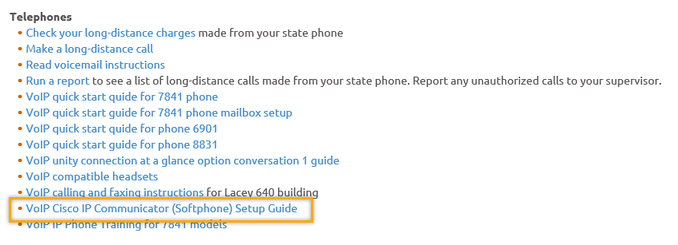
- Before submitting a service, request review these suggestions as the services desk will ask you to run through these steps. Many times, this resolves your issue without a service request!

  - Remember to log out of ETO, clicking off the browser tab here does not end your ETO session and will create issues when you log in again.
      - Always logout by opening your profile menu and clicking “Logout”
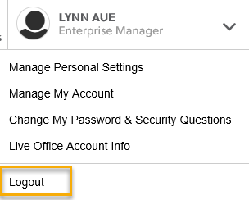
  - If you were impersonating a seeker or recruiter from ETO to WSWA remember to end the session, found in the upper left-hand corner. Clicking off your internet browser tab does not end impersonation!
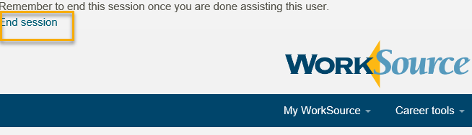

- For best performance clear your cache weekly

  - Internet Explorer (IE): Clearing IE cache starts from the top right side of the browser bar, click the settings icon and select Internet Options
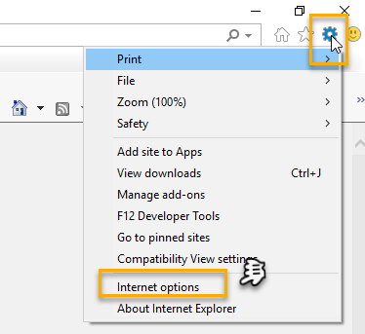

    - From the “General” tab click “Delete” which takes you to the “Delete Browsing History” screen. If not already checked click on the 2 boxes outlined here and click “Delete” you will return to the “General” tab

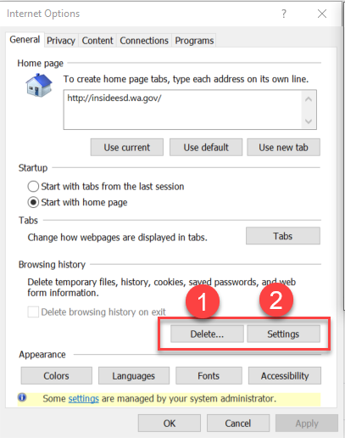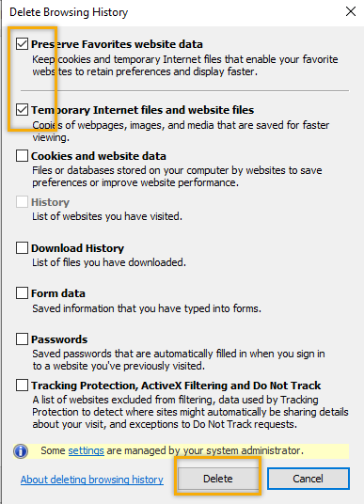

    - Next click “Settings” and if not selected click the radio button for “Every time I visit the webpage” This ensures you are using the most up to date version of ETO. Click OK
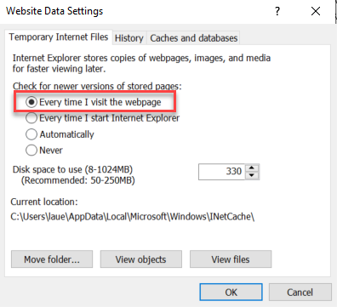
      - You will return to the General tab and click Apply and OK to complete the process of clearing your cache

  - Clearing Chrome cache starts from the top right side of the browser bar
- Click the triple dots to open the Chrome tools menu
- Hover over “More tools”
- Click “Clear browsing data” which opens a new screen
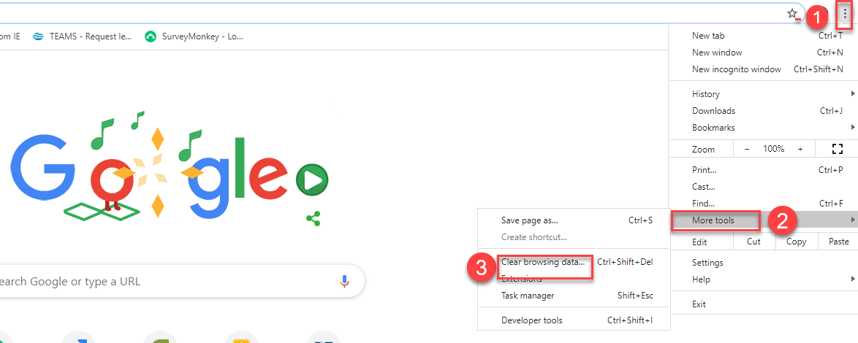

- Click “Clear data”
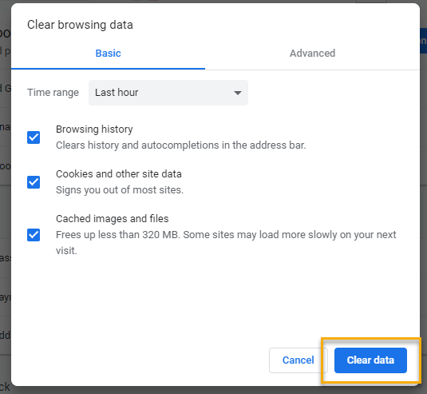

  - Finish by restarting your computer
  - If you still experience issues submit a service request https://wpc.wa.gov/tech/issues
CHAT

from Venus Talarico to everyone: 10:06 AM
Am I going to use my personal cell number?
from KCalloway to everyone: 10:13 AM
Lynnwood "Partners" use Ring Central which is a different phone system than all other ESD staff. Should we be using our own personal cell phones?
from Deanna Gillis to everyone: 10:14 AM
Our Ring Central phones take text messages so we should be good to go Kim
That’s up to you and your department. Using personal devices opens them up to public disclosure. Above all else, we recommend using your work phone if possible. Landlines do work as well as soft phones.

from Felicia Johnson to everyone: 10:08 AM
I’m using my work cell and included the 146 537 9866# and then 299#
from Felicia Johnson to everyone: 10:08 AM
for audio services
*This is in response to calling in to the meeting, not MFA (just FYI)*

from Michael Freer to everyone: 10:11 AM
If i am in and out of ETO throughout the day, will i need to verify a code each and every time?
from Merry Gottschall to everyone: 10:13 AM
excellent question re: needing a new code each time? since it times out so quickly.... :)
from Merry Gottschall to everyone: 10:17 AM
Will we need a new code each time we use ETO throughout the day?
No you do not need to verify each time you login. It will only require a code to verify once every 30 days.

from Dan Cooling to everyone: 10:13 AM
Is there a report we can run to see if our team is fully compliant with updating their profile?
from Toni Burow to everyone: 10:20 AM
Once that report is ready can it also go out to all the Access Approvers as well
Rebecca and I are working on that right now. The report should be done later today (9/9)

from Marcella Willis to everyone: 10:14 AM
So once we save our phone #, do we not need to worry about getting the code until this is implemented 9/14?
Correct! However, the 9/14 date is going to be pushed back to [TBD]
from Skyler Blumenthal to everyone: 10:18 AM
MFA is probably going to be implemented on 9/21 but we'll have a concrete answer after our meeting tomorrow with management.

from Deanna Gillis (privately): 10:20 AM
Skyler, are you the person that will be testing? I've put my Ring Central number in the system so if you want to test it, I can help with that if need be. I am the Sup in Lynnwood. 425-412-6892
to Deanna Gillis (privately): 10:23 AM
Hey Deanna, yes, I am currently doing testing of MFA. what's your e-mail? May need to get in contact with you to test.
from Deanna Gillis (privately): 10:24 AM
dgillis@esd.wa.gov We were told by our WDC that it would work (should) so this way I can make sure it does and will get the word out to our team with the definite. Thank you!!

RE: Rebecca’s survey results – some may not have gotten sent the survey (not sure if these individuals need the survey sent out to them or if staff had already answered for them) on 9/9/20 the survey was sent to all WS supervisors and administrators.
from Marcella Willis to everyone: 10:20 AM
I don't think I have
from KHesseltine to everyone: 10:21 AM
I don’t think I received
from vkemp to everyone: 10:21 AM
I don't believe I received one as of yet.
from Teresa Southard to everyone: 10:21 AM
May I request the email. Thanks
from KCalloway to everyone: 10:21 AM
Did NOT receive the email :-)

RE: using personal devices. A more informed explanation may be necessary
from Mary Sterling to everyone: 10:21 AM
You said that if we use our personal cell phone, we are subject to public records request, please elaborate, does this mean only regarding ETO use?
from CONNIE EDLER to everyone: 10:28 AM
You said that if we use our personal cell phone, we are subject to public records request, please elaborate, does this mean only regarding ETO use?
from Steven Severson to everyone: 10:31 AM
It means that anything on you cell is subject to public disclosure if there is a request
from Arturo Espinoza to everyone: 10:32 AM
Personal phone shouldn't be an issue if we never use it for work stuff.

ATTENDEES
Adeline Kerns
Adelp
Albert Verduzco
Alicia Grieco
Alma Caballero
Amanda Standley
Anna Polin
Antonilius Davis
Arturo Espinoza
ARayfield
Boliveri
Brandon
Brenda Saenz
Brian
Caller 11
Caller 12
Called 13
Caller 14
Caller 9
Carey McNallie
Chede
Christina Pitts
Claire B
Connie Edler
Cori Ching
CShaffer
Cynthia Kressin
Dan Cooling
Daniel Ledgett
Danielle
Dean Coxford
Deanna Gillis
Diane Luoma
Donetta McCormack
Donna Mack
Dorothy Rocha
Elizabeth Ibanez
Felicia Johnson
Grace Troncoso
Heidi Lamers
Hope Baker
Ion Turner
Irene Torres
Janice Herrin
Javier Cruz
Jeanette Elizabeth
Jeffery Flood
Jen Cole
Jerarda Navarro
Jessica Cardwell
Jon Ferguson
Jordan Meyenburg
Kari
Kathleen Greene
K Calloway
KHesseltine
Kim Bursell
Kimberly Chase
KKing
Kori Olsen
Larissa Lincoln
Linda Hollingsworth
Lisa Pietkauskis
L Rager
Marc
Marcella WIllis
Maria Zaragoza
Mary Sterling
M Doninguez
Melisa Flore-Sanchez
Michael Freer
Michele G
Minnie
MReeves
MSmith
Nataliya Solti
Paula Pelot
PFP Staff
Pochi Ostergren
Rebecca McGinnis
Regenal Grant
Robbin Gard
Rodolfo Aparicio
Saliymah Abdul Malik
Sarah
schmi
Sean McElligott
Seth Maier
Skyler Blumenthal
Steven Severson
Talia Ni Dufaigh
Tammy Stillwaugh
Teresa Anda
Teresa Smith
Teresa Southard
Ton Nguyen
Toni Burow
Toni Esper
Tracy Ollgaard
trobison@wdcspokane.com
Vdamneun
Venus Talarico
Victor Chacon
Victoria Wood
Vkemp
Young Suh
Yvette Dallas

Second Half Attendance

