T12 Meeting Minutes 9-30-2020
Remember: After starting a Webex meeting to mute your audio and disable the video feature. Too many attendee’s with active video can interfere with everyone’s audio quality

Thanks to all who contribute to this weekly call!

New Business
- 10-7-20 T12 meeting cancelled
- ETO Enhancements – Updates
  - Multi-Factor Authentication (MFA) was rolled back. At this time, you can sign into ETO without an authentication code. We are investigating the cause of this issue. Once we have a confirmed relaunch date, we will communicate via ETO messenger, T12 distribution list, RDs, Office Administrators and WDA directors. Here is what you need to do if you haven’t added a phone number to your ETO account.
    - Find the MFA Presentation PowerPoint, demo video and FAQ’s here https://wpc.wa.gov/tech/ETO-refresher-training
    - Preparation for MFA in ETO production requires you enter your work phone number in ETO (says Cell Phone but does support a land line) by opening your profile and clicking the “Manage My Account” menu and entering your work number.

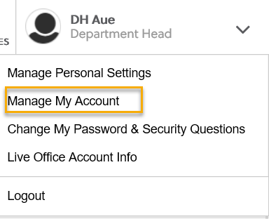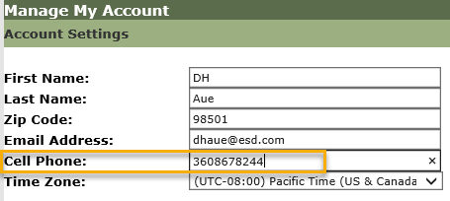

- Create an ETO Participant record by staff so you can record services
  - On 10/1/20 Steering Committee agenda, implementation date TBD once a decision is made
- Tickets into production – nothing this week
  - Change to program group display. We were unable to remove the REA selections but could move them from the beginning of the list to the bottom.
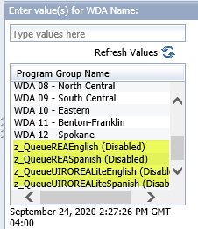

- ETO maintenance – Nothing this week
- Training issue(s) of the week –
  - Please: Submit remedy tickets for all work requests. My team cannot begin work without a service request. Reaching out to us directly can affect the time it takes to resolve your issue. Thanks!
- ETO Engage Survey – Work on desk aid/training materials is on hold at this time
- WIN0082(rev1) Real-Time Data Entry in the Efforts To Outcomes (ETO) System. https://wpc.wa.gov/policy/state/guidance
  - Reports – remember to always refresh the report list before running any report
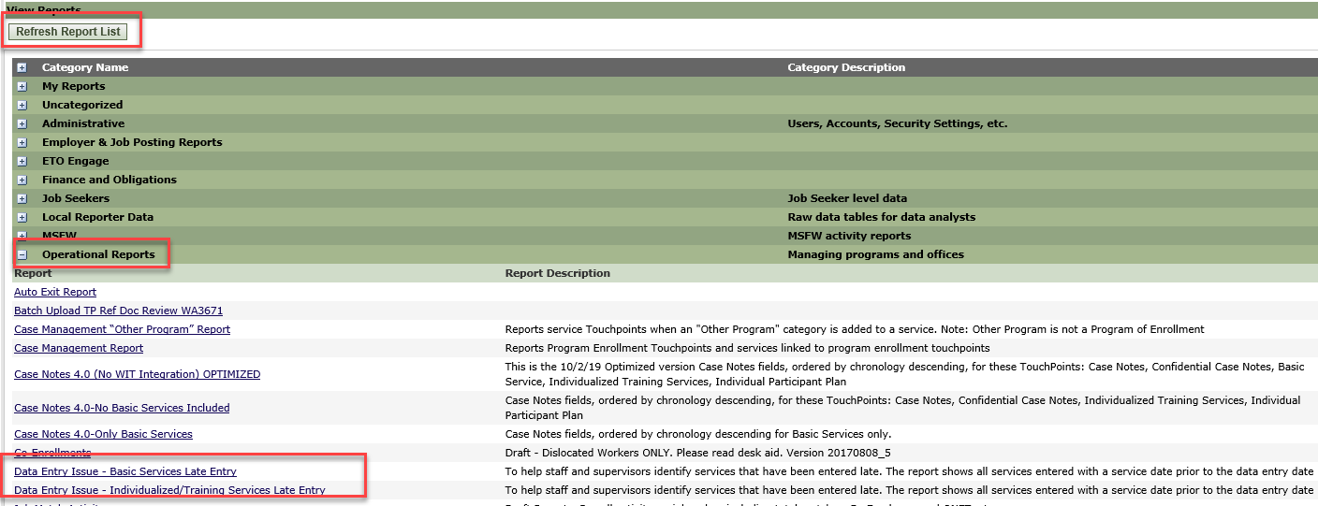
For best experience, immediately export report to Excel to filter content
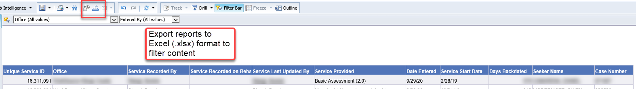
- What’s new on WPC
  - Opt-out (of data sharing with non-ESD staff) desk aid under training resources
    - Asking for input or changes if needed
  - Minutes, content descriptions added
- WSWA Virtual services to assist job seekers/employers to sharpen skills. There are many tools on WSWA but here are a couple of my favorites!
  - Check out these virtual classes under Resources>Training and other programs.
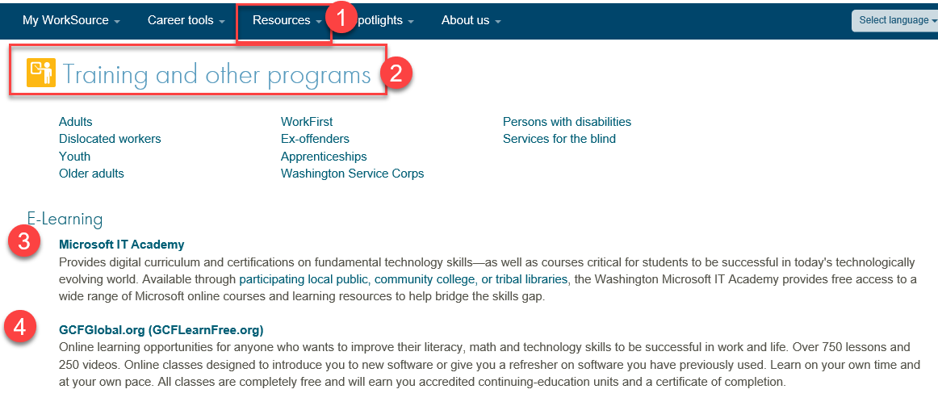
- Open discussion – see chat
- UI announcements –
  - Mandatory job search requirement is targeted to begin 10/1/2020
During the week of September 13 through September 19, there were 19,574 initial regular unemployment claims (up 6.4 % from the prior week) and 540,153 total claims for all unemployment benefit categories (down 4.6% from the prior week) filed by Washingtonians, according to the Employment Security Department (ESD).
  - Initial regular claims applications remain at elevated levels and are at 271 percent above last year’s weekly new claims applications.
  - Regular Unemployment Insurance, Pandemic Unemployment Assistance (PUA) and Pandemic Emergency Unemployment Compensation (PEUC) initial claims increased over the previous week.
ESD paid out over $154.5million for 337,390 individual claims – a decrease of $2.8 million and 2,963 less individuals compared to the prior week.
- ESD.wa.gov or ESD Facebook page for current UI information
- Before submitting a service ticket help
Old Business
- Encourage all staff who use ETO and WSWA to sign up for the T12 calls. These calls are not just for trainers but for all system users and a great way to stay up to date on changes or improvements to ETO and WSWA. Send requests to esdgpWSSteam@esd.wa.gov to be added to the ITSD Training Team’s distribution list
- ETO Basic and Refresher Training
  - ETO Basic training is the 1st Monday 10-12 and 3rd Tuesday 2-4 of every month (except when these days fall on holidays). Send email to Lynn Aue to receive more information and be added to the training Webex call.
  - Training recordings and user guides are posted on the WPC website here https://wpc.wa.gov/tech/ETO-refresher-training
  - Submit a remedy ticket asking Lynn Aue for additional training opportunities and training resources
- WorkSource Systems resources found on the WPC Technology site https://wpc.wa.gov/tech
  - We try our best to make sure all the links are operational but depend on you to submit a remedy ticket if you find broken links!
- Stay up to date on COVID19, teleworking and WorkSource Virtual services. Check out the information the WPC website to help all WorkSource staff telework.
  - IT service delivery
  - WebEx
    - Browse the Webex handbook and watch 5 videos on how to make the most out of this tool for conducting meetings with staff and customers.
  - Other resources include:
    - Now that you are teleworking reference guide
    - How to use SKYPE for online meetings
    - How to sign into ESD email from outside the network
    - How to sign into an off-site Wi-Fi from your computer
    - Can I access Internet Explorer from a MAC computer?
    - ESD service Desk information.
- UI Fraud help
  - www.esd.wa.gov/fraud
  - Fax information to claims centers 833-572-8423 –calling is not recommended due to the high volume of calls
  - Reviewing our web resources with them. Some helpful pages include:
- Employee FAQs
- Employee instructional videos
- How to file weekly claims
But you CAN’T help by:
  - Contacting an intake agent at the claims center and asking them to review your friend or family member’s claim or solve their issue.
  - Using your influence to move your friend or family member’s claim up the queue to be processed faster.
  - Using your influence to give any kind of advantage to your friend or family member.
  - Using your access to UTAB, if you have it, to give someone information about their claim.
  - Using your friend or family member’s SAW account and applying for benefits or submitting their weekly claims for them.
- Cisco Softphones training material Link http://insideesd.wa.gov/services/it-services
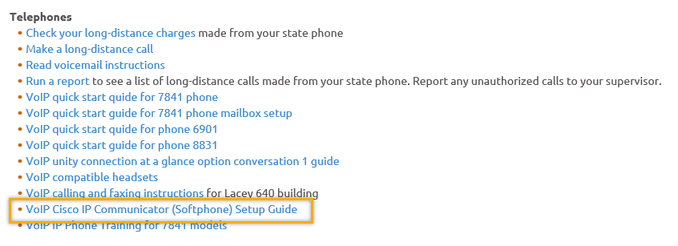
- Before submitting a service, request review these suggestions as the services desk will ask you to run through these steps. Many times, this resolves your issue without a service request!

  - Remember to log out of ETO, clicking off the browser tab here does not end your ETO session and will create issues when you log in again.
      - Always logout by opening your profile menu and clicking “Logout”
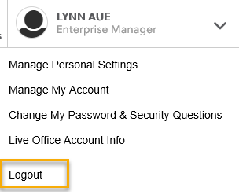
  - If you were impersonating a seeker or recruiter from ETO to WSWA remember to end the session, found in the upper left-hand corner. Clicking off your internet browser tab does not end impersonation!
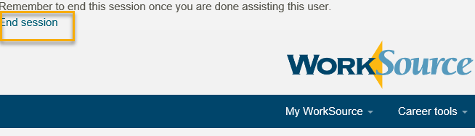

- For best performance clear your cache weekly

  - Internet Explorer (IE): Clearing IE cache starts from the top right side of the browser bar, click the settings icon and select Internet Options
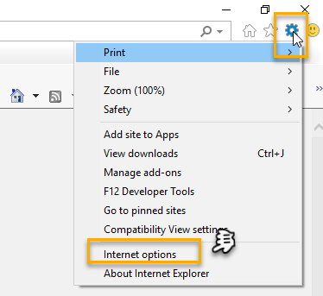

    - From the “General” tab click “Delete” which takes you to the “Delete Browsing History” screen. If not already checked click on the 2 boxes outlined here and click “Delete” you will return to the “General” tab

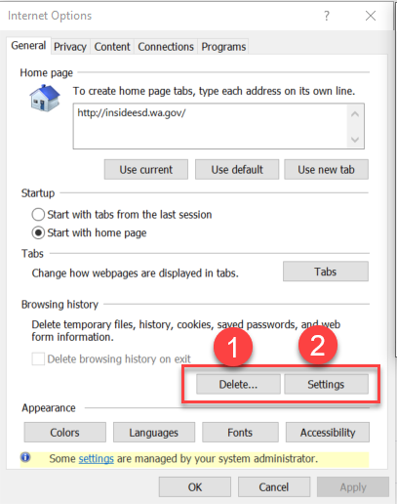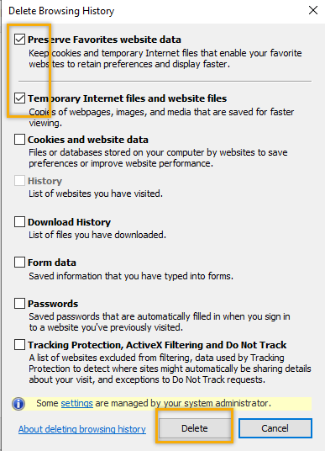

    - Next click “Settings” and if not selected click the radio button for “Every time I visit the webpage” This ensures you are using the most up to date version of ETO. Click OK
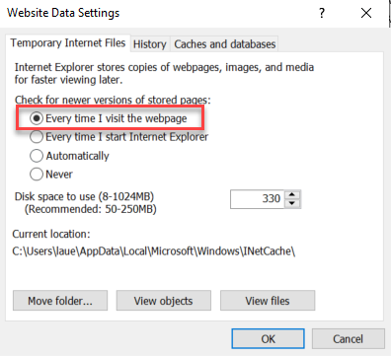
      - You will return to the General tab and click Apply and OK to complete the process of clearing your cache

  - Clearing Chrome cache starts from the top right side of the browser bar
- Click the triple dots to open the Chrome tools menu
- Hover over “More tools”
- Click “Clear browsing data” which opens a new screen
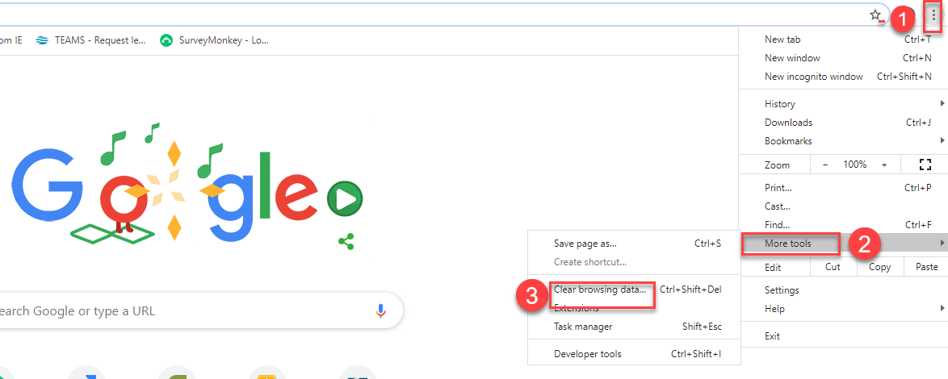

- Click “Clear data”
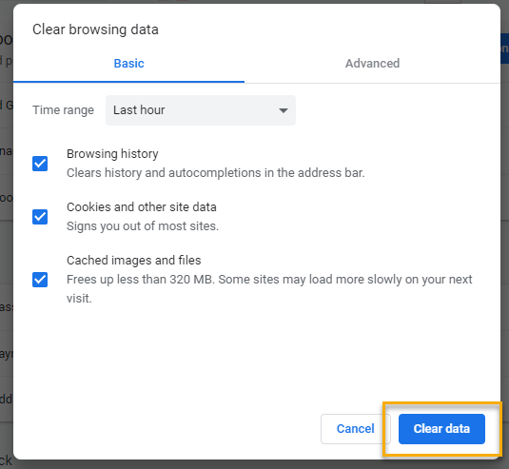

  - Finish by restarting your computer
  - If you still experience issues submit a service request https://wpc.wa.gov/tech/issues
CHATLin
from Edward Cox to everyone: 10:09 AM There are several bandwith issues going on today...

from Adeline Kerns to everyone: 10:17 AM Do these reports show if the services were not entered too or just lates? The reports do not show if the services were not entered, just that they were entered late.

from Crystal Armitage to everyone: 10:36 AM Link to WSWA reources https://seeker.worksourcewa.com/tutorials/tutorials.aspx
from Ione Turner to everyone: 10:41 AM
Thanks, Lyn. I appreciate being reminded of GCF - such a wonderful resource

from Brenda Jones to everyone: 10:41 AM
Could you please clarify the comments made regarding emails in correlation to ETO TP - what is allowed what is not allowed. You can read the updated WIN policies here: https://wpc.wa.gov/policy/state/guidance (see: WIN 0088(Rev1) and WIN 0082)

ATTENDEES
12534****94
15093***58
14941 Hickmon
Abigail Taft
Adeline Kerns
A Hughes
Arturo Espinoza
Becky Smith
Boliveri
Brenda Jones
C Martin
Carl Peterson
Catherine Geddis
Claire B
Clayton Haycraft
Cori Ching
Crystal Armitage
Dan Cooling
Daniel Ledgett
Dawn Oakes
Dean Coxford
Donetta McCormack
Dorothy Rocha
Edward Cox
Emeline Pahulu
Felicia Johnson
Gracie Troncoso
Heidi Lamers
Heidi Schauble
Ion Turner
Irene Jordan
James Lapsley jr
Jasmine Smith
John Moysiuk
Katherine Congleton
Katy Stevick
Kendall King
Kimberly Myers
Kylie Bartlett
Linda Hollingsworth
Lisa Pietkauskis
Luci Bench
Lyla Dinguss
Michael Ramos
Monique Martin
Nicholas Towne
Noel Woods
Petra Mihaluta
Phyllis Hall
Regina Cancel
Rodolfo Aparicio
Sean McElligott
Sean Wiley
Selma Tekle
Skyler Blumenthal
Teresa Smith
Timothy Mallon
TLarson
Ton Nguyen
Toni
Toni Burow
Tracy Ferrell – EWP
Tracy Ollgaard
Vdamneun
Victoria Wood
Zoryana Bilous

Second Half Attendance

