T12 Meeting Minutes 9-23-2020
Remember: After starting a Webex meeting to mute your audio and disable the video feature. Too many attendee’s with active video can interfere with everyone’s audio quality

New Business

- ETO Enhancements –
  - Multi-Factor Authentication (MFA) was rolled back. At this time, you can sign into ETO without an authentication code. We are investigating the cause of this issue. Once we have a confirmed relaunch date, we will communicate via ETO messenger, T12 distribution list, RDs, Office Administrators and WDA directors. Here is what you need to do if you haven’t added a phone number to your ETO account.
    - Find the MFA Presentation PowerPoint, demo video and FAQ’s here https://wpc.wa.gov/tech/ETO-refresher-training
    - Preparation for MFA in ETO production requires you enter your work phone number in ETO (says Cell Phone but does support a land line) by opening your profile and clicking the “Manage My Account” menu and entering your work number.

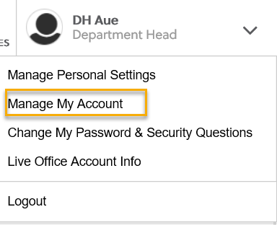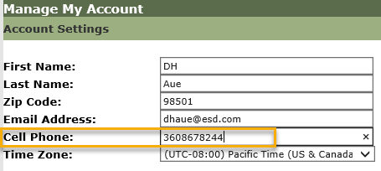

  - FYI: Menu change and cleanup of unused RESEA reports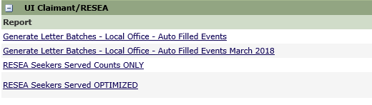

- Create an ETO Participant record by staff so you can record services
  - On 9/24/20 Steering Committee agenda, implementation date TBD once a decision is made
- Tickets into production Thursday 9/24/2020
  - WA-3806 RESEA new service
  - WA-3905 New PE “WSW Opioid Disaster NDWG PY20-21” WDA 7 only
    - No new services or changes to services catalog
  - WA-3917 CHANGE: We were unable to remove the called-out program names from the “Program Group Name” display. Instead those names were moved to the end of the list and marked (Disabled)
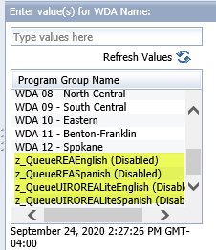

- ETO maintenance – Nothing this week
- Training issue(s) of the week –
  - Clear cache/browsing history – guidance on how to clear IE and Chrome cache at the end of minutes
  - Opt-out participants – see “Open Discussion” for guidance those who work for a WS partner agency who are unable to find a participant in ETO need to run the
  - Please: Submit remedy tickets for all work requests. My team cannot begin work without a service request. Reaching out to us directly can affect the time it takes to resolve your issue. Thanks!
- ETO Engage Survey – Work on desk aid/training materials is on hold at this time
- Open discussion
  - Boeing Program Enrollments and WIA NEG Program of Enrollments are removed from the menu
  - Opt-out (of data sharing with non-ESD staff)

- UI announcements –
  - Mandatory job search requirement is targeted to begin 10/1/2020
During the week of September 6 through September 12, there were 18,403 initial regular unemployment claims (down 8.0 % from the prior week) and 566,443 total claims for all unemployment benefit categories (up 6.6% from the prior week) filed by Washingtonians, according to the Employment Security Department (ESD).
  - Initial regular claims applications remain at elevated levels and are at 242 percent above last year’s weekly new claims applications.
  - Regular Unemployment Insurance, Pandemic Unemployment Assistance (PUA) and Pandemic Emergency Unemployment Compensation (PEUC) initial claims increased over the previous week.
ESD paid out over $157.7 million for 340,3520 individual claims – a decrease of $19.5 million and 16,349 less individuals compared to the prior week.
- ESD.wa.gov or ESD Facebook page for current UI information
- Before submitting a service ticket help
Old Business
- Encourage all staff who use ETO and WSWA to sign up for the T12 calls. These calls are not just for trainers but for all system users and a great way to stay up to date on changes or improvements to ETO and WSWA. Send requests to esdgpWSSteam@esd.wa.gov to be added to the ITSD Training Team’s distribution list
- ETO Basic and Refresher Training
  - ETO Basic training is the 1st Monday 10-12 and 3rd Tuesday 2-4 of every month (except when these days fall on holidays). Send email to Lynn Aue to receive more information and be added to the training Webex call.
  - Training recordings and user guides are posted on the WPC website here https://wpc.wa.gov/tech/ETO-refresher-training
  - Submit a remedy ticket asking Lynn Aue for additional training opportunities and training resources
- WorkSource Systems resources found on the WPC Technology site https://wpc.wa.gov/tech
  - We try our best to make sure all the links are operational but depend on you to submit a remedy ticket if you find broken links!
- Stay up to date on COVID19, teleworking and WorkSource Virtual services. Check out the information the WPC website to help all WorkSource staff telework.
  - IT service delivery
  - WebEx
    - Browse the Webex handbook and watch 5 videos on how to make the most out of this tool for conducting meetings with staff and customers.
  - Other resources include:
    - Now that you are teleworking reference guide
    - How to use SKYPE for online meetings
    - How to sign into ESD email from outside the network
    - How to sign into an off-site Wi-Fi from your computer
    - Can I access Internet Explorer from a MAC computer?
    - ESD service Desk information.
- UI Fraud help
  - www.esd.wa.gov/fraud
  - Fax information to claims centers 833-572-8423 –calling is not recommended due to the high volume of calls
  - Reviewing our web resources with them. Some helpful pages include:
- Employee FAQs
- Employee instructional videos
- How to file weekly claims
But you CAN’T help by:
  - Contacting an intake agent at the claims center and asking them to review your friend or family member’s claim or solve their issue.
  - Using your influence to move your friend or family member’s claim up the queue to be processed faster.
  - Using your influence to give any kind of advantage to your friend or family member.
  - Using your access to UTAB, if you have it, to give someone information about their claim.
  - Using your friend or family member’s SAW account and applying for benefits or submitting their weekly claims for them.
- Cisco Softphones training material Link http://insideesd.wa.gov/services/it-services
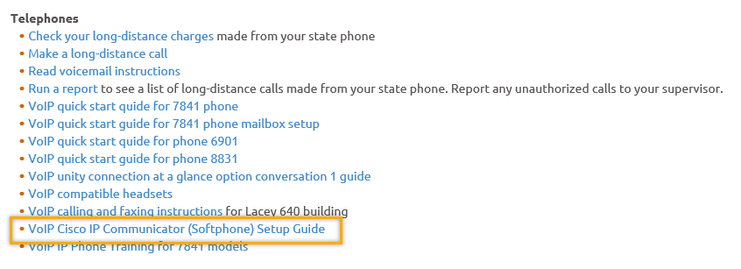
- Before submitting a service, request review these suggestions as the services desk will ask you to run through these steps. Many times, this resolves your issue without a service request!

  - Remember to log out of ETO, clicking off the browser tab here does not end your ETO session and will create issues when you log in again.
      - Always logout by opening your profile menu and clicking “Logout”
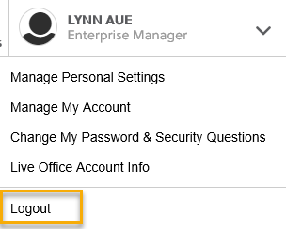
  - If you were impersonating a seeker or recruiter from ETO to WSWA remember to end the session, found in the upper left-hand corner. Clicking off your internet browser tab does not end impersonation!
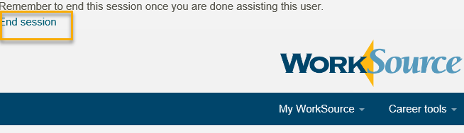

- For best performance clear your cache weekly

  - Internet Explorer (IE): Clearing IE cache starts from the top right side of the browser bar, click the settings icon and select Internet Options
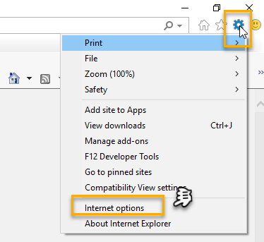

    - From the “General” tab click “Delete” which takes you to the “Delete Browsing History” screen. If not already checked click on the 2 boxes outlined here and click “Delete” you will return to the “General” tab

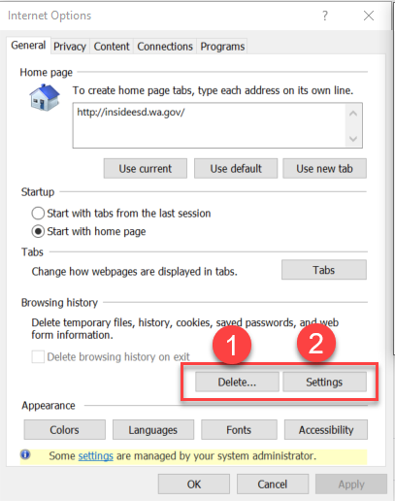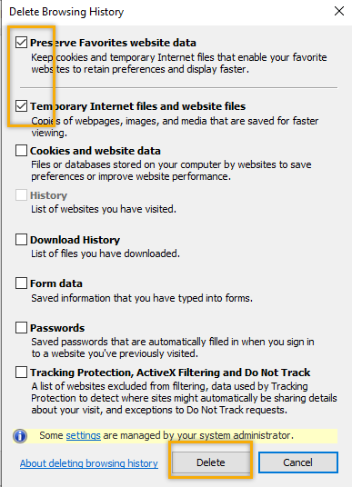

    - Next click “Settings” and if not selected click the radio button for “Every time I visit the webpage” This ensures you are using the most up to date version of ETO. Click OK
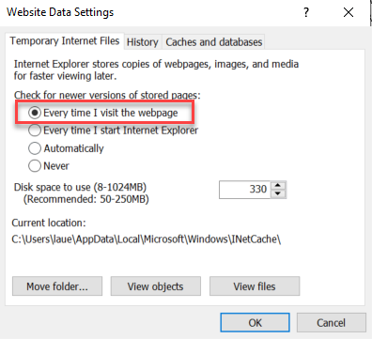
      - You will return to the General tab and click Apply and OK to complete the process of clearing your cache

  - Clearing Chrome cache starts from the top right side of the browser bar
- Click the triple dots to open the Chrome tools menu
- Hover over “More tools”
- Click “Clear browsing data” which opens a new screen
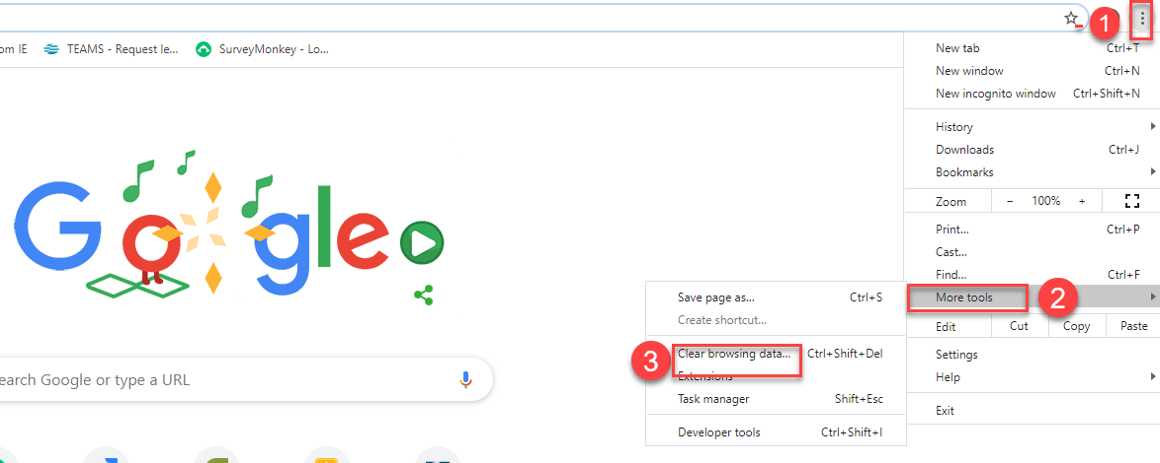

- Click “Clear data”
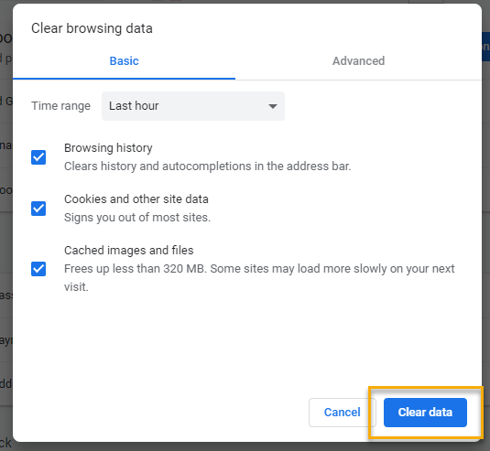

  - Finish by restarting your computer
  - If you still experience issues submit a service request https://wpc.wa.gov/tech/issues
CHAT

MFA Q & A
Craig Clark: Are you receiving notifications of staff being locked out? I received some feedback that accounts were locked but when I reviewed them the accounts were not. Many staff did not realize MFA was rolled off and they had the ability to log into ETO without the authentication code. Any additional directives in follow up? Remind staff to add their phone numbers to ETO so they are ready when MFA relaunches.
- Regarding the Authentication Code calls:
- Should all non-ESD staff (those without soft phone service) expect to receive or should they have received a call even with the rollback if they have a phone number entered in ETO? The call or text occurs after you enter your username and password. A screen pops up where you enter the authentication code. Only staff who signed into ETO would receive the code. Those who didn’t attempt to log into ETO would not receive the code. No one was sent an authentication code or asked for a code after the roll back.
- If non-ESD staff are locked out during the rollback period, can it be a result of the MFA glitches or initial phase of implementation? The roll back should not cause accounts to be locked out. I have seen other instances where staff’s ETO email/username was changed to their personal email. Staff do have the ability to change their email in “Account Settings” which they should never do. The email change could be caused by Chrome/Google auto filling them. We are looking into this occurrence.
  - If staff do not know the reason they are locked out, what is the process those non-ESD staff should follow for a resolve. General help ticket? Yes
- Especially for staff that do not have a number to enter in ETO and an exception will be needed, although not yet developed or identified? Yes, submit a ticket so those staff can be identified, and we can make an exception

Those who did not receive the MFA email notification 9/21/20
Tracy Ferrell: No. Sent to my WDC Director. Please send to me.

Comments on successfully receiving the MFA code
Emily Anderson: Everything was fine and clear for us - outside of ESD. No issues.

MISC MFA comments
Arlene Olea: Apparently, everyone that had their cell phone numbers registered did not have issues. The ones that had our Cisco Soft phone number registered did not get the call for the authentication code. But I believe this is getting resolved. Thank you!
Emily Anderson: We had the same issue, but we are in a WorkSource office. Office phones didn't work, cell phones did.

Opt-Out
Toni Burow: I have an office with 4 individuals who have opted out and need to opt back in. Is there a process to opt them back in when ESD staff say they can't fix them? I created a deskaid for opting in and out. I am attaching it to the minutes and also uploading the deskaid to the WPC training resources

Toni Burow: With everyone teleworking and a local office not open with staff, can a remedy ticket be submitted?
Emily Anderson: My experience has been ESD staff willing to remove the opt in but usually don’t know how to do it. I’ve had to walk them through. A training tool might be helpful. Done, thanks for the suggestion!
Talia Ni Dufaigh: Yesterday....I was trying to find a process to include:
• How to opt in
• Once opted in, do I take a service, i.e., Referral to WIOA
• Do I have to see ‘data share form’
• Do I have to see ID?
- Do I need to write a case note? Yes. Always add a case note that describes the action taken and why. For more informatin on case notes check out WIN0088 found on the WPC website on the Policy tab under state guidance.

ahughes: Hi Lynn, even though a person opts out, I thought we still had to provide them services. We just need to keep track of all of the services provided to them, then work with an ESD staff member to get the information entered so they are still captured on the PIRL. ??
Noel Woods: The law says the person can still receive services even if they choose to opt out
Ahughes: Here is the Policy Info for Opt Out: Per ESD Policy #1021, the participant can “opt out” of data sharing; however, their information can still be collected in “paper” form and entered into ETO by an ESD staff in order to meet federal and state reporting requirements. RCW 50.13.060(11)(b) a Thanks for providing the policy and RCW on this process.
Talia Ni Dufaigh: I’m having difficulty searching our WPC website. When I use keywords for items such as ‘Opt Out’ or ‘Program Enrollment’ I am not able to find items that I would like to share with staff. I agree. As with many systems the search feature is not very useful. I will report it to the administrator but not sur there is much to be done to improve it.
Becky Smith: Do you know when the “train the trainer” training will be rolled out? Trying to finalize the plan. More to follow.

ATTENDEES
12087
Abigail Taft
adelp
A Hughes
Albert Verfuzco
Amy
Anjrea Miller
Arlean Olea
Arturo Espinoza
Barry Dickerson
Becky Smith
bjones
Boliveri
Bzanto
Caller 3
Called 6
Carl Peterson
Carolyn Holmes
Catherine Geddis
C Carroll
Chanda Robertson
Christina Pitts
Christopher File
Claudette Dean
Clayton Haycraft
Cori Ching
Craig Clark
C Shaffer
Dawn Oakes
Dean Coxford
Emily Anderson
EPahulu
Gracie Troncoso
Heidi Schauble
Ion Turner
Janice Herrin
Jerarda Navarro
Joanie Linder
Katherine C
Kendall King
K Hesseltine
Kim Bursell
Kimberly Myers
La Qwana
Laurie Stone
Lisa Pietkauskis
Luci Bench
Lyla Dinguss
Marc Hannon
Marla McMackin
M Dominguez
Melisa Flore-Sanchez
Melissa Robinson
Nicholas Towne
Noel Woods
Petra Barba
Petru Mihaluta
Pochi Ostergren
Regina Cancel
Rodolfo Aparicio
Saliymah Abdul Malik
Sean McElligott
Sean Wiley
Selma Tekle
Talia Ni Dufaigh
Tammy Stillwaugh
Teresa Anda
Teresa Southard
Teresa Sparks
Thomas Anderson
Timothy Mallon
TLarson
Ton Nguyen
Toni
Toni Burow
Tracy Ferrell – EWP
Tracy Ollgaard
Vdamneun
WorkForce Snohomish Webex
Young Suh
Zoryana Bilous

Second Half Attendance

