The Demo for “Create an ETO Participant” is cancelled for today. The demo will happen on 9/9/20 and 9/16/20
T12 Meeting Minutes 9-2-2020
New Business
- ETO Enhancements –
  - Multi-Factor Authentication (MFA): Demo. MFA Presentation PowerPoint, demo video and FAQ’s are found here https://wpc.wa.gov/tech/ETO-refresher-training
    - Preparation for MFA in ETO production requires you enter your work phone number in ETO (says Cell Phone but does support a land line) by opening your profile and clicking the “Manage My Account” menu and entering your work number.

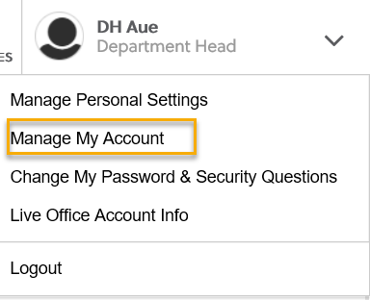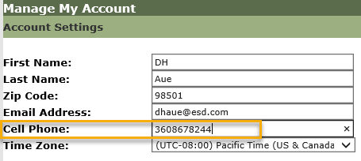
    - What if I don’t have a work number? We are aware some staff don’t have work phones at this time. Contact your supervisor so they can can submit a service request to get you set up with a phone or the Softphone computer application on your desktop.
      - What about personal phones?
    - A survey was sent out 8/20/20 to determine which office’s phone service supports MFA and to determine those who don’t have access to a direct phone line. We discovered during the call all offices did not receive the survey. We are sending the survey out to those who didn’t receive it.
    - Staff with phone extensions or those who don’t have direct phone lines will be temporarily exempted from MFA until a solution is found.
    - Demo 8/26/20, 9/2/20, 9/9/20 during the T12 meeting. All ETO users will be invited to attend via ETO internal email sent out the Monday prior to Webex meeting.
- Create an ETO participant record by staff so you can record services
  - Demo 9/9/20 and 9/16/20 during T12 call. All ETO users will be invited to attend via ETO internal email the Monday prior to call.
- Tickets into production –
  - WA-3861 change to language on Veterans homeless question in WSWA and ETO
- ETO Maintenance – Nothing this week
- Training issue(s) of the week –
  - Please: Submit remedy tickets for all work requests, my team cannot begin work without a service request. Thanks!
- ETO Engage Survey – Work on desk aid/training materials is on hold at this time
- ETO issues – open discussion if time permits
- UI announcements –
  - FEMA’s lost wages program. 2 weeks @$300. Weeks August 1-15. More information Lost Wages Assistance program.
  - Mandatory job search requirement is targeted to begin 10/1/2020
During the week of August 16 through August 22, there were 18,389 initial regular unemployment claims (down 16.2% from the prior week) and 568,881 total claims for all unemployment benefit categories (down 4.8% from the prior week) filed by Washingtonians, according to the Employment Security Department (ESD).
  - Initial regular claims applications remain at unprecedented elevated levels and are at 288 percent above last year’s weekly new claims applications.
  - Regular Unemployment Insurance, Pandemic Unemployment Assistance (PUA) and Pandemic Emergency Unemployment Compensation (PEUC) initial claims decreased over the previous week.
ESD paid out over $182.8 million for 357,077 individual claims – a decrease of $15.4 million and 5,760 fewer individuals compared to the prior week.

- ESD.wa.gov or ESD Facebook page for current UI information
- Before submitting a service ticket help
Old Business
- Encourage all staff who use ETO and WSWA to sign up for the T12 calls. These calls are not just for trainers but for all system users and a great way to stay up to date on changes or improvements to ETO and WSWA. Send requests to esdgpWSSteam@esd.wa.gov to be added to the ITSD Training Team’s distribution list
- WorkSource Systems resources found on the WPC Technology site https://wpc.wa.gov/tech
  - We try our best to make sure all the links are operational but depend on you to submit a remedy ticket if you find broken links!
- ETO Basic and Refresher Training
  - ETO Basic training is the 1st Monday 10-11:30 and 3rd Tuesday 2-3:30 of every month (except when these days fall on holidays). Send email to Lynn Aue to receive more information and be added to the training Webex call.
  - Training recordings and user guides are posted on the WPC website here https://wpc.wa.gov/tech/ETO-refresher-training
  - Submit a remedy ticket asking Lynn Aue for additional training opportunities and training resources
- Stay up to date on COVID19, teleworking and WorkSource Virtual services. Check out the information the WPC website to help all WorkSource staff telework.
  - IT service delivery
  - WebEx
    - Browse the Webex handbook and watch 5 videos on how to make the most out of this tool for conducting meetings with staff and customers.
  - Other resources include:
    - Now that you are teleworking reference guide
    - How to use SKYPE for online meetings
    - How to sign into ESD email from outside the network
    - How to sign into an off-site Wi-Fi from your computer
    - Can I access Internet Explorer from a MAC computer?
    - ESD service Desk information.
- Data Clean-up reminder: We appreciate your help cleaning up the ETO data so records are not excluded from federal reporting. We will discuss other clean-up efforts at T12 and Advisory meetings.
- We are seeking ETO Improvements ideas
  - ETO improvement ideas or current work arounds should be submitted through the remedy ticket system https://wpc.wa.gov/tech/issues
  - Tickets are reviewed to determine if your idea or work around is a training issue or needs to go through the governance process for a system change
- UI Fraud help
  - www.esd.wa.gov/fraud
  - Fax information to claims centers 833-572-8423 –calling is not recommended due to the high volume of calls
  - Reviewing our web resources with them. Some helpful pages include:
- Employee FAQs
- Employee instructional videos
- How to file weekly claims
But you CAN’T help by:
  - Contacting an intake agent at the claims center and asking them to review your friend or family member’s claim or solve their issue.
  - Using your influence to move your friend or family member’s claim up the queue to be processed faster.
  - Using your influence to give any kind of advantage to your friend or family member.
  - Using your access to UTAB, if you have it, to give someone information about their claim.
  - Using your friend or family member’s SAW account and applying for benefits or submitting their weekly claims for them.
- Cisco Softphones training material Link http://insideesd.wa.gov/services/it-services
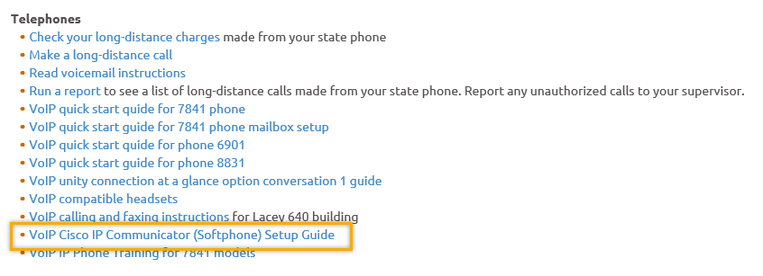
- Before submitting a service, request review these suggestions as the services desk will ask you to run through these steps. Many times, this resolves your issue without a service request!

  - Remember to log out of ETO, clicking off the browser tab here does not end your ETO session and will create issues when you log in again.
      - Always logout by opening your profile menu and clicking “Logout”
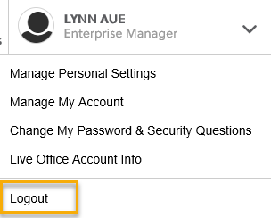
  - If you were impersonating a seeker or recruiter from ETO to WSWA remember to end the session, found in the upper left-hand corner. Clicking off your internet browser tab does not end impersonation!
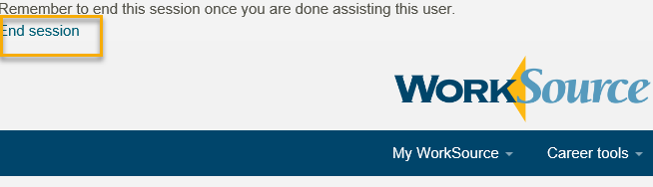

- For best performance clear your cache weekly

  - Internet Explorer (IE): Clearing IE cache starts from the top right side of the browser bar, click the settings icon and select Internet Options
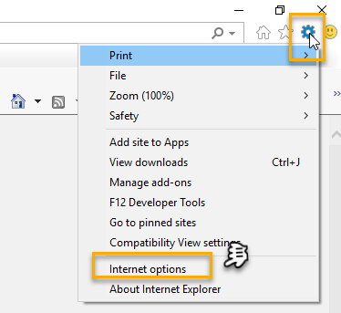

    - From the “General” tab click “Delete” which takes you to the “Delete Browsing History” screen. If not already checked click on the 2 boxes outlined here and click “Delete” you will return to the “General” tab

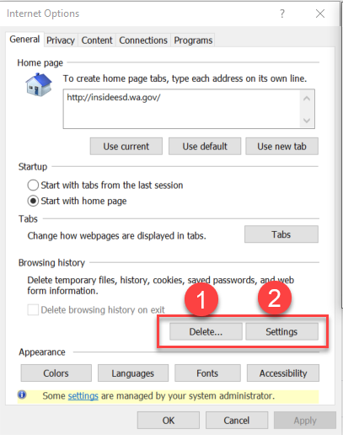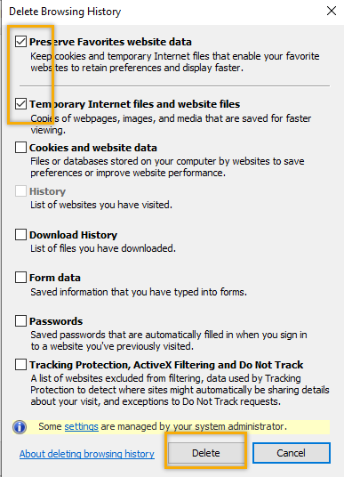

    - Next click “Settings” and if not selected click the radio button for “Every time I visit the webpage” This ensures you are using the most up to date version of ETO. Click OK
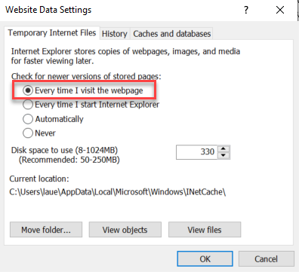
      - You will return to the General tab and click Apply and OK to complete the process of clearing your cache

  - Clearing Chrome cache starts from the top right side of the browser bar
- Click the triple dots to open the Chrome tools menu
- Hover over “More tools”
- Click “Clear browsing data” which opens a new screen
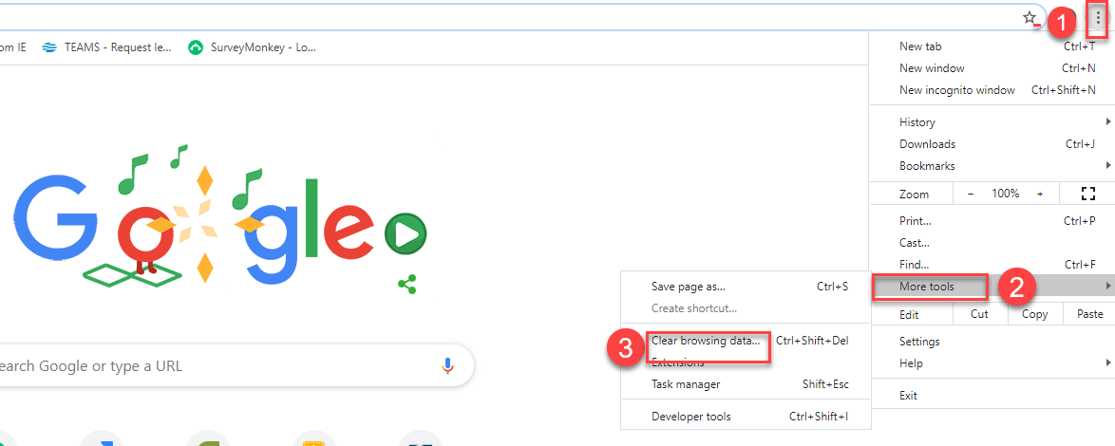

- Click “Clear data”
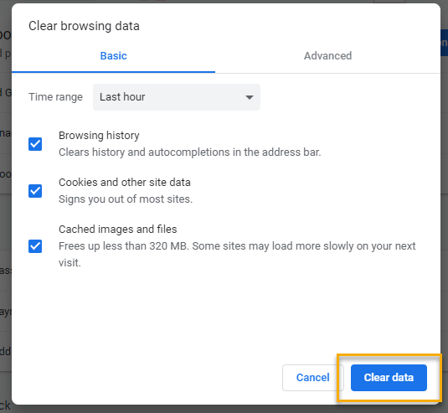

  - Finish by restarting your computer
  - If you still experience issues submit a service request https://wpc.wa.gov/tech/issues
CHAT
Will you be sending out invites for the training next week? The information for next week’s training will be sent out via ETO email or through the T12 distribution list.
Will this be record? The PowerPoint presentation, FAQ’s and a video of the MFA training is on the WPC site here: https://wpc.wa.gov/tech/ETO-refresher-training
Can you update phone number as needed later? Yes, your phone number can be updated anytime your contact changes. However, after 9/14 if you haven’t added a phone number you will be locked out of ETO and will need to submit a service request to unlock your ETO account.
What if your desk phone is forwarded to your cell phone? We don’t have an answer now but will look into it and let you know next week.
Just had a staff member identify she is locked out of her ETO account due to inactivity and opened a remedy ticket. She was told we have to have her reauthorized through our WDA. We are aware that many staff have been supporting UI and haven’t logged into ETO for over 90 days. We are putting a hold on that process until next month. If you have staff who are locked out of ETO an access request needs to be submitted by that WDA’s Access Approve. The information for ETO access is found here https://wpc.wa.gov/tech/security
Is there a way to extend the log off time on ETO? I often have to sign in multiple times a day. No, there is a state
Will we be notified if we (or our staff) have an exception in ETO? If you or your team have an exception to MFA, you'll be notified. as long as we know about it! NOTE: We will follow up on why those who submitted a survey have not been notified.
Those reporting they didn’t receive a response to the survey and are expecting guidance. Emily Anderson, Aaron Parrott, Katherine Congleton
Can this be done right way before 09-14-2020? Yes, the time to do it is now so you won’t be locked out on 9/14/20
When the authentication code is sent out after phone number is entered? The authentication code is sent out when you first attempt to log in AFTER 9/14/20
I know you said no to personal phones... Our company reimburses our phone payments as we use them for business as well. Can we use these phones for MFA? The recommendation is not to use personal phones due to public disclosure laws. However, it is up to you and your agency if you choose to use a personal phone.
Those reporting they did not receive a survey: Robbin Gard – Felica Johnson WS Pierce, Marla McMackin - Katherine Hesseltine - Jing Ko WS Rainier, TC Futures Columbia Basin, fC.Martin Rainier WS, Marla McMackin Benton Franklin WS, JNavarro WorkSource Sunnyside
Is that "homeless" information voluntary or required? I can see reluctance in responding to the question worded this way. DO they have to though? Or can it be skipped? The homeless question requires an answer. We received comments that it is a federal requirement, but I reached out to Seth Maier the Veteran program Operator for the final answer to this question.

ATTENDEES
Aaron Parrott
Adelp
Adrian Alegria
Adrianne Moreno
Amanda Stanley
Amy Gimlin
Arturo Espinoza
Ashewayene
Ashley Dittmer
Becky Smith
Bjones
Bolivero
Brandon
Brooke Zielinski
C Martin
Caller 5
Caller 6
Catherine Geddis
Chanda Robertson
Chris File
Claire B
Colleen Cook
CShaffer
Cynthia Kressin
Daniel Ledgett
David Gutierrez Betancourt
Dawn Oakes
Dean Coxford
Diane Luoma
Donetta Hanson
Dorothy Rocha
E Cox
Emily Anderson
EPahulu
Eric Lee
Felicia Johnson
Gdram
Hope Baker
Irene Jordan
Jeanette Elizabeth
Jeniifer Prewitt
JFenton
J Navarro
Jing Ko
John Moysiuk
Jordan Saunders
KatherineC
Kbanerjee
KHesseltine
Kimberly Chase
KKing
Krista Barge
Kristi Williams
Kylie Bartlett
La Qwana
Larry Allen
Lena Moses
Lisa Pietkauskis
Loretta Thomas
Marc
Maria Mondragon
Maria Zaragoza
Marla McMackin
Mary Sterling
Melisa Flores-Sanchez
Mgarza
Michael Ensor
Michael Ramos
Mila Cherchenko
Mirayia Chacon-Baker
Mitch McGeary
Mmaldonado
Monica Garza-Acevedo
Monica Reyes
Mreeves
Nadezhdal
Nancy Zellers
Norton Sweet
OMolett
Petra Barba
Pochi Ostergren
Rachel Gehrman
Regina Cancel
Rhianna Johnson
Robbin Gard
Rodolfo Aparicio
Sarah
Sean McElligott
Selma Tekle
Shannon Booth
Sieglinde Wright
Skyler Blumenthal
Talia Ni Dufaigh
TAphkas
Teresa Southard
Thyda Lim
Tiffany Plous
Tom Nguyen
Toni Burow
Tracy Ferrell
Vdamneun
Victoria Wood
Vkemp
VMcKerlie
Warsame Roble
Wendy Yunker
Yoli Alvear-Macke
Young Suh
Yvette Dallas
Zoryana Bilous

Second Half Attendance

