T12 Meeting Minutes 9-16-2020
New Business
- ETO Enhancements –
  - Multi-Factor Authentication (MFA) will deploy on 9/21/20. Find the MFA Presentation PowerPoint, demo video and FAQ’s here https://wpc.wa.gov/tech/ETO-refresher-training
    - Preparation for MFA in ETO production requires you enter your work phone number in ETO (says Cell Phone but does support a land line) by opening your profile and clicking the “Manage My Account” menu and entering your work number.

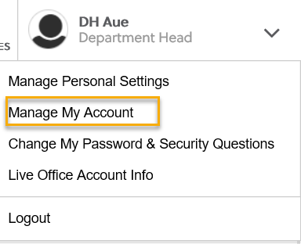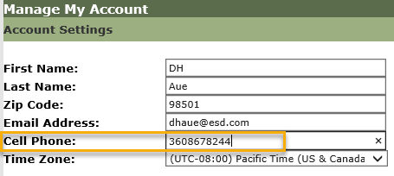
- Create an ETO Participant record by staff to record services
  - Implementation date TBD
- Tickets into production –
  - WA-3873 Update Outcomes Completion TP – Youth Credentials dropdown change
    - Replace “Attained a GED or high school diploma” with “Attained a GED or HiSET (recognized secondary school diploma equivalent)”
  - WA-3899 Services part of an ITA should only be for:
    - Apprenticeship Training
    - Customized Training (2.0)
    - Entrepreneurial Training (2.0)
    - Occupational Skills Training (2.0)
    - Occupational Skills Training (Youth Only)
- ETO maintenance – Nothing this week
- Velaro maintenance –
  - Scheduled for September 18, 2020, 3:30 am for 1 hour. We don’t expect any impact to service only a brief interruption.
- Training issue(s) of the week –
  - Please: Submit remedy tickets for all work requests, my team cannot begin work without a service request. Thanks!
- ETO Engage Survey – Work on desk aid/training materials is on hold at this time
- Open discussion
  - Boeing Program Enrollments
    - Currently there are no active Boeing Program of Enrollments although there are 2 available in the PE drop down menu. When meeting with former Boeing workers do not use those program but when appropriate, you can enroll them into TAA, WIOA programs or other programs that services may be available to the dislocated worker.
    - WIA NEG PE is no longer in use. Do not use.
- UI announcements –
  - FEMA’s lost wages program. 2 weeks @$300. Weeks August 1-15. More information Lost Wages Assistance program.
  - On September 2, FEMA’s lost wages program were approved 2 additional weeks ending August 22 and 29. Today, 9/8/20, the week ending September 5 is approved.
  - Mandatory job search requirement is targeted to begin 10/1/2020
During the week of August 30 through September 5, there were 20,006 initial regular unemployment claims (up 10.1% from the prior week) and 531,425 total claims for all unemployment benefit categories (down 6.5% from the prior week) filed by Washingtonians, according to the Employment Security Department (ESD).
  - Initial regular claims applications remain at elevated levels and are at 299 percent above last year’s weekly new claims applications.
  - Regular Unemployment Insurance, Pandemic Unemployment Assistance (PUA) and Pandemic Emergency Unemployment Compensation (PEUC) initial claims increased over the previous week.
ESD paid out over $177.7 million for 356,680 individual claims – a decrease of $1.2 million and 609 less individuals compared to the prior week.
- ESD.wa.gov or ESD Facebook page for current UI information
- Before submitting a service ticket help
Old Business
- Encourage all staff who use ETO and WSWA to sign up for the T12 calls. These calls are not just for trainers but for all system users and a great way to stay up to date on changes or improvements to ETO and WSWA. Send requests to esdgpWSSteam@esd.wa.gov to be added to the ITSD Training Team’s distribution list
- WorkSource Systems resources found on the WPC Technology site https://wpc.wa.gov/tech
  - We try our best to make sure all the links are operational but depend on you to submit a remedy ticket if you find broken links!
- ETO Basic and Refresher Training
  - ETO Basic training is the 1st Monday 10-12 and 3rd Tuesday 2-4 of every month (except when these days fall on holidays). Send email to Lynn Aue to receive more information and be added to the training Webex call.
  - Training recordings and user guides are posted on the WPC website here https://wpc.wa.gov/tech/ETO-refresher-training
  - Submit a remedy ticket asking Lynn Aue for additional training opportunities and training resources
- Stay up to date on COVID19, teleworking and WorkSource Virtual services. Check out the information the WPC website to help all WorkSource staff telework.
  - IT service delivery
  - WebEx
    - Browse the Webex handbook and watch 5 videos on how to make the most out of this tool for conducting meetings with staff and customers.
  - Other resources include:
    - Now that you are teleworking reference guide
    - How to use SKYPE for online meetings
    - How to sign into ESD email from outside the network
    - How to sign into an off-site Wi-Fi from your computer
    - Can I access Internet Explorer from a MAC computer?
    - ESD service Desk information.
- Data Clean-up reminder: We appreciate your help cleaning up the ETO data so records are not excluded from federal reporting. We will discuss other clean-up efforts at T12 and Advisory meetings.
- We are seeking ETO Improvements ideas
  - ETO improvement ideas or current work arounds should be submitted through the remedy ticket system https://wpc.wa.gov/tech/issues
  - Tickets are reviewed to determine if your idea or work around is a training issue or needs to go through the governance process for a system change
- UI Fraud help
  - www.esd.wa.gov/fraud
  - Fax information to claims centers 833-572-8423 –calling is not recommended due to the high volume of calls
  - Reviewing our web resources with them. Some helpful pages include:
- Employee FAQs
- Employee instructional videos
- How to file weekly claims
But you CAN’T help by:
  - Contacting an intake agent at the claims center and asking them to review your friend or family member’s claim or solve their issue.
  - Using your influence to move your friend or family member’s claim up the queue to be processed faster.
  - Using your influence to give any kind of advantage to your friend or family member.
  - Using your access to UTAB, if you have it, to give someone information about their claim.
  - Using your friend or family member’s SAW account and applying for benefits or submitting their weekly claims for them.
- Cisco Softphones training material Link http://insideesd.wa.gov/services/it-services
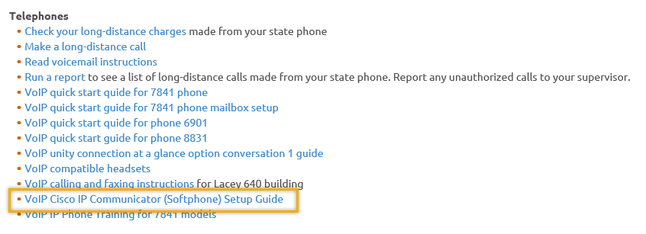
- Before submitting a service, request review these suggestions as the services desk will ask you to run through these steps. Many times, this resolves your issue without a service request!

  - Remember to log out of ETO, clicking off the browser tab here does not end your ETO session and will create issues when you log in again.
      - Always logout by opening your profile menu and clicking “Logout”
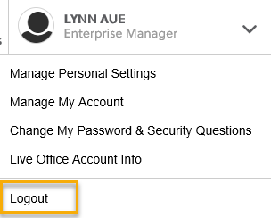
  - If you were impersonating a seeker or recruiter from ETO to WSWA remember to end the session, found in the upper left-hand corner. Clicking off your internet browser tab does not end impersonation!
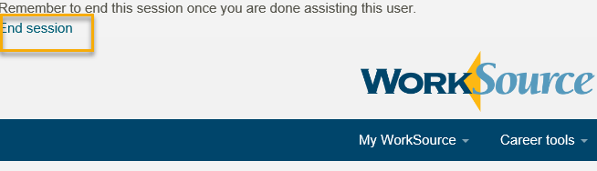

- For best performance clear your cache weekly

  - Internet Explorer (IE): Clearing IE cache starts from the top right side of the browser bar, click the settings icon and select Internet Options
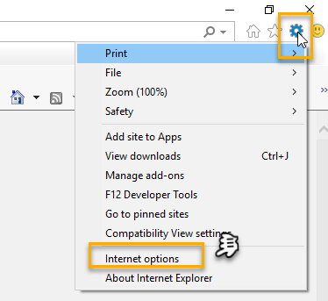

    - From the “General” tab click “Delete” which takes you to the “Delete Browsing History” screen. If not already checked click on the 2 boxes outlined here and click “Delete” you will return to the “General” tab

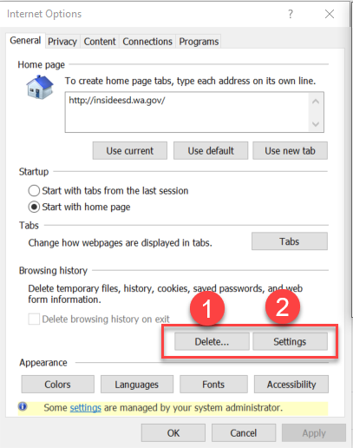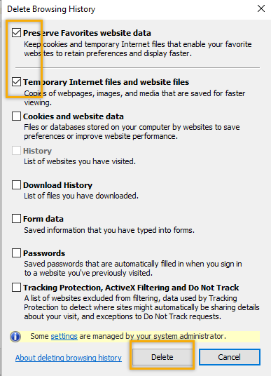

    - Next click “Settings” and if not selected click the radio button for “Every time I visit the webpage” This ensures you are using the most up to date version of ETO. Click OK
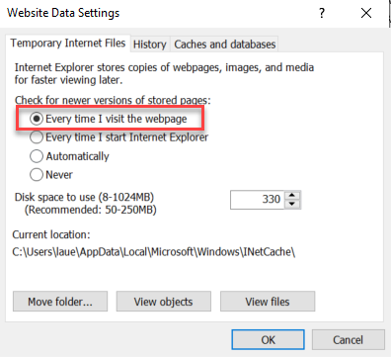
      - You will return to the General tab and click Apply and OK to complete the process of clearing your cache

  - Clearing Chrome cache starts from the top right side of the browser bar
- Click the triple dots to open the Chrome tools menu
- Hover over “More tools”
- Click “Clear browsing data” which opens a new screen
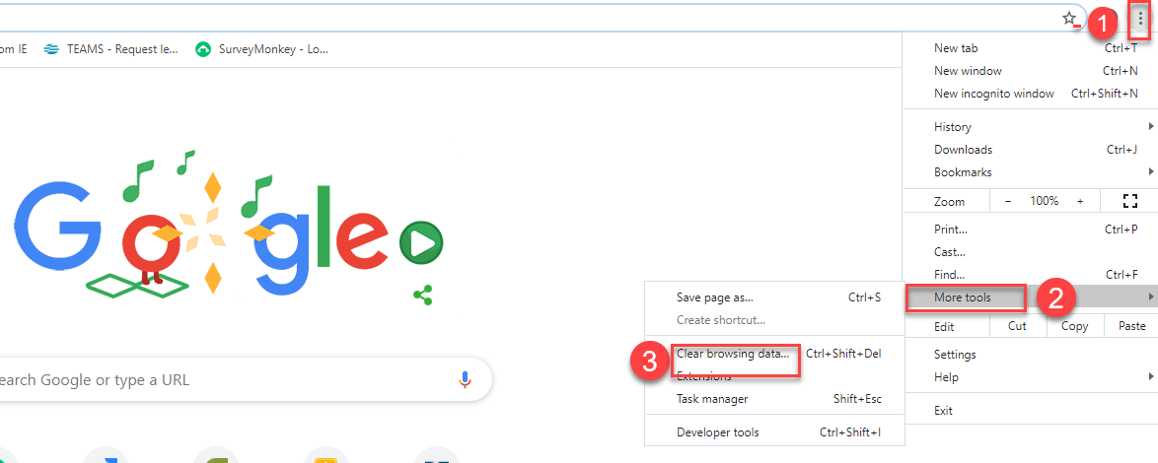

- Click “Clear data”
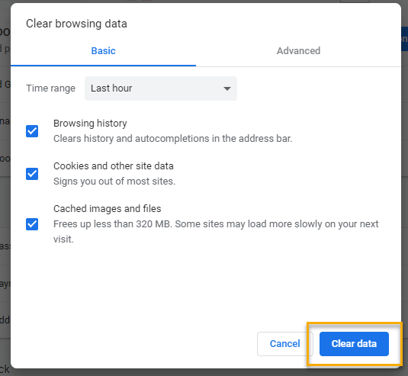

  - Finish by restarting your computer
  - If you still experience issues submit a service request https://wpc.wa.gov/tech/issues
CHAT
from Emily Anderson to everyone: 10:09 AM
Do those of us who entered numbers already and have now had it defaulted to Afghanistan need to go in and change it?
A script has been run intended to change everyone’s country code back to the US. If your account still has Afghanistan as its country code, please change it to the US (and let us know).

from Christina Pitts to everyone: 10:14 AM
What happens if we use our cisco desk number but don't have access to receive the code
from Skyler Blumenthal to everyone: 10:14 AM
Do you mean soft phone? Christina
from Christina Pitts to everyone: 10:14 AM
yes
If you have a cisco soft phone, you can still use that phone number as an acceptable means of receiving a code. It will be treated as a landline, so will require answering the call that comes when you attempt to login, and hearing the code given audibly.

from Linda Hollingsworth to everyone: 10:14 AM
Can we get a longer length of time before ETO times out on us?
No. ETO will log users out from inactivity due to legal guidelines.

from Elizabeth Ibanez to everyone: 10:16 AM
I already entered a work cell phone number, do I need to change anything?
from Skyler Blumenthal to everyone: 10:17 AM
No Elizabeth, you're all set! MFA goes live on the 21st, so after Monday when you log in for the first time, you'll get the authentication code.

from C.Martin to everyone: 10:21 AM
If we use google voice on our phone — would our personal phone still be subject to those terms (litigation allowing access to the device)
We are going to be following up with policy on this question. If it is a personal device then it will be subject to public disclosure. If you are logged into your personal google account on your work device there may be previous policies lined out about other data and MFA would adhere to those same policies.

from C.Martin to everyone: 10:28 AM
Notification that pops up on ETO when entering in telephone number — “ the telephone consumer protection act regulates the use of automated telephone equipment for text messages. The TCPA provide that you may be subject to damages the start is $500 and rise up to $1500 per recipient for each text message sent. Prior express consent of the owner of each entered phone number is required for text messages sent through these services.
What does this mean?
from Skyler Blumenthal to everyone: 10:31 AM
I will look more into it!
From ETO Devs: “It’s just a legal warning that you are approving that text messages can be sent to them and are not spam (basically). No harm in clicking ok - literally just a heads up that the user about it. Thanks!” (ref: WA-3906)

from Tracy Ferrell - EWP to everyone: 10:32 AM
Do you want remedy tickets for the phone issues that may occur, or should the employee call you directly?
Please submit a remedy ticket if you or an employee are having issues logging in, especially if it is related to MFA.

Regarding the survey sent out for MFA exemptions:
from Skyler Blumenthal to everyone: 10:36 AM
I believe that was sent shortly after T12 last week
from Emily Anderson to everyone: 10:37 AM
Did WDCs receive that? I don't think we've got it on our side.
from Emily Anderson to everyone: 10:37 AM
Ok. Thanks. I'll check on it.
from Skyler Blumenthal to everyone: 10:38 AM
Look for an e-mail from Rebecca on Sept 4th. If you have any questions about accounts that may not be eligible to have a phone number registered for MFA, shoot me an e-mail directly and I can forward anything you might need. sblumenthal@esd.wa.gov

from vdamneun to everyone: 10:26 AM
Can ETO Trainers have copy of your training materials?
Please see https://wpc.wa.gov/tech/ETO-refresher-training for training materials

Regarding creating a record in ETO:
from Emily Anderson to everyone: 10:19 AM
Is there a way we can identify those folks when we request access for new ETO users?
from Emily Anderson to everyone: 10:20 AM
Yes. It would be great if you could send this info to all access approvers.
Lynn will send out guidance to all ETO access approvers
from Emily Anderson to everyone: 10:20 AM
Thanks Lynn!

from Sandra Kint to everyone: 10:37 AM
The invite indicated you would be discussing " adding additional time to demo and provide training documentation on the “Create an ETO Participant Record” process." will you be doing that today?
from Sandra Kint to everyone: 10:38 AM
Thank you, my speaker wasn't working in the beginning, missed that!
from KHesseltine to everyone: 10:38 AM
can we not enter participants now?
from Sandra Kint to everyone: 10:39 AM
So, that's a good place to check regularly.
Create an ETO Participant Record training has been postponed for the moment. Implementation has also been delayed

ATTENDEES
Hickmon
Abby Taft
Adeline Kerns
A Hughes
Aj miller
Alisa Shaffner
Amy
Arturo Espinoza
Becky Smith
Boliveri
Bzanto
C. Martin
Caller 3
Called 4
Caller 6
Carolyn Holmes
Catherine Geddis
Christina Pitts
Claire B
Claudette Dean
Clayton Haycraft
Cori Ching
Crystal Armitage
Crystal Wink
C Shaffer
Dan Cooling
Daniel Ledgett
Dawn Oakes
Dean Coxford
Diane Luoma
Donna Mack
Dorothy Rocha
Elizabeth Ibanez
Emily Anderson
Felicia Johnson
Gracie Troncoso
Joanie Linder
John Moysiuk
Katherine C
Kendall King
Kim Bursell
Kimberly Chase
KKing
K Hesseltine
Kim Bursell
La Qwana
Linda Hollingsworth
Lisa Pietkauskis
Luci Bench
Marc
Maria Zaragoza
Marla McMackin
M Dominguez
Mei-Ling Taylor
Melisa Flore-Sanchez
Mitch McGeary
MReeves
Nataliya Solti
Nicholas Towne
Noel Woods
Petra Barba
P Webster
Reginal Cancel
Robbin Gard
Sandra Kint
Sean McElligott
Sean Wiley
Selma Tekle
Seth Maier
Shawn Brookshier
Skyler Blumenthal
Talia Ni Dufaigh
Teresa Anda
Thomas Anderson
Toni Burow
Toni Esper
Tracy Ferrell
Tyler Cole
Vdamneun
Victor kemp
Zoryana Bilous

Second Half Attendance

