T12 Meeting Minutes 8-5-2020
New Business
- WA-3865 Impersonation issue
  - Vendor is working on this, may be a delay due to the storms on the east coast. Will provide updates through ETO email
- Tickets into production –
  - WA-3855 New Program of Enrollment - COVID-19 Employment Recovery DWG for all WDAs.
    - No new services required
    - New WIN and guidance will be provided during the T12 call before implementation into production
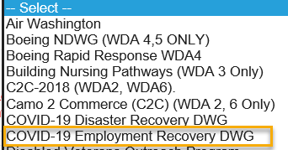
- Multi-Factor Authentication (MFA) defined: A security measure required to protect job seeker and employer private data. MFA in ETO will required users authenticate their ETO account once a month by entering a password that is sent by phone or text to you.
  - What you need to do now to prepare for MFA in ETO production?
    - Enter your work phone number in ETO (does not required a cell number) by opening your profile and opening the “Manage My Account” menu.

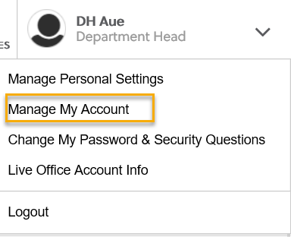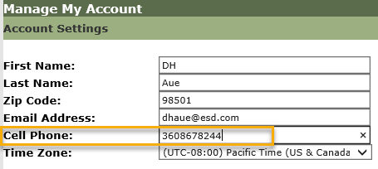
    - What if I don’t have a work number? We are aware that some don’t have work phones at this time. Contact your supervisor so they can can submit a service request to get you set up with a phone or the Softphone computer application.
    - We are working on additional training material to walk you through the next steps. Stay tuned!
- ETO Maintenance – Nothing this week
- ETO Enhancements – Follow-up on the 5/21/20 release
  - WA-3523: The change to recognize those who live on JBLM base is functioning as expected in WSWA and the information can be found in the job seekers demographic details.
- Training issue(s) of the week –
  - Please: Always submit remedy tickets for all work requests, my team cannot begin work without a service request. Thanks!
  - Read ETO messages
- ETO Engage Survey – testing the best practices from survey and creating training material. Will report out results
- ETO issues – open discussion
  - T12 notices meetings
  - ETO Basic Training beginning August
  - 1st Monday 10-11:30
  - 3rd Tuesday 2-3:30
  - Is posted on Staff development calendar. To register email Lynn Aue and include the date you want to take the training
- UI announcements –
During the week of July 26 through August 1, there were 24,985 initial regular unemployment claims (down 13.4% from the prior week) and 656,556 total claims for all unemployment benefit categories (down 3.1% from the prior week) filed by Washingtonians, according to the Employment Security Department (ESD).
  - Initial regular claims applications remain at unprecedented elevated levels and are at 524 percent above last year’s weekly new claims applications.
  - Pandemic Unemployment Assistance (PUA), Pandemic Emergency Unemployment Compensation (PEUC) initial claims decreased over the previous week while continued/ongoing claims increased over the same time period.
Since the week ending March 7 when COVID-19 job losses began:
  - A total of 2,333,456 initial claims have been filed during the pandemic (1,473,262 regular unemployment insurance, 460,478 PUA and 399,716 PEUC)
  - A total of 1,287,949 distinct individuals have filed for unemployment benefits
  - ESD has paid out over $9.2 billion in benefits
  - 985,689 individuals who have filed an initial claim have been paid
- Work search will continue to be optional through September 1.
- Claimants filing new claims with and EDC of August 2 or later will be required to serve a wait week.
- PUA Additional weekly benefit will continue, the amount is still being determined by Congress
- Extended Benefits (EB) is available starting July 5, 2020 for claimants who have exhausted all regular benefits an extension in any state. Claimants must have at least on week of their benefit year within an EB payable period. Must have a BYE (Benefit year-end) of May 30, 2020
- ESD.wa.gov or ESD Facebook page for current UI information
- Before submitting a service ticket help
Old Business
- Encourage all staff who use ETO and WSWA to sign up for the T12 calls. These calls are not just for trainers but for all system users and a great way to stay up to date on changes or improvements to ETO and WSWA. Send requests to esdgpWSSteam@esd.wa.gov to be added to the ITSD Training Team’s distribution list
- Stay up to date on COVID19, teleworking and WorkSource Virtual services. Check out the information the WPC website must help all WorkSource staff telework.
  - IT service delivery
    - All phone requests need to go through your office Administrator and/or Supervisor
    - Your needs are important to us! Please be patient with the ESD help desk staff, they are slammed and priority of service is set by our Executive Leadership.
  - WebEx
    - Browse the Webex handbook and watch 5 videos on how to make the most out of this tool for conducting meetings with staff and customers.
  - Other resources include:
    - Now that you are teleworking reference guide
    - How to use SKYPE for online meetings
    - How to sign into ESD email from outside the network
    - How to sign into an off-site Wi-Fi from your computer
    - Can I access Internet Explorer from a MAC computer?
    - Will the WSS Team be available to help us while working remote?
    - ESD service Desk information.
- UI Fraud help
  - www.esd.wa.gov/fraud
  - fax information to claims centers 833-572-8423 – calling not recommended due to the high volume of calls
- Tips from the Commissioner
  - Telling those who know they were victims of unemployment imposter fraud to NOT apply for benefits or try to access their eService’s account until they receive instructions from ESD. We need to first disconnect their stolen Social Security number from the fraudulent claim. We’re prioritizing that work. Their application process will go smoother for them if they wait until we’re done.
  - Then, we’ll send them special instructions for applying. We’re working on them now and will send before June 28.
  - Telling them what else ESD is doing right now to help:
    - SharedWork have been hosting webinars with state agency human resources staff to explain the ins and outs of SharedWork. Each agency needs to apply before employees can apply.
    - Coming soon: hosting webinars with state employees to explain SharedWork. The dates are not final yet.
  - Reviewing our web resources with them. Some helpful pages include:
- Employee FAQs
- Employee instructional videos
- How to file weekly claims
But you CAN’T help by:
  - Contacting an intake agent at the claims center and asking them to review your friend or family member’s claim or solve their issue.
  - Using your influence to move your friend or family member’s claim up the queue to be processed faster.
  - Using your influence to give any kind of advantage to your friend or family member.
  - Using your access to UTAB, if you have it, to give someone information about their claim.
  - Using your friend or family member’s SAW account and applying for benefits or submitting their weekly claims for them.
- Cisco Softphones training material Link http://insideesd.wa.gov/services/it-services
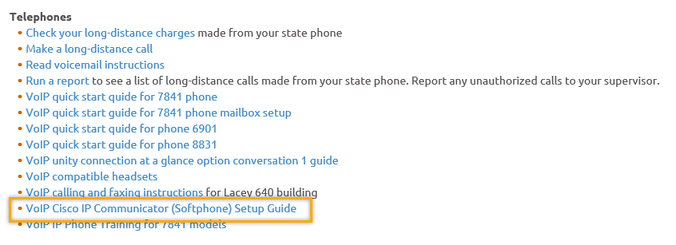
- Data Clean-up reminder: We need your help cleaning up the ETO data, so records are not excluded from federal reporting. This is also an important task for future migration efforts to another case management system. We will discuss these clean-up efforts at T12 and Advisory meetings.
- We are seeking ETO Improvements ideas
  - ETO improvement ideas or current work arounds should be submitted through the remedy ticket system https://wpc.wa.gov/tech/issues
  - Tickets are reviewed to determine if your idea or work around is a training issue or needs to go through the governance process for a system change
- ETO Refresher Training
  - Training recordings and user guides are posted on the WPC website here https://wpc.wa.gov/tech/ETO-refresher-training
  - Submit a remedy ticket asking Lynn Aue for additional training opportunities and training resources
- WorkSource Systems resources found on the WPC Technology site https://wpc.wa.gov/tech
  - We try our best to make sure all the links are operational but depend on you to submit a remedy ticket if you find broken links!
- Before submitting a service, request review these suggestions as the services desk will ask you to run through these steps. Many times, this resolves your issue without a service request!

  - Remember to log out of ETO, clicking off the browser tab here does not end your ETO session and will create issues when you log in again.
      - Always logout by opening your profile menu and clicking “Logout”
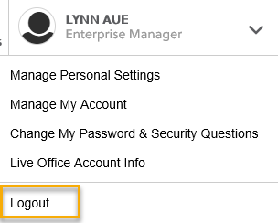
  - If you were impersonating a seeker or recruiter from ETO to WSWA remember to end the session, found in the upper left-hand corner. Clicking off your internet browser tab does not end impersonation!
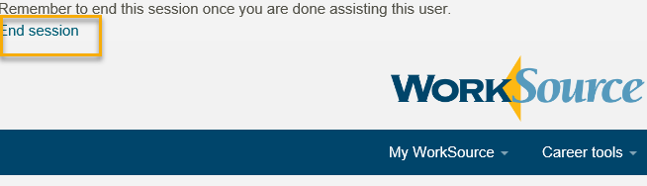

- For best performance clear your cache weekly

  - Internet Explorer (IE): Clearing IE cache starts from the top right side of the browser bar, click the settings icon and select Internet Options
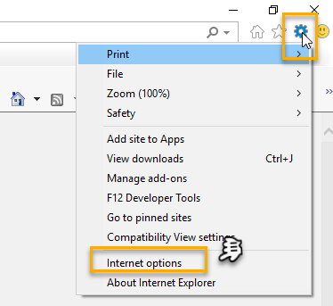

    - From the “General” tab click “Delete” which takes you to the “Delete Browsing History” screen. If not already checked click on the 2 boxes outlined here and click “Delete” you will return to the “General” tab

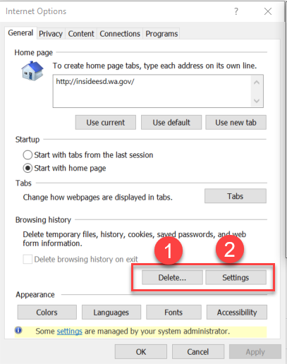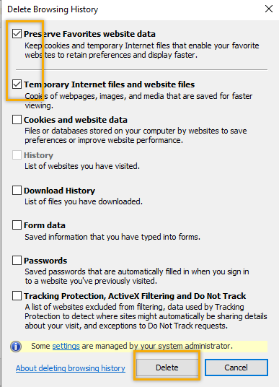

    - Next click “Settings” and if not selected click the radio button for “Every time I visit the webpage” This ensures you are using the most up to date version of ETO. Click OK
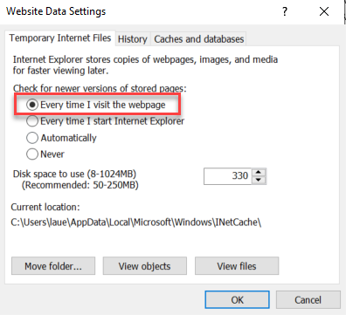
      - You will return to the General tab and click Apply and OK to complete the process of clearing your cache

  - Clearing Chrome cache starts from the top right side of the browser bar
- Click the triple dots to open the Chrome tools menu
- Hover over “More tools”
- Click “Clear browsing data” which opens a new screen
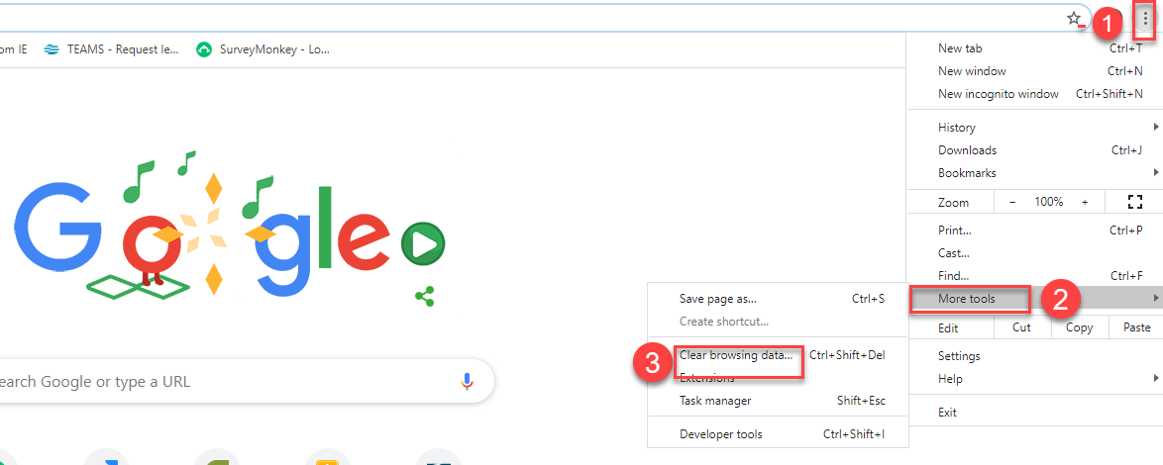

- Click “Clear data”
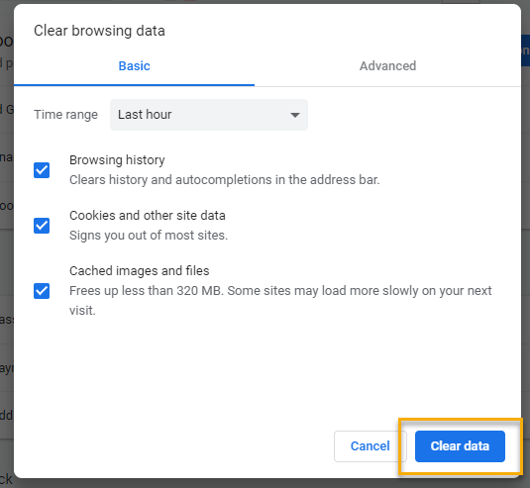

  - Finish by restarting your computer
  - If you still experience issues submit a service request https://wpc.wa.gov/tech/issues
CHAT
Noel Woods
What is the difference between Covid 19 Disaster Recovery DWG and Covid 19 Employment Recovery DWG. You can get information from the WIN0114 and WIN0115 found on the WPC site on the policy tab, read the TEGLs and contact your WDA leaders
Elizabeth Ibanez
For the purpose of authentication, can also an email would an option? Not at this time but we are looking into it. Would you be sending the link to register for trainings? Check out the staff development calendar to choose a date and send an email to Lynn Aue including the date you want training. I would like to take the refresher, and more training. Thank you so much!
Claire B
Can we use a google voice number for MFA? Mitch McGeary @Clarie B, I researched and Authy MFA does support Google Voice accounts. Please ensure that your Google account is also protected by a second factor (2FA) =)

ATTENDEES

Aaron Parrott
Adeline Kerns
adelp
Ahughes
Amanda Standley
Amy Gimlin
Amanda Standley
Arthuro Espinoza
Becky Smith
Boliveri
Brooke Zielinski
Business
C2C Guest
Catherine Geddis
Claire B
Cori Ching
CShaffer
Daniel Cooling
Dawn Oakes
Dean Coxford
Diane Luoma
Donna Mack
Dorothy Rocha
Elizabeth Ibanez
Emily Anderson
Gracie Troncoso
Heidi Lamers
Hope Baker
Irene Jordan
Jeanette Elizabeth
Jeffrey Flood
Joanie Linder
Katherine C
Kim Bursell
Kimberly Metcalf
KKing
La Qwana
Linda Venera
Lisa Pietkauskis
Lori Ries
Luci Bench
Lux Dmitri
Maria Zaragoza
Mary Zaragoza
MDominguez
Melisa Flores-Sanchez
Mitch McGreary
Noel Woods
Rachel Gehrman
Realani Rulona
Regina Cancel
Rodolfo Aparicio
Rosemary Henry
Sean McElligott
Selam Tekle
Shannon Booth
Skyle Blumenthal
Sue Keltner
Teresa Anda
Tim Robison
Toni Burrow
Tracy Ferrell -EWP
Vdamneun
Victoria Wood
Young Suh
Yvette Dallas

Second Half Attendance

