T12 Meeting Minutes 8-26-2020
New Business
- ETO Enhancements –
  - Multi-Factor Authentication (MFA): Demo. MFA Presentation PowerPoint, demo video and FAQ’s are found here https://wpc.wa.gov/tech/ETO-refresher-training
    - Preparation for MFA in ETO production requires you enter your work phone number in ETO (says Cell Phone but does support a land line) by opening your profile and clicking the “Manage My Account” menu and entering your work number.

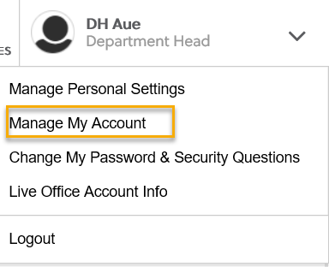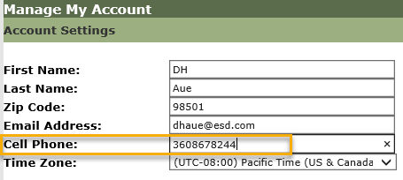
    - What if I don’t have a work number? We are aware some staff don’t have work phones at this time. Contact your supervisor so they can can submit a service request to get you set up with a phone or the Softphone computer application on your desktop.
    - A survey was sent out 8/20/20 to determine which office’s phone service supports MFA and to determine those who don’t have access to a direct phone line. We discovered during the call all offices did not receive the survey. We are sending the survey out to those who didn’t receive it.
    - Staff with phone extensions or those who don’t have direct phone lines will be temporarily exempted from MFA until a solution is found.
    - Demo 8/26/20, 9/2/20, 9/9/20 during the T12 meeting. All ETO users will be invited to attend via ETO internal email sent out the Monday prior to Webex meeting.
- Create an ETO participant record by staff so you can record services
  - Demo 9/2/20 and 9/9/20 during T12 call. All ETO users will be invited to attend via ETO internal email the Monday prior to call.
- Tickets into production – Nothing this week
- ETO Maintenance – Nothing this week
- Training issue(s) of the week –
  - Please: Submit remedy tickets for all work requests, my team cannot begin work without a service request. Thanks!
- ETO Engage Survey – Work on desk aid/training materials is on hold at this time
- ETO issues – open discussion if time permits
- UI announcements –
  - FEMA’s lost wages program. 3 weeks @$300, not $600. More information Lost Wages Assistance program.
  - Mandatory job search requirement is targeted to begin 9/1/2020
During the week of August 9 through August 15, there were 21,942 initial regular unemployment claims (down 0.9% from the prior week) and 589,631 total claims for all unemployment benefit categories (down 3.7% from the prior week) filed by Washingtonians, according to the Employment Security Department (ESD).
  - Initial regular claims applications remain at unprecedented elevated levels and are at 338 percent above last year’s weekly new claims applications.
  - Regular Unemployment Insurance, Pandemic Unemployment Assistance (PUA) and Pandemic Emergency Unemployment Compensation (PEUC) initial claims increased by 4.0 percent
ESD paid out over $198.6 million for 362,815 individual claims – a decrease of $74.4 million and 2/8,211 less individuals compared to the prior week.

Since the week ending March 7 when COVID-19 job losses began:
  - A total of 2,445,641 initial claims have been filed during the pandemic (1,519,550 regular unemployment insurance, 471,260 PUA and 414,831 PEUC)
  - A total of 1,302,868 distinct individuals have filed for unemployment benefits
  - ESD has paid out over $9.7 billion in benefits
  - 1,005,211 individuals who have filed an initial claim have been paid – nearing a third of the state’s workforce
- ESD.wa.gov or ESD Facebook page for current UI information
- Before submitting a service ticket help
Old Business
- Encourage all staff who use ETO and WSWA to sign up for the T12 calls. These calls are not just for trainers but for all system users and a great way to stay up to date on changes or improvements to ETO and WSWA. Send requests to esdgpWSSteam@esd.wa.gov to be added to the ITSD Training Team’s distribution list
- WorkSource Systems resources found on the WPC Technology site https://wpc.wa.gov/tech
  - We try our best to make sure all the links are operational but depend on you to submit a remedy ticket if you find broken links!
- ETO Basic and Refresher Training
  - ETO Basic training is the 1st Monday 10-11:30 and 3rd Tuesday 2-3:30 of every month (except when these days fall on holidays). Send email to Lynn Aue to receive more information and be added to the training Webex call.
  - Training recordings and user guides are posted on the WPC website here https://wpc.wa.gov/tech/ETO-refresher-training
  - Submit a remedy ticket asking Lynn Aue for additional training opportunities and training resources
- Stay up to date on COVID19, teleworking and WorkSource Virtual services. Check out the information the WPC website to help all WorkSource staff telework.
  - IT service delivery
  - WebEx
    - Browse the Webex handbook and watch 5 videos on how to make the most out of this tool for conducting meetings with staff and customers.
  - Other resources include:
    - Now that you are teleworking reference guide
    - How to use SKYPE for online meetings
    - How to sign into ESD email from outside the network
    - How to sign into an off-site Wi-Fi from your computer
    - Can I access Internet Explorer from a MAC computer?
    - ESD service Desk information.
- Data Clean-up reminder: We appreciate your help cleaning up the ETO data so records are not excluded from federal reporting. We will discuss other clean-up efforts at T12 and Advisory meetings.
- We are seeking ETO Improvements ideas
  - ETO improvement ideas or current work arounds should be submitted through the remedy ticket system https://wpc.wa.gov/tech/issues
  - Tickets are reviewed to determine if your idea or work around is a training issue or needs to go through the governance process for a system change
- UI Fraud help
  - www.esd.wa.gov/fraud
  - Fax information to claims centers 833-572-8423 –calling is not recommended due to the high volume of calls
  - Reviewing our web resources with them. Some helpful pages include:
- Employee FAQs
- Employee instructional videos
- How to file weekly claims
But you CAN’T help by:
  - Contacting an intake agent at the claims center and asking them to review your friend or family member’s claim or solve their issue.
  - Using your influence to move your friend or family member’s claim up the queue to be processed faster.
  - Using your influence to give any kind of advantage to your friend or family member.
  - Using your access to UTAB, if you have it, to give someone information about their claim.
  - Using your friend or family member’s SAW account and applying for benefits or submitting their weekly claims for them.
- Cisco Softphones training material Link http://insideesd.wa.gov/services/it-services
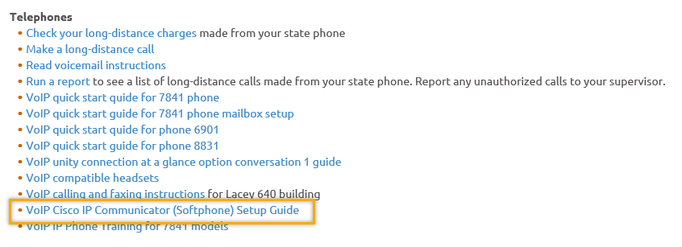
- Before submitting a service, request review these suggestions as the services desk will ask you to run through these steps. Many times, this resolves your issue without a service request!

  - Remember to log out of ETO, clicking off the browser tab here does not end your ETO session and will create issues when you log in again.
      - Always logout by opening your profile menu and clicking “Logout”
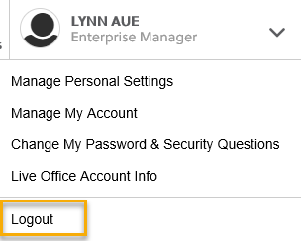
  - If you were impersonating a seeker or recruiter from ETO to WSWA remember to end the session, found in the upper left-hand corner. Clicking off your internet browser tab does not end impersonation!
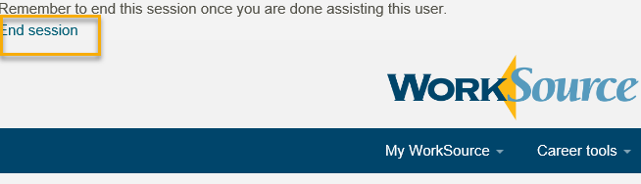

- For best performance clear your cache weekly

  - Internet Explorer (IE): Clearing IE cache starts from the top right side of the browser bar, click the settings icon and select Internet Options
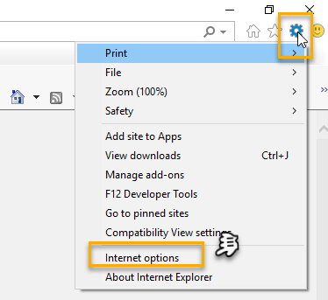

    - From the “General” tab click “Delete” which takes you to the “Delete Browsing History” screen. If not already checked click on the 2 boxes outlined here and click “Delete” you will return to the “General” tab

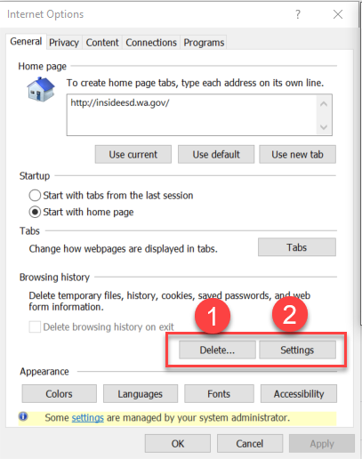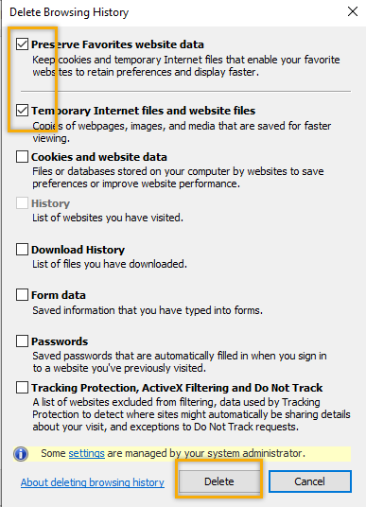

    - Next click “Settings” and if not selected click the radio button for “Every time I visit the webpage” This ensures you are using the most up to date version of ETO. Click OK
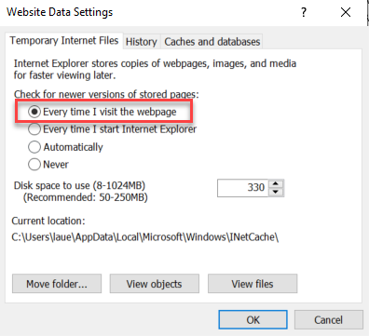
      - You will return to the General tab and click Apply and OK to complete the process of clearing your cache

  - Clearing Chrome cache starts from the top right side of the browser bar
- Click the triple dots to open the Chrome tools menu
- Hover over “More tools”
- Click “Clear browsing data” which opens a new screen
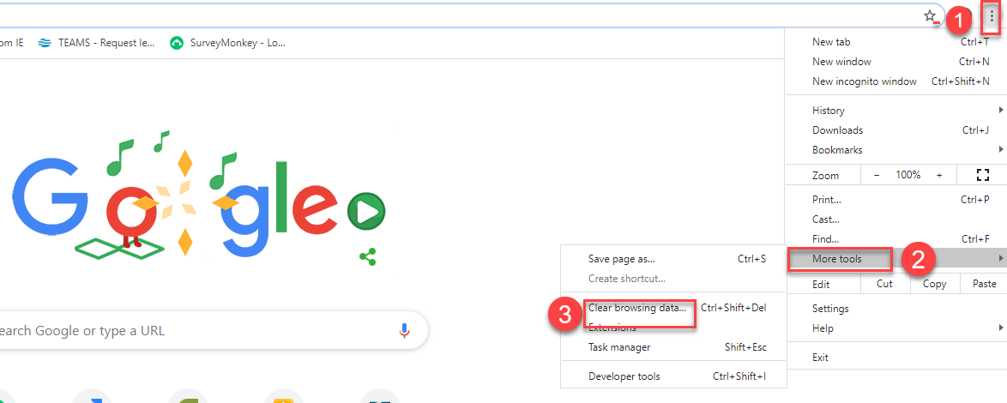

- Click “Clear data”
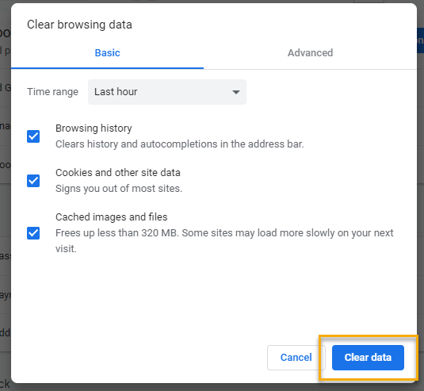

  - Finish by restarting your computer
  - If you still experience issues submit a service request https://wpc.wa.gov/tech/issues
CHAT
MFA is a security measure required to protect the private data stored in ETO related to job seekers and employers. To prepare for MFA you need to enter your work cell phone number or your work landline phone number into your ETO profile before September 14,2020.

The first time you log into ETO on September 14,2020, or after that time, you will receive an authentication code either by a text message on your cell phone or a voice message on a landline. You have 10 minutes to enter that authentication code into a box provided in ETO. If you do not enter the code within 10 minutes you will need to start the process again. If you enter the code incorrectly 5 times you will be locked out of your ETO account and will need to submit a remedy ticket to unlock your account.

If you do not enter a phone number before implementation of MFA to receive the authentication code by September 14,2020 you will need to submit a remedy ticket for the service desk to add your phone number and/or unlock your ETO account.

Those who need the survey: Aaron Parrot, Emily Anderson, Jacqueline Perry. Katherine Geddis, Teresa Sparks

Susan Montgomery WorkSource Colville, I don't have phone access: Contact your supervisor if you don’t have phone access. If you don’t have phone access on 9/14/20 your ETO will be exempted from MFA until this issue is resolved.
What if we don’t have a work cell number? MFA can be done using a cell phone or land line. Cell phones will receive a text message, land lines will receive a phone call to verbally tell you the access code

Will we receive a reminder each month as to what day it will renew? So, we can anticipate? No, every 30 days when you log into ETO an authentication code will be sent to the phone you entered into your ETO profile.
If we do not log in for several months, how will that work? Per ESD policy 2010, inactive ETO accounts will be disabled. So, if you haven’t logged in for 90 days your account will be inactive and you will need to ask your supervisor to make an access request. The first time you log into ETO you will be sent an authentication code to activate your account or the next time you log in after 30 days has elapsed you will get the Authentication code message
Garth Soltman UI/TRA unit: Has this been tested with claim center soft-phones SIP soft phone? I believe this is different than other staff's soft phones? We don’t know the answer to this but are testing it before implementation.
When the contact number is a landline, what exact information will be provided? numeric only, alpha only, or alpha-numeric? Will it the information be relying on the "reading" of a text by the system? The authentication code is numeric only and is repeated 3 times before it ends.
Will it leave a voice mail if you don't answer it quickly enough? With the voice message, does it repeat the "number" or just a single time? It repeats the number 3 times, but it will start providing the code as soon as the phone answers and may not provide time to “listen” to your voicemail message so may not provide enough time to record the code. If you miss the call press cancel and start the process over. You must use your direct line phone number, not an extension. If your phone line doesn’t have the capability to do this send an email to request an exception esdgpwssteam@esd.wa.gov or submit a remedy ticket
We are using our work phone # or personal? You are not to use your personal phone number, only use your work number.
If we do not have access to a phoneline, what did you say the steps were to ask for exemption? Contact your supervisor. If you are a supervisor contact the WSS team here esdgpwssteam@esd.wa.gov or submit a remedy ticket
Is this training recorded? The training demo was not recorded during the meeting, but a recording was done after the call and is now on the WPC web site here https://wpc.wa.gov/tech/ETO-refresher-training

Are there other meetings scheduled that we need to attend? There are other meetings on 9/2/20 and 9/9/20 but they will cover the same material but you are not required to attend. We will be updating the FAQs with questions and answers as they come up.

ATTENDEES
Aaron Parrott
Abby Taft
Adeline Kerns
adelp
ahughes
AJohnson
Alisa Shaffner
Amanda Standley
Angelica Reyna
Azucena Corona
Barbara
Becky Day
Becky Smith
Boliveri
Cameron McClary
Catherine Ayres
Catherine Geddis
ccarroll
Charles Ballinger
Claire B
Cori Ching
Crystal Armitage
Crystal Wink
CShaffer
Cynthia Kressin
Dan Cooling
Danielle
Dawn Oakes
DEAN COXFORD
Deborah Dumont
Deitra Garrett
DHughes
Diana McKnight
DNava
Donetta Hanson
Donna Mack
Dorothy Rocha
Douglas Loney
ecox
Elizabeth Ibanez
Emily Anderson
Garth Soltman
Gena Garcia
Gracie Troncoso
Heather Kaelber
Heidi Lamers
Hope Baker
Jacqueline Perry
javiercruz
Jeanette Elizabeth
Jennifer Stearns
Jessica Heinzman
jhardy
JLTATE
JNavarro
John Moysiuk
Karen Nordeng
katherinec
kdawson
Keely Christ
KHesseltine
Kim Bursell
Kirk McDonnell
Kylie Bartlett
La Qwana
Lisa Pietkauskis
Lisa Robinson
Luci Bench
Lux Dmitri
Lyn Lopez-Smith
lyn Rivers
Lynn Aue
MAJohnson
Maria Zaragoza
Marla McMackin
Melisa Flores-Sanchez
Misael Maldonado
Mitch McGeary
Monique Martin
MRoman
Natalie Karnath
NBarton
Noel Woods
Pamela Noll
Paul Pelot
Peggy Lewis
Realani Rulona
Rebecca McGinnis
Regina Cancel
Renee Meyocks
Robbin Gard
Roger Trapp
rrodriguez
Sarah
Scott Haas
Sean McElligott
Sean Wiley
Selam Tekle
Skyler Blumenthal
Stephanie Butterfield
Susan Montgomery
Tamela McNamee
Tammy Stillwaugh
Taylor Inman-Scott
Teresa Anda
Teresa Sparks
Tina Newcomer
Ton Nguyen
Toni Burow
tracy ferrell
vdamneun
victoria.wood
William Adamek
Yolanda Alvear-Macke
Young Suh
Yvette
Zoryana Bilous

Second Half Attendance

