T12 Meeting Minutes 8-19-2020
New Business
- Tickets into production – WA-3707 This ticket was created due to federal reporting errors. System Performance received feedback from policy on. The result was these 2 services were added to ETO.
  - Entrepreneurial Training:
    - ONET code is required for the service
    - ONET code to use: Chief Executive/president of their own company business (ONET
Code 11-1011.00)
    - Guidance through T12-no WIN issued
  - For Adult Education & Literacy with Training:
    - ONET code is required for the service
- ETO Enhancements –
  - Create an ETO participant record
    - Demo 9/2/20 and 9/9/20 during T12 call. All ETO users will be invited to attend via ETO email.
  - MFA: Multi-Factor Authentication (MFA) defined: A security measure required to protect job seeker and employer private data. MFA in ETO will required users authenticate their ETO account once a month by entering a password that is sent by phone or text to you.
    - Preparation for MFA in ETO production by entering your work phone number in ETO (does not required a cell number) by opening your profile and opening the “Manage My Account” menu.

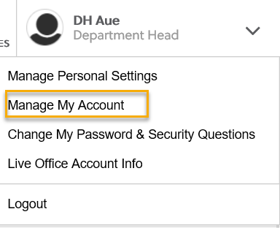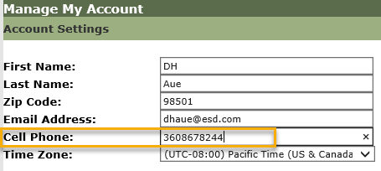
    - What if I don’t have a work number? We are aware that some don’t have work phones at this time. Contact your supervisor so they can can submit a service request to get you set up with a phone or the Softphone computer application. A survey was sent out to every office 8/20/20 to determine if each offices phone service supports MFA
    - We are working on additional training material to walk you through the next steps.
    - Demo 8/26/20, 9/2/20, 9/9/20 during T12 meeting. All ETO users will be invited to attend via ETO email.
- ETO Maintenance – Nothing this week
- Training issue(s) of the week –
  - Please: Submit remedy tickets for all work requests, my team cannot begin work without a service request. Thanks!
  - WSWA and email address-can only be linked to 1 account. Cannot be used for multiple job seeker or employer accounts
  - WSWA accounts need to be logged into every 3 years – impersonation will not keep account open
- ETO Engage Survey – Work on desk aid/training materials is on hold at this time
- ETO issues – open discussion
  - What if someone changes their name. How do you change their ETO/WSWA account? Name wchanges can be done through impersonation with the job seekers permission
  - Just to clarify, would we be able to assist customers to register in ETO from our desks? I am thinking of the customers who don’t have the necessary computer skills. If that is the case, I like that, since one of our goals is to increase the number of customers having access to services and resources via online. The create am ETO participant record will roll out 9/10/20. Training will take place during the 9/2/20 and 9/9/20 T12 call.
- UI announcements –
During the week of August 2 through August 8, there were 22,140 initial regular unemployment claims (down 11.4% from the prior week) and 571,410 total claims for all unemployment benefit categories (down 13% from the prior week) filed by Washingtonians, according to the Employment Security Department (ESD).
  - Initial regular claims applications remain at unprecedented elevated levels and are at 307 percent above last year’s weekly new claims applications.
  - Regular Unemployment Insurance, Pandemic Unemployment Assistance (PUA) and Pandemic Emergency Unemployment Compensation (PEUC) initial claims as well as continuing claims all decreased over the previous week.
ESD paid out over $273.8 million for 391,025 individual claims – a decrease of $301.3 million and 53,583 less individuals compared to the prior week.

Since the week ending March 7 when COVID-19 job losses began:
  - A total of 2,338,445 initial claims have been filed during the pandemic (1,475,571 regular unemployment insurance, 461,251 PUA and 401,251 PEUC)
  - A total of 1,295,080 distinct individuals have filed for unemployment benefits
  - ESD has paid out over $9.5 billion in benefits
  - 996,048 individuals who have filed an initial claim have been paid
- ESD.wa.gov or ESD Facebook page for current UI information
- Before submitting a service ticket help
Old Business
- Encourage all staff who use ETO and WSWA to sign up for the T12 calls. These calls are not just for trainers but for all system users and a great way to stay up to date on changes or improvements to ETO and WSWA. Send requests to esdgpWSSteam@esd.wa.gov to be added to the ITSD Training Team’s distribution list
- Stay up to date on COVID19, teleworking and WorkSource Virtual services. Check out the information the WPC website must help all WorkSource staff telework.
  - IT service delivery
    - All phone requests need to go through your office Administrator and/or Supervisor
    - Your needs are important to us! Please be patient with the ESD help desk staff, they are slammed and priority of service is set by our Executive Leadership.
  - WebEx
    - Browse the Webex handbook and watch 5 videos on how to make the most out of this tool for conducting meetings with staff and customers.
  - Other resources include:
    - Now that you are teleworking reference guide
    - How to use SKYPE for online meetings
    - How to sign into ESD email from outside the network
    - How to sign into an off-site Wi-Fi from your computer
    - Can I access Internet Explorer from a MAC computer?
    - Will the WSS Team be available to help us while working remote?
    - ESD service Desk information.
- UI Fraud help
  - www.esd.wa.gov/fraud
  - fax information to claims centers 833-572-8423 – calling not recommended due to the high volume of calls
- Tips from the Commissioner
  - Telling those who know they were victims of unemployment imposter fraud to NOT apply for benefits or try to access their eService’s account until they receive instructions from ESD. We need to first disconnect their stolen Social Security number from the fraudulent claim. We’re prioritizing that work. Their application process will go smoother for them if they wait until we’re done.
  - Then, we’ll send them special instructions for applying. We’re working on them now and will send before June 28.
  - Telling them what else ESD is doing right now to help:
    - SharedWork have been hosting webinars with state agency human resources staff to explain the ins and outs of SharedWork. Each agency needs to apply before employees can apply.
    - Coming soon: hosting webinars with state employees to explain SharedWork. The dates are not final yet.
  - Reviewing our web resources with them. Some helpful pages include:
- Employee FAQs
- Employee instructional videos
- How to file weekly claims
But you CAN’T help by:
  - Contacting an intake agent at the claims center and asking them to review your friend or family member’s claim or solve their issue.
  - Using your influence to move your friend or family member’s claim up the queue to be processed faster.
  - Using your influence to give any kind of advantage to your friend or family member.
  - Using your access to UTAB, if you have it, to give someone information about their claim.
  - Using your friend or family member’s SAW account and applying for benefits or submitting their weekly claims for them.
- Cisco Softphones training material Link http://insideesd.wa.gov/services/it-services
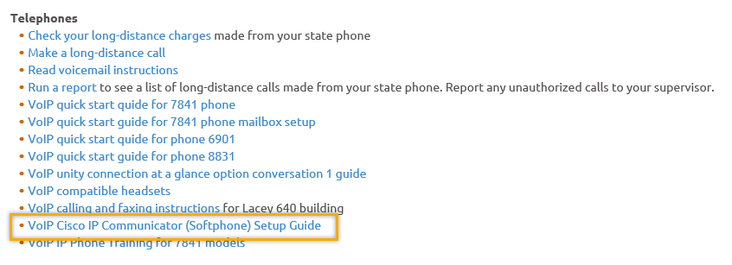
- Data Clean-up reminder: We need your help cleaning up the ETO data, so records are not excluded from federal reporting. This is also an important task for future migration efforts to another case management system. We will discuss these clean-up efforts at T12 and Advisory meetings.
- We are seeking ETO Improvements ideas
  - ETO improvement ideas or current work arounds should be submitted through the remedy ticket system https://wpc.wa.gov/tech/issues
  - Tickets are reviewed to determine if your idea or work around is a training issue or needs to go through the governance process for a system change
- ETO Refresher Training
  - Training recordings and user guides are posted on the WPC website here https://wpc.wa.gov/tech/ETO-refresher-training
  - Submit a remedy ticket asking Lynn Aue for additional training opportunities and training resources
- WorkSource Systems resources found on the WPC Technology site https://wpc.wa.gov/tech
  - We try our best to make sure all the links are operational but depend on you to submit a remedy ticket if you find broken links!
- Before submitting a service, request review these suggestions as the services desk will ask you to run through these steps. Many times, this resolves your issue without a service request!

  - Remember to log out of ETO, clicking off the browser tab here does not end your ETO session and will create issues when you log in again.
      - Always logout by opening your profile menu and clicking “Logout”
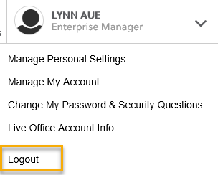
  - If you were impersonating a seeker or recruiter from ETO to WSWA remember to end the session, found in the upper left-hand corner. Clicking off your internet browser tab does not end impersonation!
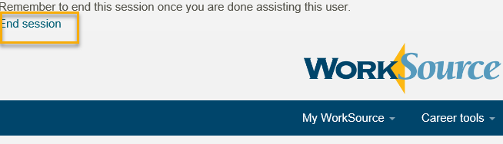

- For best performance clear your cache weekly

  - Internet Explorer (IE): Clearing IE cache starts from the top right side of the browser bar, click the settings icon and select Internet Options
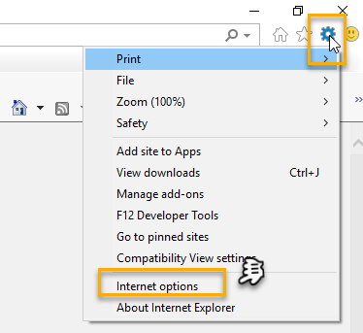

    - From the “General” tab click “Delete” which takes you to the “Delete Browsing History” screen. If not already checked click on the 2 boxes outlined here and click “Delete” you will return to the “General” tab

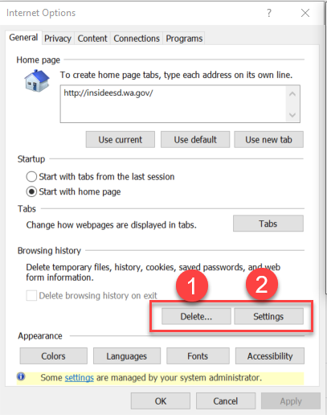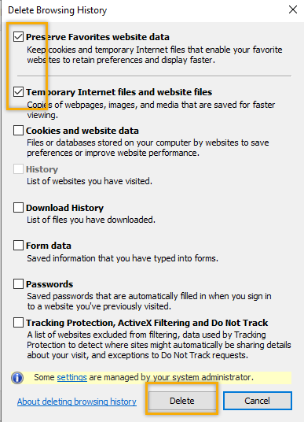

    - Next click “Settings” and if not selected click the radio button for “Every time I visit the webpage” This ensures you are using the most up to date version of ETO. Click OK
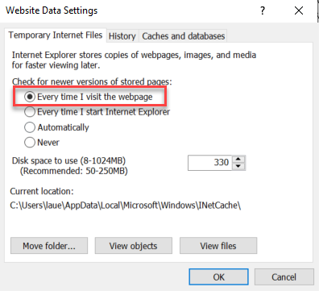
      - You will return to the General tab and click Apply and OK to complete the process of clearing your cache

  - Clearing Chrome cache starts from the top right side of the browser bar
- Click the triple dots to open the Chrome tools menu
- Hover over “More tools”
- Click “Clear browsing data” which opens a new screen
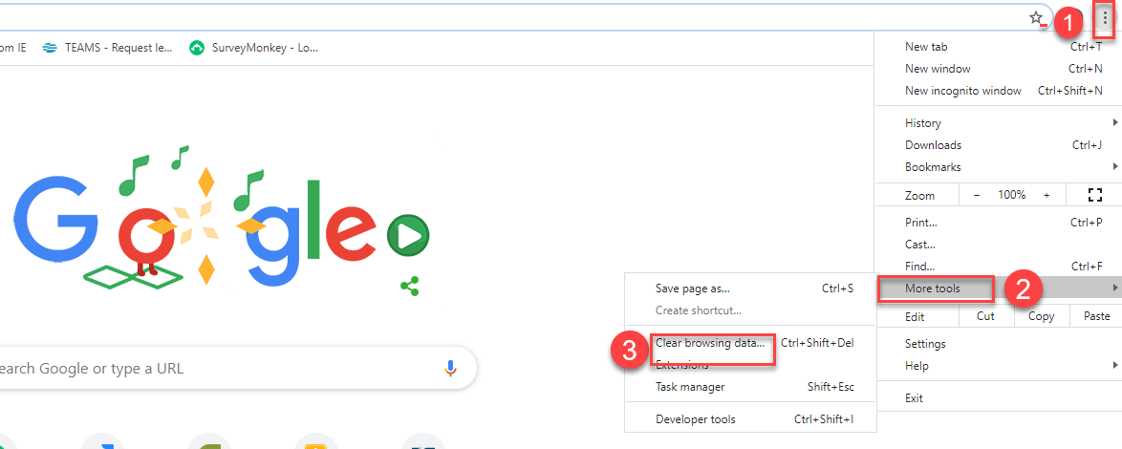

- Click “Clear data”
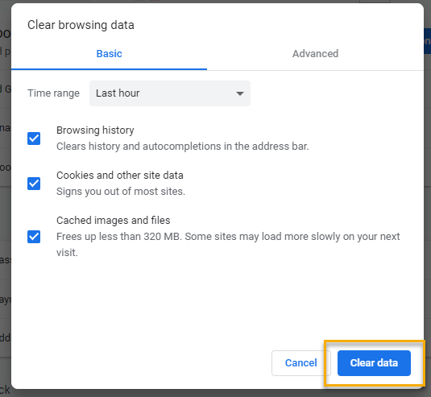

  - Finish by restarting your computer
  - If you still experience issues submit a service request https://wpc.wa.gov/tech/issues
CHAT
Regarding Multifactor Authentication (MFA):
from Aaron Parrott to everyone: 10:14 AM
When should we be seeing that survey? (to find out phone situations in offices)
Rebecca sent it out 08/20/19
from Aaron Parrott to everyone: 10:15 AM
Thanks!
from Elizabeth Ibanez to everyone: 10:15 AM
Lynn, what time on the 26th?
(TBA?)
from Elizabeth Ibanez to everyone: 10:16 AM
Great!
Regarding Specific tickets:
from JOANIE LINDER to everyone: 10:23 AM
The ITSS was saved as draft.
from JOANIE LINDER to everyone: 10:23 AM
I helped with that ticket.
from JOANIE LINDER to everyone: 10:23 AM
Karen grabbed a screenshot of the TP.
from CShaffer to everyone: 10:23 AM
I'm thinking we're talking about a different ticket, Katherine
from JOANIE LINDER to everyone: 10:23 AM
Okay :)
from Cori Ching to everyone: 10:24 AM
ETO was deleting identifiers. Was Monster able to fix that issue?
Skyler: I got in touch with Karen shortly after closing that ticket, the issue was resolved as far as I know
(re: identifiers not being attached to TPs)

from CShaffer to everyone: 10:25 AM
We struggled with 6 customers that should have had an enrollment end date populate by 8/5 ish and they didn't actually populate until 8/14. This is the ticket we were asking about.
We’re still getting to the bottom of this; it seems to have been a fluke? See INC000000672898. Still monitoring it

ATTENDEES
Aaron Parrott
Adeline Kerns
Adelp
Arturo Espinoza
Boliveri
Cori Ching
Crystal Armitage
CShaffer
Dan Cooling
Dawn Oakes
Dean Coxford
Diana Cook
DNava
Donetta Hanson
Donna Mack
Elizabeth Ibanez
Emily Anderson
Heidi Lamers
Hope Baker
Irene Jordan
Jeanette Elizabeth
Jessie Cardwell
Joanie Linder
Jordan Meyenburg
KatherineC
KHesseltine
Kimberly Metcalf
Linda Venera
Lori Ries
Luci Bench
Lux Dmitri
MDominguez
Melisa Flores-Sanches
Mitch McGeary
Noel Woods
Realani Rulona
Regina Cancel
Rosemary Henry
Sean McElligott
Selam Tekle
Shalina Latiff
Shannon Booth
Tammy Stillwaugh
trobison@wdcspokane.com
Teresa Anda
Tracy Ferrell
Vdamneun
Young Suh
Yvette Dallas
Zoryana Bilous

Second Half Attendance

