T12 Meeting Minutes 7-8-2020
New Business
- WA-3792 Job seeker has WSWA account but didn’t migrate to ETO
  - Can’t find seeker in ETO? Follow these steps before submitting a remedy ticket:
    - Check for different name spellings/name changes (is there a seeker with the correct DOB/SSN?)
    - Partners: did seeker opt-out of data sharing? Use the Opt-Out Lookup Widget and search for seeker using SSN
    - If no seeker is found submit a remedy ticket including DOB>full SSN>email address using the online service or form found here https://wpc.wa.gov/tech/issues
    - Wait for the WSS Team to respond that the WSWA-ETO accounts have been merged. To eliminate future data corrections or creating a customer record that will be excluded from federal reporting, wait for a response from the WSS Team before enrolling the participant into any programs or adding services.
    - Once the WSWA and ETO accounts are merged, go to the seekers ETO account, click on their “Access Seeker/Participant Account” widget on their dashboard to impersonate in WSWA
    - Open the seeker menu and select “Profile”
    - After the seeker profile opens, scroll the bottom of the page and click “Apply” this will update their demographics and other details TPs so you don’t have to do it manually.
- Survey to collect feedback on how ETO is functioning while you telework sent on 6/25/20 and again on 7/6/20. Better, the same, or worse? Does it seem faster? Improvement using Chrome? Closes on 7/10/20
- ETO Maintenance – nothing this week
- ETO Enhancements – Follow-up on the 5/21/20 release
  - WA-3523: The change to recognize those who live on JBLM base is functioning as expected in WSWA but not updating information into ETO. This is a known issue we are working on.
- Heads up: ETO Training Environment will be down for a few days for testing in anticipation of implementing Multi-Factor Authentication for all users in ETO. Exact dates are still TBD, but we plan on the downtime to be Friday through Monday leaving you opportunities to train staff Tuesday-Thursday. We will send a message with exact dates to the T12 list and in ETO email messaging.
- Training issue(s) of the week –
  - Seekers who Opt-out of data sharing
    - If you work for a partner agency, run the opt out report from your desktop widget to determine if the seeker has opted out of data sharing. Follow your local procedure to opt seeker into data sharing
  - Submit remedy tickets for all work requests – always please, my team cannot begin work without a service request Thanks!
  - ETO issue: open discussion Issue with Data entry Issue – Basic Services Late Entry and ITSS “We wanted to bring attention to reporting issues in ETO. Over the last couple of weeks, I have noticed the Late Entry reports in ETO are pulling inaccurate data. I have cross-referenced the late entries below and have emails requesting a department head to enter. After the department head entry, the case managers went in to make updates as needed and now the late entry is attached to them. Previously, reporting didn’t show it like this. The entry would stay tagged to the person who originally entered the touchpoint” Lynn is reviewing this report to discover inconsistencies and issues. More to follow
- ETO Engage Survey results – sending out summary of survey results with the minutes
- UI announcements –
  - Work search will continue to be optional and the waiting week continues to be waived through the week ending August 2. Claimants filing new claims with and EDC of August 2 or later will be required to serve a wait week.
  - Extended Benefits (EB) is available starting July 5, 2020 for claimants who have exhausted all regular benefits an extension in any state. Claimants must have at least on week of their benefit year within an EB payable period. Bye of May 30, 2020
  - ESD.wa.gov or ESD Facebook page for current UI information
  - Since the week ending March 7 when COVID-19 job losses began through 6/27/20
    - A total of 2,143,073 initial claims have been filed during the pandemic (1,340,721 regular unemployment insurance, 431,002 PUA and 371,350 PEUC)
    - A total of 1,200,639 distinct individuals have filed for unemployment benefits
    - ESD has paid out over $6.7 billion in benefits
    - 866,416 individuals who have filed an initial claim have been paid
- UI Fraud help
  - www.esd.wa.gov/fraud
  - fax information to claims centers 833-572-8423 – calling not recommended due to the high volume of calls
- Tips from the Commissioner
  - Telling those who know they were victims of unemployment imposter fraud to NOT apply for benefits or try to access their eServices account until they receive instructions from ESD. We need to first disconnect their stolen Social Security number from the fraudulent claim. We’re prioritizing that work. Their application process will go smoother for them if they wait until we’re done.
  - Then, we’ll send them special instructions for applying. We’re working on them now and will send before June 28.
  - Telling them what else ESD is doing right now to help:
    - SharedWork have been hosting webinars with state agency human resources staff to explain the ins and outs of SharedWork. Each agency needs to apply before employees can apply.
    - Coming soon: hosting webinars with state employees to explain SharedWork. The dates are not final yet.
  - Reviewing our web resources with them. Some helpful pages include:
- Employee FAQs
- Employee instructional videos
- How to file weekly claims
But you CAN’T help by:
  - Contacting an intake agent at the claims center and asking them to review your friend or family member’s claim or solve their issue.
  - Using your influence to move your friend or family member’s claim up the queue to be processed faster.
  - Using your influence to give any kind of advantage to your friend or family member.
  - Using your access to UTAB, if you have it, to give someone information about their claim.
  - Using your friend or family member’s SAW account and applying for benefits or submitting their weekly claims for them.
- Before submitting a service ticket help
Old Business
- Encourage all staff who use ETO and WSWA to sign up for the T12 calls. These calls are not just for trainers but for all system users and a great way to stay up to date on changes or improvements to ETO and WSWA. Send requests to esdgpWSSteam@esd.wa.gov to be added to the ITSD Training Team’s distribution list or find meeting information on the Trumba Staff Development Calendar here https://wpc.wa.gov/tech/staff/calendar
- Stay up to date on COVID19, teleworking and WorkSource Virtual services. Check out the information the WPC website must help all WorkSource staff telework.
  - IT service delivery
    - All phone requests need to go through your office Administrator and/or Supervisor
    - Your needs are important to us! Please be patient with the ESD help desk staff, they are slammed and priority of service is set by our Executive Leadership.
  - WebEx
    - Browse the Webex handbook and watch 5 videos on how to make the most out of this tool for conducting meetings with staff and customers.
  - Other resources include:
    - Now that you are teleworking reference guide
    - How to use SKYPE for online meetings
    - How to sign into ESD email from outside the network
    - How to sign into an off-site Wi-Fi from your computer
    - Can I access Internet Explorer from a MAC computer?
    - Will the WSS Team be available to help us while working remote?
    - ESD service Desk information.
- Cisco Softphones training material Link http://insideesd.wa.gov/services/it-services
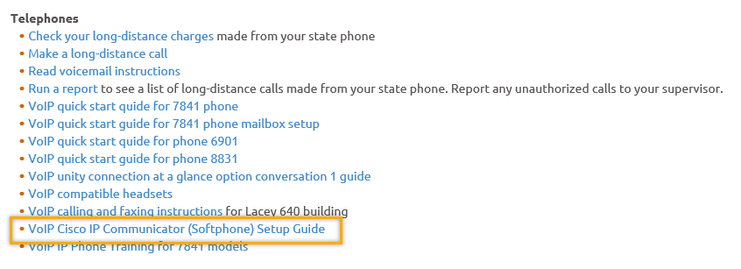
- Data Clean-up reminder: We need your help cleaning up the ETO data, so records are not excluded from federal reporting. This is also an important task for future migration efforts to another case management system. We will discuss these clean-up efforts at T12 and Advisory meetings.
- We are seeking ETO Improvements ideas
  - ETO improvement ideas or current work arounds should be submitted through the remedy ticket system https://wpc.wa.gov/tech/issues
  - Tickets are reviewed to determine if your idea or work around is a training issue or needs to go through the governance process for a system change
- ETO Refresher Training
  - Training recordings and user guides are posted on the WPC website here https://wpc.wa.gov/tech/ETO-refresher-training
  - Submit a remedy ticket asking Lynn Aue for additional training opportunities and training resources
- WorkSource Systems resources found on the WPC Technology site https://wpc.wa.gov/tech
  - We try our best to make sure all the links are operational but depend on you to submit a remedy ticket if you find broken links!
- Before submitting a service, request review these suggestions as the services desk will ask you to run through these steps. Many times, this resolves your issue without a service request!
  - What internet browser are you using? ETO is now internet browser neutral
    - Edge vs Internet Explorer? Use IE, Edge is sometimes problematic

  - Log out of ETO, don’t click off your browser tab here Your ETO session will still be active. Always logout here
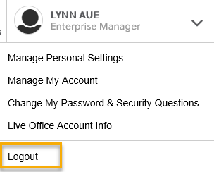
  - If you were impersonating a seeker or recruiter from ETO to WSWA remember to end the session, found in the upper left-hand corner. Clicking off your internet browser tab does not end impersonation!
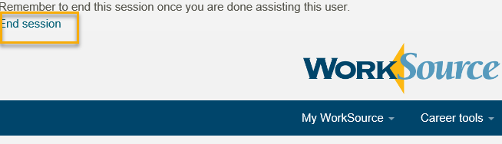

  - Clear your cache weekly for best performance and check your Internet Settings.
    - Clearing Internet Explorer cache: From the top of your browser click the Settings icon and then select Internet Options
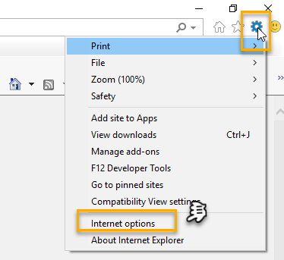

- Begin by clicking Delete on the General tab which takes you to the Delete Browsing History screen. If not already checked click on the 3 boxes outlined here and click delete

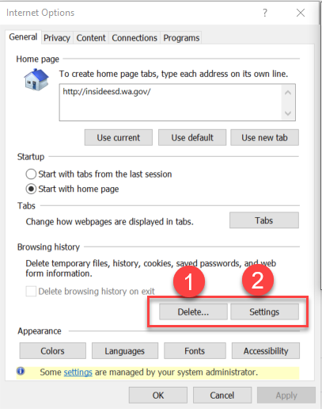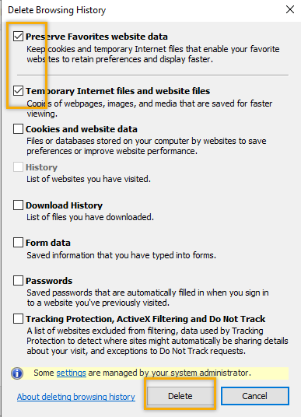

- Next click the Settings tab to ensure you will be using the most up to date version of ETO and click OK
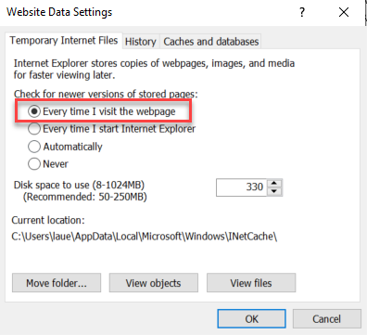
    - You will return to the General tab and click Apply and OK to complete the process of clearing your cache
    - Clearing cache in Chrome:
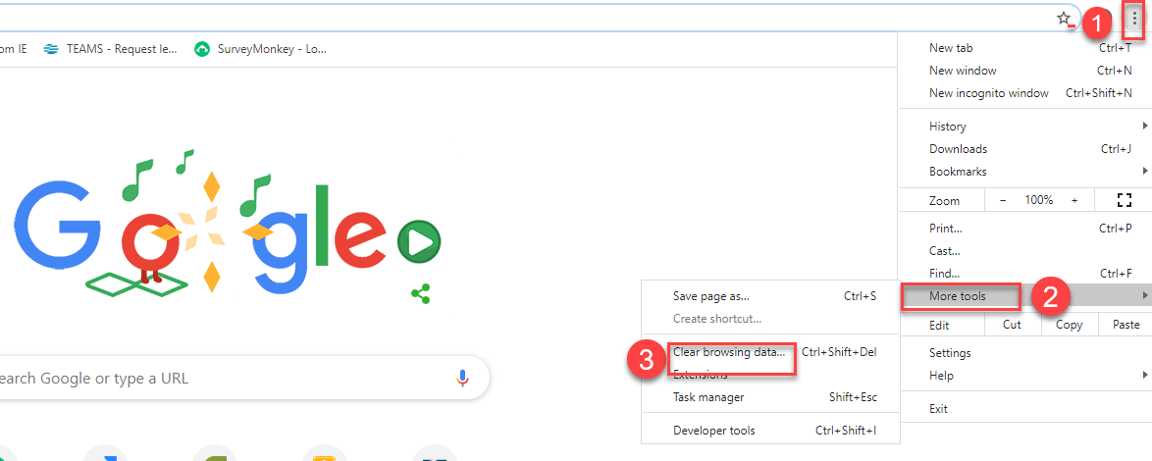
  - Restart your computer
CHAT

ATTENDEES

Aaron Parrott
Adeline Kerns
Amy
Becky Smith
Boliveri
Business
CCauthron
Claire B *
Cori Ching
Daniel Cooling
Danielle
Dawn Oaks *
Dean Coxford *
Diane Luoma
Donna Mack
Dorothy Rocha *
Elizabeth Ibanez *
Emily Anderson *
Hope Baker
Irene Jordan
Joanie Linder *
Jordan Meyenburg
Katherine C
Kking *
Luci Bench *
Melisa Flores-Sanchez *
Paige Schmelzer
Phyllis Hall
Schehera Gates
Sean McElligott
Selam Tekle
Skyler Blumenthal
Teresa Anda
Tracy Ferrell -EWP
Vdamneun
Young Suh

* Second half attendance

