T12 Meeting Minutes 7-22-2020
New Business
- Tickets into production
  - WA-3837 New Program of Enrollment – COVID 19 (WDA5 ONLY)
    - Grant Management provided guidance to WDA5 staff
  - WA-3855 New Program of Enrollment - COVID-19 Employment Recovery DWG for all WDAs. Projected production date is set for 7/30/20.
    - No new services
    - New WIN and guidance will be provided during the T12 call before implementation into prod
- Multi-Factor Authentication (MFA) in ETO
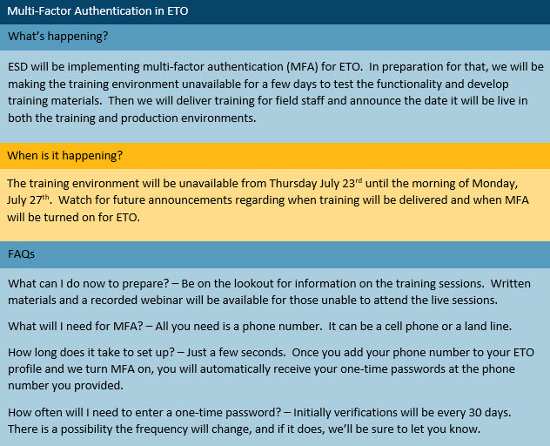

- WA-3792 Job seeker has WSWA account but didn’t migrate to create ETO account. API issue resolved
  - Clean-up in progress
  - Department Head does not need to add the 4 detail TPs (Demographics, Vets, Disability and MSFW) for this issue as initially instructed, staff can create the detail TPs by moving the information from WSWA to ETO by following this process:
    - Start by impersonating the seeker in WSWA
    - Open seeker profile
    - Scroll to bottom of profile page and click “Apply”
    - Don’t forget to end the session before going back to ETO and refreshing (F5) the seeker account. The detail TPs will move to ETO.
- ETO Maintenance – Nothing this week
- ETO Enhancements – Follow-up on the 5/21/20 release
  - WA-3523: The change to recognize those who live on JBLM base is functioning as expected in WSWA but not updating information into ETO. Currently testing the fix.
- Training issue(s) of the week –
  - Please: Always submit remedy tickets for all work requests, my team cannot begin work without a service request. Thanks!
- ETO Engage Survey – testing the best practices from survey and creating training material. Will report out results
- UI announcements –
  - Work search will continue to be optional and the waiting week continues to be waived through the week ending August 2. Claimants filing new claims with and EDC of August 2 or later will be required to serve a wait week.
  - PUA Additional $600 weekly benefit ends 7/25/20
  - Extended Benefits (EB) is available starting July 5, 2020 for claimants who have exhausted all regular benefits an extension in any state. Claimants must have at least on week of their benefit year within an EB payable period. Must have a BYE (Benefit year-end) of May 30, 2020
  - ESD.wa.gov or ESD Facebook page for current UI information
  - Since the week ending March 7 when COVID-19 job losses began through 7/11/20
    - 40,466 initial regular unemployment claims (up 42.5% from the prior week) and 706,309 total claims for all unemployment benefit categories (down 4.1% from the prior week) filed by Washingtonians, according to the Employment Security Department (ESD).
    - Initial regular claims applications remain at unprecedented elevated levels and are at 549 percent above last year’s weekly new claims applications.
    - Pandemic Unemployment Assistance (PUA), Pandemic Emergency Unemployment Compensation (PEUC) initial claims as well as continued/ongoing claims all decreased over the previous week.
    - ESD paid out over $490.4 million for 423,697 individual claims – an increase of $19.8 million and 19,223 more individual claims compared to the prior week.
    - A total of 2,283,609 initial claims have been filed during the pandemic (1,438,620 regular unemployment insurance, 453,085 PUA and 391,692 PEUC)
    - A total of 1,261,075 distinct individuals have filed for unemployment benefits
    - ESD has paid out over $7.6 billion in benefits
    - 920,153 individuals who have filed an initial claim have been paid
- ETO issues – open discussion
  - ETO Basic Training beginning August
  - 1st Monday 10-11
  - 3rd Tuesday 2-3
  - Will post on Staff development calendar for registration
- Before submitting a service ticket help
Old Business
- Encourage all staff who use ETO and WSWA to sign up for the T12 calls. These calls are not just for trainers but for all system users and a great way to stay up to date on changes or improvements to ETO and WSWA. Send requests to esdgpWSSteam@esd.wa.gov to be added to the ITSD Training Team’s distribution list or find meeting information on the Trumba Staff Development Calendar here https://wpc.wa.gov/tech/staff/calendar
- Stay up to date on COVID19, teleworking and WorkSource Virtual services. Check out the information the WPC website must help all WorkSource staff telework.
  - IT service delivery
    - All phone requests need to go through your office Administrator and/or Supervisor
    - Your needs are important to us! Please be patient with the ESD help desk staff, they are slammed and priority of service is set by our Executive Leadership.
  - WebEx
    - Browse the Webex handbook and watch 5 videos on how to make the most out of this tool for conducting meetings with staff and customers.
  - Other resources include:
    - Now that you are teleworking reference guide
    - How to use SKYPE for online meetings
    - How to sign into ESD email from outside the network
    - How to sign into an off-site Wi-Fi from your computer
    - Can I access Internet Explorer from a MAC computer?
    - Will the WSS Team be available to help us while working remote?
    - ESD service Desk information.
- UI Fraud help
  - www.esd.wa.gov/fraud
  - fax information to claims centers 833-572-8423 – calling not recommended due to the high volume of calls
- Tips from the Commissioner
  - Telling those who know they were victims of unemployment imposter fraud to NOT apply for benefits or try to access their eService’s account until they receive instructions from ESD. We need to first disconnect their stolen Social Security number from the fraudulent claim. We’re prioritizing that work. Their application process will go smoother for them if they wait until we’re done.
  - Then, we’ll send them special instructions for applying. We’re working on them now and will send before June 28.
  - Telling them what else ESD is doing right now to help:
    - SharedWork have been hosting webinars with state agency human resources staff to explain the ins and outs of SharedWork. Each agency needs to apply before employees can apply.
    - Coming soon: hosting webinars with state employees to explain SharedWork. The dates are not final yet.
  - Reviewing our web resources with them. Some helpful pages include:
- Employee FAQs
- Employee instructional videos
- How to file weekly claims
But you CAN’T help by:
  - Contacting an intake agent at the claims center and asking them to review your friend or family member’s claim or solve their issue.
  - Using your influence to move your friend or family member’s claim up the queue to be processed faster.
  - Using your influence to give any kind of advantage to your friend or family member.
  - Using your access to UTAB, if you have it, to give someone information about their claim.
  - Using your friend or family member’s SAW account and applying for benefits or submitting their weekly claims for them.
- Cisco Softphones training material Link http://insideesd.wa.gov/services/it-services
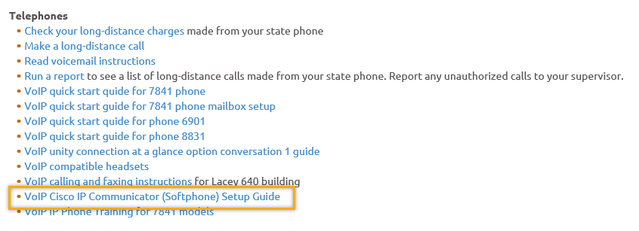
- Data Clean-up reminder: We need your help cleaning up the ETO data, so records are not excluded from federal reporting. This is also an important task for future migration efforts to another case management system. We will discuss these clean-up efforts at T12 and Advisory meetings.
- We are seeking ETO Improvements ideas
  - ETO improvement ideas or current work arounds should be submitted through the remedy ticket system https://wpc.wa.gov/tech/issues
  - Tickets are reviewed to determine if your idea or work around is a training issue or needs to go through the governance process for a system change
- ETO Refresher Training
  - Training recordings and user guides are posted on the WPC website here https://wpc.wa.gov/tech/ETO-refresher-training
  - Submit a remedy ticket asking Lynn Aue for additional training opportunities and training resources
- WorkSource Systems resources found on the WPC Technology site https://wpc.wa.gov/tech
  - We try our best to make sure all the links are operational but depend on you to submit a remedy ticket if you find broken links!
- Before submitting a service, request review these suggestions as the services desk will ask you to run through these steps. Many times, this resolves your issue without a service request!

  - Remember to log out of ETO, clicking off the browser tab here does not end your ETO session and will create issues when you log in again.
      - Always logout by opening your profile menu and clicking “Logout”
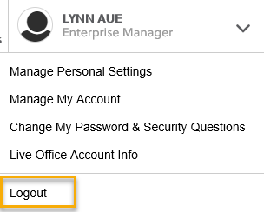
  - If you were impersonating a seeker or recruiter from ETO to WSWA remember to end the session, found in the upper left-hand corner. Clicking off your internet browser tab does not end impersonation!
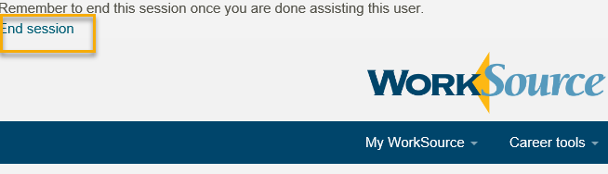

- For best performance clear your cache weekly

  - Internet Explorer (IE): Clearing IE cache starts from the top right side of the browser bar, click the settings icon and select Internet Options
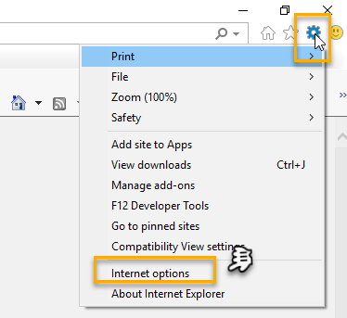

    - From the “General” tab click “Delete” which takes you to the “Delete Browsing History” screen. If not already checked click on the 2 boxes outlined here and click “Delete” you will return to the “General” tab

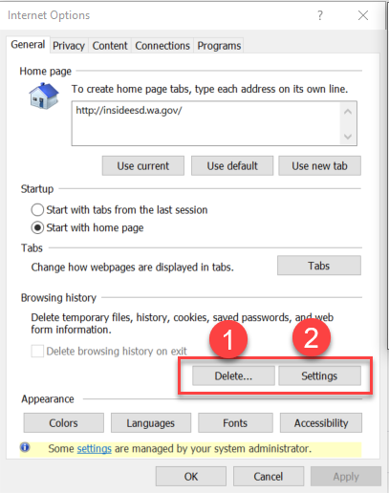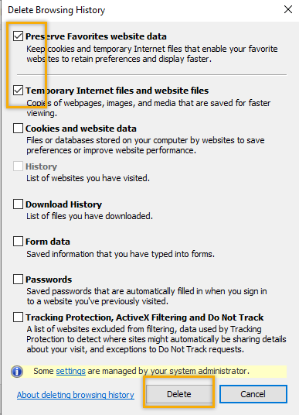

    - Next click “Settings” and if not selected click the radio button for “Every time I visit the webpage” This ensures you are using the most up to date version of ETO. Click OK
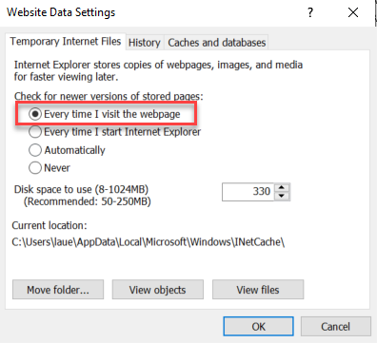
      - You will return to the General tab and click Apply and OK to complete the process of clearing your cache

  - Clearing Chrome cache starts from the top right side of the browser bar
- Click the triple dots to open the Chrome tools menu
- Hover over “More tools”
- Click “Clear browsing data” which opens a new screen
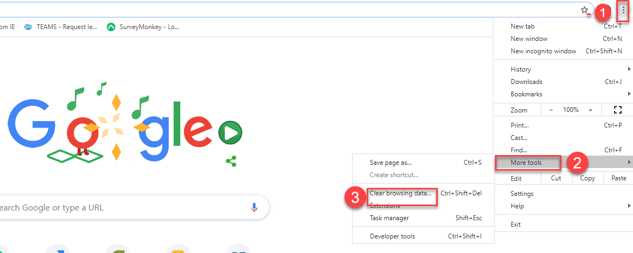

- Click “Clear data”
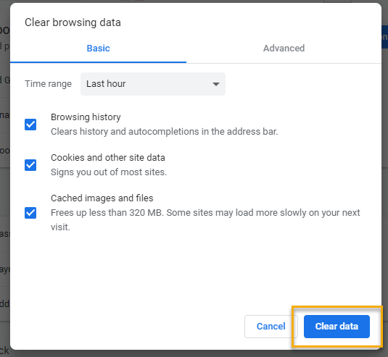

  - Finish by restarting your computer
  - If you still experience issues submit a service request https://wpc.wa.gov/tech/issues
CHAT
Regarding API issue(s):
from JOANIE LINDER to everyone:
Update re: the issue with WSWA accounts: - all of the reported accounts have been linked, with the exception of 5 accounts that require additional analysis.
(Stay tuned to your remedy tickets regarding these cases. )

Regarding training in ETO:
from Teresa Sparks to everyone:
Will you be looking for volunteers for train the traners?
from Linda Venera to everyone:
Thank you Lynn for supporting the BASIC ETO training, also recognizing we need more local trainers identified with train the trainer provided to them. You have been amazing in covering this function!
from Phyllis Hall to everyone:
I sm still available to train in ETO? Since it would be virtual I can assist
from ahughes to everyone:
Hi Lynn, I'm our local trainer, so I'm here if you need me! :)
from Becky Smith to everyone:
How will the ETO Access Approvers know that someone has taken the training?
Lynn: I have created a ‘train the trainer’ program that has yet to be released that has an access approver form, to verify that someone has been trained. Send it to the local access approver.

from Tracy Ferrell - EWP to everyone:
Would love to have te training. I'm supposed to be the traininer in our area, but have never received training. I'm very frustrated and would appreciate any help!!
from Tracy Ferrell - EWP to everyone:
Sorry for the spelling errors!!
from Elizabeth Ibanez to everyone:
I would certainly like to take the training.
from Phyllis Hall to everyone:
I would love to take a refresher train the trainor session
from Teresa Sparks to everyone:
Mondays and Tuesday would be ideal.
from Linda Venera to everyone:
How long is the train the trainer trainnig in length of time?
Lynn: we want to have it happen quarterly (as refresher), and it lasts for about a day at a time.
from Luci Bench to everyone:
I would like a refresher, too
from Phyllis Hall to everyone:
good idea
from Linda Venera to everyone:
Thank you. I'll share this information with our region to assist in identifying whom we can identify for this support in our region.
from Toni Burow to everyone:
As a traininer I like that idea of quarterly updating
from Linda Venera to everyone:
Ditto the quarterly updating.
from Linda Venera to everyone:
Yes, Felicia Johnson
from Teresa Anda to everyone:
Can the dates be posted on the Staff Calendar so interested parties can sign up?
from Linda Venera to everyone:
Question, will there be refresher training to staff on ETO for providing referrals to customers in the near future?
from Young Suh to everyone:
Thank you
from Teresa Anda to everyone:
Universal process will also help bring us to a standard around the state.
from EManson to everyone:
Report pulling training would be amazing!
from Teresa Anda to everyone:
YAY!!!
from Teresa Sparks to everyone:
I agree!
from Linda Venera to everyone:
KUDOS!!!!
from Teresa Anda to everyone:
I would love to assist with reporting!

ATTENDEES
“12087” (?)
Aaron Parrott
Adelp
Ahughes
Amandy Standley
Amy Gimlin
Arturo Espinoza
Becky Smith
Boliveri
Business
Catherine Geddis
Claire B
Dan Cooling
Danielle
Dawn Oakes
Dean Coxford
Donna Mack
Dorothy Rocha
Elizabeth Ibanez
EManson
Emily Anderson
Heidi Lamers
Heidi.schauble
Irene Jordan
Joanie Linder
Jordan Meyenburg
Katherinec
Kdudley
KHesseltine
Kim Bursell
Kking
Linda Venera
Lisa Pietkauskis
Luci Bench
Lux Dmitri
MDominguez
Melisa Flores-Sanchez
Noel Woods
Paige Schmeizer
Patricia Connell
Phallina
Phyllis Hall
Rodolfo Aparicio
Sean McElligott
Selam Tekle
Teresa Anda
Teresa Sparks
Toni Burow
Tracy Ferrell
Vdamneun
Victoria.wood
Young Suh

Second half attendance

