T12 Meeting Minutes 6-24-2020
New Business
- WA-3792 Job seeker has WSWA account but didn’t migrate to ETO
  - Can’t find seeker in ETO? Follow these steps before submitting a remedy ticket:
    - Check for different name spellings/name changes (is there a seeker with the correct DOB/SSN?)
    - Partners: did seeker opt-out of data sharing? Use the Opt-Out Lookup Widget and search for seeker using SSN
    - Submit remedy ticket online or using the form found here https://wpc.wa.gov/tech/issues
    - WSS Team will review your case to determine if this issue is related to Ticket WA-3792
    - If related to WA-3792 WSS TEAM will direct, you to contact your local area Department Head (user role in ETO) to add participant to ETO
    - Adding participants to ETO requires adding 4 Detail TPs that come over with the WSWA account. This can be done by the DH or by the staff (recommended) meeting with the participant. Participants who don’t have these TPs will be excluded from federal reporting until completed.
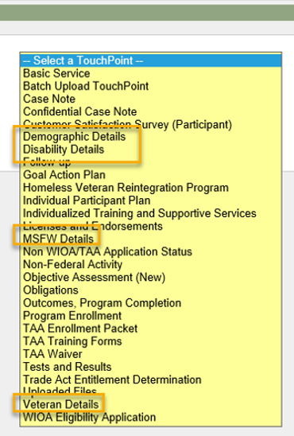

- Tickets into production tonight -
  - WA-3778 new program of enrollment for COVID-19
    - Update to Services Catalog and new WIN 0011X (Still unknown)
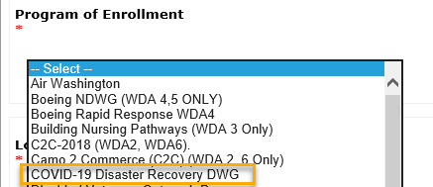

  - WA-3796 change of service for COVID-19 grants
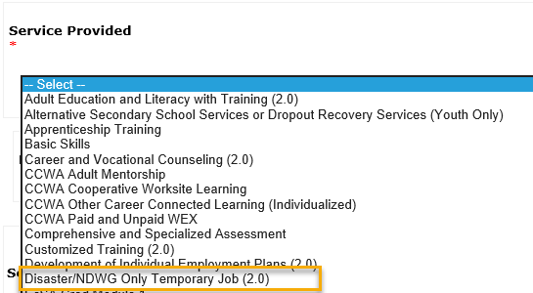

  - WA-3802 Edit Outcome/Completion TP to eliminate future dating for a credential being earned
- ETO Browser neutral 6/18/20
- Watch for Survey collection feedback on how ETO is functioning while you telework. Better, the same, or worse? Does it seem faster? Improvement using Chrome?
- ETO Maintenance – Nothing this week
- ETO Enhancements – Follow-up on the 5/21/20 release
  - WA-3523: The change to recognize those who live on JBLM base is functioning as expected in WSWA but not updating information into ETO. This is a known issue we are working on.
- Heads up: ETO Training Environment will be down. In anticipation of implementing Multi-Factor Authentication for all users in ETO, we will be doing some testing in the Training Environment. Exact dates are still TBD, but we will send a message in ETO. It should only be down for a couple of days.
- Training issue(s) of the week –
  - Based on some of the recent problems in Federal Reporting, System Performance asked to remind staff to review and update the demographic details prior to recording services
- UI announcements – same data as last week
  - ESD.wa.gov or ESD Facebook page for current UI information
  - Since the week ending March 7 when COVID-19 job losses began through 6/13/20
    - A total of 2,112,219 initial claims have been filed during the pandemic (1,320,239 regular unemployment insurance, 424,431 PUA and 367,549 PEUC)
    - A total of 1,180,748 distinct individuals have filed for unemployment benefits
    - ESD has paid out over $5.4 billion in benefits
    - 856,428 individuals who have filed an initial claim have been paid
- UI Fraud help
  - www.esd.wa.gov/fraud
  - fax information to claims centers 833-572-8423 – calling not recommended due to the high volume of calls
- Tips from the Commissioner
  - Telling those who know they were victims of unemployment imposter fraud to NOT apply for benefits or try to access their eServices account until they receive instructions from ESD. We need to first disconnect their stolen Social Security number from the fraudulent claim. We’re prioritizing that work. Their application process will go smoother for them if they wait until we’re done.
  - Then, we’ll send them special instructions for applying. We’re working on them now and will send before June 28.
  - Telling them what else ESD is doing right now to help:
    - SharedWork have been hosting webinars with state agency human resources staff to explain the ins and outs of SharedWork. Each agency needs to apply before employees can apply.
    - Coming soon: hosting webinars with state employees to explain SharedWork. The dates are not final yet.
  - Reviewing our web resources with them. Some helpful pages include:
- Employee FAQs
- Employee instructional videos
- How to file weekly claims
But you CAN’T help by:
  - Contacting an intake agent at the claims center and asking them to review your friend or family member’s claim or solve their issue.
  - Using your influence to move your friend or family member’s claim up the queue to be processed faster.
  - Using your influence to give any kind of advantage to your friend or family member.
  - Using your access to UTAB, if you have it, to give someone information about their claim.
  - Using your friend or family member’s SAW account and applying for benefits or submitting their weekly claims for them.
- ETO issue: open discussion
  - We are uploading enrollment Documents, I-9 Documents, and with Measurable Skill Gains will be uploading training related documents. Are there any standard do’s and don’ts, limitations, or do not load in this areas…..guidelines…..
    - Suggested from Lynn: I have heard some WS Offices are asking participants to upload personal information (PII) in their WSWA upload document feature. This is a security risk to the job seeker/employer and should never be suggested. It is also a risk to yourself and your agency. If you have participants who you know have uploaded PII ask them to remove them.
      - Monster provides this disclaimer: Upload a document from your local storage or add it from Dropbox or Google Drive. Consider your documents carefully. Note that although employers do not have access to these files, we recommend that you do not upload documents with sensitive information, such as your Social Security card, Driver's License, Passport, School, or Military ID.
    - Suggestion from Teresa Anda: In our area the case manager/service provider has a scanner to scan and upload documents into the participants record. For ease of locating information at a later time, anything that is a service goes into that service TP (basic service, Individualized Training and Supportive Services, WIOA Eligibility App, etc), case note, upload document, etc.
- Before submitting a service ticket help
Old Business
- Encourage all staff who use ETO and WSWA to sign up for the T12 calls. These calls are not just for trainers but for all system users and a great way to stay up to date on changes or improvements to ETO and WSWA. Send requests to esdgpWSSteam@esd.wa.gov to be added to the ITSD Training Team’s distribution list or find meeting information on the Trumba Staff Development Calendar here https://wpc.wa.gov/tech/staff/calendar
- Stay up to date on COVID19, teleworking and WorkSource Virtual services. Check out the information the WPC website must help all WorkSource staff telework.
  - IT service delivery
    - All phone requests need to go through your office Administrator and/or Supervisor
    - Your needs are important to us! Please be patient with the ESD help desk staff, they are slammed and priority of service is set by our Executive Leadership.
  - WebEx
    - Browse the Webex handbook and watch 5 videos on how to make the most out of this tool for conducting meetings with staff and customers.
  - Other resources include:
    - Now that you are teleworking reference guide
    - How to use SKYPE for online meetings
    - How to sign into ESD email from outside the network
    - How to sign into an off-site Wi-Fi from your computer
    - Can I access Internet Explorer from a MAC computer?
    - Will the WSS Team be available to help us while working remote?
    - ESD service Desk information.
- Cisco Softphones training material Link http://insideesd.wa.gov/services/it-services
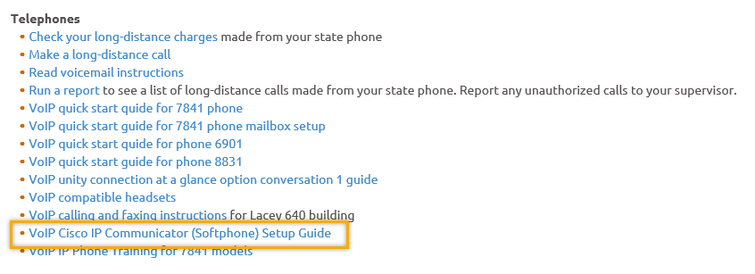
- Data Clean-up reminder: We need your help cleaning up the ETO data, so records are not excluded from federal reporting. This is also an important task for future migration efforts to another case management system. We will discuss these clean-up efforts at T12 and Advisory meetings.
- We are seeking ETO Improvements ideas
  - ETO improvement ideas or current work arounds should be submitted through the remedy ticket system https://wpc.wa.gov/tech/issues
  - Tickets are reviewed to determine if your idea or work around is a training issue or needs to go through the governance process for a system change
- ETO Refresher Training
  - Training recordings and user guides are posted on the WPC website here https://wpc.wa.gov/tech/ETO-refresher-training
  - Contact Lynn Aue directly at laue@esd.wa.gov for additional training opportunities and training resources
- WorkSource Systems resources found on the WPC Technology site https://wpc.wa.gov/tech
  - We try our best to make sure all the links are operational but depend on you to email us if you find broken links!
- Before submitting a service, request review these suggestions as the services desk will ask you to run through these steps. Many times, this resolves your issue without a service request!
  - What internet browser are you using? ETO is now internet browser neutral
    - Edge vs Internet Explorer? Use IE, Edge is sometimes problematic

  - Log out of ETO, don’t click off your browser tab here Your ETO session will still be active. Always logout here
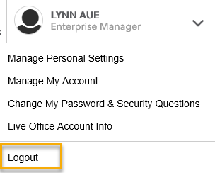
  - If you were impersonating a seeker or recruiter from ETO to WSWA remember to end the session, found in the upper left-hand corner. Clicking off your internet browser tab does not end impersonation!
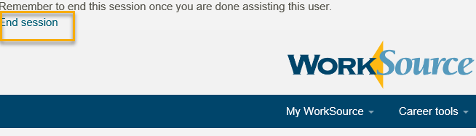

  - Clear your cache weekly for best performance and check your Internet Settings.
    - Clearing Internet Explorer cache: From the top of your browser click the Settings icon and then select Internet Options
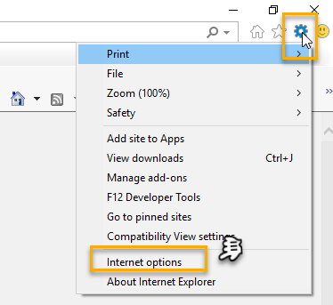

- Begin by clicking Delete on the General tab which takes you to the Delete Browsing History screen. If not already checked click on the 3 boxes outlined here and click delete

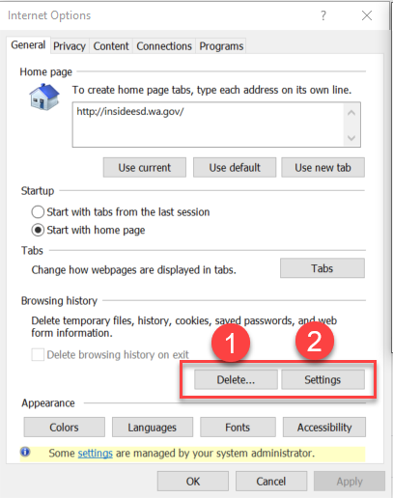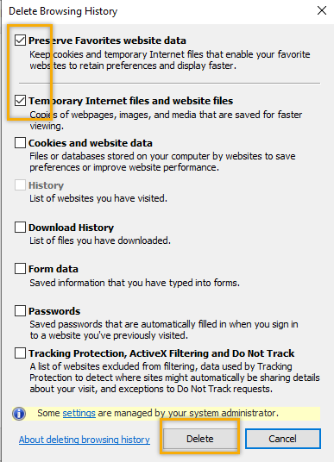

- Next click the Settings tab to ensure you will be using the most up to date version of ETO and click OK
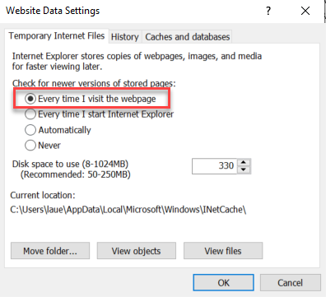
    - You will return to the General tab and click Apply and OK to complete the process of clearing your cache
    - Clearing cache in Chrome:
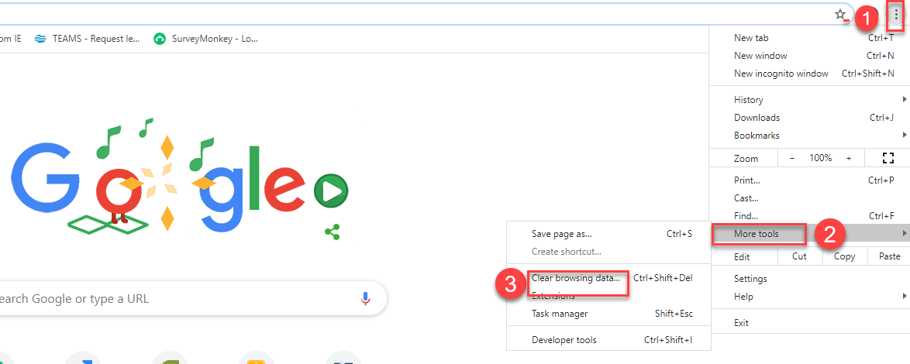
  - Restart your computer
CHAT
from Teresa Anda to everyone: If I already created the ETO account, do you still need me to send a remedy ticket? Thanks! “Yes, you need to let us know, because we still coordinate with Monster to ‘marry’ the two accounts (ETO and WSWA) up together. If this isn’t done, you won’t be able to impersonate the seeker or see any of their job search activities.”
from Daniel Cooling to everyone: If we summit a remedy ticket for this issue what is the expected turnaround time to hear back from the WSS Team with next steps. I just want to be able to set realistic time frame for a case manager. The WSS team responds to remedy tickets within24 hours. If you don’t hear from us send an email inquiry to esdwssteam@esd.wa.gov
(regarding WA-3792 issue)
from Dawn Oakes to everyone: Is this just adult or applies to youth as well? Yes. This process applies to all programs

ATTENDEES

Adelp *
Amanda Standley
Barbara
Becky Smith
Boliveri
Business
Call-in User_3
Call-in User_4
Catherine Geddis
Daniel Cooling
Dawn Oakes
Diane Luoma *
Donna Mack
Heidi Lamers *
Heidi.schauble
Hope Baker
Irene Jordan
Katherinec
Kking
La Qwana *
Lisa Peitkauskis
Luci Bench
Lux Dmitri *
MDominguez
Melisa Flores-Sanchez *
Patricia Connell
Phyllis Hall
Sean McElligott
Selam Tekle
Shalina Latiff *
Teresa Anda
Teresa Sparks
Toni Burow
Tracy Ferrell
trobison@wdcspokane.com
vdamneun
Victoria.wood
John Traugott *

*2nd half Meeting Attendance

