T12 Meeting Minutes 6-17-2020
New Business
- Heads up: ETO Training Environment will be down. In anticipation of implementing Multi-Factor Authentication for all users in ETO, we will be doing some testing in the Training Environment. Exact dates are still TBD, but we will send a message in ETO. It should only be down for a couple of days.
- We need your feedback on how ETO is functioning while you telework. Better, the same, or worse? Does it seem faster? Look for a Survey Monkey to get your feedback on this.
- Tickets into production – Nothing this week
  - Status on a new program of enrollment for COVID-19: is pushed out another week. Will provide guidance and training during T12 call
- WA-3792 Job seeker has WSWA account but didn’t migrate to ETO, known issue we are working on. Continue to submit a remedy ticket if you experience this with a customer so our team can create an ETO account
- ETO Maintenance – June 20-21, 2020, Saturday 6pm – Sunday 3am
- ETO Enhancements – Follow-up on the 5/21/20 release
  - WA-3523: The change to recognize those who live on JBLM base is functioning as expected in WSWA but not updating information into ETO. This is a known issue we are working on.
- ETO Engage discussion – ended 5/29/20
  - Processing the feedback
- UI announcements
  - ESD.wa.gov or ESD Facebook page for current UI information
  - Since the week ending March 7 when COVID-19 job losses began through 6/3/20:
    - A total of 2,082,098 initial claims have been filed during the pandemic (1,301,944 regular unemployment insurance, 417,757 PUA and 362,397 PEUC)
    - A total of 1,168,129 distinct individuals have filed for unemployment benefits
    - ESD has paid out over $5.4 billion in benefits
    - 844,077 individuals who have filed an initial claim have been paid
- UI Fraud help
  - www.esd.wa.gov/fraud
  - fax information to claims centers 833-572-8423 – calling not recommended due to the high volume of calls
- Training issue(s) of the week – Nothing to report this week
- ETO issue(s): open discussion
  - Issue: While enrolling participants into WIOA>WIOA eligibility application, some staff report having issues uploading the attachments. A remedy ticket was submitted, and the response was:
    - After reviewing the error, it LOOKS like its tied to one of the file attachments questions. I know there’s 22 of them, so it’s not easy - sorry about that. I’ve looked at every single setting for each one of the 22, and they’re all the same. The ONLY idea I have is if someone possibly began the upload on one of the attachments and moved to the next question (or page or something along those lines) before it finished uploading the file.

  - Issue: ETO now requires an Actual Outcome for Support Services – Fees, Supplies, etc. (youth Only) basic service requires an actual outcome. When did this change?
    - There has not been a change to the ITSS basic services configuration. When you select a basic (transactional) service ETO auto-populates the end date and does not require an actual outcome (You do have the ability to select an outcome but it is not required).The issue reported was most probably caused as a result of staff originally selecting a durational service, then changing that service to a basic (transactional) service. When you select a durational service, the system demands you enter an end date and an actual outcome.
  - Snap information is not showing on the enrollment report. Is this new or never been on the report?
    - A Jira ticket has been submitted to the vendor to review this issue. I will report out on wat we discover. Thanks for addressing it!
- Before submitting a service ticket help
Old Business
- Encourage all staff who use ETO and WSWA to sign up for the T12 calls. These calls are not just for trainers but for all system users and a great way to stay up to date on changes or improvements to ETO and WSWA. Send requests to esdgpWSSteam@esd.wa.gov to be added to the ITSD Training Team’s distribution list or find meeting information on the Trumba Staff Development Calendar here https://wpc.wa.gov/tech/staff/calendar
- Stay up to date on COVID19, teleworking and WorkSource Virtual services
  - WPC website has information to help all WorkSource staff telework.
  - IT service delivery
    - All phone requests need to go through your office Administrator and/or Supervisor
    - Your needs are important to us! Please be patient with the ESD help desk staff, they are slammed and priority of service is set by our Executive Leadership.
  - WebEx
    - Browse the Webex handbook and watch 5 videos on how to make the most out of this tool for conducting meetings with staff and customers.
  - Other resources include:
    - Now that you are teleworking reference guide
    - How to use SKYPE for online meetings
    - How to sign into ESD email from outside the network
    - How to sign into an off-site Wi-Fi from your computer
    - Can I access Internet Explorer from a MAC computer?
    - Will the WSS Team be available to help us while working remote?
    - ESD service Desk information.
- Cisco Softphones training material Link http://insideesd.wa.gov/services/it-services
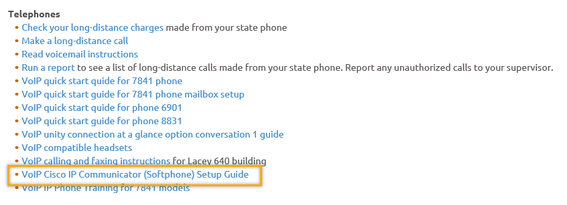
- Data Clean-up reminder
  - We need your help cleaning up the ETO data, so records are not excluded from federal reporting. This is also an important task for future migration to another case management system. We will discuss these clean-up efforts at Advisory and T12 meetings.
- We are seeking ETO Improvements ideas
  - ETO improvement ideas or current work arounds should be submitted through the remedy ticket system https://wpc.wa.gov/tech/issues
  - Tickets are reviewed to determine if your idea or work around is a training issue or needs to go through the governance process for a system change
- ETO Refresher Training
  - Training recordings and user guides are posted on the WPC website here https://wpc.wa.gov/tech/ETO-refresher-training
  - Contact Lynn Aue directly at laue@esd.wa.gov for additional training opportunities and training resources
- WorkSource Systems resources found on the WPC Technology site https://wpc.wa.gov/tech
  - We try our best to make sure all the links are operational but depend on you to email us if you find broken links!
- Before submitting a service, request review these suggestions as the services desk will ask you to do this and many times this resolves your issue timelier:
  - What internet browser are you using?
    - Edge vs Internet Explorer?
    - Remember, only Internet Explorer gives you the best ETO experience. ETO system requirements are: Hardware Compatibility Customer Management software runs on Windows computers and is not compatible with Apple computers unless configured to operate Windows. To prevent potential issues, Windows updates should be conducted on a regular basis. It is recommended that the computer is setup to receive automatic updates for Windows.
    - Software Compatibility: Customer Management software is accessed through the internet. It is highly recommended that Internet Explorer (IE) be used as the browser for the WorkSource solution. Customer Management software is only compatible with Internet Explorer versions 9, 10 and 11. Other browsers, such as other versions of IE, Firefox, Google Chrome, Safari, may appear to function properly, but the feature may not function or save properly. Some features are browser neutral and can be accessed in Safari on the iPad as a mobile option.

  - Log out of ETO, don’t click off the tab here Your ETO session will still be active. Always logout here
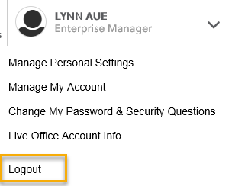
  - If you were impersonating a seeker or recruiter remember to end the session (found in the upper left corner of the seeker or employer home page). Clicking off the browser tab does not end impersonation!
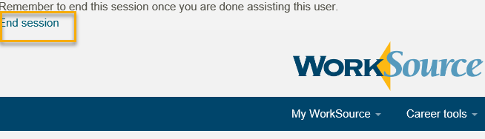

  - Clear your cache weekly for best performance and check your Internet Settings.
    - Clearing Internet Explorer cache: From the top of your browser click the Settings icon and then select Internet Options
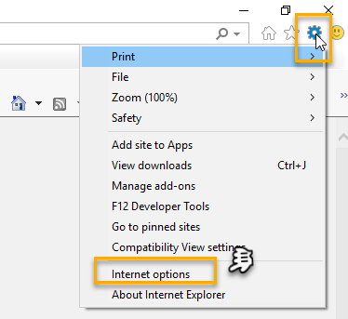

- Begin by clicking Delete on the General tab which takes you to the Delete Browsing History screen. If not already checked click on the 2 boxes outlined here and click delete. You will return to the General tab. Next click the Settings tab to ensure you will be using the most up to date version of ETO and click OK

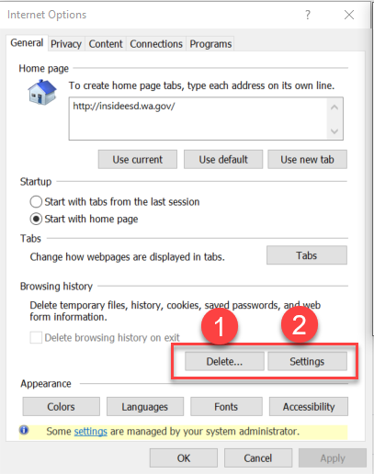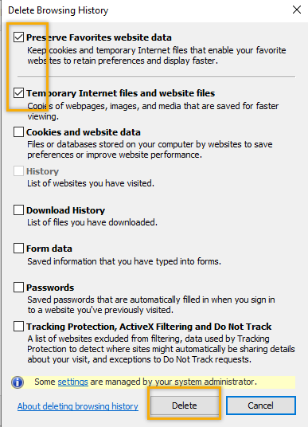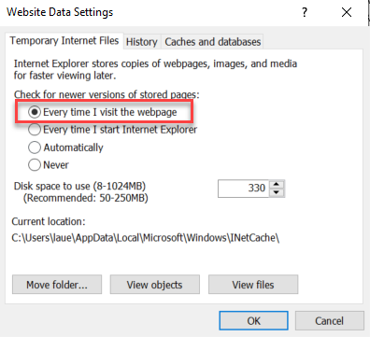

- You will return to the General tab and click Apply and OK to complete the process of clearing your cache
  - Clearing cache in Chrome:
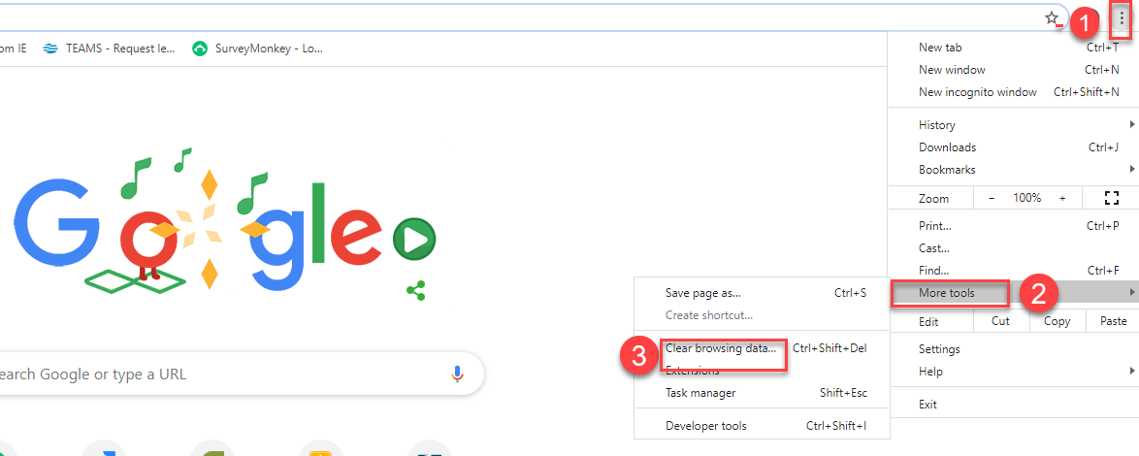

  - Restart your computer

CHAT
from Business to everyone (concerning ITSS requiring an actual outcome for basic service: I usually enter "Not required for this service" in the actual outcome

from Daniel Cooling to everyone: Is there a desk aid to explain the outcomes for touchpoints? What and where to use each different type? There is not a desk aid on how to enter data in the outcomes TP. I suggest you talk to the program operator if there is one for your program (TAA, Veterans, etc). If there isn’t a program operator and you don’t have someone locally to answer this question you can email the Employment Security Department policy group email box for guidance here SystemPolicy@ESD.WA.GOV

from Teresa Anda to everyone: Lynn, I noticed that the enrollment report is not showing SNAP information from the eligibility tp, sure if others have noticed this.
A Jira ticket has been submitted to the vendor to review this issue. I will report out on what we discover. Thanks for addressing it!
from Business to everyone: For a HOLD status, it is required to put the end date even though we are planning to put them on HOLD for 90 days. Do we need to go back and enter the actual end date after 90 days? “Hold: Gap Hold in Service(Training or Individualized)” is intended to last for 90 days. The case manager needs to stay in contact with the participant during the 90 days to access if the reason for the hold is still applicable. If at any time you find the reason for the hold no longer exists, you can close the program. If at the 90 days you determine there is just cause to extend the hold, you can enter the service for an additional 90 days. ETO is configured to automatically enter an end date at the time you create the “Hold: Gap Hold in Service (Training or Individualized)” TP so it is not an open-ended service.

from Selam Tekle to everyone: Why is Post-secondary non duration service? Our clients are in Post-Secondary service for over one quarter. What should we do for clients that are in Post-Secondary Service? This question was taken offline to gather more information.

ATTENDEES

Aaron Parrott
Adline Kerns
ahughes
Arturo Espinoza
Becky Smith
Boliveri
Business
Call-in User_4
Call-in User_7
Craig Clark
Daniel Cooling
Dawn Oakes
Diane Luoma
Donna Mack
Dorothy Rocha
Gena Garcia
Heidi Lamers
Hope Baker
Jeffery Flood *
Joanie Linder
kking
Lisa Pietkauskis
Lux Dmitri
Melisa Flores-Sanches
MCheeseman *
Noel Woods
Patricia Connell
Phyllis Hall
Rebecca McGinnis
Regina Cancel
Schehera Gates
Sean McElligott
Selam Tekle
Teresa Anda
Teresa Southard
Tiffany Granillo
Tiscott
Toni Burow
Tracy Ferrell
trobison@wdcspokane.com
vdamneun
Victoria.wood
Young Suh

Red incidates stayed for second half

