T12 Meeting Agenda 5-6-2020
New Business
- Tickets into production – Nothing tonight
- ETO Maintenance – Nothing this week
- ETO Improvements – None to report this week
- ETO Engage discussion – Survey
  - 33 no responses
  - 4 yes responses
- Training issue(s) of the week –
  - Local staff with ETO Department Head role can make data corrections
  - The WSS team cannot make them
- Headphone update
- Teleworking issues?
- Before submitting a service ticket help
- Tests and Results user guide emailed last week with minutes
  - Thoughts?
Old Business
- Stay up to date on COVID19, teleworking and WorkSource Virtual services
  - WPC website has information to help all WorkSource staff telework.
  - IT service delivery
    - All phone requests need to go through your office Administrator and/or Supervisor
    - Your needs are important to us! Please be patient with the ESD help desk staff, they are slammed and priority of service is set by our Executive Leadership.
  - WebEx
    - Browse the Webex handbook and watch 5 videos on how to make the most out of this tool for conducting meetings with staff and customers.
  - Other resources include:
    - Now that you are teleworking reference guide
    - How to use SKYPE for online meetings
    - How to sign into ESD email from outside the network
    - How to sign into an off-site Wi-Fi from your computer
    - Can I access Internet Explorer from a MAC computer?
    - Will the WSS Team be available to help us while working remote?
    - ESD service Desk information.
- ESD.wa.gov or ESD Facebook page for current UI information
  - Cisco Softphones Webex and training material Link http://insideesd.wa.gov/services/it-services
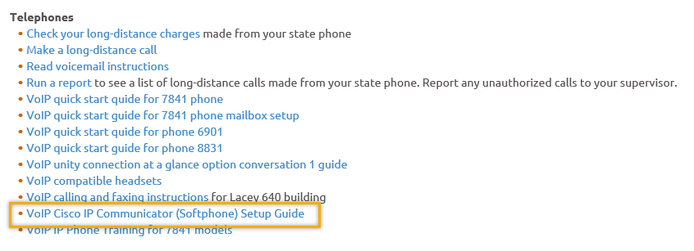
- T12 Webex meeting invite and sign up information
  - Email esdgpwssteam@esd.wa.gov to be added to the distribution list and meeting invite
  - Find call information on the Trumba Staff Development Calendar here https://wpc.wa.gov/tech/staff/calendar
- Reported issues/fixes in the works–
  - WA-3704 Intermittent issues with ETO time out
    - The current issue is caused by a timeout feature used by some customers. It was turned on for all ETO customers March 2019. The vendor’s developer is working on turning this additional time out feature off for Washington users.
- Data Clean-up reminder
  - We need your help with cleaning up the data in ETO. We will discuss these clean-up efforts at the Advisory meeting and report out at the T12 meetings as we continue our efforts of cleaning up ETO data before migrating data to the new system
- We are seeking ideas for ETO Improvements
  - ETO improvement ideas or current work arounds should be submitted through the remedy ticket system.
  - Tickets are reviewed to determine if idea or work around is a training issue or needs to go through the governance process for a system change
  - Submit remedy ticket here https://wpc.wa.gov/tech/issues
- ETO Refresher Training
  - Training recordings and user guides are posted on the WPC website on the Technology tab>ETO Training Resources
  - Contact Lynn Aue directly at laue@esd.wa.gov for additional training opportunities and training resources
- WorkSource Systems resources are found on the WPC Technology site https://wpc.wa.gov/tech
  - We try our best to make sure all the links are operational but depend on you to email us if you find broken links!
- Encourage office staff who use ETO and WSWA to sign up for the T12 calls. These calls are not just for trainers but for all system users and a great way to stay up to date on changes or improvements to ETO and WSWA. Send requests to esdgpWSSteam@esd.wa.gov to be added to the ITSD Training Team’s distribution list

- Before submitting a service request review these suggestions as the services desk will ask you to do this and many times this resolves your issue timelier:
  - What internet browser are you using?
    - Edge vs Internet Explorer?
    - Remember, only Internet Explorer gives you the best ETO experience. ETO system requirements are: Hardware Compatibility Customer Management software runs on Windows computers and is not compatible with Apple computers unless configured to operate Windows. To prevent potential issues, Windows updates should be conducted on a regular basis. It is recommended that the computer is setup to receive automatic updates for Windows.
    - Software Compatibility: Customer Management software is accessed through the internet. It is highly recommended that Internet Explorer (IE) be used as the browser for the WorkSource solution. Customer Management software is only compatible with Internet Explorer versions 9, 10 and 11. Other browsers, such as other versions of IE, Firefox, Google Chrome, Safari, may appear to function properly, but the feature may not function or save properly. Some features are browser neutral and can be accessed in Safari on the iPad as a mobile option.

  - Log out of ETO, don’t click off the tab here Your ETO session will still be active. Always logout here
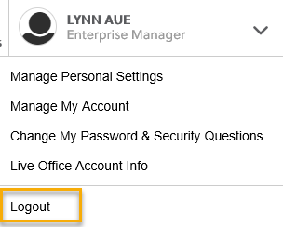
  - If you were impersonating a seeker or recruiter remember to end the session. Clicking off the browser tab does not end impersonation!
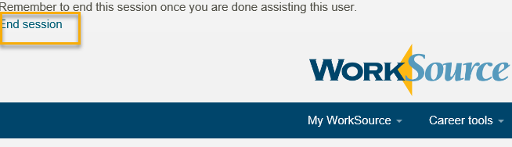

  - Clear your cache weekly for best performance and check your Internet Settings.
    - Clearing Internet Explorer cache: From the top of your browser click the Settings icon and then select Internet Options
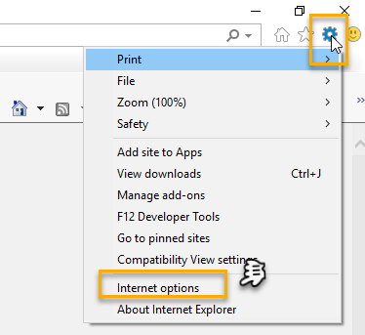

- Begin by clicking Delete on the General tab which takes you to the Delete Browsing History screen. If not already checked click on the 3 boxes outlined here and click delete

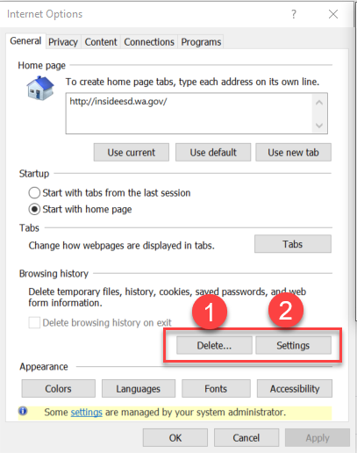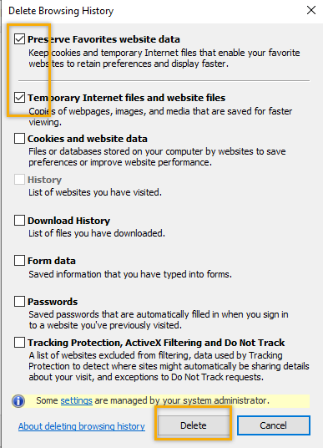
- Next click the Settings tab to ensure you will be using the most up to date version of ETO and click OK
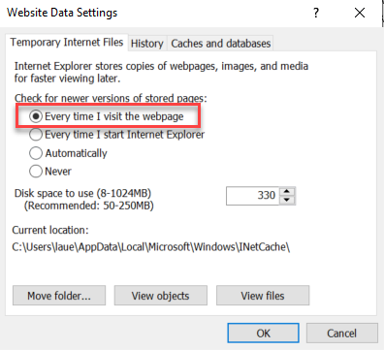
    - You will return to the General tab and click Apply and OK to complete the process of clearing your cache
    - Clearing cache in Chrome:
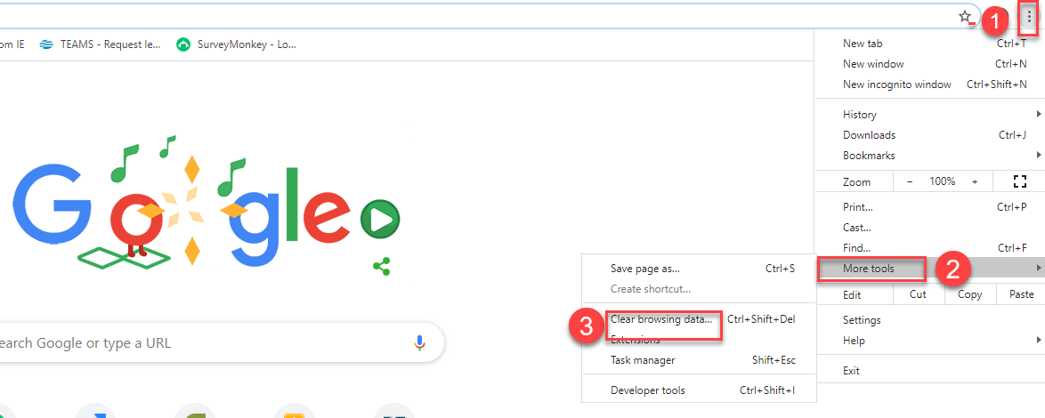
  - Restart your computer
CHAT
Emily Anderson to everyone: Who all did the survey go to? To everyone on the T12 Distribution list. I didn't receive it. I know, because I inadvertently removed you. You are on it now. Sorry

Crystal Armitage to everyone: Here is the link https://www.surveymonkey.com/r/BFYJRSX to the ETO Engage survey

Skyler Blumenthal to everyone: (regarding Voice/Headphone functionality) yeah for WebEx it's hard to be heard because even if you plug in your headphones it still wants to use your laptop's internal microphone. What I've done is join on my computer and mute myself, and then join on my work phon as a call-in user if i want to speak

Schehera Gates to everyone: My headphones work flawlessly.They are Logitech(regarding teleworking and ergonomics/wellness – Be sure to take time to stretch, walk around etc. during your breaks)

Phyllis Hall to everyone: for me teleworking means being tied to my computer more than I ever was at the office
Remember to get up every hour and walk around. Set a reminder on your outlook or phone or I have a FitBit that vibrates to let me know to take 250 steps. Take care of you. Sitting is hard on your body and mind!

Rosemary Henry to everyone: ETO times out quickly. Does that mean we've logged out? are is it still running?ETO time out at 30 minutes. At the 25 minute mark you get a warning that in 5 minutes your session will end. You can refresh your session by clicking the F5 key before anytime before the 30 minute time-out. If you click F5 and you land on the log on page, you timed out. Remember: refreshing (F5) your ETO session does not refresh your WSWA session. WSWA is on a different platform. To keep both ETO and WSWA live you need to log out and log back in before impersonating a job seeker or employer

Skyler Blumenthal to everyone: So we have to navigate to WSWA while impersonating to end the session?No, logging out of ETO and logging back in refreshes your WSWA session.

Kim Bursell to everyone: Is this info available? Somewhere? About clearing cache Yes, it is included in the T12 agenda, minutes and also on the WPC website on the menu under T12 Documents>minutes
Jackie to everyone:
I would like to be added to the distributinon list

ATTENDEES

Amy
Arturo Espinoza *
Boliveri
Becky Smith
Chris File
Claire B
Cori Ching *
Crystal Armitage *
CShaffer
Dan Cooling
Dawn Oakes *
Dean *
Diana Cook *
Dorothy Rocha *
Donna Mack
Emily Anderson
Heidi Lamers
Hope Baker
Ismaila Maidadi
Jackie *
Katherinec
Kim Bursell *
Kking
Linden Obel
Luci Bench
MDominguez *
Mirayia Chacon-Baker
Phyllis Hall
Rosemary Henry *
Schehera Gates *
Sean McElligott *
Selam Tekle *
Shelley Blackburn
Slatiff
swillis
Teresa Sparks
Toni Burow
Vdamneun
Young Suh *
Yvette Dallas

*stayed for the training on ETO

