T12 Meeting Minutes 5-27-2020
New Business
- Tickets into production – Nothing this week
  - Heads up on a new program of enrollment for COVID-19: is pushed out another week
- WA-3785 UI Interface to ETO: due to the increased number of claimants the file is so large we experiencing issues running the job that creates claimant ETO records
- WA-3792 Job seeker has WSWA account but didn’t migrate to ETO, known issue we are working on. Submit a remedy ticket if you experience this with a customer so our team can create an account
- ETO Maintenance/Changes – Nothing this week
- ETO Enhancements/Bug fixes – Follow-up on the 5/21/20 release
  - Impersonation to WSWA. The old version disn’t allow seekers WSWA account to activate until page 2 of the account is completed. After the enhancement, seekers who complete page 1 will now have ETO accounts.Staff can then impersonation the seeker (with permission) to WSWA to complete the account.
  - WA-3523: The change to recognize those who live on JBLM base is functioning as expected in WSWA but not updating information into ETO. This is a known issue we are working on. DVOPs want to identify those seekers who live on JBLM by using these zip codes:
    - 98431
    - 98433
    - 98438
    - 98439
    - 98499
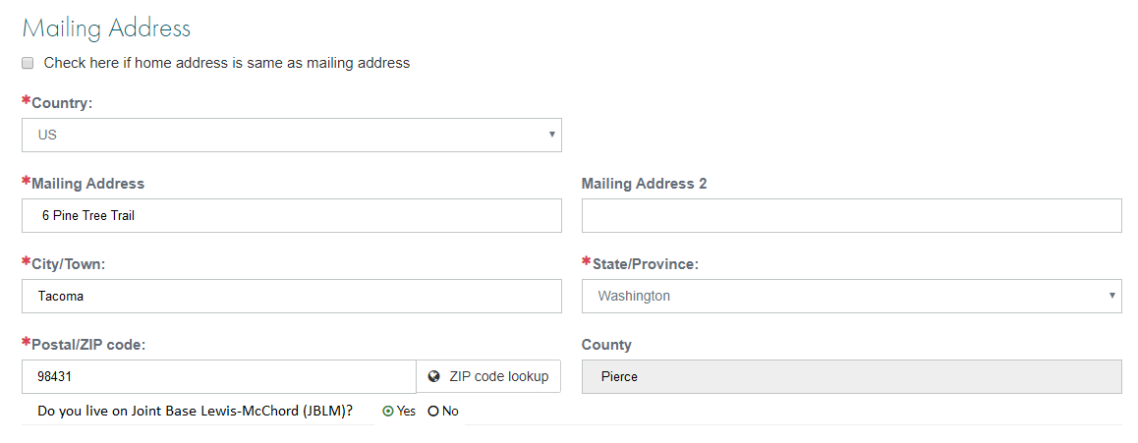

  - Close out alert banner on WSWA – a user can hide the banner so it doesn’t obstruct the full view of the WSWA homepage. Users can click the X to close. Note: this option is also available on mobile devices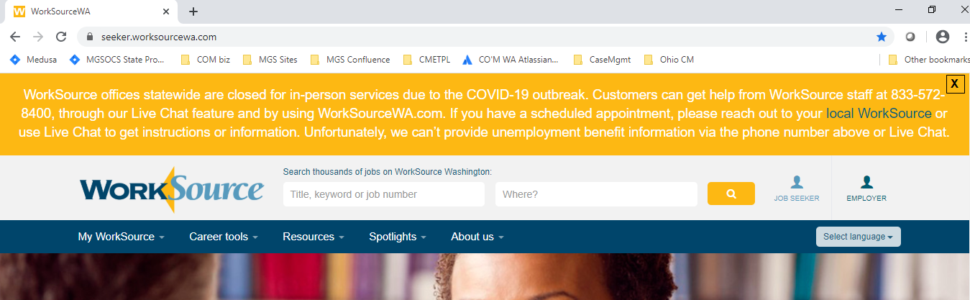
Users will have the ability to reopen the banner after closing by clicking on “View Alert”
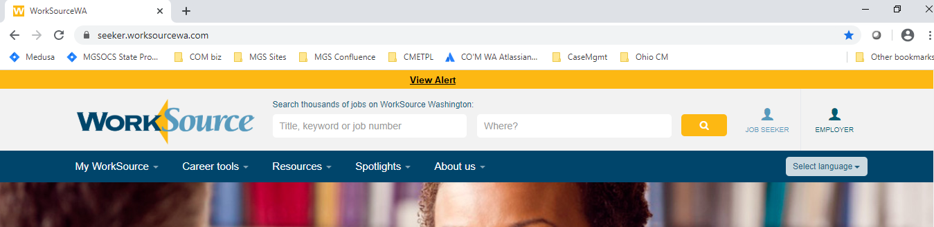

- Upload files from Google drive – this was identified as a bug and now reported as fixed
- WA-3704 Intermittent issues with ETO time out
  - The current issue was caused by a timeout feature used by some SSG/ETOcustomers. This issue is reported as fixed
- ETO Engage discussion – Survey https://www.surveymonkey.com/r/BFYJRSX
  - 55 no responses
  - 25 yes responses
  - Survey will close 5/29/20
  - Results will be reviewed for future ETO Engage improvements
- UI announcements
  - ESD.wa.gov or ESD Facebook page for current UI information
  - Since the week ending March 7 when COVID-19 job losses began through 5/16/20:
    - A total of 1,937,576 initial claims have been filed during the pandemic (1,222,861 regular unemployment insurance, 381,904 PUA and 332,811 PEUC)
    - A total of 1,106,684 distinct individuals have filed for unemployment benefits
    - ESD has paid out nearly $3.8 billion in benefits
    - 768,217 individuals who have filed an initial claim have been paid
- UI Fraud help
  - www.esd.wa.gov/fraud
  - fax information to claims centers 833-572-8423 – calling not recommended due to the high volume of calls
- Training issue(s) of the week – nothing to report
- Before submitting a service ticket help
Old Business
- Encourage all staff who use ETO and WSWA to sign up for the T12 calls. These calls are not just for trainers but for all system users and a great way to stay up to date on changes or improvements to ETO and WSWA. Send requests to esdgpWSSteam@esd.wa.gov to be added to the ITSD Training Team’s distribution list or find meeting information on the Trumba Staff Development Calendar here https://wpc.wa.gov/tech/staff/calendar
- Stay up to date on COVID19, teleworking and WorkSource Virtual services
  - WPC website has information to help all WorkSource staff telework.
  - IT service delivery
    - All phone requests need to go through your office Administrator and/or Supervisor
    - Your needs are important to us! Please be patient with the ESD help desk staff, they are slammed and priority of service is set by our Executive Leadership.
  - WebEx
    - Browse the Webex handbook and watch 5 videos on how to make the most out of this tool for conducting meetings with staff and customers.
  - Other resources include:
    - Now that you are teleworking reference guide
    - How to use SKYPE for online meetings
    - How to sign into ESD email from outside the network
    - How to sign into an off-site Wi-Fi from your computer
    - Can I access Internet Explorer from a MAC computer?
    - Will the WSS Team be available to help us while working remote?
    - ESD service Desk information.
- Cisco Softphones training material Link http://insideesd.wa.gov/services/it-services
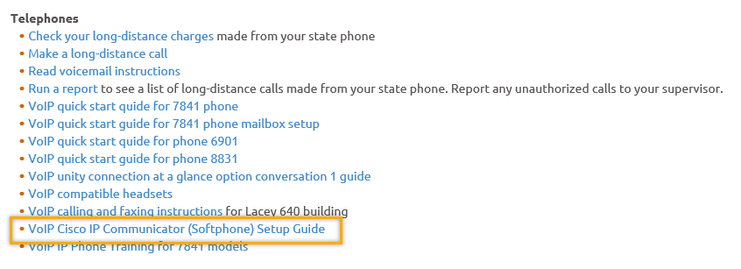
- Data Clean-up reminder
- We need your help cleaning up the ETO data so records are not excluded from federal reporting. This is also an important task for future migration to another case management system. We will discuss these clean-up efforts at Advisory and T12 meetings.
- We are seeking ETO Improvements ideas
  - ETO improvement ideas or current work arounds should be submitted through the remedy ticket system https://wpc.wa.gov/tech/issues
  - Tickets are reviewed to determine if your idea or work around is a training issue or needs to go through the governance process for a system change
- ETO Refresher Training
  - Training recordings and user guides are posted on the WPC website here https://wpc.wa.gov/tech/ETO-refresher-training
  - Contact Lynn Aue directly at laue@esd.wa.gov for additional training opportunities and training resources
- WorkSource Systems resources found on the WPC Technology site https://wpc.wa.gov/tech
  - We try our best to make sure all the links are operational but depend on you to email us if you find broken links!
- Before submitting a service request review these suggestions as the services desk will ask you to do this and many times this resolves your issue timelier:
  - What internet browser are you using?
    - Edge vs Internet Explorer?
    - Remember, only Internet Explorer gives you the best ETO experience. ETO system requirements are: Hardware Compatibility Customer Management software runs on Windows computers and is not compatible with Apple computers unless configured to operate Windows. To prevent potential issues, Windows updates should be conducted on a regular basis. It is recommended that the computer is setup to receive automatic updates for Windows.
    - Software Compatibility: Customer Management software is accessed through the internet. It is highly recommended that Internet Explorer (IE) be used as the browser for the WorkSource solution. Customer Management software is only compatible with Internet Explorer versions 9, 10 and 11. Other browsers, such as other versions of IE, Firefox, Google Chrome, Safari, may appear to function properly, but the feature may not function or save properly. Some features are browser neutral and can be accessed in Safari on the iPad as a mobile option.

  - Log out of ETO, don’t click off the tab here Your ETO session will still be active. Always logout here
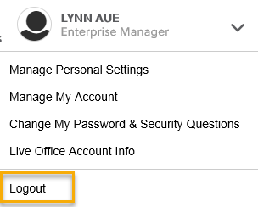
  - If you were impersonating a seeker or recruiter remember to end the session. Clicking off the browser tab does not end impersonation!
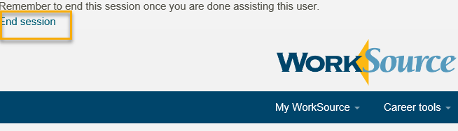

  - Clear your cache weekly for best performance and check your Internet Settings.
    - Clearing Internet Explorer cache: From the top of your browser click the Settings icon and then select Internet Options
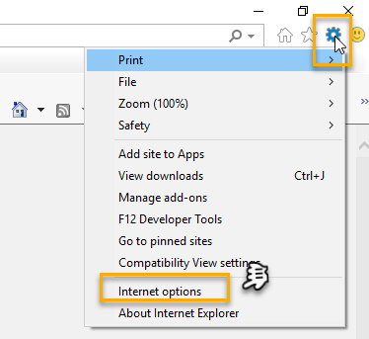

- Begin by clicking Delete on the General tab which takes you to the Delete Browsing History screen. If not already checked click on the 3 boxes outlined here and click delete

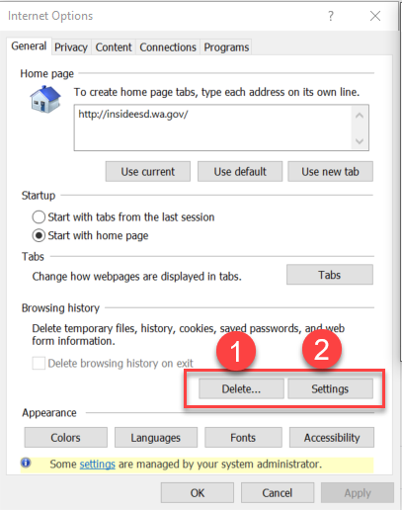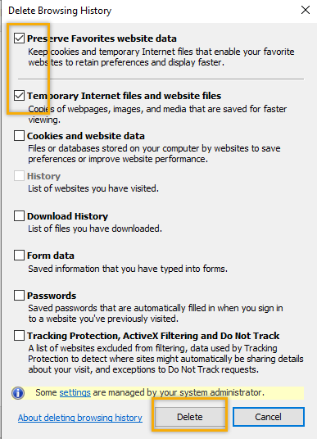

- Next click the Settings tab to ensure you will be using the most up to date version of ETO and click OK
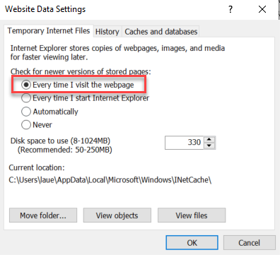
    - You will return to the General tab and click Apply and OK to complete the process of clearing your cache
    - Clearing cache in Chrome:
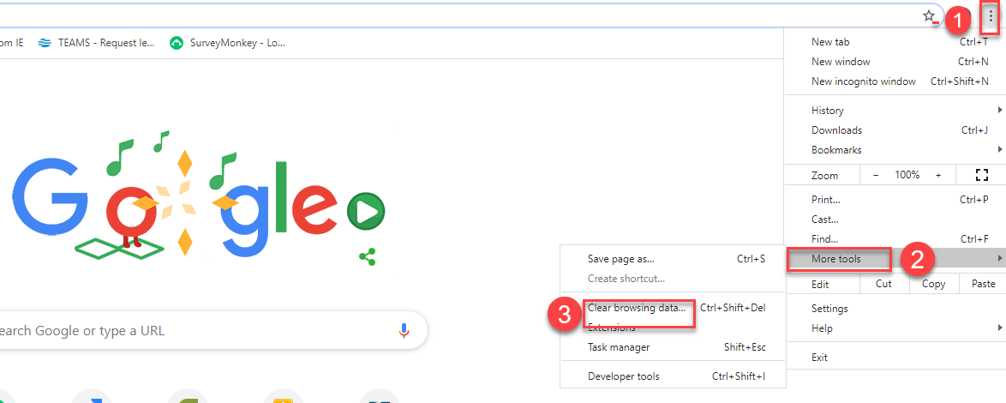
  - Restart your computer
CHAT
Teresa Anda: What should we do in the meantime to provide services to these customers? For those that we can't find ETO? Submit a remedy tickets for your customers whose WSWA accounts are not migrating to ETO
Diana Cook: Is Webex a secure platform? Contact Mike Juhl or someone on ESD’s security team about this and your concerns about the security of Webex.

ATTENDEES
Adelp*
Amanda Standley*
Arturo Espinoza*
Becky Smith
Boliveri*
Business
Catherine Geddis
Cori-Ann
CShaffer
Diana Cook*
Daniel Cooling
Dawn Oakes
Donna Mack
Emily Anderson
Heidi Lamers
Heidi Schauble*
Hope Baker
Jackie
JNavarro*
JSmith*
Kim Bursell*
Kking*
La Qwana*
Linden Obel
Lux Dmitri*
MDomingez*
Melisa Flores-Sanchez*
Mirayia Chacon-Baker
Monique Martin
Noel Woods
Schehera Gates
Sean McElligott
Selam Tekle
Shalina Latiff*
Skyler Blumenthal*
Sue Keltner*
Taylor Inman-Scott*
Teresa Anda
Teresa Sparks
Tracy Ferrell
Vdamneun
Young Suh*
Yvette Dallas

*2nd half Meeting Attendance

