T12 Meeting Minutes 5-13-2020
New Business
- Tickets into production –
  - WA-3771, 8 new services, 8 deactivated services, update to services catalog
    - New/Activated services:
      - Program Support Services (Other) (3.0)
      - Labor Market Information Services (2.0) (Youth Only)
      - Labor Market Information Services in Follow-Up (2.0) (Youth Only)
      - Paid and Unpaid Work Experience with Academic/Education Component – Internships or Employment Opportunities (Youth Only)
      - Paid and Unpaid Work Experience with Academic/Education Component – Job Shadowing (Youth Only)
      - Career Guidance Services (3.0)
      - Deskside Job Seeker Assistance (3.0)
      - Career and Vocational Counseling (2.0)
    - Deactivated Services:
      - Program Support Services (Other) (2.0)
      - Labor Market Information Services (Youth Only)
      - Labor Market Information Services in Follow-Up (Youth Only)
      - Paid and Unpaid Work Experience with Academic/Education Component – Employment Opportunities (Youth Only)
      - Paid and Unpaid Work Experience with Academic/Education Component – Internships and Job Shadowing (Youth Only)
      - Career Guidance Services (2.0)
      - Deskside Job Seeker Assistance (2.0)
      - Career and Vocational Counseling
- ETO Maintenance – server security maintenance 5/16/-5/17/20
- ETO Enhancements/Bug fixes – Scheduled for 5/21/20 release
  - Impersonation to WSWA. Currently seekers WSWA account is disabled until page 2 of the account is completed. After the enhancement, accounts will be enabled for ETO to WSWA impersonation for seekers who complete page 1
  - Do you live on JBLM base - DVOPs want to identify those seekers who live on JBLM by using these zip JBLM Zip Codes:
    - 98431
    - 98433
    - 98438
    - 98439
    - 98499
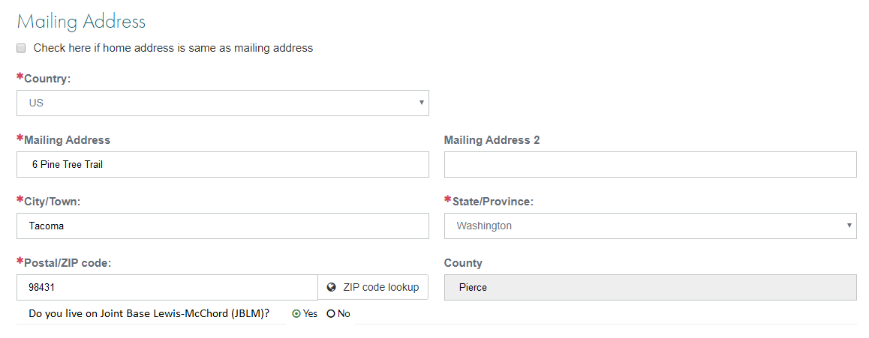
  - Close out alert banner on WSWA – a user wants to fide the banner so it doesn’t obstruct the full view of the WSWA homepage. Users can click the X to close 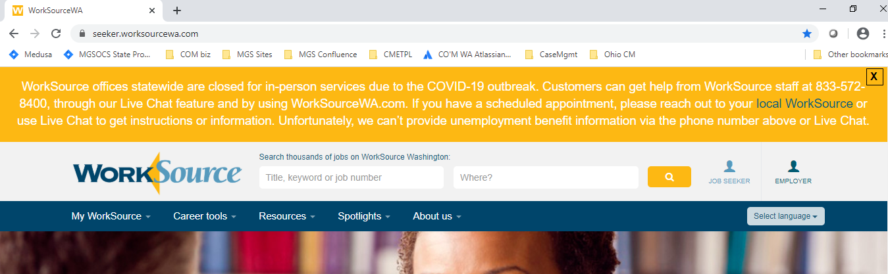

Users will have the ability to reopen the banner after closing it as well

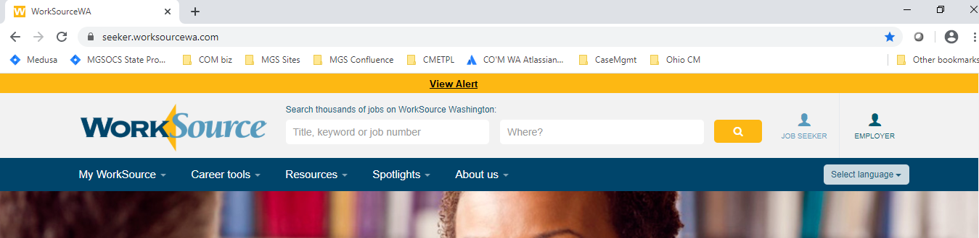
  - Upload files from Google drive – this was identified as a bug and will be fixed in this release
- ETO Engage discussion – Survey
  - 35 no responses
  - 15 yes responses
- UI announcments
  - Fraud alert
    - esdfraud@esd.w.gov
    - Call 800-246-9763 (not recommended) or fax 833-572-8423
  - Temparary phone system change
    - May 13 to May 20, limiting inbound calls so claims staff can focus on outbound calling to resolve pending claims and complex issues. Inbound calls will be reserved for those who lack internet access and need to use the phone to apply for benefits and submit weekly claims.
- Training issue(s) of the week – nothing to report
- Before submitting a service ticket help
Old Business
- Stay up to date on COVID19, teleworking and WorkSource Virtual services
  - WPC website has information to help all WorkSource staff telework.
  - IT service delivery
    - All phone requests need to go through your office Administrator and/or Supervisor
    - Your needs are important to us! Please be patient with the ESD help desk staff, they are slammed and priority of service is set by our Executive Leadership.
  - WebEx
    - Browse the Webex handbook and watch 5 videos on how to make the most out of this tool for conducting meetings with staff and customers.
  - Other resources include:
    - Now that you are teleworking reference guide
    - How to use SKYPE for online meetings
    - How to sign into ESD email from outside the network
    - How to sign into an off-site Wi-Fi from your computer
    - Can I access Internet Explorer from a MAC computer?
    - Will the WSS Team be available to help us while working remote?
    - ESD service Desk information.
- ESD.wa.gov or ESD Facebook page for current UI information
  - Cisco Softphones Webex and training material Link http://insideesd.wa.gov/services/it-services
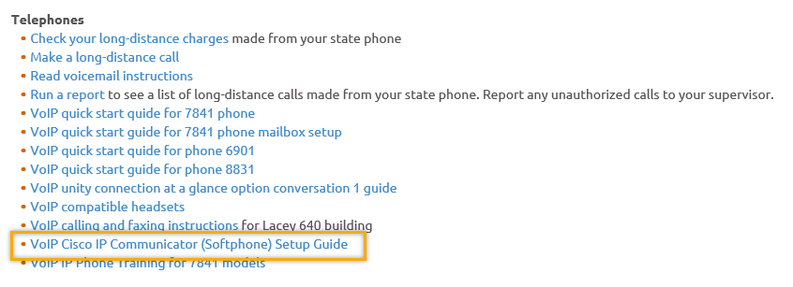
- T12 Webex meeting invite and sign up information
  - Email esdgpwssteam@esd.wa.gov to be added to the distribution list and meeting invite
  - Find call information on the Trumba Staff Development Calendar here https://wpc.wa.gov/tech/staff/calendar
- Reported issues/fixes in the works–
  - WA-3704 Intermittent issues with ETO time out
    - The current issue is caused by a timeout feature used by some customers. It was turned on for all ETO customers March 2019. The vendor’s developer is working on turning this additional time out feature off for Washington users.
- Data Clean-up reminder
  - We need your help with cleaning up the data in ETO. We will discuss these clean-up efforts at the Advisory meeting and report out at the T12 meetings as we continue our efforts of cleaning up ETO data before migrating data to the new system
- We are seeking ideas for ETO Improvements
  - ETO improvement ideas or current work arounds should be submitted through the remedy ticket system.
  - Tickets are reviewed to determine if idea or work around is a training issue or needs to go through the governance process for a system change
  - Submit remedy ticket here https://wpc.wa.gov/tech/issues
- ETO Refresher Training
  - Training recordings and user guides are posted on the WPC website on the Technology tab>ETO Training Resources
  - Contact Lynn Aue directly at laue@esd.wa.gov for additional training opportunities and training resources
- WorkSource Systems resources are found on the WPC Technology site https://wpc.wa.gov/tech
  - We try our best to make sure all the links are operational but depend on you to email us if you find broken links!
- Encourage office staff who use ETO and WSWA to sign up for the T12 calls. These calls are not just for trainers but for all system users and a great way to stay up to date on changes or improvements to ETO and WSWA. Send requests to esdgpWSSteam@esd.wa.gov to be added to the ITSD Training Team’s distribution list

- Before submitting a service request review these suggestions as the services desk will ask you to do this and many times this resolves your issue timelier:
  - What internet browser are you using?
    - Edge vs Internet Explorer?
    - Remember, only Internet Explorer gives you the best ETO experience. ETO system requirements are: Hardware Compatibility Customer Management software runs on Windows computers and is not compatible with Apple computers unless configured to operate Windows. To prevent potential issues, Windows updates should be conducted on a regular basis. It is recommended that the computer is setup to receive automatic updates for Windows.
    - Software Compatibility: Customer Management software is accessed through the internet. It is highly recommended that Internet Explorer (IE) be used as the browser for the WorkSource solution. Customer Management software is only compatible with Internet Explorer versions 9, 10 and 11. Other browsers, such as other versions of IE, Firefox, Google Chrome, Safari, may appear to function properly, but the feature may not function or save properly. Some features are browser neutral and can be accessed in Safari on the iPad as a mobile option.

  - Log out of ETO, don’t click off the tab here Your ETO session will still be active. Always logout here
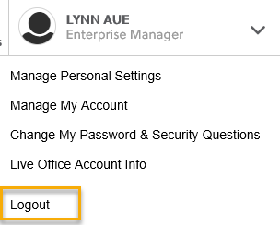
  - If you were impersonating a seeker or recruiter remember to end the session. Clicking off the browser tab does not end impersonation!
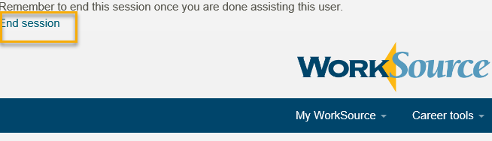

  - Clear your cache weekly for best performance and check your Internet Settings.
    - Clearing Internet Explorer cache: From the top of your browser click the Settings icon and then select Internet Options
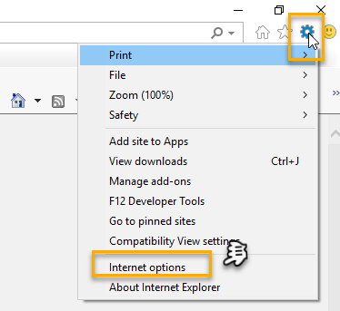

- Begin by clicking Delete on the General tab which takes you to the Delete Browsing History screen. If not already checked click on the 3 boxes outlined here and click delete

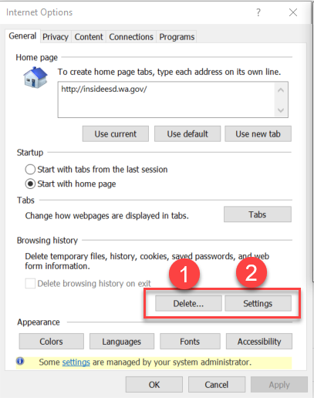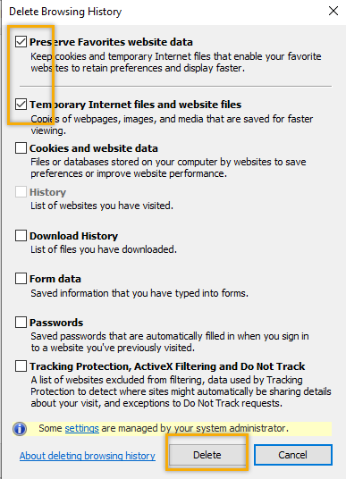
- Next click the Settings tab to ensure you will be using the most up to date version of ETO and click OK
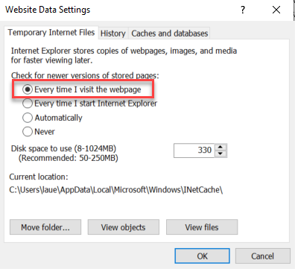
    - You will return to the General tab and click Apply and OK to complete the process of clearing your cache
    - Clearing cache in Chrome:
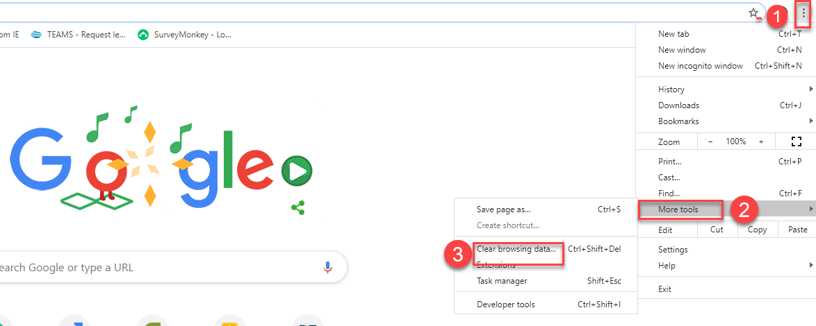
  - Restart your computer
CHAT
Regarding ‘page 2’ and being able to fill out that information via impersonation:
from Crystal Armitage to everyone: What is the value of impersonation if they only complete page 1. My understanding is that they only have a WS dashboard after completing page 2. Right now the seeker has to complete page 2 or the account isn’t available to impersonate (ETO to LX). We are implementing a change on Thursday, as part of the .11 release, to resolve this so that the seeker can be impersonated as soon as they complete page 1.
from Crystal Armitage to everyone: Can we complete page 2 for the customer? I don’t know that a case manager shouldn’t or couldn’t assist the seeker with this. Right now that isn’t an option because of the issue with impersonation (and not having page 2 completed) but after the .11 release, case managers will be able to provide this assistance, from a functionality perspective.
from Monique Martin to everyone: would it be possible to impersonate them, finish page two so that they will then have a dashboard? Because that is the request in the ticket (WA-3523). These are the zip codes that are included in the US Postal Service definition of primary and secondary zip codes.
from Schehera Gates to everyone: We were previoiusly unable to impersonate until page two was completed.
from Business to everyone:
How will it affect the full WIOA Eligibility Enrollment, having only one page of WS WA account?

Regarding accessing via Mobile and other questions:
from Monique Martin to everyone:
regarding the JBLM question, does it only pop up when those specific zip codes are listed? YES
from Crystal Armitage to everyone: can we get an "X" option on mobile devices for the WS banner? That is going to be part of the functionality when this change is implemented during the .11 release. The corresponding ticket is WA-3773.

ATTENDEES

Aaron Parrott
Adeline Kerns *
Ahughes
Barbara
Becky Smith
Boliveri
Business *
Catheine Geddis *
Claire B *
Cori Ching *
CShaffer
Crystal Armitage *
Daniel Cooling
Danielle *
Dawn Oakes
Donna Hendrickson
Donna Mack
Dorothy Rocha
Emily Anderson
Heidi Lamers
Jackie *
Jeffery Flood
Jing Ko *
Jordan Meyenburg *
Katherinec
KHesseltine
Kking
Linden Obel
Lisa Pietkauskis
MDominguez *
Melisa Flores-Sanchez *
Monique Martin *
Noel Woods *
Paige Schmelzer *
Rosemary Henry
Schehera Gates
Sean McElligot
Selam Tekle
Sue Keltner
Taylor Inman-Scott *
Teresa Anda
Teresa Southard
Toni Burow
Tracy
trobison@wdcspokane.com *
vdamneun
Young Suh *

Yvette Dallas
Dean
* stayed for training after

