T12 Meeting Minutes 4-8-2020
New Business
- New T12 Webex meeting invite and sign up information
  - Email esdgpwssteam@esd.wa.gov to be added to the distribution list and meeting invite
  - Find call information on the Trumba Staff Development Calendar here https://wpc.wa.gov/tech/staff/calendar
- ESD.wa.gov or ESD Facebook page for current UI information

- UI benefit update – I am not a UI specialist this is for your reference. Refer job seekers, employers, claimants, family and friends to ESD’s website and Facebook page for the latest update
What’s new: On 3/27/20, the President signed the CARES Act into law. This law provides relief for workers affected by the Coronavirus. This update explains the addition of $600 each week to eligible claims, known as Federal Pandemic Unemployment Compensation (FPUC). The other two programs, Pandemic Emergency Unemployment Compensation (PEUC) and Pandemic Unemployment Assistance (PUA), will be addressed in subsequent updates.
Eligibility
FPUC adds $600 each week to the current weekly benefits from these UI programs (underlying benefits):
  - Regular UI (including UCFE, UCX)
  - Pandemic Emergency Unemployment Compensation (PEUC)
  - Pandemic Unemployment Assistance (PUA)
  - Extended Benefits (EB)
  - Short-time Compensation (SharedWork)
  - Trade Readjustment Allowances (TRA)
  - Disaster Unemployment Assistance (DUA)
  - Self-employment Assistance Program (SEAP)
Note: FPUC is not payable on Training Benefits (TB) because it is a state program.
- It is payable for weeks ending 4/4/20 through 7/25/20.
- Claimants do not have to apply to receive the additional payment amount. It is automatically added to eligible weekly claims.
- Payments are retroactive to the first eligible week once UTAB is updated to accommodate the program.
- It will pay $600 in addition to the weekly benefit amount if claimants are eligible for at least $1 of underlying benefits after deductions. For example, claimants eligible for $1 after deductions will receive a payment of $601.
Deductions from FPUC
- Earnings and one-seventh and two-sevenths deductions for availability are not deductible from the $600 FPUC payment. Claimants who are not eligible for at least $1 in underlying benefits will not receive FPUC.
- Child support is deductible from the $600.
- FPUC is taxable. Claimants can choose to have 10% withheld for taxes.
- FPUC can be used to offset overpayments, but no more than 50% of the FPUC payment can be used. For example:
- Claimant’s WBA is $600, FPUC is $600.
- Overpayment balance is $3000.
- Claimant only has $1200 remaining balance of regular benefits.
- We can offset at 100% of the WBA because the balance available is equal to or less than the balance of the overpayment.
- We can offset $600 from the regular benefits but no more than $300 from the FPUC, to equal an offset of $900. The claimant still gets a check for $300.
Other informationUnder the CARES Act, quitting work just to obtain FPUC benefits is not good cause and considered fraud. This does not apply to regular quits without good cause. You must assess fraud on this quit decision.

If fraud is committed on any underlying issue for a week that claimants receive FPUC, they are denied benefits the same as any other fraud issue.
Can they appeal not receiving FPUC?
No. Ineligibility for FPUC alone is not appealable since claimants aren’t eligible for FPUC without underlying benefits. If claimants disagree with the denial of FPUC, they must file an appeal on the underlying denied issue.
Overpayments
Overpayments for FPUC may be waived using the same equity and good conscience considerations as regular UI overpayments.
Does it affect experience rating?
No. FPUC is 100% federally funded. Employers are not charged for FPUC.

- Tickets into production – tonight after business hours
  - NAIC values list in WSWA will be updated from the 2012 list to 2017 list
  - What does this update mean to WSWA?
There are 380 existing WSWA companies be impacted because the NAICS code they use is being REPLACED. This represents approximately 1% of WSWA Hiring companies. When one of these existing employers EDITS their account info or an existing job posting, they will be required to enter a new NAICS code. For any NEW accounts created or jobs posted, the NAICS/Company Industry dropdown will present only the new 2017 NAICS codes.
- ETO Maintenance – April 18-19, 2020 6pm Saturday to 3am Sunday
- ETO Improvements – none to report
- Training issue(s) of the week –
  - CCWA – program ended 3/31/2020. Waiting on decision from Grants management and Policy on process.
- Cisco Softphones Webex and training material
  - Link http://insideesd.wa.gov/services/it-services 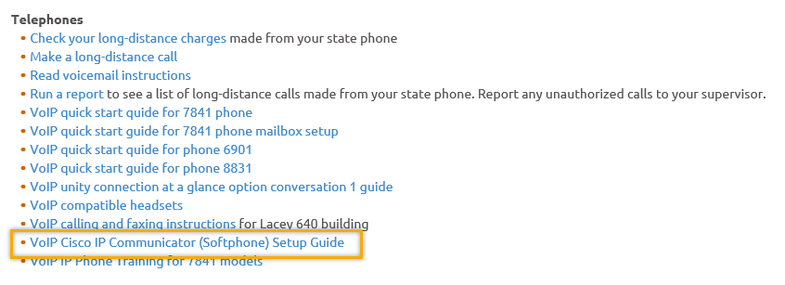
- Stay up to date on COVID19, teleworking and WorkSource Virtual services
  - WPC website has information to help all WorkSource staff telework.
  - IT service delivery
    - All phone requests need to go through your office Administrator and/or Supervisor
    - Your needs are important to us! Please be patient with the ESD help desk staff, they are slammed and priority of service is set by our Executive Leadership.
  - WebEx
    - Browse the Webex handbook and watch 5 videos on how to make the most out of this tool for conducting meetings with staff and customers.
  - Other resources include:
    - Now that you are teleworking reference guide
    - How to use SKYPE for online meetings
    - How to sign into ESD email from outside the network
    - How to sign into an off-site Wi-Fi from your computer
    - Can I access Internet Explorer from a MAC computer?
    - Will the WSS Team be available to help us while working remote?
    - ESD service Desk information.
- Before submitting a service ticket help
Old Business
- Reported issues/fixes in the works–
  - WA-3704 Intermittent issues with ETO time out
    - The current issue is caused by a timeout feature used by some customers. It was turned on for all ETO customers March 2019. The vendor’s developer is working on turning this additional time out feature off for Washington users.
- Data Clean-up reminder
  - We need your help with cleaning up the data in ETO. We will discuss these clean-up efforts at the Advisory meeting and report out at the T12 meetings as we continue our efforts of cleaning up ETO data before migrating data to the new system
- We are seeking ideas for ETO Improvements
  - ETO improvement ideas or current work arounds should be submitted through the remedy ticket system.
  - Tickets are reviewed to determine if idea or work around is a training issue or needs to go through the governance process for a system change
  - Submit remedy ticket here https://wpc.wa.gov/tech/issues
- ETO Refresher Training
  - Training recordings and user guides are posted on the WPC website on the Technology tab>ETO Training Resources
  - Contact Lynn Aue directly at laue@esd.wa.gov for additional training opportunities and training resources
- WorkSource Systems resources are found on the WPC Technology site
  - https://wpc.wa.gov/tech
  - We try our best to make sure all the links are operational but depend on you to email us if you find broken links!
- Encourage office staff who use ETO and WSWA to sign up for the T12 calls. These calls are not just for trainers but for all system users and a great way to stay up to date on changes or improvements to ETO and WSWA. Send requests to esdgpWSSteam@esd.wa.gov to be added to the ITSD Training Team’s distribution list

- Before submitting a service request review these suggestions as the services desk will ask you to do this and many times this resolves your issue timelier:
  - What internet browser are you using?
    - Edge vs Internet Explorer?
    - Remember, only Internet Explorer gives you the best ETO experience. ETO system requirements are: Hardware Compatibility Customer Management software runs on Windows computers and is not compatible with Apple computers unless configured to operate Windows. To prevent potential issues, Windows updates should be conducted on a regular basis. It is recommended that the computer is setup to receive automatic updates for Windows.
    - Software Compatibility: Customer Management software is accessed through the internet. It is highly recommended that Internet Explorer (IE) be used as the browser for the WorkSource solution. Customer Management software is only compatible with Internet Explorer versions 9, 10 and 11. Other browsers, such as other versions of IE, Firefox, Google Chrome, Safari, may appear to function properly, but the feature may not function or save properly. Some features are browser neutral and can be accessed in Safari on the iPad as a mobile option.

  - Log out of ETO, don’t click off the tab here Your ETO session will still be active. Always logout here
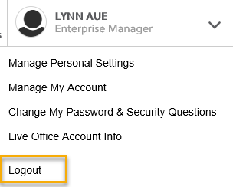
  - If you were impersonating a seeker or recruiter remember to end the session. Clicking off the browser tab does not end impersonation!
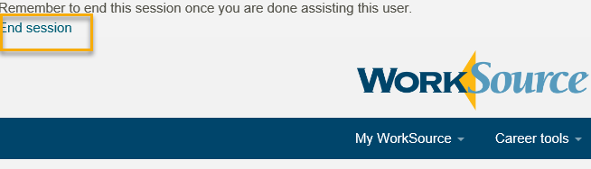

  - Clear your cache weekly for best performance and check your Internet Settings.
    - From the top of your browser click the Settings icon and then select Internet Options
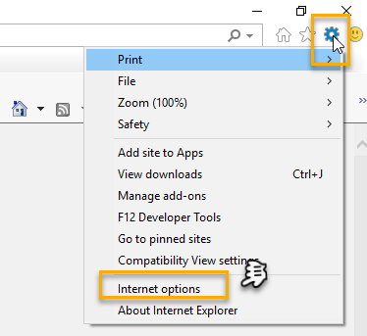

- Begin by clicking Delete on the General tab which takes you to the Delete Browsing History screen. If not already checked click on the 3 boxes outlined here and click delete

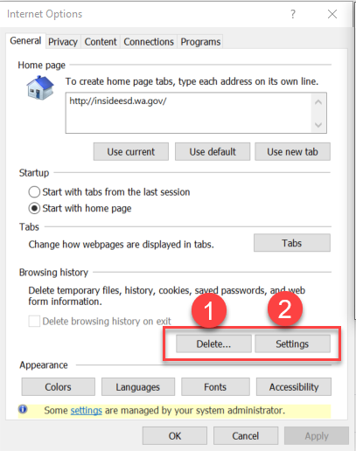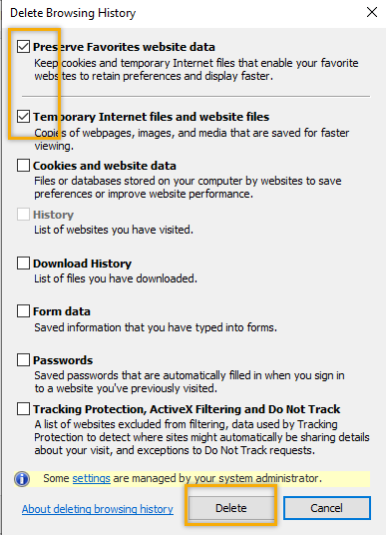
- Next click the Settings tab to ensure you will be using the most up to date version of ETO and click OK
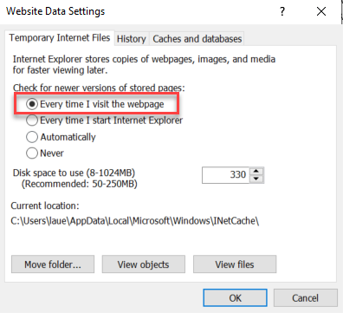
    - You will return to the General tab and click Apply and OK to complete the process of clearing your cache
  - Restart your computer
CHAT – Nothing in today’s chat

ATTENDEES

Aaron Parrott
Abigail Taft
Amy
Barbara
BMenter
Brett
Brooke Zielinski
ccauthron
Craig Clark
CShaffer
Dawn Oakes
Dean
Donna Mack
Emily Anderson
Heidi Lamers
Haidi Schauble
Irene Jordan
Ismaila Maidadi
Jeff Flood
Jessica Corpuel
Joanie Linder
Jordan Meyenburg
Katherine C
Linden Obel
Luci Bench
Maria
MDoningues
MOMartin
Phillis Hall
Rachel
RCancel
Rebecca McGinnis
RJonas
S Butler
Selam Tekle
SGates
TSparks
Teresa Anda
Tiffany Granillo
Ton Nguyen
Tracy
Tracy Ollgaard
Vdamneun
Yolanda Alvear

