T12 Meeting Minutes 4-29-2020
New Business
- Tickets into production – Nothing tonight
- ETO Maintenance – Nothing this week
- ETO Improvements – None to report this week
- ETO Engage discussion – Joanie Linder, WSS Team, all users
  - Who uses it and how do you use it?
  - Expect a survey from Lynn 4/30/20
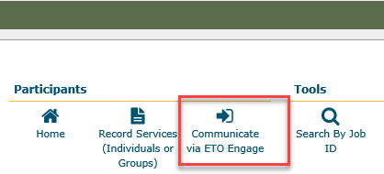
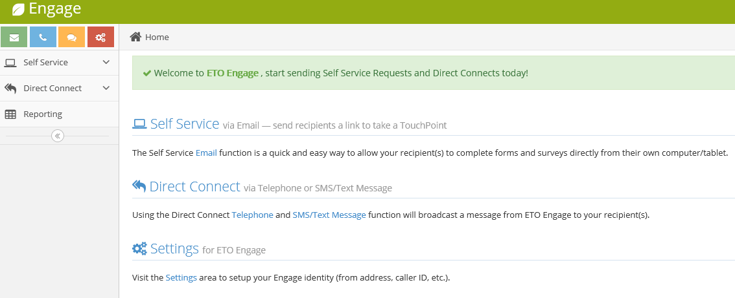
- Training issue(s) of the week –
  - Clear your cache – instructions in the “Old Business” sections at the end of minutes
  - Refresh Reports Menu before running reports, everytime!
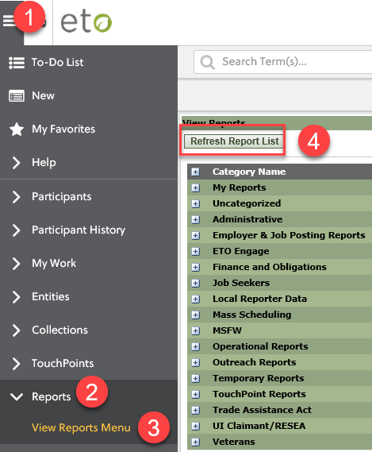
- Before submitting a service ticket help
- Tests and Results user guide
  - Sending draft out with minutes for your testing and input
- Adding group basic services and how this function applies to the current state
  - Follow-up. Working with It/Business to see how we can improve the current functionality
Old Business
- Stay up to date on COVID19, teleworking and WorkSource Virtual services
  - WPC website has information to help all WorkSource staff telework.
  - IT service delivery
    - All phone requests need to go through your office Administrator and/or Supervisor
    - Your needs are important to us! Please be patient with the ESD help desk staff, they are slammed and priority of service is set by our Executive Leadership.
  - WebEx
    - Browse the Webex handbook and watch 5 videos on how to make the most out of this tool for conducting meetings with staff and customers.
  - Other resources include:
    - Now that you are teleworking reference guide
    - How to use SKYPE for online meetings
    - How to sign into ESD email from outside the network
    - How to sign into an off-site Wi-Fi from your computer
    - Can I access Internet Explorer from a MAC computer?
    - Will the WSS Team be available to help us while working remote?
    - ESD service Desk information.
- ESD.wa.gov or ESD Facebook page for current UI information
  - Cisco Softphones Webex and training material Link http://insideesd.wa.gov/services/it-services
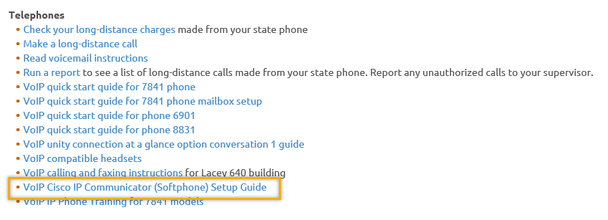
- T12 Webex meeting invite and sign up information
  - Email esdgpwssteam@esd.wa.gov to be added to the distribution list and meeting invite
  - Find call information on the Trumba Staff Development Calendar here https://wpc.wa.gov/tech/staff/calendar
- Reported issues/fixes in the works–
  - WA-3704 Intermittent issues with ETO time out
    - The current issue is caused by a timeout feature used by some customers. It was turned on for all ETO customers March 2019. The vendor’s developer is working on turning this additional time out feature off for Washington users.
- Data Clean-up reminder
  - We need your help with cleaning up the data in ETO. We will discuss these clean-up efforts at the Advisory meeting and report out at the T12 meetings as we continue our efforts of cleaning up ETO data before migrating data to the new system
- We are seeking ideas for ETO Improvements
  - ETO improvement ideas or current work arounds should be submitted through the remedy ticket system.
  - Tickets are reviewed to determine if idea or work around is a training issue or needs to go through the governance process for a system change
  - Submit remedy ticket here https://wpc.wa.gov/tech/issues
- ETO Refresher Training
  - Training recordings and user guides are posted on the WPC website on the Technology tab>ETO Training Resources
  - Contact Lynn Aue directly at laue@esd.wa.gov for additional training opportunities and training resources
- WorkSource Systems resources are found on the WPC Technology site https://wpc.wa.gov/tech
  - We try our best to make sure all the links are operational but depend on you to email us if you find broken links!
- Encourage office staff who use ETO and WSWA to sign up for the T12 calls. These calls are not just for trainers but for all system users and a great way to stay up to date on changes or improvements to ETO and WSWA. Send requests to esdgpWSSteam@esd.wa.gov to be added to the ITSD Training Team’s distribution list

- Before submitting a service request review these suggestions as the services desk will ask you to do this and many times this resolves your issue timelier:
  - What internet browser are you using?
    - Edge vs Internet Explorer?
    - Remember, only Internet Explorer gives you the best ETO experience. ETO system requirements are: Hardware Compatibility Customer Management software runs on Windows computers and is not compatible with Apple computers unless configured to operate Windows. To prevent potential issues, Windows updates should be conducted on a regular basis. It is recommended that the computer is setup to receive automatic updates for Windows.
    - Software Compatibility: Customer Management software is accessed through the internet. It is highly recommended that Internet Explorer (IE) be used as the browser for the WorkSource solution. Customer Management software is only compatible with Internet Explorer versions 9, 10 and 11. Other browsers, such as other versions of IE, Firefox, Google Chrome, Safari, may appear to function properly, but the feature may not function or save properly. Some features are browser neutral and can be accessed in Safari on the iPad as a mobile option.

  - Log out of ETO, don’t click off the tab here Your ETO session will still be active. Always logout here
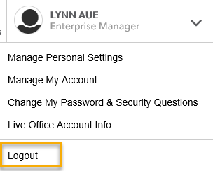
  - If you were impersonating a seeker or recruiter remember to end the session. Clicking off the browser tab does not end impersonation!
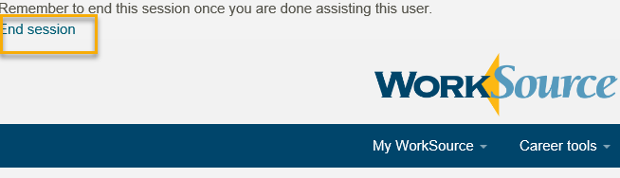

  - Clear your cache weekly for best performance and check your Internet Settings.
    - Clearing Internet Explorer cache: From the top of your browser click the Settings icon and then select Internet Options
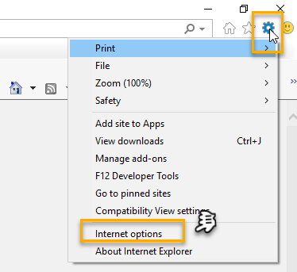

- Begin by clicking Delete on the General tab which takes you to the Delete Browsing History screen. If not already checked click on the 3 boxes outlined here and click delete

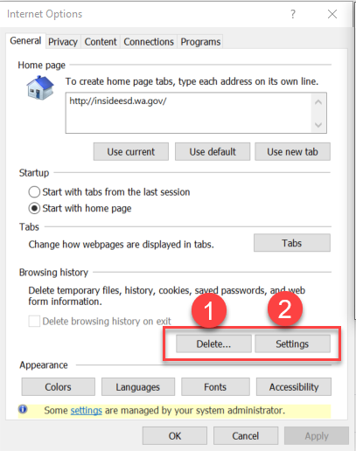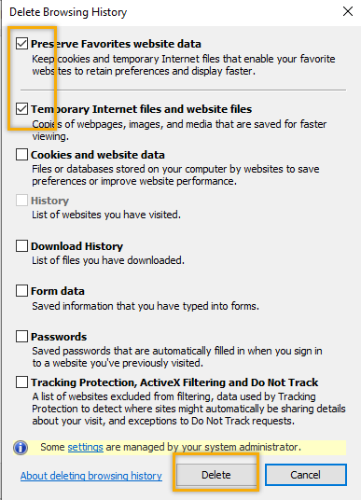
- Next click the Settings tab to ensure you will be using the most up to date version of ETO and click OK
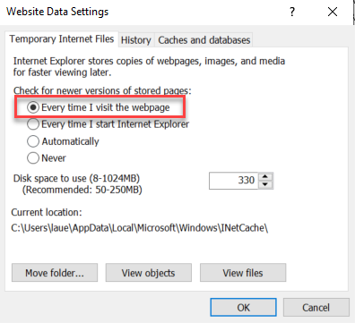
    - You will return to the General tab and click Apply and OK to complete the process of clearing your cache
    - Clearing cache in Chrome:
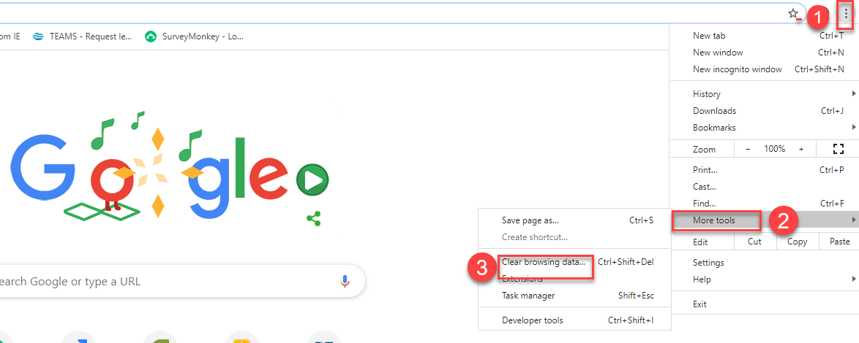
  - Restart your computer
CHAT
Teresa Sparks: I'm not familiar ETO Engage? Can you speak to this?
robison@wdcspokane.com: An Engage touchpoint that collects WIOA Title I and WIOA Title III registration data (required for PIRL) would be awesome!
Lynn Aue: ETO Engage can be used to text, make robo calls and send forms to customers. I included screen shots of where to find it on the user dashboard and its features. I will send out a survey tomorrow asking who uses ETO Engage and how it is used to conduct local business.
CShaffer: We use ETO Engage for the email function primarily. However, recently, we have seen it's not being recorded as touchpoints anymore under "ETO Engage Effort" as it had previously been recorded.
Phyllis Hall: WS Lewis workfirst used Engage to connect with participants once a week
CShaffer: Yes please
trobison@wdcspokane.com: I like that idea
Tiffany Granillo: I like that idea too
Schehera Gates: Absolutely!
Linden Obel: I think that makes sense
Teresa Sparks: Good idea
mhansen: that sounds like a plan....Colville doesn't use it that I know of
Linda Venera: Great idea
CShaffer: Yes
Aaron Parrott: Seen
Skyler Blumenthal: I've not yet taken my laptop home yet (but I will probably be today.) Is there anything I have to setup in regards of VPN access to work from home? Where would I find that information. okay thank you
ATTENDEES

Aaron Parrott
Adeline Kerns
Amy
Arturo Espinoza
Becky Smith
Boliveri
Business
CCauthron
CShaffer
Daniel Cooling
Donna Mack
Dorothy Rocha
Emily Anderson
Heidi Lamers
Irene Jordan
Jackie
Joanie Linder
Katherinec
Kendal King
Linda Venera
Linden Obel
Lisa Pietkauskis
Lisa Robinson
Luci Bench
Margaret Balcom
MDominguez
mhansen
MZavala
Phyllis Hall
Schehera Gates
Sean McElligott
Skyler Blumenthal
slatiff
Sue Keltner
swillis
Teresa Sparks
Tiffany Granillo
Toni
trobison@wdspokane
vdamneun
Yvette Dallas

