T12 Meeting Agenda 4-22-2020
New Business
- Tickets into production – tonight after business hours
  - WA-3753 remove CCWA from the Program of Enrollment list
  - WA-3747 Add/deactivate basic services for WDA07
    - Update to WIN0077 and the services catalog
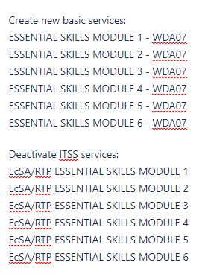
- ETO Maintenance – Nothing this week
- Velaro Maintenance- the Velaro Product Team will be performing maintenance activity on Friday, April 24, at 3:30AM PT (6:30AM ET). The estimated duration is 1 hour. We do not expect any impact to your service, yet in some cases, there may be a brief interruption.
- ETO Improvements – none to report
- Training issue(s) of the week –
  - Clear cache
  - Use IE
  - Refresh reports menu
- Stay up to date on COVID19, teleworking and WorkSource Virtual services
  - WPC website has information to help all WorkSource staff telework.
  - IT service delivery
    - All phone requests need to go through your office Administrator and/or Supervisor
    - Your needs are important to us! Please be patient with the ESD help desk staff, they are slammed and priority of service is set by our Executive Leadership.
  - WebEx
    - Browse the Webex handbook and watch 5 videos on how to make the most out of this tool for conducting meetings with staff and customers.
  - Other resources include:
    - Now that you are teleworking reference guide
    - How to use SKYPE for online meetings
    - How to sign into ESD email from outside the network
    - How to sign into an off-site Wi-Fi from your computer
    - Can I access Internet Explorer from a MAC computer?
    - Will the WSS Team be available to help us while working remote?
    - ESD service Desk information.
- ESD.wa.gov or ESD Facebook page for current UI information
- Cisco Softphones Webex and training material
  - Link http://insideesd.wa.gov/services/it-services
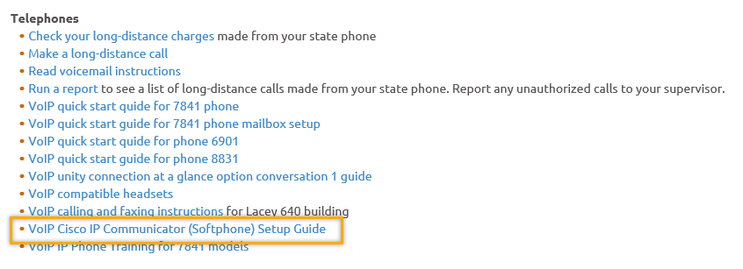
- Before submitting a service ticket help
- Adding group basic services and how this function applies to the current state
Old Business
- T12 Webex meeting invite and sign up information
  - Email esdgpwssteam@esd.wa.gov to be added to the distribution list and meeting invite
  - Find call information on the Trumba Staff Development Calendar here https://wpc.wa.gov/tech/staff/calendar
- Reported issues/fixes in the works–
  - WA-3704 Intermittent issues with ETO time out
    - The current issue is caused by a timeout feature used by some customers. It was turned on for all ETO customers March 2019. The vendor’s developer is working on turning this additional time out feature off for Washington users.
- Data Clean-up reminder
  - We need your help with cleaning up the data in ETO. We will discuss these clean-up efforts at the Advisory meeting and report out at the T12 meetings as we continue our efforts of cleaning up ETO data before migrating data to the new system
- We are seeking ideas for ETO Improvements
  - ETO improvement ideas or current work arounds should be submitted through the remedy ticket system.
  - Tickets are reviewed to determine if idea or work around is a training issue or needs to go through the governance process for a system change
  - Submit remedy ticket here https://wpc.wa.gov/tech/issues
- ETO Refresher Training
  - Training recordings and user guides are posted on the WPC website on the Technology tab>ETO Training Resources
  - Contact Lynn Aue directly at laue@esd.wa.gov for additional training opportunities and training resources
- WorkSource Systems resources are found on the WPC Technology site
  - https://wpc.wa.gov/tech
  - We try our best to make sure all the links are operational but depend on you to email us if you find broken links!
- Encourage office staff who use ETO and WSWA to sign up for the T12 calls. These calls are not just for trainers but for all system users and a great way to stay up to date on changes or improvements to ETO and WSWA. Send requests to esdgpWSSteam@esd.wa.gov to be added to the ITSD Training Team’s distribution list

- Before submitting a service request review these suggestions as the services desk will ask you to do this and many times this resolves your issue timelier:
  - What internet browser are you using?
    - Edge vs Internet Explorer?
    - Remember, only Internet Explorer gives you the best ETO experience. ETO system requirements are: Hardware Compatibility Customer Management software runs on Windows computers and is not compatible with Apple computers unless configured to operate Windows. To prevent potential issues, Windows updates should be conducted on a regular basis. It is recommended that the computer is setup to receive automatic updates for Windows.
    - Software Compatibility: Customer Management software is accessed through the internet. It is highly recommended that Internet Explorer (IE) be used as the browser for the WorkSource solution. Customer Management software is only compatible with Internet Explorer versions 9, 10 and 11. Other browsers, such as other versions of IE, Firefox, Google Chrome, Safari, may appear to function properly, but the feature may not function or save properly. Some features are browser neutral and can be accessed in Safari on the iPad as a mobile option.

  - Log out of ETO, don’t click off the tab here Your ETO session will still be active. Always logout here
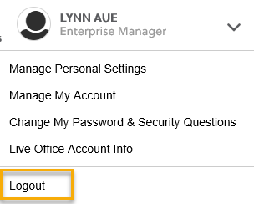
  - If you were impersonating a seeker or recruiter remember to end the session. Clicking off the browser tab does not end impersonation!
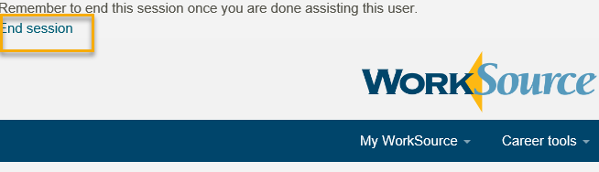

  - Clear your cache weekly for best performance and check your Internet Settings.
    - From the top of your browser click the Settings icon and then select Internet Options
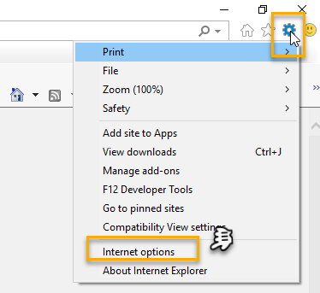

- Begin by clicking Delete on the General tab which takes you to the Delete Browsing History screen. If not already checked click on the 3 boxes outlined here and click delete

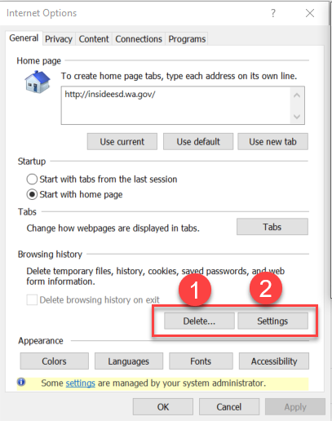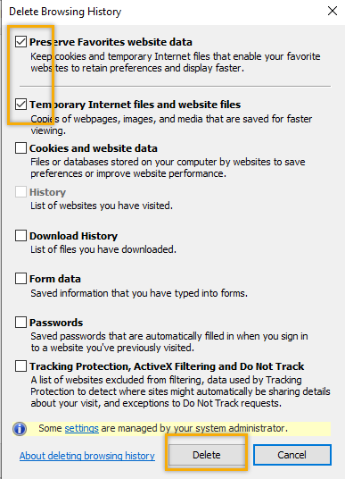
- Next click the Settings tab to ensure you will be using the most up to date version of ETO and click OK
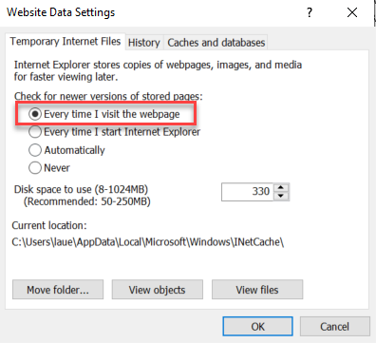
    - You will return to the General tab and click Apply and OK to complete the process of clearing your cache
  - Restart your computer
CHAT
Teresa Anda:
Can the meeting invitation be re-sent with the meeing information in the body of the message and not in the Location field? Thanks! I normaly use the invitation but i will start using the trumba info. I updated the Trumba calendar. Thanks for the suggestion Teresa!

ATTENDEES

Amy
Barbara
Becky Smith
Brett
Crystal Armitage
CShaffer
Dan Cooling
David Gutierrez Betancourt
Dawn Oaks
Dean Coxford
Ismaila Maidadi
Jackie
Joanie Linder
John Traugott
Katherinec
Linden Obel
Linda Pietkauskis
Luci Bench
Maria
MDominguez
Monique Martin
Phyllis Hall
RCancel
Robert Jonas
Schehera Gates
Sean McElligott
Selam Tekle
swillis
Teresa Anda
Tiffany Granillo
Toni Burrow
Vdamneun
Yvette Dallas

