T12 Meeting Minutes 4-1-2020
New Business
- New T12 Webex meeting and sign up information
  - Will send out cancelation of existing meeting
  - Send out new Invite
  - Created event on Trumba Staff Development Calendar
- Softphones Webex and training material
  - Link http://insideesd.wa.gov/services/it-services
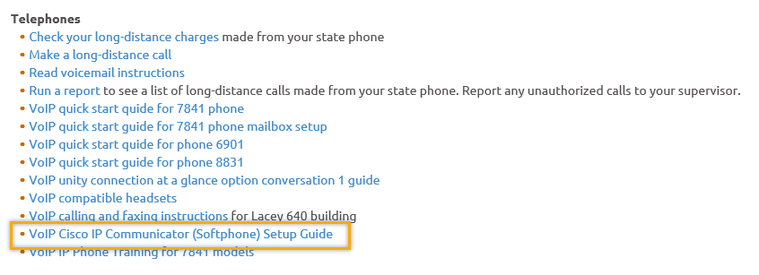
- Tickets into production –
  - WA-3732 ONET code now required on some services-tonight
    - Incumbent Worker Training
    - Occupational Skills Training (2.0)
    - Occupational Skills Training (Youth Only)
    - Paid and Unpaid Work Experience with Academic/Education Component - Employment Opportunities (Youth Only)
    - Paid and Unpaid Work Experience with Academic/Education Component - Internships and Job Shadowing (Youth Only)
    - Paid and Unpaid Work Experience with Academic/Education Component - On-The-Job Training Opportunities (Youth Only)
    - Paid and Unpaid Work Experience with Academic/Education Component - Pre-Apprenticeship Programs (Youth Only)
  - WA-3728 RESEA method of contact- tonight
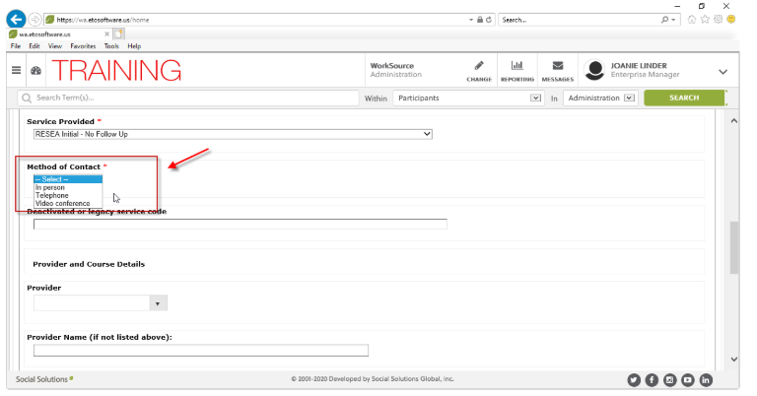
  - WA-3729 New tab on WSWA called “All Virtual Events” Found on Career Tools-already in production

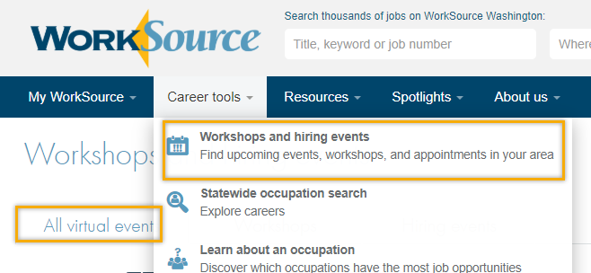

- ETO Maintenance – April 18-19, 2020
- ETO Improvements –
  - Update on Optimized reports
    - Old reports hidden,
  - Impersonation changes- coming soon
- Training issue(s) of the week –
  - Weekly maintenance- Clear cache
  - Internet browsers
  - Refresh reports list
- ESD.wa.gov or ESD Facebook page to receive current UI information
- Stay up to date on COVID19, teleworking and WorkSource Virtual services
  - WPC website has information to help all WorkSource staff telework.
  - IT service delivery
    - All phone requests need to go through your office Administrator and/or Supervisor
    - Your needs are important to us! Please be patient with the ESD help desk staff, they are slammed and priority of service is set by our Executive Leadership.
  - WebEx
    - Browse the Webex handbook and watch 5 videos on how to make the most out of this tool for conducting meetings with staff and customers.
  - Other resources include:
    - Now that you are teleworking reference guide
    - How to use SKYPE for online meetings
    - How to sign into ESD email from outside the network
    - How to sign into an off-site Wi-Fi from your computer
    - Can I access Internet Explorer from a MAC computer?
    - Will the WSS Team be available to help us while working remote?
    - ESD service Desk information.
- Before submitting a service ticket help
Old Business
- Reported issues/fixes in the works–
  - WA-3704 Intermittent issues with ETO time out
    - The current issue is caused by a timeout feature used by some customers. It was turned on for all ETO customers March 2019. The vendor’s developer is working on turning this additional time out feature off for Washington users.
- Data Clean-up reminder
  - We need your help with cleaning up the data in ETO. We will discuss these clean-up efforts at the Advisory meeting and report out at the T12 meetings as we continue our efforts of cleaning up ETO data before migrating data to the new system
- We are seeking ideas for ETO Improvements
  - ETO improvement ideas or current work arounds should be submitted through the remedy ticket system.
  - Tickets are reviewed to determine if idea or work around is a training issue or needs to go through the governance process for a system change
  - Submit remedy ticket here https://wpc.wa.gov/tech/issues
- ETO Refresher Training
  - Training recordings and user guides are posted on the WPC website on the Technology tab>ETO Training Resources
  - Contact Lynn Aue directly at laue@esd.wa.gov for additional training opportunities and training resources
- WorkSource Systems resources are found on the WPC Technology site
  - https://wpc.wa.gov/tech
  - We try our best to make sure all the links are operational but depend on you to email us if you find broken links!
- Encourage office staff who use ETO and WSWA to sign up for the T12 calls. These calls are not just for trainers but for all system users and a great way to stay up to date on changes or improvements to ETO and WSWA. Send requests to esdgpWSSteam@esd.wa.gov to be added to the ITSD Training Team’s distribution list

- Before submitting a service request review these suggestions as the services desk will ask you to do this and many times this resolves your issue timelier:
  - What internet browser are you using?
    - Edge vs Internet Explorer?
    - Remember, only Internet Explorer gives you the best ETO experience. ETO system requirements are: Hardware Compatibility Customer Management software runs on Windows computers and is not compatible with Apple computers unless configured to operate Windows. To prevent potential issues, Windows updates should be conducted on a regular basis. It is recommended that the computer is setup to receive automatic updates for Windows.
    - Software Compatibility: Customer Management software is accessed through the internet. It is highly recommended that Internet Explorer (IE) be used as the browser for the WorkSource solution. Customer Management software is only compatible with Internet Explorer versions 9, 10 and 11. Other browsers, such as other versions of IE, Firefox, Google Chrome, Safari, may appear to function properly, but the feature may not function or save properly. Some features are browser neutral and can be accessed in Safari on the iPad as a mobile option.

  - Log out of ETO, don’t click off the tab here Your ETO session will still be active. Always logout here
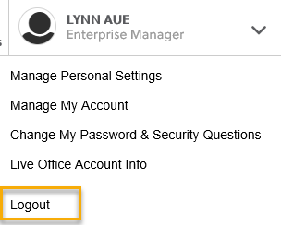
  - If you were impersonating a seeker or recruiter remember to end the session. Clicking off the browser tab does not end impersonation!
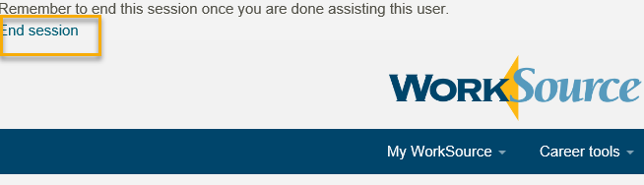

  - Clear your cache weekly for best performance and check your Internet Settings.
    - From the top of your browser click the Settings icon and then select Internet Options
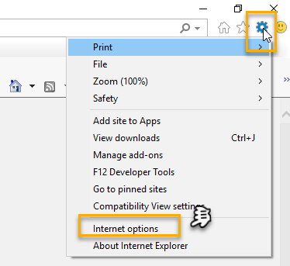

- Begin by clicking Delete on the General tab which takes you to the Delete Browsing History screen. If not already checked click on the 3 boxes outlined here and click delete

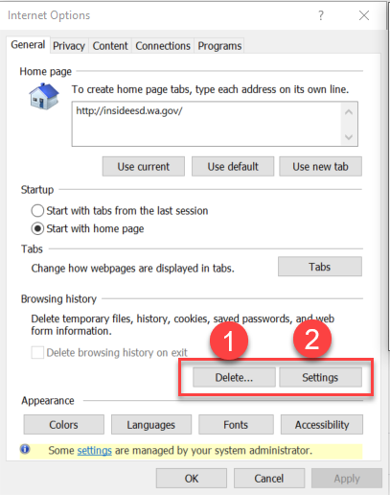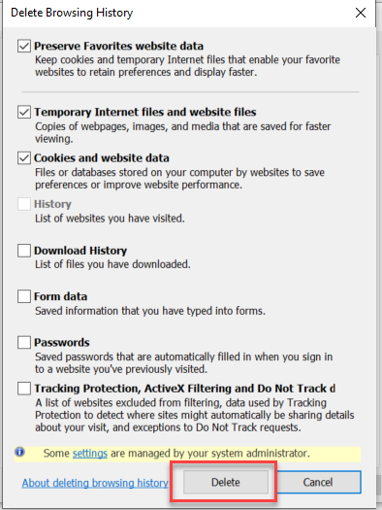
- Next click the Settings tab to ensure you will be using the most up to date version of ETO and click OK
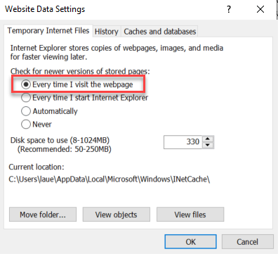
    - You will return to the General tab and click Apply and OK to complete the process of clearing your cache
  - Restart your computer
CHAT
Maria:
GM- Is anyone else having trouble capturing enrollment data past Feb? I have run the reports several times and March is not even an option under start date 2020. Please submit a remedy ticket and we can take a look with you

Toni Burow:
I ran a report this morning using the optimized report and it run ok. Thanks for the comment Toni!

Carya Bair:
Can we receive information on putting on virtual hiring event. I'm one of the Business Services team member. Thanks
Will there be any upcoming training for putting on Virtual Job Fairs for those of us fielding Business Solutions questions? Thank you.. I reached out to Nona Mallicoat who responded “Good question – I am looping Keoni Fontaine in as he is the Project Manager for the Virtual hiring event. This is not ESD led, so I don’t have further guidance at this time”. I will share with you all when I hear more. Please email me directly if you have information to share on this topic.
sgate:
Kitsap and Clallam are working on one for next week. Contact Patrice Varela-Daylo in Clallam for information. Thanks for the comment Sher!

KDowning:
Hi Lyn, what does "optimized" means when you say "optimized reports"? Sorry, I've been out of the loop for a bit ;) Optimized is the naming convention used to ID the new improved reports. They are the same reports you are familiar with except performance is improved and Optimized was added after the old versions name.

ATTENDEES
Aaron Parrott
adelp
amyxg
Barbara
Becky Smith
Brett
Business
Carya Bair
ccauthron
CShaffer
Daniel Cooling
Diana Cook
Diane Luoma
Dmach
Donna Hendrickson
Dorothy Rocha
Doug Evans
Emily Anderson
hBaker
Heidi Lamers
Heidi schauble
IJordan
jbrunkhorst
Jessica Corpuel
Jordan Meyenburg
Katherinec
KDowning
Kellina
Linden Obel
Lisa Pietkauskis
Luci Bench
Mahr
Maria
Martha Guerra
MDominguez
Mirayia chacon-baker
Petra Barba
Phyllis hall
Rachel
RCancel
SButler
Selam Tekle
sgates
Tasparks
Teresa anda
Tiffany Granillo
Ton Nguyen
Toni Burrow
Tracy
Tracy Ollgaard
trobinson@wdcspokane.com
tsouthard
vdamneun
Yolanda alvear
Yvette Dallas

