T12 Meeting Minutes 3-18-2020
New Business
- Stay up to date on COVID19, teleworking and WorkSource Virtual services
  - WPC website has information to help all WorkSource staff telework.
  - ESD Telework resources and hardware requests
    - Staff need to complete the telework agreement, sign and submit to your supervisor
    - Hardware requests need to be approved by your supervisor and a remedy ticket submitted
  - Staff not using ESD issued equipment need to follow their agencies procedure for telework agreements and equipment. Do not call the ESD service desk for telework and hardware requests.
  - IT service delivery
    - All phone requests need to go through your office Administrator and/or Supervisor
    - Your needs are important to us! Please be patient with the ESD help desk staff, they are slammed and priority of service is set by our Executive Leadership.
  - WebEx
    - Browse the Webex handbook and watch 5 videos on how to make the most out of this tool for conducting meetings with staff and customers.
  - Other resources include:
    - Now that you are teleworking reference guide
    - How to use SKYPE for online meetings
    - How to sign into ESD email from outside the network
    - How to sign into an off-site Wi-Fi from your computer
    - Can I access Internet Explorer from a MAC computer?
    - Will the WSS Team be available to help us while working remote?
    - ESD service Desk information.
- Tickets into production – nothing this week
- ETO Maintenance – March 21, 2019
- ETO Improvements – nothing this week
- Training issue(s) of the week – nothing this week
- Before submitting a service ticket help
Old Business
- Reported issues/fixes in the works–
  - WA-3704 Intermittent issues with ETO time out
    - The current issue is caused by a timeout feature used by some customers. It was turned on for all ETO customers March 2019. The vendor’s developer is working on turning this additional time out feature off for Washington users.
- Data Clean-up reminder
  - We need your help with cleaning up the data in ETO. We will discuss these clean-up efforts at the Advisory meeting and report out at the T12 meetings as we continue our efforts of cleaning up ETO data before migrating data to the new system
- We are seeking ideas for ETO Improvements
  - ETO improvement ideas or current work arounds should be submitted through the remedy ticket system.
  - Tickets are reviewed to determine if idea or work around is a training issue or needs to go through the governance process for a system change
  - Submit remedy ticket here https://wpc.wa.gov/tech/issues
- ETO Refresher Training
  - Training recordings and user guides are posted on the WPC website on the Technology tab>ETO Training Resources
  - Contact Lynn Aue directly at laue@esd.wa.gov for additional training opportunities and training resources
- WorkSource Systems resources are found on the WPC Technology site
  - https://wpc.wa.gov/tech
  - We try our best to make sure all the links are operational but depend on you to email us if you find broken links!
- Encourage office staff who use ETO and WSWA to sign up for the T12 calls. These calls are not just for trainers but for all system users and a great way to stay up to date on changes or improvements to ETO and WSWA. Send requests to esdgpWSSteam@esd.wa.gov to be added to the ITSD Training Team’s distribution list

- Before submitting a service request review these suggestions as the services desk will ask you to do this and many times this resolves your issue more timely:
  - What internet browser are you using?
    - Edge vs Internet Explorer?
    - Remember, only Internet Explorer gives you the best ETO experience. ETO system requirements are: Hardware Compatibility Customer Management software runs on Windows computers and is not compatible with Apple computers unless configured to operate Windows. To prevent potential issues, Windows updates should be conducted on a regular basis. It is recommended that the computer is setup to receive automatic updates for Windows.
    - Software Compatibility: Customer Management software is accessed through the internet. It is highly recommended that Internet Explorer (IE) be used as the browser for the WorkSource solution. Customer Management software is only compatible with Internet Explorer versions 9, 10 and 11. Other browsers, such as other versions of IE, Firefox, Google Chrome, Safari, may appear to function properly, but the feature may not function or save properly. Some features are browser neutral and can be accessed in Safari on the iPad as a mobile option.

  - Log out of ETO, don’t click off the tab here Your ETO session will still be active. Always logout here
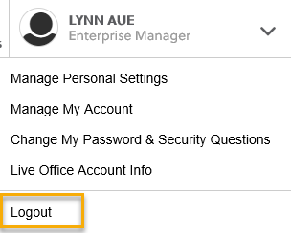
  - If you were impersonating a seeker or recruiter remember to end the session. Clicking off the browser tab does not end impersonation!
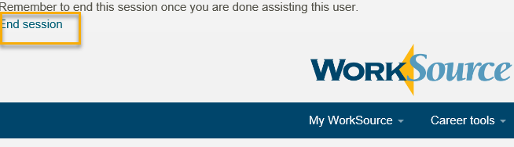

  - Clear your cache weekly for best performance and check your Internet Settings.
    - From the top of your browser click the Settings icon and then select Internet Options
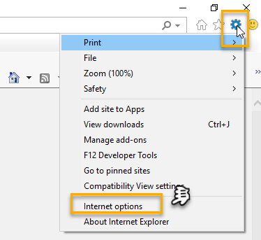

- Begin by clicking Delete on the General tab which takes you to the Delete Browsing History screen. If not already checked click on the 3 boxes outlined here and click delete

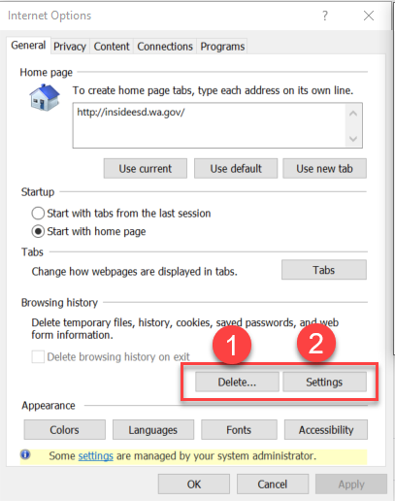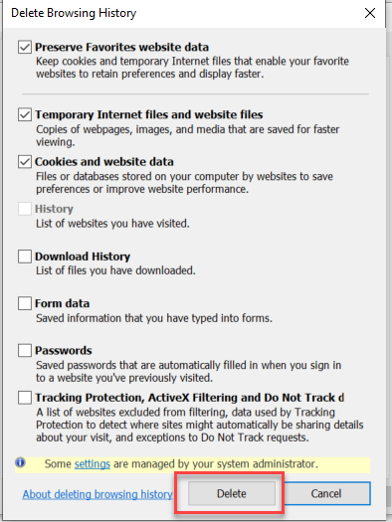
- Next click the Settings tab to ensure you will be using the most up to date version of ETO and click OK
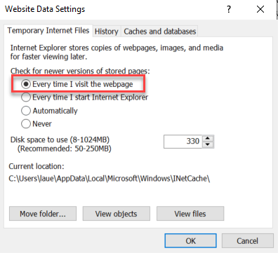
    - You will return to the General tab and click Apply and OK to complete the process of clearing your cache
  - Restart your computer
CHAT

ATTENDEES

