T12 Meeting Minutes 2-19-2020
New Business
- Tickets into production –
  - WA-3686 ETO case notes Widget/Report isn’t working for some staff. This is currently being worked on and should be resolved today. If asked for PID enter the Case Number.
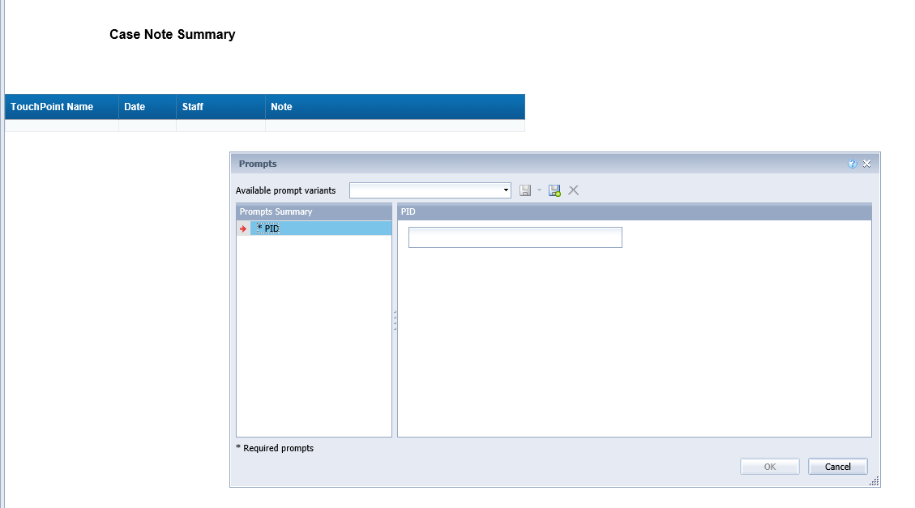
- Reported issue fixes in the works–
  - WA-3691 Seekers Served by Office report totals don’t display correctly.
  - WA-3693 Staff are unable to edit job postings through recruiter impersonation. During the edit process the second page of the job posting won’t load. Currently a small red triangle appears at the top of the posting, but there is no visible error message.
- Enabling Flash to Attend Adobe Connect Webinar – will include desk aid with the minutes
- Velaro Maintenance - The Velaro product team will be performing maintenance activity on Friday, February 21st at 3:30AM PT (6:30AM ET). The estimated time is one hour. We do not expect any impact to your service, yet in some cases, there may be a brief interruption. This release adds new features to chatbot and improves a number of back-office functions. Please see the release notes for more details.
- ETO Maintenance 2-14-20 was successful with no reported issues
- ETO Improvements – Nothing this week
- Training issue(s) of the week – Nothing this week
Old Business
- Data Clean-up reminder
  - We need your help with cleaning up the data in ETO. We will discuss these clean-up efforts at the Advisory meeting and report out at the T12 meetings as we continue our efforts of cleaning up ETO data before migrating data to the new system
- We are seeking ideas for ETO Improvements
  - ETO improvement ideas or current work arounds should be submitted through the remedy ticket system.
  - Tickets are reviewed to determine if idea or work around is a training issue or needs to go through the governance process for a system change
  - Submit remedy ticket here https://wpc.wa.gov/tech/issues
- ETO Refresher Training
  - Training recordings and user guides are posted on the WPC website on the Technology tab>ETO Training Resources
  - Contact Lynn Aue directly at laue@esd.wa.gov for additional training opportunities and training resources
- WorkSource Systems resources are found on the WPC Technology site
  - https://wpc.wa.gov/tech
  - We try our best to make sure all the links are operational but depend on you to email us if you find broken links!
- Encourage office staff who use ETO and WSWA to sign up for the T12 calls. These calls are not just for trainers but for all system users and a great way to stay up to date on changes or improvements to ETO and WSWA. Send requests to esdgpWSSteam@esd.wa.gov to be added to the ITSD Training Team’s distribution list
- Before submitting a service request review these suggestions:
  - What internet browser are you using?
    - Edge vs Internet Explorer?
    - Remember, only Internet Explorer gives you the best ETO experience. ETO system requirements are: Hardware Compatibility Customer Management software runs on Windows computers and is not compatible with Apple computers unless configured to operate Windows. To prevent potential issues, Windows updates should be conducted on a regular basis. It is recommended that the computer is setup to receive automatic updates for Windows.
    - Software Compatibility: Customer Management software is accessed through the internet. It is highly recommended that Internet Explorer (IE) be used as the browser for the WorkSource solution. Customer Management software is only compatible with Internet Explorer versions 9, 10 and 11. Other browsers, such as other versions of IE, Firefox, Google Chrome, Safari, may appear to function properly, but the feature may not function or save properly. Some features are browser neutral and can be accessed in Safari on the iPad as a mobile option.

  - Log out of ETO, don’t click off the tab here Your ETO session will still be active. Always logout here
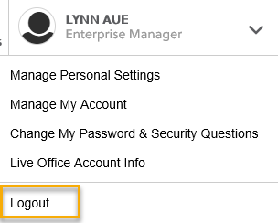
  - If you were impersonating a seeker or recruiter remember to end the session. Clicking off the browser tab does not end impersonation!
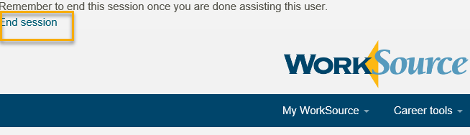

  - Restart your computer
  - Clear your cache weekly for best performance
    - From the top of your browser click the Settings icon and then select Internet Options
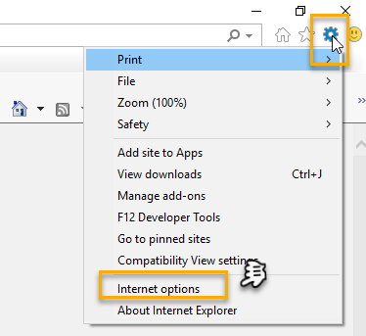

    - Click Delete on the General tab which takes you to the Delete Browsing History screen. If not already checked click on the 2 boxes outlined here and click delete
    - You will return on the General tab where you click Apply and OK to complete the process of clearing your cache

CHAT
Teresa Anda: Keep in mind that the totals for seekers served by office may be because the report is showing unique numbers. Just a thought. Monster is using your comments in the work on this report/ticket. Thanks!

ATTENDEES
Aaron Parrott
Abigail Taft
A Hughes
Amy
Brooke Zielinski
Chris File
C Peterson
Dan Cooling
Danielle
Dawn Oakes
Dean
Donna Hendrickson
Dorothy Rocha
Emily Anderson
Epahulu
Heidi Lamers
IJordan
Ismaila Maidadi
JFlood
Jsutton
Lisa Pietkauskis
Luci Bench
Maria
Meilissa Robinson
MOMartin
Petra Barba
S Butler
Slatiff
Stacey W
Teresa Anda
Toni Burrow
Tracy Ferrell
TRobison@wdcspokane.com
TSouthard
VDamneun

