T12 Meeting Minutes 2-12-2020
New Business
- Tickets into production –
  - WA-3684 – Follow-up Touchpoint not functioning as expected. Critical ticket fixed same day. Submit a remedy ticket if you are still having an issue with this TP.
- ETO Improvements – Nothing this week
- Training issue(s) of the week
  - Who can delete programs and services?
    - Department Heads. Remember: If program enrollments are deleted don’t leave “Orphaned” services
  - Employer accounts deactivating after 3 years because staff access account using the impersonation function. Impersonation does not count as an activity/login.
    - WSS team can activate the account but it will deactivate overnight
    - Employers need to log in with their username and password
  - Choosing wrong seeker as participant
    - Added program enrollment and services that need to be deleted
    - Changing date of birth on wrong seeker account- could lead to an unnecessary fraud investigation
- When you submit a remedy ticket or service request the service desk staff or WSS team will ask you if you: using Internet Explorer, cleared your cache, just finished running a report or impersonating an seeker or employer and clicked off the browser tab or clicked “End Session”, log out of ETO, logged off your computer.
  - To save yourself time and possibly fix your issue before submitting a service request, check out and follow the instructions below called Before submitting a service request.
Old Business
- Data Clean-up reminder
  - We need your help with cleaning up the data in ETO. We will discuss these clean-up efforts at the Advisory and report out at the T12 meetings as we continue our efforts of cleaning up ETO data before migrating data to the new system
- We are seeking ideas for ETO Improvements
  - ETO improvement ideas or current work arounds should be submitted through the remedy ticket system.
  - Tickets are reviewed to determine if issue or idea is a training issue or need to go through the governance process for system change
  - Submit remedy ticket here https://wpc.wa.gov/tech/issues
- ETO Refresher Training
  - Training recordings and user guides are posted on the WPC website on the Technology tab>ETO Training Resources
  - Contact Lynn Aue directly at laue@esd.wa.gov for additional training opportunities and training resources
- WorkSource Systems resources are found on the WPC Technology site
  - https://wpc.wa.gov/tech
  - We try our best to make sure all the links are operational but depend on you to email us if you find broken links!
- Encourage office staff who use ETO and WSWA to sign up for the T12 calls. These calls are not just for trainers but for all system users and a great way to stay up to date on changes or improvements to ETO and WSWA. Send requests to esdgpWSSteam@esd.wa.gov to be added to the ITSD Training Team’s distribution list
- Before submitting service request
    - What internet browser are you using?
    - Edge vs Internet Explorer? Remember, only Internet Explorer gives you the best ETO experience. ETO system requirements are: Hardware Compatibility Customer Management software runs on Windows computers and is not compatible with Apple computers unless configured to operate Windows. To prevent potential issues, Windows updates should be conducted on a regular basis. It is recommended that the computer is setup to receive automatic updates for Windows.
    - Software Compatibility: Customer Management software is accessed through the internet. It is highly recommended that Internet Explorer (IE) be used as the browser for the WorkSource solution. Customer Management software is only compatible with Internet Explorer versions 9, 10 and 11. Other browsers, such as other versions of IE, Firefox, Google Chrome, Safari, may appear to function properly, but the feature may not function or save properly. Some features are browser neutral and can be accessed in Safari on the iPad as a mobile option.

  - Log out of ETO, don’t click off the tab here Your ETO session will still be active. Always logout here
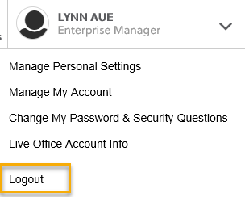
  - If you were impersonating a seeker or recruiter remember to end the session. Clicking off the browser tab does not end impersonation!
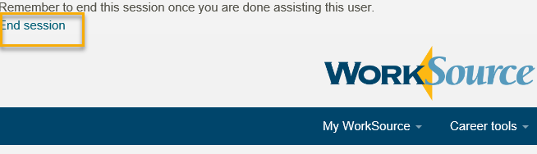

  - Restart your computer
  - Clear your cache weekly for best performance
    - From the top of your browser click the Settings icon and then select Internet Options
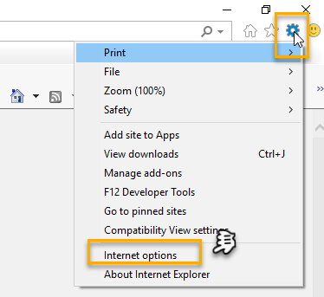

    - Click Delete on the General tab which takes you to the Delete Browsing History screen. If not already checked click on the 2 boxes outlined here and click delete
    - You will return on the General tab where you click Apply and OK to complete the process of clearing your cache

CHAT
Dorothy Rocha:
Is anyone else noticing that the Outcomes/Program Completion touchpoints are not printing correctly??
- The "Reason for Completion" and "Completion Date" isn't printing but info is in ETO. We are definitely in Internet Explorer.
- Yes, we print and submit to our WDC.
- The Eligibility Touchpoint no longer prints out the "Applicant May Be Eligible for:" field either. I will work on getting a Remedy Ticket submitted.
Please submit a remedy ticket so we can have MGS look into this

Maria Cheeseman:
When youth age out how do we record the change in their status?
The system is designed to restrict changing the WIOA Eligibility application status. We suggest you take a copy of their SS document and add it to a case note. This practice is supported by the Monitoring team. (See BrookeZ’s comment below). Note: As part of the ETO enhancements we are talking about changes to the WIOA app making the process more program friendly.

BZielinski:
From a monitoring perspective, case notes is an appropriate place to document selective service after enrollment

Maria Cheeseman: How long can we expect it to take to hear about an ETO improvement suggestion?
You should hear back within 48 hours from our team. After we get the remedy ticket we determine if the issue can be resolved with training or it is going to require a change request with MGS. All change requests go through the governance process. Our team will update you on the progress as the idea goes through the process.

Maria:
Okay will do, thanks
Thank you Brooke

ATTENDEES
Aaron Parrott
Abagail Taft
AHughes
AKerns
Amy
Arthur
Barbara
Becky Smith
Bpannell
Brett
BZielinski
Chris File
CPeterson
CShaffer
Dan Cooling
Dawn Oakes
Dean
Debra Kavanaugh
Diane Luoma
D Mack
Donna Hendrickson
Dorothy Rocha
Emily Anderson
EPahulu
IJordan
Ismaila Maidadi
JDiaz
Joanie Linder
Linda Pietkauskis
Maria
Melissa Robinson
Michelle G
POstergren
R Cancel
RJonas
S Butler
Scher
Sean McElligott
Selam Tekle
SKeltner
SLatiff
Swiley
Teresa anda
Teresa sparks
Tollgaard
Ton nguyen
Toni Burow
Tracy ferrell
Zoryana Bilous

