T12 Meeting Minutes 11-04-2020
Remember: After starting a Webex meeting to mute your audio and disable the video feature. Too many attendee’s with active video can interfere with everyone’s audio quality. Hover over the lower edge of your monitor screen to find the icons.

Thanks to all who contribute to this weekly call!

New Business
- ETO Enhancements updates -
  - Multi-Factor Authentication (MFA) was rolled back. Delayed to first quarter 2021
  - Create an ETO Participant record by staff so you can record services – on hold, implementation date TBD
- Tickets into production – nothing this week
- ETO/WSWA maintenance – nothing this week
- Velaro maintenance – nothing this week
- Training issue(s) of the week – nothing this week
  - Reminder: Submit remedy tickets for all work requests. My team cannot begin work without a service request. Reaching out to us directly can affect the time it takes to resolve your issue. Thanks!
- ETO Engage Survey – Work on desk aid/training materials is on hold at this time. We are getting closer to training!
- What’s new on WPC – nothing this week but am in the process of revamping the look and will post material next week.
- ETO Basic and Refresher Training
  - ETO Basic training is the 1st Monday 10-12 and 3rd Tuesday 2-4 of every month (except holidays). Send email to Lynn Aue to receive more information, training account if needed and be added to the training Webex call. Invites should not be forwarded.
  - Training recordings and user guides are posted on the WPC website here https://wpc.wa.gov/tech/ETO-refresher-training
  - Submit a remedy ticket asking Lynn Aue for additional training opportunities and training resources
- Open discussion –
  - Entering Employer Hiring, Rapid Response and Job Fair Events in ETO
  - WPC site WDA contacts list. Mary MacLennan is reaching out to each area to update the list. 5 areas have responded to her requests! Thanks to all for your input on the process.
- WSWA Virtual services to assist job seekers/employers to sharpen skills. There are many tools on WSWA but here are a couple of my favorites!
  - Check out these virtual classes under Resources>Training and other programs.
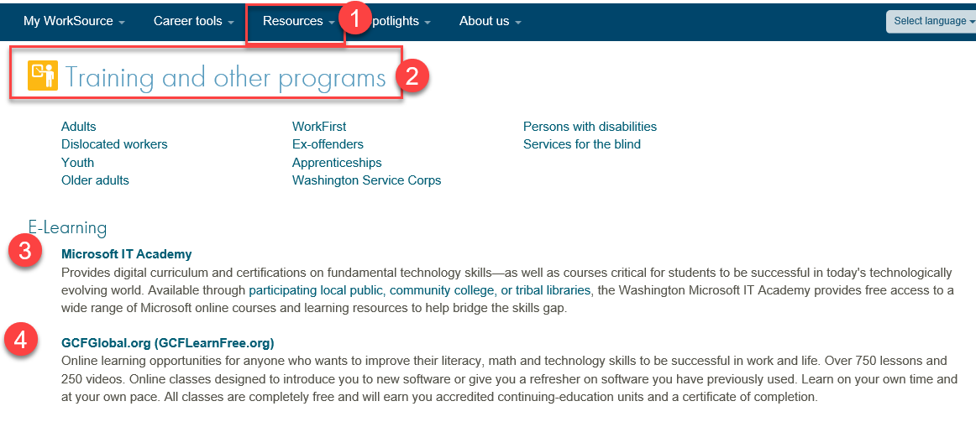
- UI announcements –
  - Optional job search extended through 11/8
  - Job search information found here https://esd.wa.gov/unemployment/job-search-requirements
  - Here is the information to provide feedback on Work Search Requirements
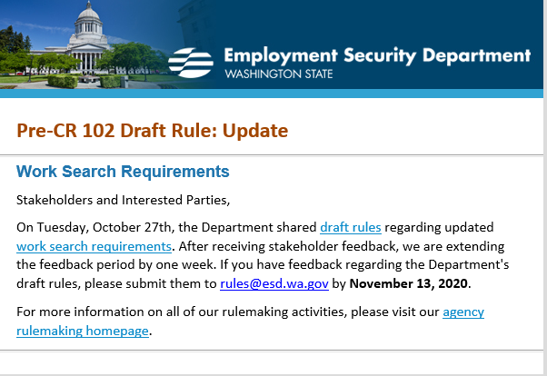

During the week of October 25-31, there were 14,681 initial regular unemployment claims (up 3.4% from the prior week) and 465,563 total claims for all unemployment benefit categories (down 2.1% from the prior week) filed by Washingtonians, according to the Employment Security Department (ESD).
  - Initial regular claims applications remain at elevated levels and are at 113 percent above last year’s weekly new claims applications.
  - Continued claims for regular Unemployment Insurance, Pandemic Unemployment Assistance (PUA) initial claims and Pandemic Emergency Unemployment Compensation (PEUC) initial claims all decreased over the week.
  - The increases in initial regular unemployment claims were primarily in manufacturing and accommodation and food service. Retail and transportation and warehousing also showed increases
In the week ending October 31, ESD paid out over $143 million for 307,351 individual claims. Since the crisis began in March, ESD has paid more than $11.9 billion in benefits to over a million Washingtonians.
- ESD.wa.gov or ESD Facebook page for current UI information
- Before submitting a service ticket help
Review of ETO/WSWA and other resources (AKA old business)
- Encourage all staff who use ETO and WSWA to sign up for the T12 calls. These calls are not just for trainers but for all system users and a great way to stay up to date on changes or improvements to ETO and WSWA. Send requests to esdgpWSSteam@esd.wa.gov to be added to the ITSD Training Team’s distribution list
- WorkSource Systems resources found on the WPC Technology site https://wpc.wa.gov/tech
  - We try our best to make sure all the links are operational but depend on you to submit a remedy ticket if you find broken links!
- Stay up to date on COVID19, teleworking and WorkSource Virtual services. Check out the information the WPC website to help all WorkSource staff telework.
  - IT service delivery
  - WebEx
    - Browse the Webex handbook and watch 5 videos on how to make the most out of this tool for conducting meetings with staff and customers.
  - Other resources include:
    - Now that you are teleworking reference guide
    - How to use SKYPE for online meetings
    - How to sign into ESD email from outside the network
    - How to sign into an off-site Wi-Fi from your computer
    - Can I access Internet Explorer from a MAC computer?
    - ESD service Desk information.
- UI Fraud help
  - www.esd.wa.gov/fraud
  - Fax information to claims centers 833-572-8423 –calling is not recommended due to the high volume of calls
  - Reviewing our web resources with them. Some helpful pages include:
- Employee FAQs
- Employee instructional videos
- How to file weekly claims
But you CAN’T help by:
  - Contacting an intake agent at the claims center and asking them to review your friend or family member’s claim or solve their issue.
  - Using your influence to move your friend or family member’s claim up the queue to be processed faster.
  - Using your influence to give any kind of advantage to your friend or family member.
  - Using your access to UTAB, if you have it, to give someone information about their claim.
  - Using your friend or family member’s SAW account and applying for benefits or submitting their weekly claims for them.
- Cisco Softphones training material Link http://insideesd.wa.gov/services/it-services
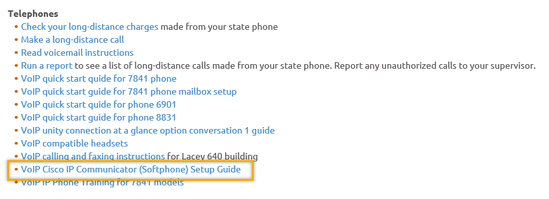
- Before submitting a service, request review these suggestions as the services desk will ask you to run through these steps. Many times, this resolves your issue without a service request!

  - Remember to log out of ETO, clicking off the browser tab here does not end your ETO session and will create issues when you log in again.
      - Always logout by opening your profile menu and clicking “Logout”
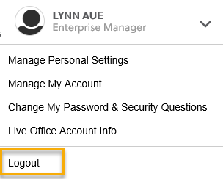
  - If you were impersonating a seeker or recruiter from ETO to WSWA remember to end the session, found in the upper left-hand corner. Clicking off your internet browser tab does not end impersonation!
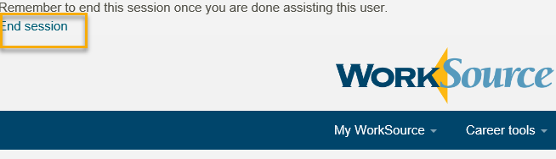

- For best performance clear your cache weekly

  - Internet Explorer (IE): Clearing IE cache starts from the top right side of the browser bar, click the settings icon and select Internet Options
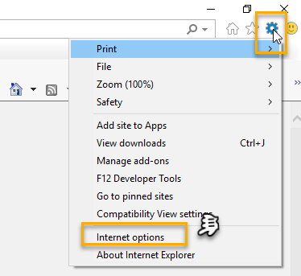

    - From the “General” tab click “Delete” which takes you to the “Delete Browsing History” screen. If not already checked click on the 2 boxes outlined here and click “Delete” you will return to the “General” tab

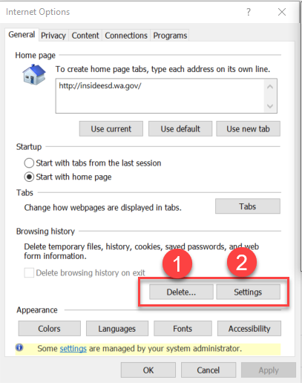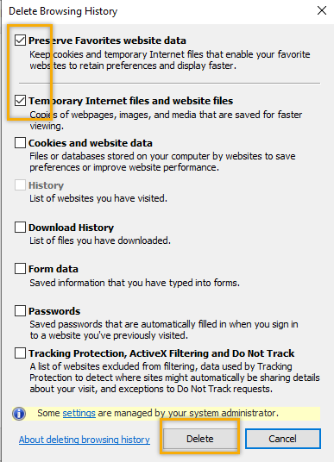

    - Next click “Settings” and if not selected click the radio button for “Every time I visit the webpage” This ensures you are using the most up to date version of ETO. Click OK
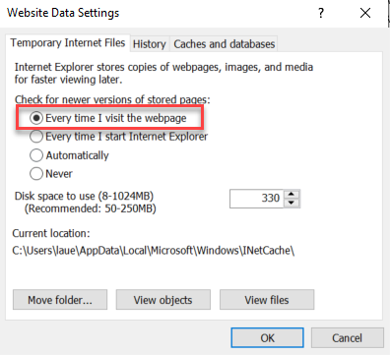
      - You will return to the General tab and click Apply and OK to complete the process of clearing your cache

  - Clearing Chrome cache starts from the top right side of the browser bar
- Click the triple dots to open the Chrome tools menu
- Hover over “More tools”
- Click “Clear browsing data” which opens a new screen
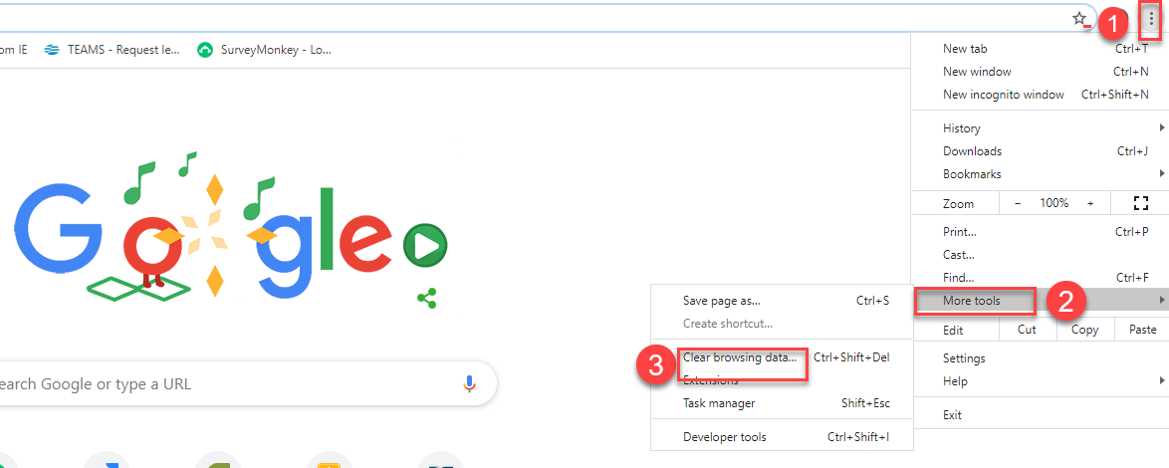

- Click “Clear data”
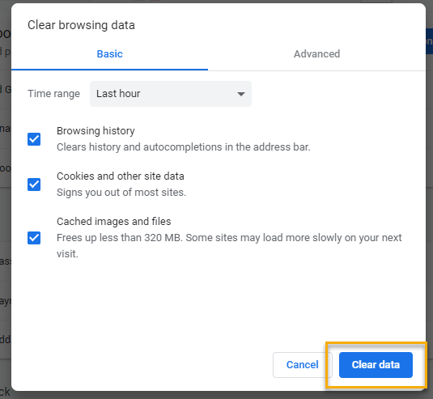

  - Finish by restarting your computer
  - If you still experience issues submit a service request https://wpc.wa.gov/tech/issues
CHAT

Regarding if there is a Rapid Response number system in place to enter into the Employer Events TP:from Donna Mack to everyone: 10:13 AM The RR numbering process is not completed, expect it to be re-initiated soon!

Regarding Touchpoints:
from Emeline Pahulu to everyone: 10:22 AM
Every year the WDC at the end of the year asks for this type of report and it will be nice to have.
from vdamneun to everyone: 10:22 AM
What is the difference between TouchPoint Name and Seeker in TouchPoints?
from JOANIE LINDER to everyone: 10:27 AM That is a search feature. This is a filter within the search feature.
(Asked on “touchpoints” page in ETO)
The “Touchpoint Name” you see on the touchpoints page in ETO is just a filter, to see all the available touchpoints (NOT all seekers.) In general, when you see the following symbol: This is just used to sort the list you see below it.

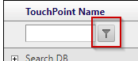

from Diane Castro to everyone: 10:23 AM From the employer events will there be an option to enter those that attended not just a number of attendees?
from JOANIE LINDER to everyone: 10:24 AM General TPs are things like the NDA TP or the Employer Events TP. (You do not record specific seekers in these touchpoints.) Seeker TPs are TPs recorded for specific seekers. TP that don't attribute to a specific seeker or employer are "General TPs".
Regarding Reports and how to find report of TP’s taken:
from Miriam Cisneros to everyone: 10:13 AM Is there a report that connects with the touchpoints for employer events? There is now!
from Miriam Cisneros to everyone: 10:18 AM Would this touchpoint only be visible to the person who entered the touchpoint, or would it be visible to other staff? This TP would only be visible to the person who entered it, but the data can be found in the newly created “Employer Events Report”
From Skyler:
If you would like a report for this, submit a remedy ticket to us (WSS Team) with the exact info you’re looking for in the report. After a bit of research, I’ve found the exact table to query in our snapshot database that may help you.

from Robbin Gard to everyone: 10:26 AM Regarding touchpoints Lynn, is there a way to run a touchpoint report based on service type from an office or team within a timeframe?
from Elizabeth Ibanez to everyone: 10:45 AM Like for example, how many Spanish Speakers customer we serve in a quarter, or in a year? Just a thought.
from Abby Taft to everyone: 10:37 AM Any reports that will track contact attempts/case notes? I know the Local Reporter Services tracks the last service provided and how many days, is there anything to track simple contact attempts? Yes!

Regarding Report: Which report to choose when you are looking for specific info in them:
Teresa and Joanie have provided important information below regarding where to find important information in reports.
from JOANIE LINDER to everyone: 10:30 AM The identifier relates to the participation episode. That is a value we need for performance.
from Teresa Anda to everyone: 10:32 AM Under the Local Reporter Data there are several reports that show seeker services. Basic Services Report Non-WIT Integration shows only basic services. Individualized Training and Support Services TPs shows only individualizes services. Local Reporter Services Report OPTIMIZED shows both basic and individualized services
from JOANIE LINDER to everyone: 10:38 AM I definitely encourage folks to look around at all of the reports available.
from Teresa Anda to everyone: 10:38 AM Contact attempts are not considered a service so this information will live in a case note.
from Teresa Anda to everyone: 10:39 AM Unless the participant is exited, it will probably live in a follow up service

Regarding finding information about follow up:
From C to everyone: (Paraphrase of audio in meeting):
What touchpoint has information regarding follow-up attempts / reaching out to the participants? In order to track how and when our staff reached out to participants. Last contact attempt. Using a case note, we would need to run a report for all participants — one individual would be really hard to run reports on for everyone.
from JOANIE LINDER to everyone: 10:39 AM
What about the Non-Federal Activity TP?
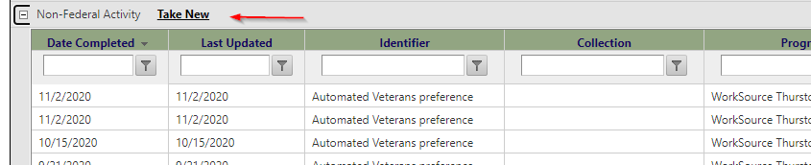
from JOANIE LINDER to everyone: 10:46 AM You could run it for the actual TP but you COULD add a report so that it filters just by the seeker, too.
from Skyler Blumenthal to everyone: 10:52 AM Just to echo Lynn/Joanie here: If you are looking for a specific report or information and can't find anything that is already in the report’s menu, submit a remedy ticket! We can get you that information if it isn't already there.
from Teresa Anda to everyone: 10:42 AM Wow! Didn't know about this tp. We are working on creating a report for this TP.
from C to everyone: 10:46 AM That would be AWESOME
from Teresa Anda to everyone: 10:47 AM Yes, ETO is rich in information. Unfortunately, not always is there a way to pull it out of ETO.
from Teresa Anda to everyone: 10:49 AM Yes, and I very much appreciate it!
from Elizabeth Ibanez to everyone: 10:50 AM Such important information could be helpful for planning, and for a development of a strategic plan on needs assessment
from JOANIE LINDER to everyone: 10:50 AM Dean did the work on that effort!! :)

ATTENDEES
Aaron Parrott
Abby Taft
Adeline Kerns
Adelp
A Hughes
Amanda Siburg
Arturo Espinoza
Barry Dickerson
Becky Smith
Boliveri
Brooklynn Zanto
C2C guest
Catherine Geddis
Christina Shaffer
Christopher File
Cori Ching
Crystal Armitage
Dawn Oaks
Dean Coxford
Debra Gibson
Diane Castro
Donetta McCormack
Donna Mack
Dorothy Rocha
Elizbeth Ibanez
Emeline Pahulu
Emily Anderson
Gracie Troncoso
Heidi Lamers
Heidi Schauble
Hope Baker
Ione Turner
Joanie Linder
Jordan Meyenburg
Kalyn Bevan
Katherine Congleton
Lisa Pietkauskis
Luci Bench
Lux Dmitri
Malmi Peiris
Maria Zaragoza
Melisa Flores-Sanchez
Melissa Robinson
Miriam Cisneros
Petru Mihaluta
Philip Hall
Pochi Ostergren
Robbin Gard
Rodolfo Aparicio
Sean McElligott
Selma Tekle
Skyler Blumenthal
Teresa Anda
Teresa Smith
Ton Nguyen
Tracy Ferrell
Vdamneun
Victoria Wood
Young Suh
Zoryana Bilous

Attended first and second half

