T12 Meeting Minutes 11-18-2020
Remember: After starting a Webex meeting to mute your audio and disable the video feature. Too many attendee’s with active video can interfere with everyone’s audio quality. Hover over the lower edge of your monitor screen to find the icons.

Thanks to all who contribute to this weekly call!

New Business
- ETO Enhancements updates -
  - Create an ETO Participant record by staff so you can record services – on hold, implementation date TBD
- Tickets into production –
  - WA-3979 MSFW information not updating on WIOA Eligibility Application
    - Currently WIOA Elig. App. is looking at the historical value for “Are most of your wages from farm work or food processing?” and “Which one (farm work or food processing) did you do most?”
    - Change: WIOA Elig. App will look at the (NEW) MSFW Details tab and display Are any of your wages in the past 12 months from farm work or food processing? and Which one (farm work or food processing) did you do most? (note that the name of the question is the same, but it is a different element)
    - This WILL NOT automatically update existing Eligibility Applications. This will ONLY update the cross references for new applications taken after the config change is complete, or existing ones that are edited after the config change is complete.
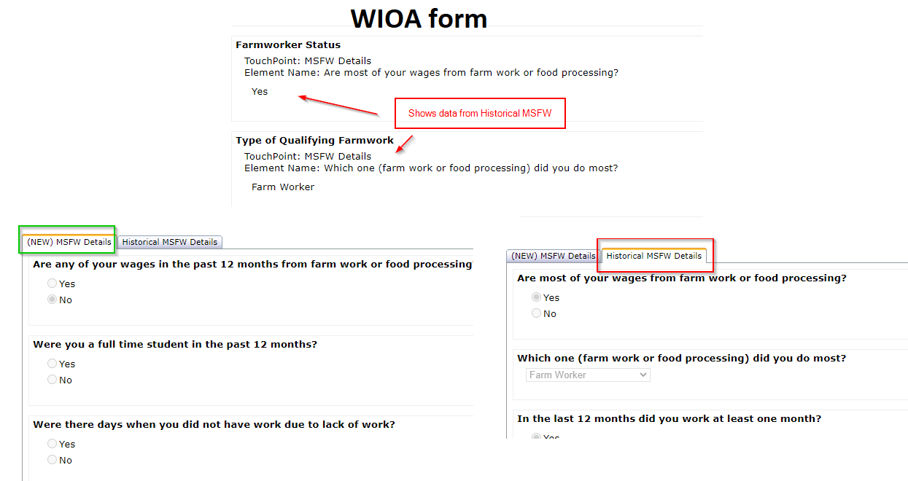

  - WA-3991 Non-Federal Activity – Participant Contact Report
    - WDA and Office initial prompts are optional, run by either one or both or none
- ETO/WSWA maintenance –
  - ETO unavailable 11/21/20-11/22-2020 beginning Saturday from 6PM-Sunday 3AM
- Velaro maintenance – nothing this week
- Training issue(s) of the week – nothing this week
  - Reminder: Submit remedy tickets for all work requests. My team cannot begin work without a service request. Reaching out to us directly can affect the time it takes to resolve your issue. Thanks!
- ETO Engage Survey – Work on desk aid/training materials is on hold at this time. We are getting closer to training!
- What’s new on WPC – nothing this week but am in the process of revamping the look and will post material next week.
- ETO Basic and Refresher Training
  - ETO Basic training is the 1st Monday 10-12 and 3rd Tuesday 2-4 of every month (except holidays). Send email to Lynn Aue to receive more information, training account if needed and be added to the training Webex call. Invites should not be forwarded.
  - Training recordings and user guides are posted on the WPC website here https://wpc.wa.gov/tech/ETO-refresher-training
  - Submit a remedy ticket requesting additional training opportunities and resources
- Open discussion – Non-Federal Activity TP
  - Non-federal Activity TP is a way to capture activity you have customers who is not yet enrolled into a program or receiving services under WIOA or Wagner Peyser. These services do not start or extend participation. We are working on enhancements on the TP. Stay tuned for updates.
- WSWA Virtual services to assist job seekers/employers to sharpen skills. There are many tools on WSWA but here are a couple of my favorites!
  - Check out these virtual classes under Resources>Training and other programs.
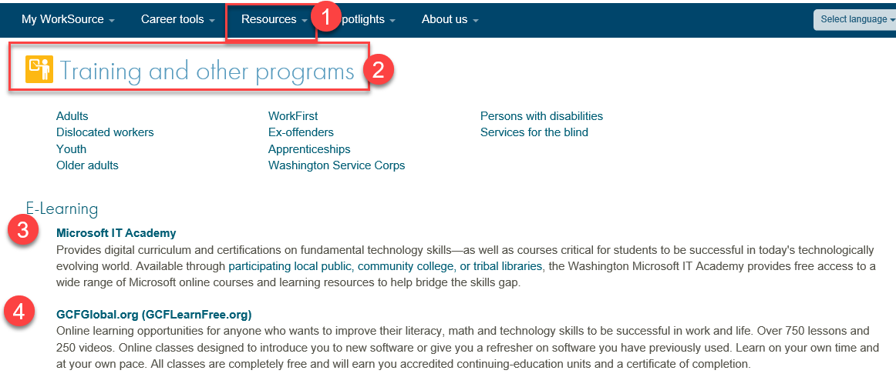
- UI announcements –
  - Optional job search extended through 12/07/20
  - Job search information found here https://esd.wa.gov/unemployment/job-search-requirements
  - Here is the information to provide feedback on Work Search Requirements
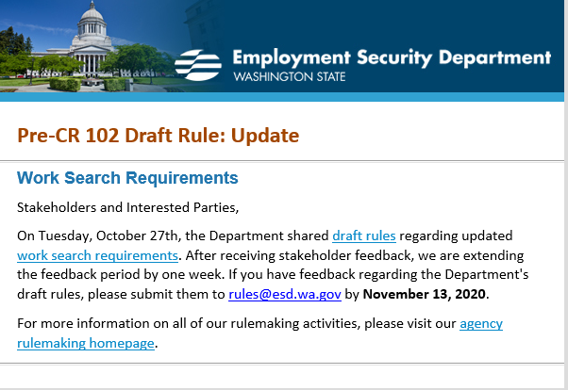

During the week of November 1-7, there were 25,201 initial regular unemployment claims (up 71.7% from the prior week) and 429,063 total claims for all unemployment benefit categories (down 2.1% from the prior week) filed by Washingtonians, according to the Employment Security Department (ESD).
  - Initial regular claims applications remain at elevated levels and are at 223 percent above last year’s weekly new claims applications.
  - This is the largest weekly increase in initial regular claims since the week of Mar. 21.
  - Initial regular claims last hovered around 25,000 initial claims during the week ending Aug. 1.
  - Initial regular claims typically increase this time of year due to seasonal layoffs, primarily in the agriculture and construction industries.
- The following types of claims decreased over the week:
  - Initial claims for Pandemic Unemployment Assistance (PUA).
  - Continued claims for regular benefits.
- Initial claims for Pandemic Emergency Unemployment Compensation increased over the week.
In the week ending November 7, ESD paid out over $146.5 million for 291,628 individual claims. Since the crisis began in March, ESD has paid more than $12.2 billion in benefits to over a million Washingtonians.
- ESD.wa.gov or ESD Facebook page for current UI information
- Before submitting a service ticket help
Review of ETO/WSWA and other resources (AKA old business)
- Encourage all staff who use ETO and WSWA to sign up for the T12 calls. These calls are not just for trainers but for all system users and a great way to stay up to date on changes or improvements to ETO and WSWA. Send requests to esdgpWSSteam@esd.wa.gov to be added to the ITSD Training Team’s distribution list
- WorkSource Systems resources found on the WPC Technology site https://wpc.wa.gov/tech
  - We try our best to make sure all the links are operational but depend on you to submit a remedy ticket if you find broken links!
- Stay up to date on COVID19, teleworking and WorkSource Virtual services. Check out the information the WPC website to help all WorkSource staff telework.
  - IT service delivery
  - WebEx
    - Browse the Webex handbook and watch 5 videos on how to make the most out of this tool for conducting meetings with staff and customers.
  - Other resources include:
    - Now that you are teleworking reference guide
    - How to use SKYPE for online meetings
    - How to sign into ESD email from outside the network
    - How to sign into an off-site Wi-Fi from your computer
    - Can I access Internet Explorer from a MAC computer?
    - ESD service Desk information.
- UI Fraud help
  - www.esd.wa.gov/fraud
  - Fax information to claims centers 833-572-8423 –calling is not recommended due to the high volume of calls
  - Reviewing our web resources with them. Some helpful pages include:
- Employee FAQs
- Employee instructional videos
- How to file weekly claims
But you CAN’T help by:
  - Contacting an intake agent at the claims center and asking them to review your friend or family member’s claim or solve their issue.
  - Using your influence to move your friend or family member’s claim up the queue to be processed faster.
  - Using your influence to give any kind of advantage to your friend or family member.
  - Using your access to UTAB, if you have it, to give someone information about their claim.
  - Using your friend or family member’s SAW account and applying for benefits or submitting their weekly claims for them.
- Cisco Softphones training material Link http://insideesd.wa.gov/services/it-services
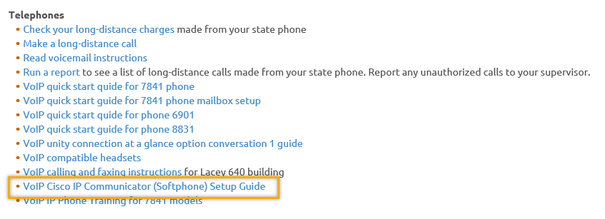
- Before submitting a service, request review these suggestions as the services desk will ask you to run through these steps. Many times, this resolves your issue without a service request!

  - Remember to log out of ETO, clicking off the browser tab here does not end your ETO session and will create issues when you log in again.
      - Always logout by opening your profile menu and clicking “Logout”
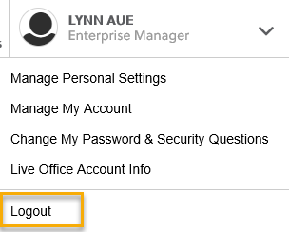
  - If you were impersonating a seeker or recruiter from ETO to WSWA remember to end the session, found in the upper left-hand corner. Clicking off your internet browser tab does not end impersonation!
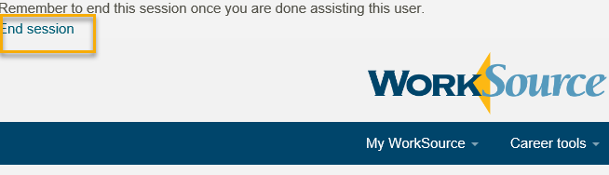

- For best performance clear your cache weekly

  - Internet Explorer (IE): Clearing IE cache starts from the top right side of the browser bar, click the settings icon and select Internet Options
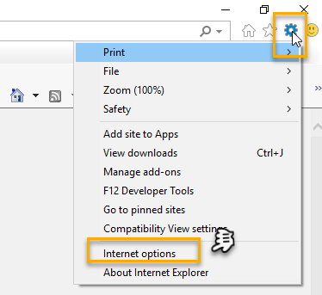

    - From the “General” tab click “Delete” which takes you to the “Delete Browsing History” screen. If not already checked click on the 2 boxes outlined here and click “Delete” you will return to the “General” tab

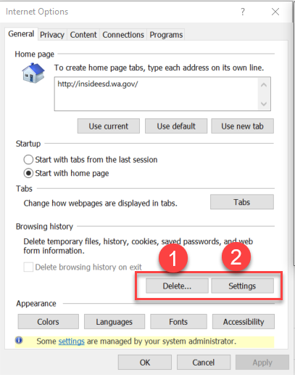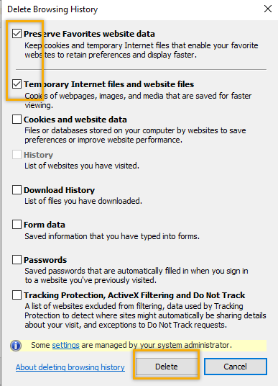

    - Next click “Settings” and if not selected click the radio button for “Every time I visit the webpage” This ensures you are using the most up to date version of ETO. Click OK
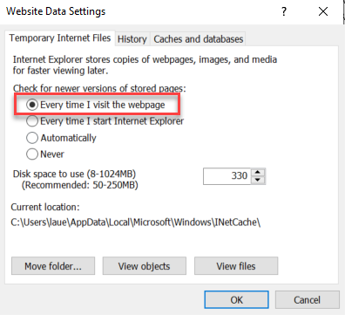
      - You will return to the General tab and click Apply and OK to complete the process of clearing your cache

  - Clearing Chrome cache starts from the top right side of the browser bar
- Click the triple dots to open the Chrome tools menu
- Hover over “More tools”
- Click “Clear browsing data” which opens a new screen
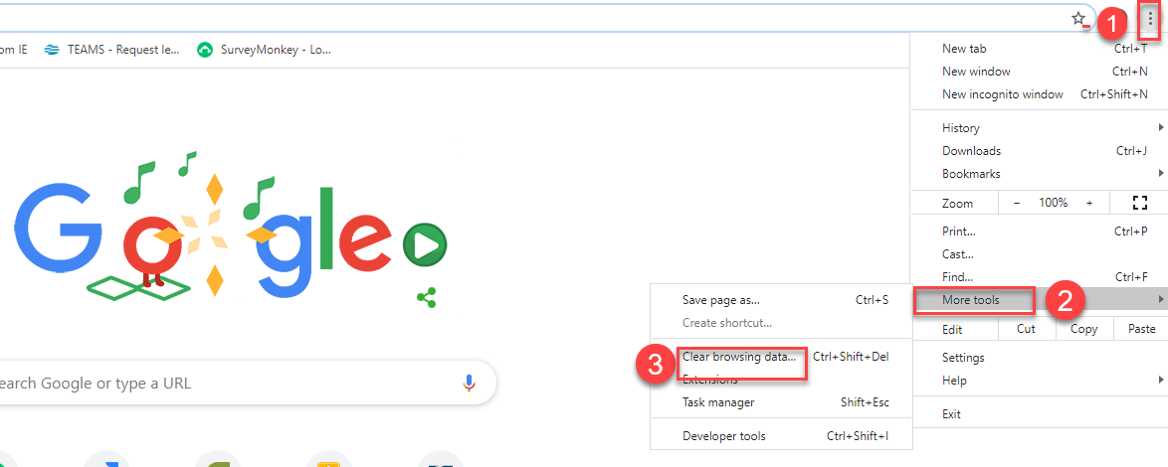

- Click “Clear data”
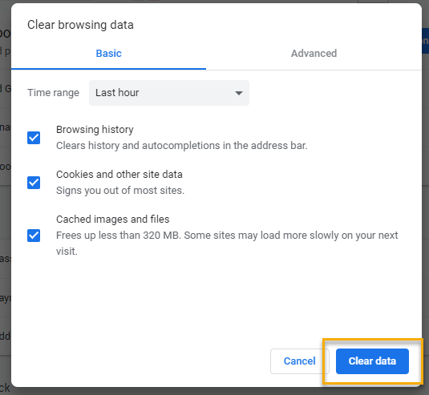

  - Finish by restarting your computer
  - If you still experience issues submit a service request https://wpc.wa.gov/tech/issues
CHAT
Concerning work on reports enhancement’s: We will be adding a section to the “Enhancement” tab on the WPC where you can see what reports are under construction!
If you’re not able to flag it possibly just sending a weekly update on "Current repots being modified” and then list the reports that are being modified. Just an idea.
Thank you for this feedback. We are actively working on improving the experience for accessing reports in ETO, and any suggestions would be appreciated!

from Teresa Sparks to everyone: 10:27 AM
That's great! You and Mary are awesome with all the work that you do!
from Craig Clark to everyone: 10:27 AM
That option sounds great. Thank you.
from Skyler Blumenthal to everyone: 10:29 AM
Job Match requirement was extended from 11/8 to 12/07 I believe
from Skyler Blumenthal to everyone: 10:29 AM
probably expected to be extended again
from Craig Clark to everyone: 10:30 AM
Thank you. Talk with you again next time. Have a wonderful holiday.

Regarding adding a participant record manually:
from Ton Nguyen to everyone: 10:30 AM
Hey Lynn, are you going to be going through the creating an ETO account for a customer under extreme circumstances without an WorkSource WA account?
Implementation of the ‘add a record to ETO’ function has been delayed until further notice. However, this function is still possible for your Department Head. If they run into any issues or need help to do this, please submit a remedy ticket.

from Skyler Blumenthal to everyone: 10:32 AM
WSS team e-mail: ESDGPWSSTeam@esd.wa.gov
Website for any issues (i.e. how to submit a remedy ticket): https://wpc.wa.gov/tech/issues

ATTENDEES
Aaron Parrott
Abby Taft
Adeline Kerns
Adelp
A Hughes
Amy
Ariana
Arturo Espinoza
Barry Dickerson
Brooklynn Zanto
C
Carl Peterson
Catherine Geddis
Christopher File
Cori Ching
Craig Clark
Dan Cooling
David Nava
Dean Coxford
Diana Luoma
Donetta McCormack
Donna Mack
Dorothy Rocha
Elijah Wabnitz
Emily Anderson
Gracie Troncoso
Heidi Schauble
Ione Turner
Janice Herrin
Joanie Linder
Katherine Congleton
Kendall King
Kimberly Newkirk
La Qwana
Lisa Pietkauskis
Luci Bench
Maria Zaragoza
Megan Irwin
Melissa Maynard
Michael Ensor
Nelva March
Noel Woods
Petru Mihaluta
Rebecca McGinnis
rjonas
Robbin Gard
Sean McElligott
Selma Tekle
Skyler Blumenthal
Talia Ni Dufaigh
Tamela McNamee
Teresa Anda
Teresa Sparks
Thomas Anderson
Timothy Mallon
T Larson
Ton Nguyen
Toni Burrow
Tracy Ferrell
Vdamneun
Victoria Wood
Young Suh
Zoryana Bilous

Attended second half

