T12 Meeting MInutes 10-28-2020
Remember: After starting a Webex meeting to mute your audio and disable the video feature. Too many attendee’s with active video can interfere with everyone’s audio quality. Hover on the lower monitor screen to find these icons.

Thanks to all who contribute to this weekly call!

New Business
- ETO Enhancements updates -
  - Multi-Factor Authentication (MFA) was rolled back. Delayed to first quarter 2021
  - Create an ETO Participant record by staff so you can record services – on hold, implementation date TBD
- Tickets into production – Change to EO language on the WIOA Eligibility Application
- ETO/WSWA maintenance – nothing this week
- Velaro maintenance – nothing this week
- Training issue(s) of the week –
  - How to re-open a closed PE desk aid https://wpc.wa.gov/tech/ETO-refresher-training
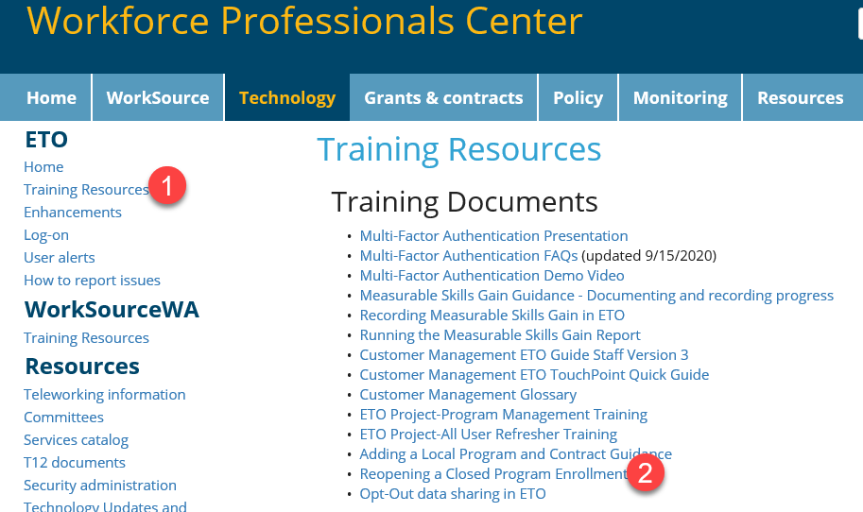
  - Changes to participant information who don’t have a WSWA account is allowable without participant permission on the View/Edit screen. Permission from the participant is needed for changes made through impersonation
  - Reminder: Submit remedy tickets for all work requests. My team cannot begin work without a service request. Reaching out to us directly can affect the time it takes to resolve your issue. Thanks!
- ETO Engage Survey – Work on desk aid/training materials is on hold at this time
- What’s new on WPC – nothing this week
- ETO Basic and Refresher Training
  - ETO Basic training is the 1st Monday 10-12 and 3rd Tuesday 2-4 of every month (except holidays). Send email to Lynn Aue to receive more information, training account if needed and be added to the training Webex call. Invites should not be forwarded.
  - Training recordings and user guides are posted on the WPC website here https://wpc.wa.gov/tech/ETO-refresher-training
  - Submit a remedy ticket asking Lynn Aue for additional training opportunities and training resources
- Open discussion –
  - WPC site WDA contacts list. Mary MacLennan will be reaching out to each area to update the list. Thanks to all for your input on the process.
  - Via ETO Engage, can a message be sent out to the Mass Call list? Is that functionality in place. The team would like to send a Voice Message that WS is open that has music behind it. We think so and will follow up with you. We get reports from many areas who use ETO Engage daily is a great tool used to contact customers. We heard it helps with appointment shows. Monster and I are working on this process and developing a training guide and compiling best practices.
- WSWA Virtual services to assist job seekers/employers to sharpen skills. There are many tools on WSWA but here are a couple of my favorites!
  - Check out these virtual classes under Resources>Training and other programs.
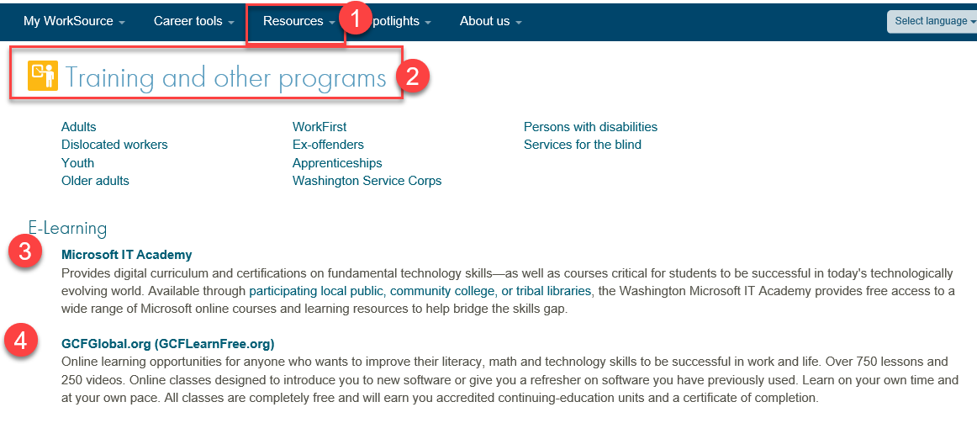
- UI announcements –
  - Optional job search extended through 11/8
  - Job search information found here https://esd.wa.gov/unemployment/job-search-requirements
  - Here is the information to provide feedback on Work Search Requirements
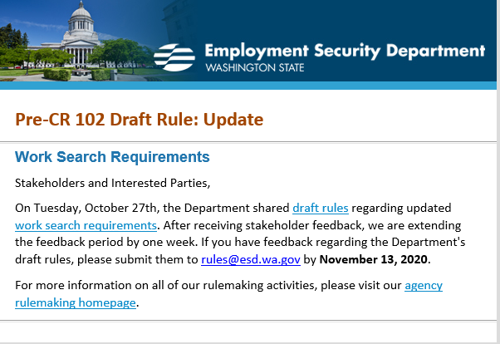

During the week of October 18 through October 24, there were 14,198 initial regular unemployment claims (down 15.9 % from the prior week) and 475,441 total claims for all unemployment benefit categories (down 3.2% from the prior week) filed by Washingtonians, according to the Employment Security Department (ESD).
  - Initial regular claims applications remain at elevated levels and are at 128 percent above last year’s weekly new claims applications.
  - Continued claims for regular Unemployment Insurance, Pandemic Unemployment Assistance (PUA) initial claims and Pandemic Emergency Unemployment Compensation (PEUC) initial claims all decreased over the week.
  - The increases in initial regular unemployment claims were primarily in manufacturing and accommodation and food service. Retail and transportation and warehousing also showed increases
In the week ending October 10, ESD paid out over $145 million for 307,548 individual claims. Since the crisis began in March, ESD has paid more than $11.9 billion in benefits to over a million Washingtonians.
- ESD.wa.gov or ESD Facebook page for current UI information
- Before submitting a service ticket help
Review of ETO/WSWA and other resources (AKA old business)
- Encourage all staff who use ETO and WSWA to sign up for the T12 calls. These calls are not just for trainers but for all system users and a great way to stay up to date on changes or improvements to ETO and WSWA. Send requests to esdgpWSSteam@esd.wa.gov to be added to the ITSD Training Team’s distribution list
- WorkSource Systems resources found on the WPC Technology site https://wpc.wa.gov/tech
  - We try our best to make sure all the links are operational but depend on you to submit a remedy ticket if you find broken links!
- Stay up to date on COVID19, teleworking and WorkSource Virtual services. Check out the information the WPC website to help all WorkSource staff telework.
  - IT service delivery
  - WebEx
    - Browse the Webex handbook and watch 5 videos on how to make the most out of this tool for conducting meetings with staff and customers.
  - Other resources include:
    - Now that you are teleworking reference guide
    - How to use SKYPE for online meetings
    - How to sign into ESD email from outside the network
    - How to sign into an off-site Wi-Fi from your computer
    - Can I access Internet Explorer from a MAC computer?
    - ESD service Desk information.
- UI Fraud help
  - www.esd.wa.gov/fraud
  - Fax information to claims centers 833-572-8423 –calling is not recommended due to the high volume of calls
  - Reviewing our web resources with them. Some helpful pages include:
- Employee FAQs
- Employee instructional videos
- How to file weekly claims
But you CAN’T help by:
  - Contacting an intake agent at the claims center and asking them to review your friend or family member’s claim or solve their issue.
  - Using your influence to move your friend or family member’s claim up the queue to be processed faster.
  - Using your influence to give any kind of advantage to your friend or family member.
  - Using your access to UTAB, if you have it, to give someone information about their claim.
  - Using your friend or family member’s SAW account and applying for benefits or submitting their weekly claims for them.
- Cisco Softphones training material Link http://insideesd.wa.gov/services/it-services
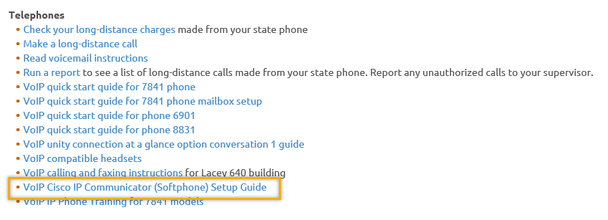
- Before submitting a service, request review these suggestions as the services desk will ask you to run through these steps. Many times, this resolves your issue without a service request!

  - Remember to log out of ETO, clicking off the browser tab here does not end your ETO session and will create issues when you log in again.
      - Always logout by opening your profile menu and clicking “Logout”
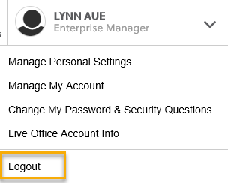
  - If you were impersonating a seeker or recruiter from ETO to WSWA remember to end the session, found in the upper left-hand corner. Clicking off your internet browser tab does not end impersonation!
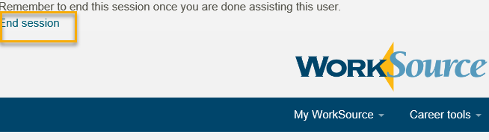

- For best performance clear your cache weekly

  - Internet Explorer (IE): Clearing IE cache starts from the top right side of the browser bar, click the settings icon and select Internet Options
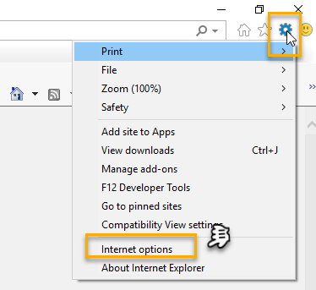

    - From the “General” tab click “Delete” which takes you to the “Delete Browsing History” screen. If not already checked click on the 2 boxes outlined here and click “Delete” you will return to the “General” tab

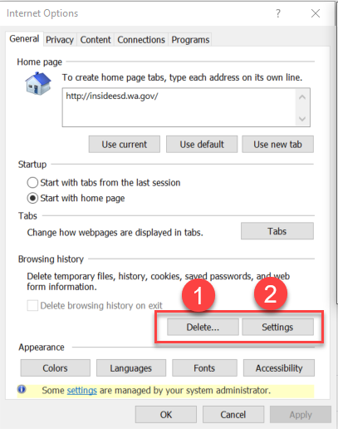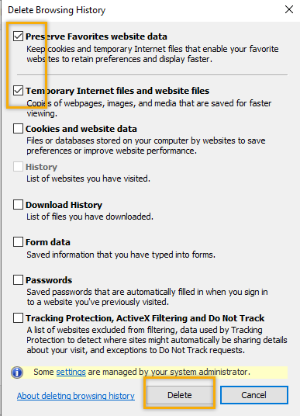

    - Next click “Settings” and if not selected click the radio button for “Every time I visit the webpage” This ensures you are using the most up to date version of ETO. Click OK
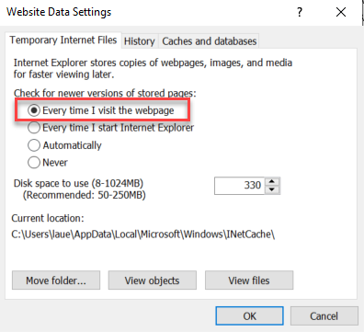
      - You will return to the General tab and click Apply and OK to complete the process of clearing your cache

  - Clearing Chrome cache starts from the top right side of the browser bar
- Click the triple dots to open the Chrome tools menu
- Hover over “More tools”
- Click “Clear browsing data” which opens a new screen
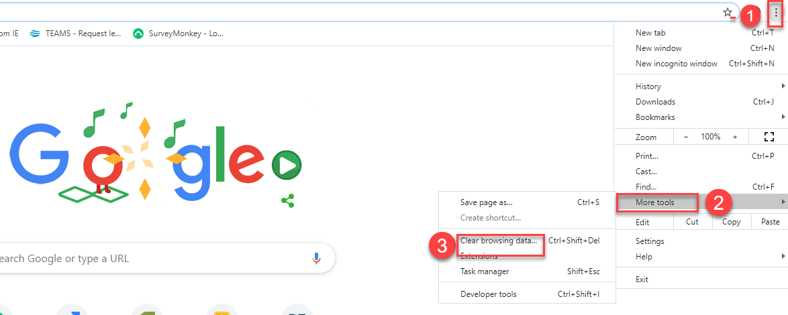

- Click “Clear data”
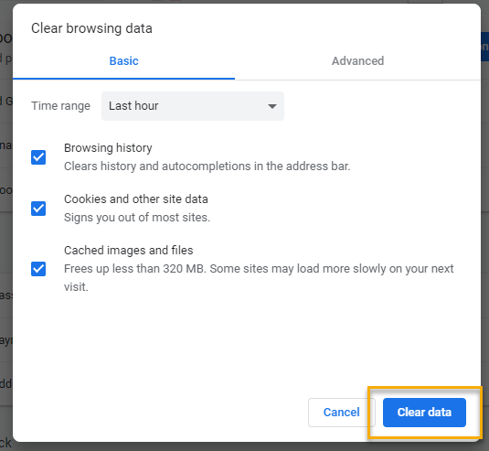

  - Finish by restarting your computer
  - If you still experience issues submit a service request https://wpc.wa.gov/tech/issues
CHAT
Regarding Multi-factor Authentication (MFA):
from Crystal Armitage to everyone: 10:04 AM Did you say that MFA would be changed to email instead of phone?
from Skyler Blumenthal to everyone: 10:07 AM MFA (Multi-factor authentication) has been rolled back, we're currently determining if e-mail can be used as an alternative to phone verification, but nothing has been definitively decided yet. For the time being, MFA is not enabled in ETO.

Regarding Data Corrections for ETO:
from Crystal Armitage to everyone: 10:14 AM Why are all the data corrections staff from outside ESD?
from Skyler Blumenthal to everyone: 10:22 AM Rebecca knows more about this but from what I understand we just get in touch with a representative for the office/WDA, to have the individuals who took the original touchpoint to correct the data.

Regarding Department Heads/WDA representatives:
From Craig 10:23 AM If we need to have our account changed to Department Head (DH) do we still get in contact with Eric Lee? Eric Lee is who you’d get in contact with if you need an access approver. Eric just changes the list. To change ones’ permissions/etc, the Local Access Approver should use the ETO Add/Change User Form found here: https://wpc.wa.gov/tech/security
Maybe if there was a desk aid explaining all the different lists and processes
Thank you for this suggestion; we will see what we can do in providing better training for these processes. In the meantime, there is a lot of helpful information at https://wpc.wa.gov/tech

Regarding custom reports/getting information:
from Toni Burow to everyone: 10:25 AM Is there a department head report that can be generated for each WDC to make sure it is correct? Submit a remedy ticket and our team will send you an up to date report
from Skyler Blumenthal to everyone: 10:30 AM If you aren't able to find a specific report, submit a remedy ticket and the WSS Team will get that information to you via a custom query (if possible)
from Emily Anderson to everyone: 10:31 AM Skyler and Toni, I just had someone (Rebecca, maybe?) pull a list for me last week. She had to pull a list of all WDCs, and I looked through for names I recognized. She stated there is no WDC-specific list of Department Heads.

NOTE: If you are looking for specific information from a report (e.g. “what department heads are in my area?” or “can I get a list of Spanish-speaking seekers in this county?”) the WSS team may be able to help. However, if you are trying to request changes to your or another’s account (“Can you change this account to Department Head?”) we will not be able to help you, you must get in contact with your access approvers to make those changes.

ATTENDEES
Aaron Parrott
Abigail Taft
adelp
Albert Verduzco
Amanda Siburg
Anjrea Miller
Arturo Espinoza
Becky Smith
Boliveri
Brooklynn Zanto
Caroline Homes
Catherine Geddis
Christopher File
Cori Ching
Craig Clark
Crystal Armitage
Dan Cooling
Dean Coxford
Dorothy Rocha
Eileen Boylston
Emily Anderson
Heidi Lamers
Heidi Schauble
Hope Baker
Ione Turner
Irene Jordan
Jesus Diaz
Joanie Linder
Jordan Meyenburg
Kate Hesseltine
Kate Stevick
Kendall King
Laurie Stone
Luci Bench
Lux Dmitri
Maria Zaragoza
Melisa Flores-Sanchez
Michael Ensor
Miriam Cisneros
Monique Martin
Nicholas Towne
Noel Woods
Petru Mihaluta
Philip Hall
Pochi Ostergren
Regina Cancel
Robbin Gard
Rodolfo Aparicio
Shannon Booth
Skyler Blumenthal
Talia Ni Dufaigh
Tamela McNamee
Teresa Anda
Teresa Southard
Teresa Sparks
Timothy Mallon
TLarson
Ton Nguyen
Toni Burow
Tracy Ferrell
Tracy Oligaard
Zoryana Bilous
Attended second half

