T12 Meeting Minutes 10-21-2020
Remember: After starting a Webex meeting to mute your audio and disable the video feature. Too many attendee’s with active video can interfere with everyone’s audio quality. Hover on the lower monitor screen to find these icons.

Thanks to all who contribute to this weekly call!

New Business
- ETO Enhancements – Updates
  - Multi-Factor Authentication (MFA) was rolled back. At this time, you can sign into ETO without an authentication code. We are investigating the cause of this issue. Once we have a confirmed relaunch date, we will communicate via ETO messenger, T12 distribution list, RDs, Office Administrators and WDA directors. Here is what you need to do if you haven’t added a phone number to your ETO account.
    - Find the MFA Presentation PowerPoint, demo video and FAQ’s here https://wpc.wa.gov/tech/ETO-refresher-training
    - Preparation for MFA in ETO production requires you enter your work phone number in ETO (says Cell Phone but does support a land line) by opening your profile and clicking the “Manage My Account” menu and entering your work number.

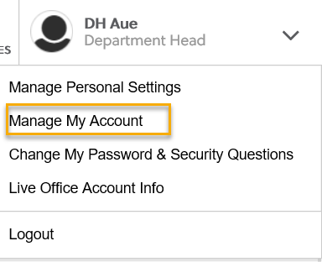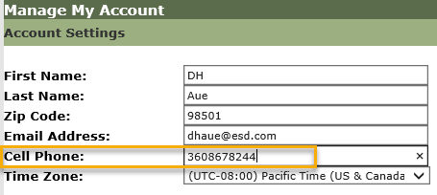

  - Create an ETO Participant record by staff so you can record services – on hold, implementation date TBD
- Tickets into production – nothing this week
- WSWA maintenance – 10/25/20-10/26/20 10PM to 12AM. Submit a remedy ticket if you experience issues
- Velaro maintenance – Delayed from 10/16/20 to 10/23/20 approximately 1 hour @ 3:30AM. Maintenance will not interrupt service delivery. Submit a remedy ticket but if you hear of issues
- Training issue(s) of the week –
  - Reminder: Submit remedy tickets for all work requests. My team cannot begin work without a service request. Reaching out to us directly can affect the time it takes to resolve your issue. Thanks!
- ETO Engage Survey – Work on desk aid/training materials is on hold at this time
- What’s new on WPC – Public use computers and Virtual WS tools
- ETO Basic and Refresher Training
  - ETO Basic training is the 1st Monday 10-12 and 3rd Tuesday 2-4 of every month (except holidays). Send email to Lynn Aue to receive more information, training account if needed and be added to the training Webex call. Invites should not be forwarded.
  - Training recordings and user guides are posted on the WPC website here https://wpc.wa.gov/tech/ETO-refresher-training
  - Submit a remedy ticket asking Lynn Aue for additional training opportunities and training resources
- Open discussion –
  - Follow-up: How do you get participants signatures in this virtual environment we are in? During the 10/14/20 call it was signature by proxy was suggested. I want to clarify this process is used by the Workfirst program to confirm participants attended their DSHS required WS orientation and is authorized by the WF Program Operator.Check with you local area as to what they recommend. This issue has been elevated to the RD’s to find a statewide solution. More to follow.
  - We are having a problem getting pay points due to duplicate accounts in WorkSourceWA. Has there been any discussion about this issue regarding the system being updated so this is not possible or is this even feasible? Is this process written as a desk aide? We will get a desk aid put on the wpc site. In the meantime, if you run into a duplicate account in ETO, please submit a ticket to our team https://wpc.wa.gov/tech/issues explaining that a duplicate account needs to be merged, and provide the following information:
    - - Name of seeker, Date of Birth
    - - Case numbers for both accounts
    - - Which account has the correct SSN (if there is any discrepancy)
    - (provide only the last 4 of the SSN, do NOT include full SSN in the ticket.)
- WSWA Virtual services to assist job seekers/employers to sharpen skills. There are many tools on WSWA but here are a couple of my favorites!
  - Check out these virtual classes under Resources>Training and other programs.
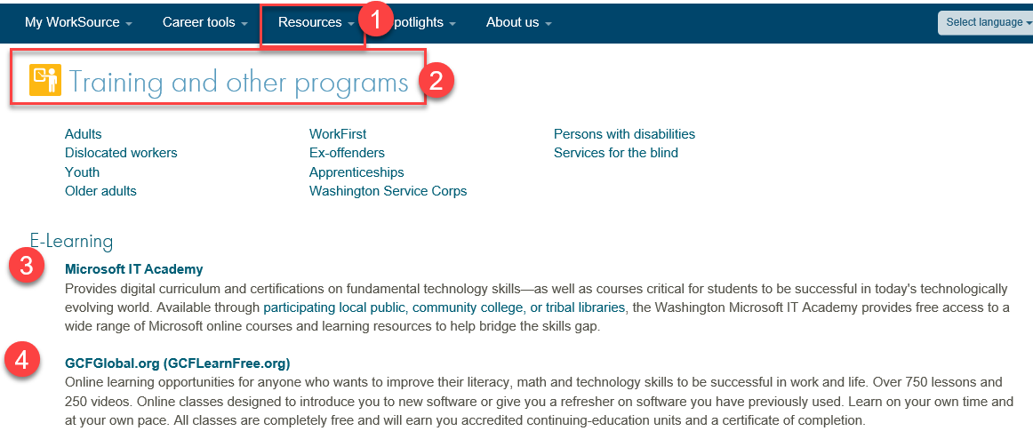
- UI announcements –
  - Optional job search extended through 11/8

During the week of October 4 through October 10, there were 22,324 initial regular unemployment claims (up 44.1 % from the prior week) and 476,735 total claims for all unemployment benefit categories (down 5.9% from the prior week) filed by Washingtonians, according to the Employment Security Department (ESD).
  - Initial regular claims applications remain at elevated levels and are at 252 percent above last year’s weekly new claims applications.
  - Continued claims for regular Unemployment Insurance, Pandemic Unemployment Assistance (PUA) initial claims and Pandemic Emergency Unemployment Compensation (PEUC) initial claims all decreased over the week.
  - The increases in initial regular unemployment claims were primarily in manufacturing and accommodation and food service. Retail and transportation and warehousing also showed increases
In the week ending October 10, ESD paid out over $153 million for 318,534 individual claims. Since the crisis began in March, ESD has paid more than $11.6 billion in benefits to over a million Washingtonians.
- ESD.wa.gov or ESD Facebook page for current UI information
- Before submitting a service ticket help
Review of ETO/WSWA and other resources
- Encourage all staff who use ETO and WSWA to sign up for the T12 calls. These calls are not just for trainers but for all system users and a great way to stay up to date on changes or improvements to ETO and WSWA. Send requests to esdgpWSSteam@esd.wa.gov to be added to the ITSD Training Team’s distribution list
- WorkSource Systems resources found on the WPC Technology site https://wpc.wa.gov/tech
  - We try our best to make sure all the links are operational but depend on you to submit a remedy ticket if you find broken links!
- Stay up to date on COVID19, teleworking and WorkSource Virtual services. Check out the information the WPC website to help all WorkSource staff telework.
  - IT service delivery
  - WebEx
    - Browse the Webex handbook and watch 5 videos on how to make the most out of this tool for conducting meetings with staff and customers.
  - Other resources include:
    - Now that you are teleworking reference guide
    - How to use SKYPE for online meetings
    - How to sign into ESD email from outside the network
    - How to sign into an off-site Wi-Fi from your computer
    - Can I access Internet Explorer from a MAC computer?
    - ESD service Desk information.
- UI Fraud help
  - www.esd.wa.gov/fraud
  - Fax information to claims centers 833-572-8423 –calling is not recommended due to the high volume of calls
  - Reviewing our web resources with them. Some helpful pages include:
- Employee FAQs
- Employee instructional videos
- How to file weekly claims
But you CAN’T help by:
  - Contacting an intake agent at the claims center and asking them to review your friend or family member’s claim or solve their issue.
  - Using your influence to move your friend or family member’s claim up the queue to be processed faster.
  - Using your influence to give any kind of advantage to your friend or family member.
  - Using your access to UTAB, if you have it, to give someone information about their claim.
  - Using your friend or family member’s SAW account and applying for benefits or submitting their weekly claims for them.
- Cisco Softphones training material Link http://insideesd.wa.gov/services/it-services
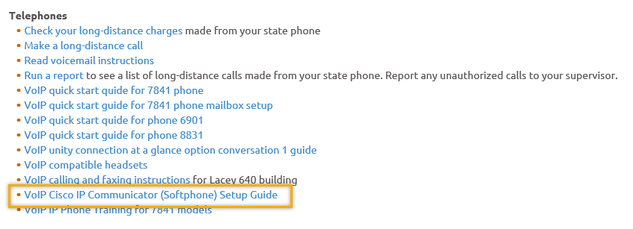
- Before submitting a service, request review these suggestions as the services desk will ask you to run through these steps. Many times, this resolves your issue without a service request!

  - Remember to log out of ETO, clicking off the browser tab here does not end your ETO session and will create issues when you log in again.
      - Always logout by opening your profile menu and clicking “Logout”
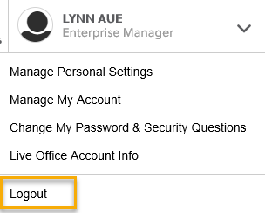
  - If you were impersonating a seeker or recruiter from ETO to WSWA remember to end the session, found in the upper left-hand corner. Clicking off your internet browser tab does not end impersonation!
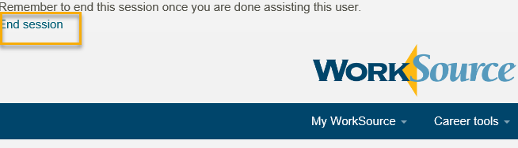

- For best performance clear your cache weekly

  - Internet Explorer (IE): Clearing IE cache starts from the top right side of the browser bar, click the settings icon and select Internet Options
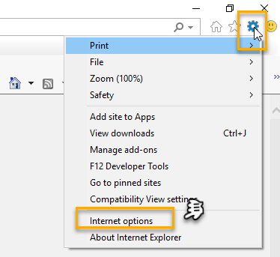

    - From the “General” tab click “Delete” which takes you to the “Delete Browsing History” screen. If not already checked click on the 2 boxes outlined here and click “Delete” you will return to the “General” tab

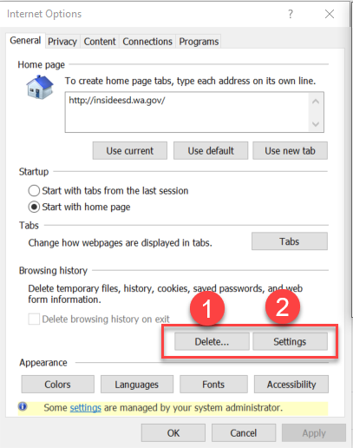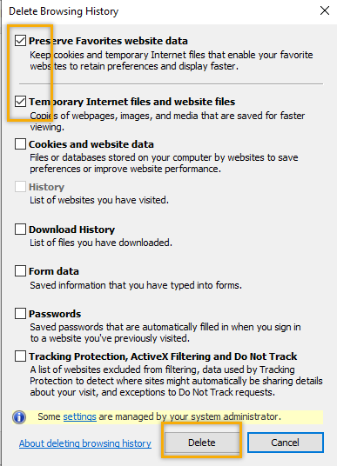

    - Next click “Settings” and if not selected click the radio button for “Every time I visit the webpage” This ensures you are using the most up to date version of ETO. Click OK
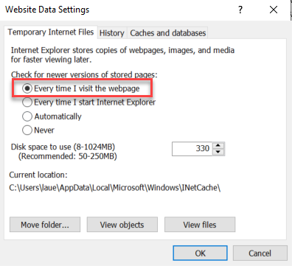
      - You will return to the General tab and click Apply and OK to complete the process of clearing your cache

  - Clearing Chrome cache starts from the top right side of the browser bar
- Click the triple dots to open the Chrome tools menu
- Hover over “More tools”
- Click “Clear browsing data” which opens a new screen
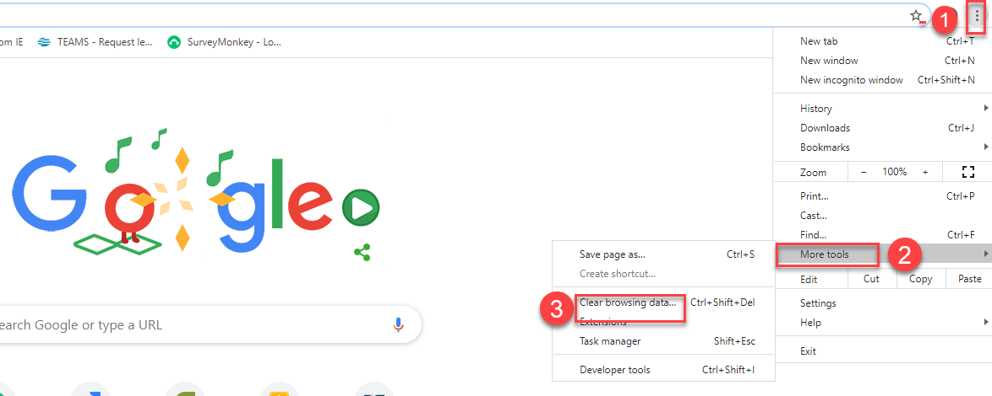

- Click “Clear data”
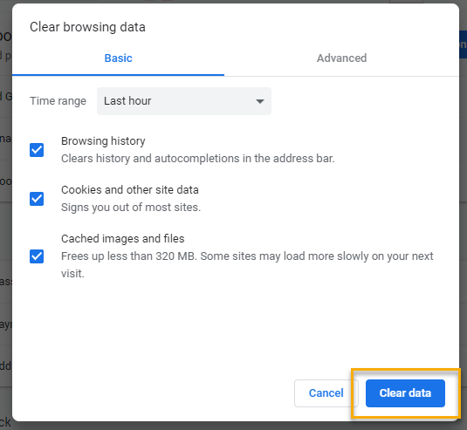

  - Finish by restarting your computer
  - If you still experience issues submit a service request https://wpc.wa.gov/tech/issues
CHAT
from Debra Gibson to everyone: 10:13 AM
Good morning, is this same class I attended yesterday? T-12 weekly call is different from the bi-monthly ETO Basic/Refresher training; Basic training is a one-time training necessary before approved for a new employee account on ETO. Some staff attend as a refresher if they haven’t been in ETO for awhile. T-12 is a weekly meeting with announcements and helpful information for all staff.

from Robbin Gard to everyone: 10:13 AM Lynn where is the link to the training calendar? The Webex link to the training calendar for T12 was removed from the WPC website as unauthorized persons were entering our meetings but the contact information is still on the staff development calendar

Regarding pulling reports in ETO:
Reminder: 6/20/20 ETO became browser neutral, meaning you can use IE or Chrome
from Robbin Gard to everyone: 10:20 AM question about reports... Seems like it takes for ever to run a report and then the system times out. Any suggestions?
Makes no difference home or office, typically staff efforts and RESEA and I refresh every time prior to running
from Skyler Blumenthal to everyone: 10:24 AM for myself: reports are still pretty slow but fastest when using Chrome. Also, if running a report with a specific timeframe, the larger slice of time you choose it will take longer because it has to load more data.
from Craig Clark to everyone: 10:25 AM
It also depends on the amount of data you are trying to pull and the time span you are requesting data for.
from Robbin Gard to everyone: 10:28 AM Will give it another go with smaller date ranges. Thanks

Regarding duplicate accounts:
from Regina Cancel to everyone: 10:24 AM
We are having a problem getting pay points due to duplicate accounts in WorkSourceWA. Has there been any discussion about this issue regarding the system being updated so this is not possible or is this even feasible? Is this process written as a desk aide? We will get a desk aid put on the wpc site. In the meantime, if you run into a duplicate account in ETO, please submit a ticket to our team (https://wpc.wa.gov/tech/issues) explaining that a duplicate account needs to be merged, and provide the following information:
- Name of seeker, Date of Birth
- Case numbers for both accounts
- Which account has the correct SSN (if there is any discrepancy)
(provide only the last 4 of the SSN, do NOT include full SSN in the ticket.)

ATTENDEES
Aaron Parrott
Abigail Taft
Adeline Kerns
Adelp
Albert Verduzco
Barbara Cromwell
Barry Dickerson
Becky Smith
Branda Jones
C
Catherine Geddis
Christopher File
Cori Ching
Craig Clark
Chrystal Armitage
CShaffer
Dawn Oakes
Dean Coxford
Debra Gibson
Diane Luoma
Dorothy Rocha
Drloney
Eileen Boylston
Elizabeth Ibanez
Emily Anderson
Gracie Troncoso
Heidi Lamers
Irene Jordan
Jesus Diaz
Joanie Linder
Jordan Meyenburg
Kate Hesseltine
Kate Stevick
Kendall King
Kimberly Chase
Kylie Bartlett
La Qwana
Laurie Stone
Lisa Pietkauskis
Luci Bench
Lyla Dinguss
Maria Zaragoza
Maribel Dominguez
Mauricio Kenny
Melisa Flores-Sanchez
Michael Ensor
Miriam Cisneros
Monique Martin
Nicholas Towne
Noel Woods
Petru Mihaluta
Pochi Ostergren
Regina Cancel
Robbin Gard
Rodolfo Aparicio
Sean McElligott
Selma Tekle
Skyler Blumenthal
Sue Keltner
Teresa Anda
Timothy Mallon
TLarson
Toni Burow
Tracy Oligaard
Vdamneun
Victoria Wood
Zoryana Bilous

Attended second half

